**挑错题高频考点**

**非谓语动词**

非谓语作宾语（超高频）

非谓语 语态、强调顺序、意料之外结果

53. Henry is not used to live (A) in a noisy and crowed (B) community though (C) he grew up (D) in New York.

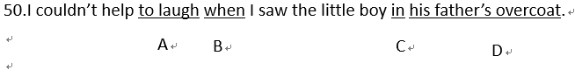







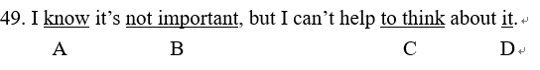

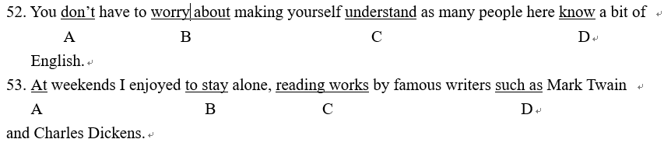

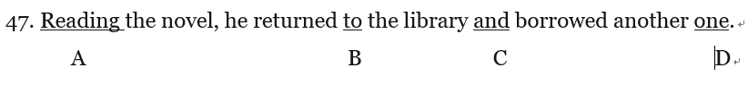

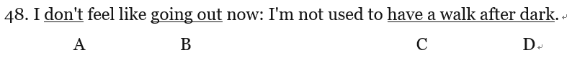



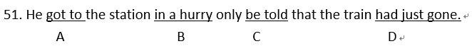



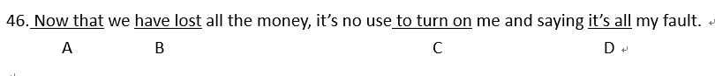

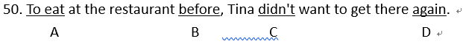

**从句连词、并列连词**

定语从句介词后引导词、表原因的引导词、并列、转折连词、虽然但是、

No matter -ever系列、形式宾语/主语、从句语序

49. The reason (A) I didn’t attend (B) the lecture was simply because (C) I caught a bad cold (D) that day.

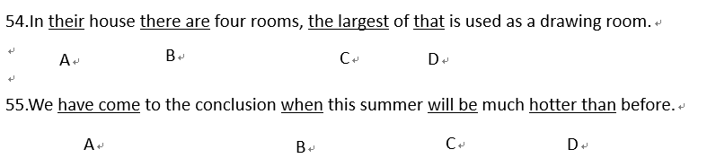

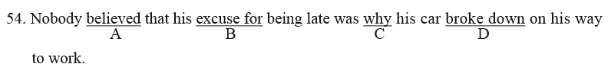

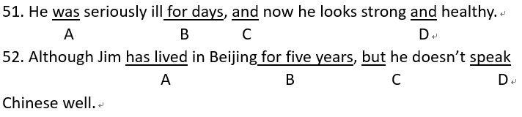

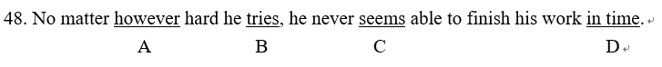

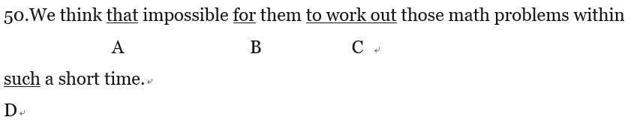

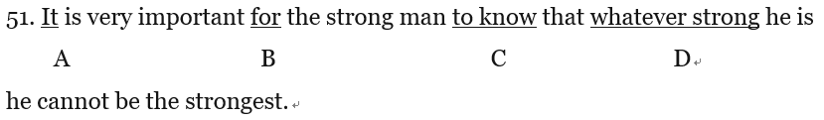

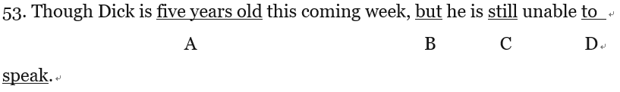

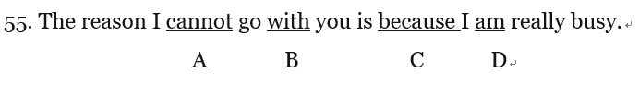

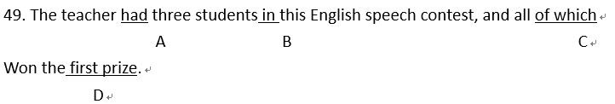





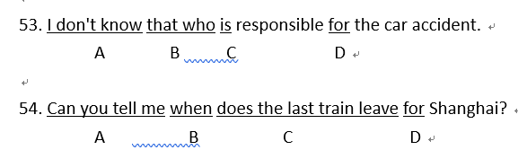

**主谓一致**

插入部分不算主语

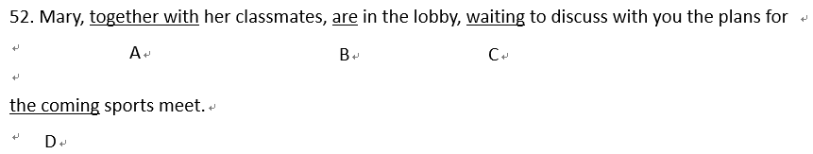



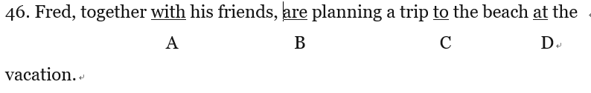

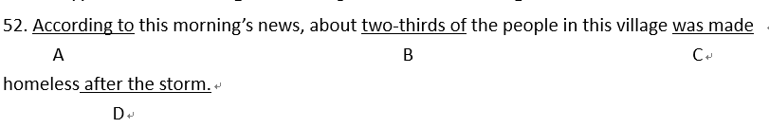

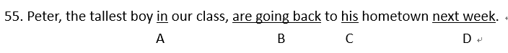

**时态语态**

主将从现、注意语态

52. In (A)the morning I got on(B) the train, which arrived (C) Shanghai at night (D).

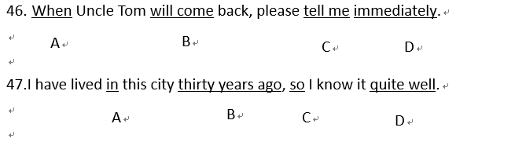

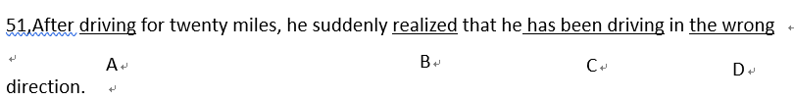

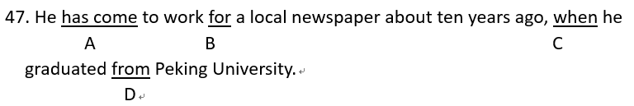

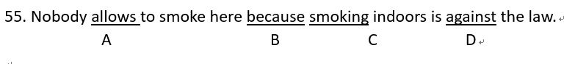

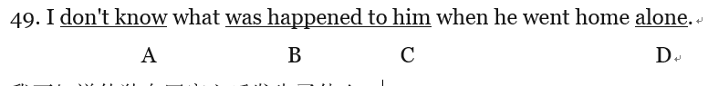

**比较级和最高级**

The +比较级…., the+比较级

重复加级

Very不修饰比较级，用much

55. The harder he worked (A), the most (B) troubles he had (C) in his early days as a scientist (D).

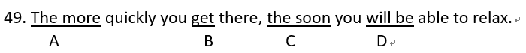

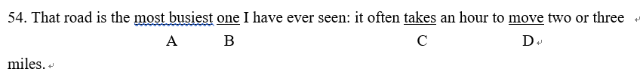

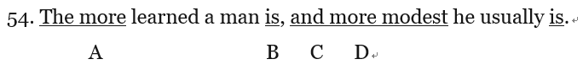

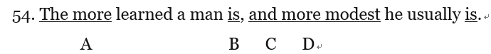

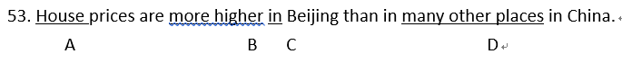



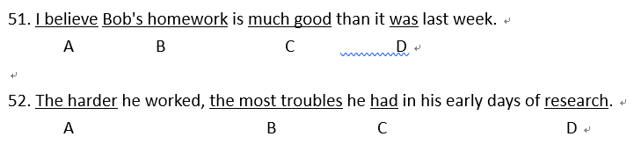

**动词并列**

50. DR. Bell gave (A) some lectures, visited (B) the Great Wall and going (C) shopping downtown in Beijing. (D)

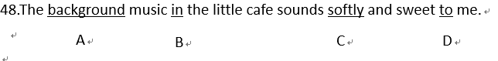









**代词**

One… the other;

主格宾格

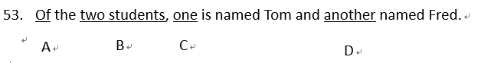

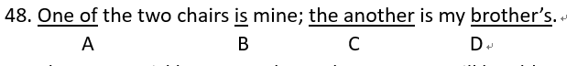

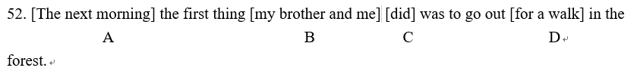

**名词 可数不可数**

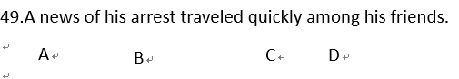

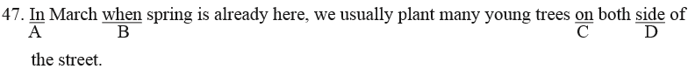

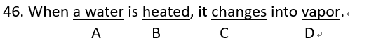

**倒装**

47. Hardly they had (A) got to (B) the bus stop when (C) the bus suddenly pulled away (D)





**虚拟语气**

46. If you had studied (A) the problem carefully yesterday (B), you won’t have (C) any difficulty now (D)

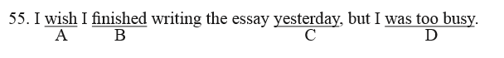



**反义疑问句**



**冠词**

54. Do you know (A) the old English saying that (B) a apple (C) a day keeps (D) the doctor away?



**情态动词**



**其他**

51. The first (A )man swim (B) across the (C) river will receive a prize (D).

48. The mountain was (A) really very high (B), but (C) I tried hardly (D) to climb it.

