There are 2 spiders for one websites as usual.

First is categories_of_xxx and second one is xxx_spider.

1. Getting combinations for needed queries. (categories_of_xxx)

To generate the combinations, you should edit seed files of csv in the root directory.

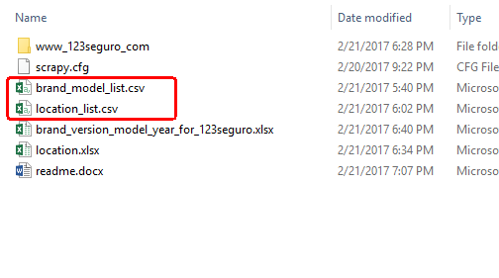

You can know what the format they have once you open the csv files. You should fill out as many rows as you need.

**How do you know a specific _id number.**

The most import value is model_id when you input the a specific data like brand, model, year, age and etc. You can refer the data set file named “brand_version_model_year_for_123seguro.xlsx” to find a certain model_id for. And the “year” value is only available in the range printed in the data set file.

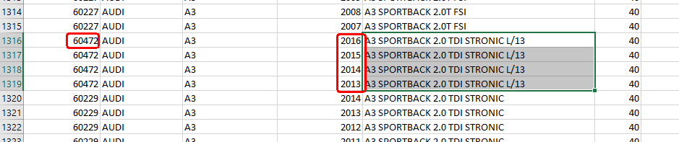

**How do you know a specific location_id?**

Similar to above approach.

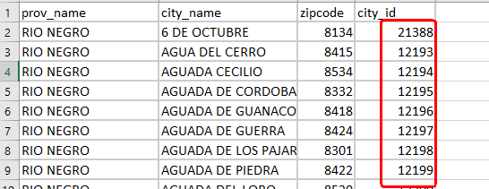

1. Scraping prices. (xxx_spider)

If you prepared the seed files, you can scraped the prices from the generated combination.

The usage is same with old website spiders.