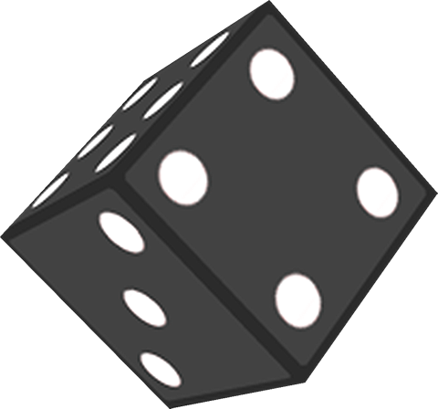Project SuperDice!

# Basic concept

Team members

* Stephan Menzi (menzs2)
* Hansjürg Jaggi (jaggh1)
* Satesh Paramasamy(paras1)

Main idea

The app will be a simple dice game. For this project, one dice game will be implemented, but the app will be open for games with different rules.

Key features

* Players can roll a die or multiple dice depending on the rules of the game using the device’s accelerometer sensor.
* The rolling of the dice will return an array with integer values of the thrown dice results and is animated using OpenGL.
* Results can be stored.
* Results can be added to a total.
* Results and totals can be compared to other players.
* We will implement „Pig“ [http://en.wikipedia.org/wiki/Pig_(dice)]:
* Each player can enter his name or pick his name if it is already stored in the device memory.
* Set a goal, for example 40 points.
* The game starts and each player plays one turn.
* The current player rolls a die…
  + - * ...if the result is 1, the score for the turn is set to 0 and his turn ends.
      * ...if the result is 2 to 6 the result is added to his total score.  
        The player may roll again or skip, add the turn score to his total score and end his turn.
* At the end, the player closest to the goal wins.

Server use

We will use our own Apache webserver with a MySQL database to store the user’s names and number of games won. Data will be transferred using JSON. Using a centralized server allows to have unique user names and a global high-score list.

Additional Features

This is a list of further, optional features

* Implementation of more dice-games
* Integration of Google Play for more interesting multiplayer options
* More things that will bring us slowly to perfection…

Basic project plan

|  |  |
| --- | --- |
| **Task** | **Deadline** |
| Define screenplay and UI design | 21.03.2014 |
| Define test cases | 21.03.2014 |
| First working prototype | 28.03.2014 |
| Testing, refactoring and finishing the project | 04.04.2014 |