PETABYTE-SCALE MIGRATION: TRANSACTIONAL DB → HADOOP ML DATA PLATFORM
Architecture Proposal & Migration Plan — Personal Technical Project
Gagandeep Kaur (“Hanjot”) · Hypothetical case study, independent of any employer

1. EXECUTIVE SUMMARY
This document is a self-directed technical design exercise: how I would architect and execute a migration of a large, transactional dataset out of a relational (OLTP) database and into a Hadoop-based data platform, specifically to support a machine-learning risk/scoring model that needs far more historical volume than the source database can practically serve.
It is written the way I would actually approach this at work — starting from the business driver, not the technology — and it deliberately spends real space on the part most people skip past: the storage-efficiency trade-off of Hadoop's default 3x replication at petabyte scale, and when Erasure Coding is the better answer.
Framing note: this is a hypothetical, independently-designed case study built to demonstrate architecture and trade-off thinking — it is not a description of a specific employer's system or data.
2. PROBLEM STATEMENT — WHY MIGRATE AT ALL
The trigger for this kind of project is almost always the same: a machine-learning model — in this case a transaction risk/scoring model — needs to learn from a much larger window of historical data than a live, transactional database is built to hold or serve.
- The source OLTP database is optimized for fast, small, single-record reads and writes (approve/decline a transaction in milliseconds) — not for scanning years of history.
- Querying years of historical data directly out of that database for model training risks degrading the live, revenue-critical transaction path — not an acceptable trade-off.
- The ML/data-science team needs a much larger, queryable, historically-complete dataset to train and continuously improve the scoring model — and needs it in a form that scales cheaply as data volume grows into the petabytes.
The answer: move the historical data (and keep syncing new data) into a Hadoop-based data lake purpose-built for large-volume storage and batch/analytical processing, decoupled entirely from the live transactional system.
3. TARGET ARCHITECTURE
Source system → ingestion (bulk + incremental) → HDFS raw zone → Spark ETL → curated Hive tables (hot + cold tiers) → analytics and the ML training pipeline → model serving. A validation gate sits between raw ingestion and promotion to the curated tier — the migration is never “done” until reconciliation passes.
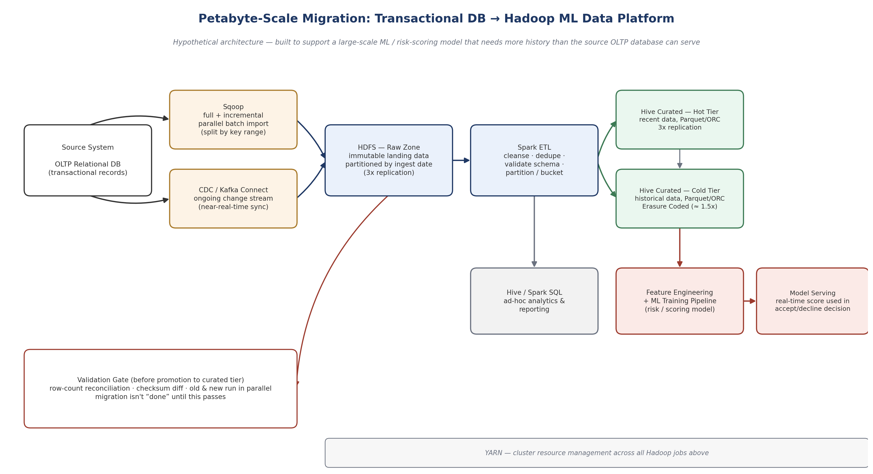
Component roles
- HDFS (Hadoop Distributed File System): distributed storage — where data physically lives, split into blocks across many machines for scale and fault tolerance.
- Sqoop: bulk, parallel batch transfer of structured data between a relational database and HDFS/Hive — used here for the initial full historical load, split by primary-key ranges across mappers so no single thread has to move the whole dataset.
- CDC / Kafka Connect: captures ongoing changes in the source database after the initial bulk load, so the lake keeps catching up incrementally instead of needing repeated full re-exports.
- Spark: the processing engine — cleans, deduplicates, validates schema, and repartitions/buckets data as it moves from the raw zone into curated Hive tables.
- Hive: the SQL-like query and schema layer over data sitting in HDFS — lets analysts and the ML pipeline query structured tables instead of raw files.
- YARN: the cluster resource manager underneath all of it — schedules and allocates CPU/memory across every Sqoop, Spark, and Hive job running on the cluster.
4. ETL PROCESS & SCHEMA DESIGN
4.1 Ingestion
- Initial full load: Sqoop import split by primary-key ranges, run with multiple parallel mappers so a petabyte-scale historical export completes in hours/days, not weeks — written into HDFS as the immutable 'raw zone', partitioned by original transaction date (not ingestion date), so later queries can prune partitions instead of scanning everything.
- Ongoing sync: CDC (or Kafka Connect against the database's change log) streams new/changed rows continuously after the initial load, so the lake never falls far behind the source.
4.2 Schema & file format
- File format: Parquet (columnar) rather than a row-based format like CSV — a query that only needs 3 of 40 columns reads only those columns off disk, and similar values sitting together compress far better.
- Partitioning: by transaction date (e.g., year/month/day) — the single highest-leverage decision, since almost every query and every ML training run filters by a date range first.
- Bucketing: by a high-cardinality join key (e.g., account or merchant ID) within each partition — speeds up joins and aggregations without exploding the number of small partition files.
- Schema evolution: source schema changes (a new column, a changed type) are handled with a schema registry / Hive schema versioning rather than silently breaking downstream Spark jobs — new columns default to nullable so old partitions remain readable.
4.3 Validation gate
Data isn't trusted — or exposed to Hive/the ML pipeline — until it passes reconciliation: row counts and checksums compared between source and lake, old and new systems run in parallel for a defined window, and any mismatch blocks promotion rather than getting silently waved through.
5. STORAGE & REPLICATION — THE 3x PROBLEM
The question that actually separates a real design from a hand-wave: at petabyte scale, replication overhead is a budget line, not a footnote.
HDFS's default fault-tolerance mechanism is 3x replication: every block is stored on three different machines, so losing one or even two copies doesn't lose data. That's simple and fast to recover from — but it means 1 petabyte of logical data actually costs 3 petabytes of raw disk. At petabyte scale, that 2x-and-then-some of ‘wasted’ storage is a genuinely large, recurring infrastructure cost, not a rounding error.
The better answer for most of the data: Erasure Coding (EC)
- Instead of storing 3 full copies, EC splits data into blocks, computes parity blocks across them (Reed-Solomon encoding), and stripes both across the cluster — the classic policy, RS-6-3, stores 6 data blocks plus 3 parity blocks and can still fully recover from losing any 3.
- Storage overhead drops from 3x (200% overhead) to roughly 1.5x (about 50% overhead) with RS-6-3 — for a petabyte of logical data, that's the difference between needing 3 PB and needing about 1.5 PB of raw disk.
- The real trade-off, and the reason EC isn't used everywhere: reconstructing a lost block under EC means reading and recomputing from multiple other blocks and parity data — far more CPU and network cost than replication's simple copy, and noticeably slower on data that's read or written constantly.
The design decision that actually matters here: tier the data instead of picking one policy for everything. Keep recent, frequently-accessed “hot” data (the last few weeks/months) on standard 3x replication for fast reads and cheap recovery, since that's what the live scoring pipeline touches constantly. Once data ages past an active window and becomes “cold” — read occasionally for model retraining or historical analysis, rarely if ever rewritten — convert it to Erasure Coding. That's exactly what the hot/cold split in the architecture diagram represents.
Illustrative cluster-storage math (for a hypothetical 1 PB logical dataset)
- All hot / 3x replication: 1 PB logical → 3 PB raw storage needed.
- All cold / RS-6-3 erasure coded: 1 PB logical → ~1.5 PB raw storage needed.
- Realistic tiered mix (e.g., 20% hot / 80% cold once the pipeline has been running a while): (0.2 × 3 PB) + (0.8 × 1.5 PB) = 0.6 + 1.2 = 1.8 PB raw — a real, defensible number to bring into an interview, clearly labeled as illustrative math, not a claimed production metric.
⚠ Discipline note (same rule as everywhere else in my interview prep): these are illustrative numbers for a hypothetical design exercise, not a real system's measured figures. In an interview, the honest version is “here's how I'd model the trade-off and the rough math,” never a specific unverified production number.
6. PHASED MIGRATION PLAN
- Phase 0 — Discovery & sizing: profile the source dataset (volume, growth rate, table relationships), size the target cluster (nodes, storage tier split, network), and agree the success/validation criteria up front.
- Phase 1 — Infrastructure provisioning: stand up the Hadoop cluster (HDFS, YARN, Hive metastore, Spark), configure the replication and EC storage policies, and provision the ingestion tooling (Sqoop, CDC/Kafka Connect).
- Phase 2 — Initial bulk load: full historical Sqoop import into the HDFS raw zone, partitioned by date, run in parallel batches sized to avoid saturating the source database's live traffic.
- Phase 3 — Validation gate: row-count reconciliation and checksum comparison between source and raw zone before anything is promoted or trusted.
- Phase 4 — Parallel run: CDC/incremental sync keeps the lake current while the source system keeps running unchanged — old and new systems operate side by side, continuously re-validated, before anyone relies on the new pipeline for anything real.
- Phase 5 — Phased cutover: the ML training pipeline and analytics queries move onto Hive/curated tables first (lowest risk); only once that's stable does anything latency-sensitive change — never a single big-bang switch for the whole platform at once.
- Phase 6 — Tiering & decommission: age hot data into the cold/EC tier on a defined schedule (e.g., 90 days), and decommission only the specific source-side extracts that are no longer needed — not the source system itself, which keeps serving live transactions throughout.
7. RISKS & MITIGATIONS
- Risk: schema drift between source and lake breaks downstream Spark/Hive jobs silently. Mitigation: schema registry/versioning, nullable-by-default new columns, alerting on schema-validation failures in the ETL gate.
- Risk: initial bulk load degrades live transaction performance on the source database. Mitigation: throttled parallelism, scheduled during lower-traffic windows, read replicas used for the export instead of the primary where possible.
- Risk: erasure-coded cold data becomes slow to recover during a real failure. Mitigation: keep EC only on genuinely cold, infrequently-accessed data; monitor reconstruction time as a real operational metric, not an assumption.
- Risk: reconciliation gate becomes a rubber stamp under schedule pressure. Mitigation: make the gate's pass/fail criteria explicit and automated (not a judgment call), and treat a failed gate as a hard stop, not a note to “fix later”.
8. HOW THIS MAPS TO REAL INTERVIEW QUESTIONS
This design exercise exists to make sure the answers below are backed by real, walkable reasoning — not memorized vocabulary.
- “Why Hadoop instead of a cloud data warehouse?” — Hadoop/HDFS is a reasonable choice when the workload is large-scale batch processing with a mix of structured and semi-structured data and there's a desire to control infrastructure and cost directly at large, steady-state volume; a cloud warehouse (e.g., Snowflake/BigQuery) can be simpler operationally but shifts the cost model to consumption-based pricing — the right answer depends on data volume, query patterns, and whether the org already runs Hadoop infrastructure elsewhere.
- “Why not just add read replicas to the OLTP database?” — Replicas help with read scaling but don't solve the fundamental mismatch: a row-oriented transactional database is still the wrong storage shape for scanning years of history for ML feature engineering, and doesn't get cheaper at petabyte scale the way a data lake with tiered storage does.
- “What's the hardest part of a migration like this?” — Not moving the bytes — it's proving the migrated data is correct (the validation gate) and sequencing the cutover so nothing latency-sensitive is ever at risk, which is why this plan treats reconciliation and phased rollout as first-class steps, not afterthoughts.
- “Walk me through a technical trade-off you'd own as a TPM, not an engineer.” — The hot/cold replication-vs-erasure-coding split is exactly this: I don't need to implement Reed-Solomon encoding, but I do need to understand the real cost/performance trade-off well enough to ask the right questions, sign off on the tiering policy, and defend the choice to both engineering and finance.

APPENDIX — GLOSSARY
One line each — useful as a last glance before a technical interview.
- HDFS: Hadoop Distributed File System — stores data as blocks spread across a cluster of machines.
- Sqoop: bulk parallel transfer tool between relational databases and Hadoop.
- Hive: SQL-like query and schema layer over data stored in HDFS.
- Spark: distributed processing engine for transforming large datasets, faster than older MapReduce jobs.
- YARN: Hadoop's cluster resource manager — schedules jobs across available CPU/memory.
- Parquet / ORC: columnar file formats — faster analytical queries and better compression than row-based formats like CSV.
- Replication factor: how many full copies of each data block HDFS keeps by default (3) for fault tolerance.
- Erasure Coding (EC): a storage-efficient alternative to full replication — splits data into blocks plus parity blocks (Reed-Solomon), tolerating failures at roughly half the storage overhead of 3x replication, at the cost of higher CPU/network use during recovery.
- CDC (Change Data Capture): a way of streaming ongoing inserts/updates/deletes from a source database instead of repeatedly re-exporting everything.
- Partitioning vs. bucketing: partitioning splits data into separate directories by a column (e.g., date) so queries can skip irrelevant ones; bucketing further splits data within a partition by a hashed key, to speed up joins.

