IPP(631/tcp) on Thya

Table of Contents
Is ipp on Thya a Hack? 2

Is ipp on Thya a Hack?
What is ipp and how did it get there?

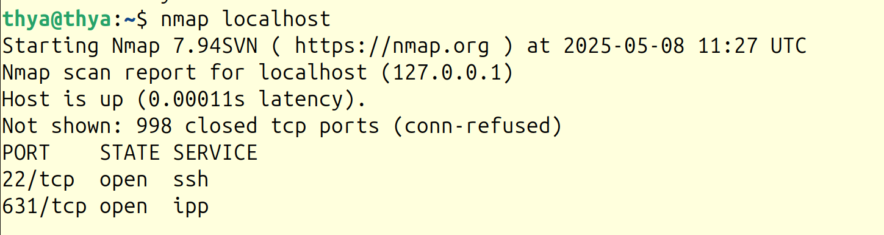

Ubuntu desktop and IPP
Ubuntu desktop was installed to try and get mp3 files to play.
It makes sense that IPP was installed with ubuntu desktop.

