Moses Notes

Table of Contents

Nmap

moses
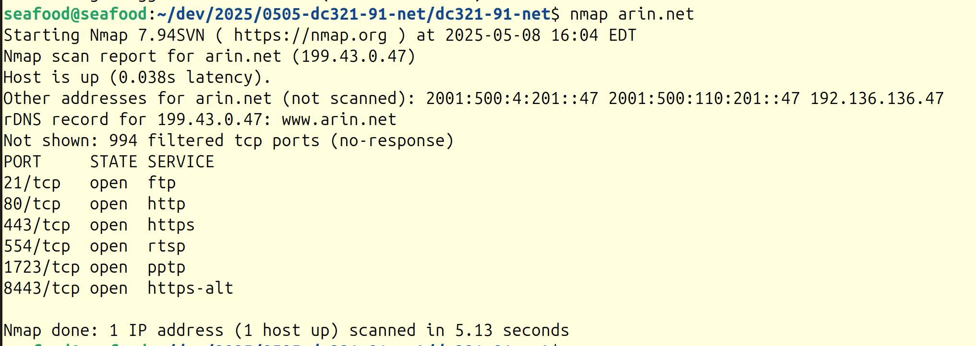

Opp
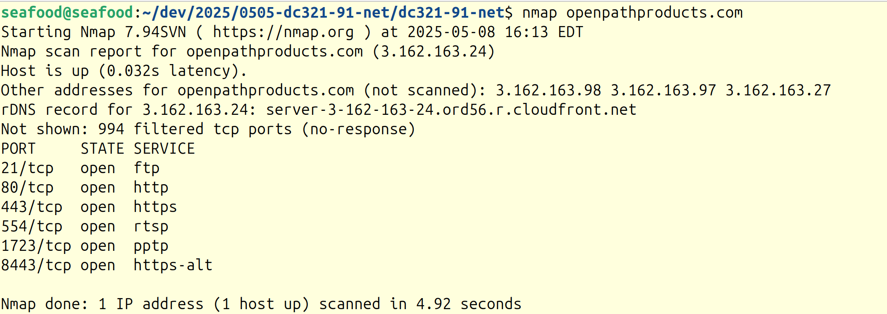

Traceroute

Moses
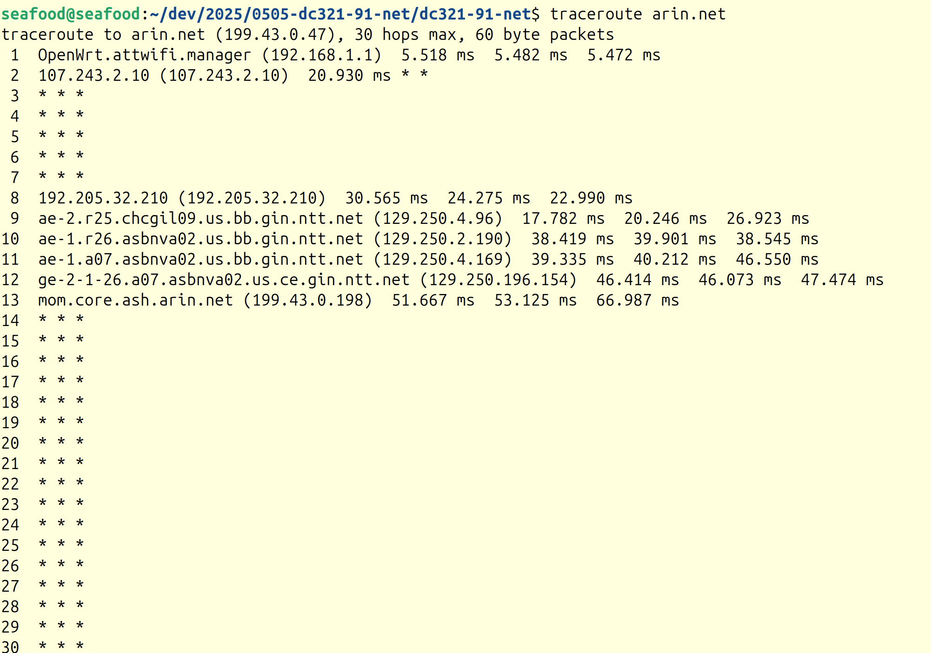

$ traceroute arin.net
traceroute to arin.net (199.43.0.47), 30 hops max, 60 byte packets
1 OpenWrt.attwifi.manager (192.168.1.1) 5.518 ms 5.482 ms 5.472 ms
2 107.243.2.10 (107.243.2.10) 20.930 ms * *
3 * * *
4 * * *
5 * * *
6 * * *
7 * * *
8 192.205.32.210 (192.205.32.210) 30.565 ms 24.275 ms 22.990 ms
9 ae-2.r25.chcgil09.us.bb.gin.ntt.net (129.250.4.96) 17.782 ms 20.246 ms 26.923 ms
10 ae-1.r26.asbnva02.us.bb.gin.ntt.net (129.250.2.190) 38.419 ms 39.901 ms 38.545 ms
11 ae-1.a07.asbnva02.us.bb.gin.ntt.net (129.250.4.169) 39.335 ms 40.212 ms 46.550 ms
12 ge-2-1-26.a07.asbnva02.us.ce.gin.ntt.net (129.250.196.154) 46.414 ms 46.073 ms 47.474 ms
13 mom.core.ash.arin.net (199.43.0.198) 51.667 ms 53.125 ms 66.987 ms
14 * * *
15 * * *
16 * * *
17 * * *
18 * * *
19 * * *
20 * * *
21 * * *
22 * * *
23 * * *
24 * * *
25 * * *
26 * * *
27 * * *
28 * * *
29 * * *
30 * * *

sudo nmap -Pn -p- -A -T4 -oN scan.txt arin.net

$ sudo nmap -Pn -p- -A -T4 -oN scan.txt arin.net
Starting Nmap 7.94SVN ( https://nmap.org ) at 2025-05-08 16:12 EDT
Nmap scan report for arin.net (192.136.136.47)
Host is up (0.022s latency).
Other addresses for arin.net (not scanned): 2001:500:110:201::47 2001:500:4:201::47 199.43.0.47
rDNS record for 192.136.136.47: www.arin.net
Not shown: 65532 filtered tcp ports (no-response)
PORT STATE SERVICE VERSION
80/tcp open http-proxy F5 BIG-IP load balancer http proxy
|_http-server-header: BigIP
|_http-open-proxy: Proxy might be redirecting requests
|_http-title: Did not follow redirect to https://arin.net/
443/tcp open ssl/http nginx
| ssl-cert: Subject: commonName=*.arin.net/organizationName=American Registry for Internet Numbers, Ltd./stateOrProvinceName=Virginia/countryName=US
| Subject Alternative Name: DNS:*.arin.net, DNS:arin.net
| Not valid before: 2024-08-27T00:00:00
|_Not valid after: 2025-09-10T23:59:59
|_ssl-date: TLS randomness does not represent time
|_http-title: Did not follow redirect to https://www.arin.net/
8443/tcp open https-alt?
Warning: OSScan results may be unreliable because we could not find at least 1 open and 1 closed port
Device type: broadband router|WAP|general purpose|router|specialized
Running (JUST GUESSING): OneAccess embedded (87%), Linux 2.4.X|3.X (85%), MikroTik RouterOS 6.X (85%), AVtech embedded (85%)
OS CPE: cpe:/h:oneaccess:1641 cpe:/o:linux:linux_kernel:2.4.20 cpe:/o:linux:linux_kernel:3.2.0 cpe:/o:mikrotik:routeros:6.15
Aggressive OS guesses: OneAccess 1641 router (87%), Tomato 1.27 - 1.28 (Linux 2.4.20) (85%), Linux 3.2.0 (85%), MikroTik RouterOS 6.15 (Linux 3.3.5) (85%), AVtech Room Alert 26W environmental monitor (85%)
No exact OS matches for host (test conditions non-ideal).
Network Distance: 2 hops
Service Info: Device: load balancer

TRACEROUTE (using port 443/tcp)
HOP RTT ADDRESS
1 6.12 ms OpenWrt.attwifi.manager (192.168.1.1)
2 25.37 ms www.arin.net (192.136.136.47)

OS and Service detection performed. Please report any incorrect results at https://nmap.org/submit/ .
Nmap done: 1 IP address (1 host up) scanned in 1886.70 seconds

opp
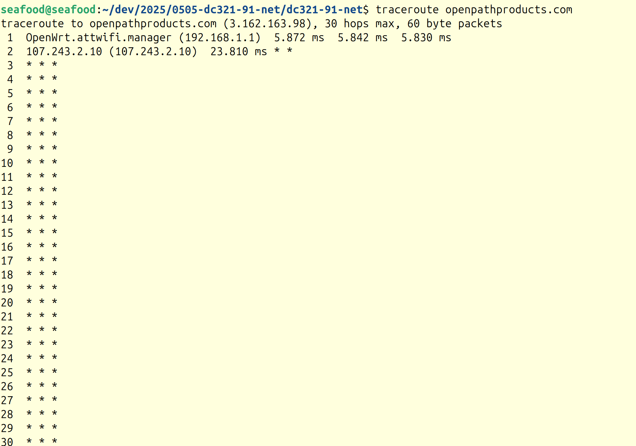
$ traceroute openpathproducts.com
traceroute to openpathproducts.com (3.162.163.98), 30 hops max, 60 byte packets
1 OpenWrt.attwifi.manager (192.168.1.1) 5.872 ms 5.842 ms 5.830 ms
2 107.243.2.10 (107.243.2.10) 23.810 ms * *
3 * * *
4 * * *
5 * * *
6 * * *
7 * * *
8 * * *
9 * * *
10 * * *
11 * * *
12 * * *
13 * * *
14 * * *
15 * * *
16 * * *
17 * * *
18 * * *
19 * * *
20 * * *
21 * * *
22 * * *
23 * * *
24 * * *
25 * * *
26 * * *
27 * * *
28 * * *
29 * * *
30 * * *

sudo nmap -Pn -p- -A -T4 -oN scan.txt openpathproducts.com

$ sudo nmap -Pn -p- -A -T4 -oN scan.txt openpathproducts.com
[sudo] password for seafood:
Sorry, try again.
[sudo] password for seafood:
Starting Nmap 7.94SVN ( https://nmap.org ) at 2025-05-08 16:17 EDT
Nmap scan report for openpathproducts.com (3.162.163.24)
Host is up (0.022s latency).
Other addresses for openpathproducts.com (not scanned): 3.162.163.98 3.162.163.97 3.162.163.27
rDNS record for 3.162.163.24: server-3-162-163-24.ord56.r.cloudfront.net
Not shown: 65532 filtered tcp ports (no-response)
PORT STATE SERVICE VERSION
80/tcp open http Amazon CloudFront httpd
|_http-title: Did not follow redirect to https://openpathproducts.com/
|_http-server-header: CloudFront
443/tcp open ssl/http Amazon CloudFront httpd
| ssl-cert: Subject: commonName=*.openpathproducts.com/organizationName=OPENPATH PRODUCTS LLC/stateOrProvinceName=Maryland/countryName=US
| Subject Alternative Name: DNS:*.openpathproducts.com, DNS:openpathproducts.com
s| Not valid before: 2024-06-08T00:00:00
|_Not valid after: 2025-07-09T23:59:59
|_http-title: OpenPath Products: Professional Software Development and QA
| http-server-header:
| AmazonS3
|_ CloudFront
8443/tcp open https-alt?
Warning: OSScan results may be unreliable because we could not find at least 1 open and 1 closed port
Device type: broadband router|WAP|general purpose|router|specialized
Running (JUST GUESSING): OneAccess embedded (87%), Linux 2.4.X|3.X (85%), MikroTik RouterOS 6.X (85%), AVtech embedded (85%)
OS CPE: cpe:/h:oneaccess:1641 cpe:/o:linux:linux_kernel:2.4.20 cpe:/o:linux:linux_kernel:3.2.0 cpe:/o:mikrotik:routeros:6.15
Aggressive OS guesses: OneAccess 1641 router (87%), Tomato 1.27 - 1.28 (Linux 2.4.20) (85%), Linux 3.2.0 (85%), MikroTik RouterOS 6.15 (Linux 3.3.5) (85%), AVtech Room Alert 26W environmental monitor (85%)
No exact OS matches for host (test conditions non-ideal).
Network Distance: 2 hops

TRACEROUTE (using port 80/tcp)
HOP RTT ADDRESS
1 2.02 ms OpenWrt.attwifi.manager (192.168.1.1)
2 24.27 ms server-3-162-163-24.ord56.r.cloudfront.net (3.162.163.24)

OS and Service detection performed. Please report any incorrect results at https://nmap.org/submit/ .
Nmap done: 1 IP address (1 host up) scanned in 1251.78 seconds

