CSE152 homework3

Name: ShihHan Chan

PID: A15677346

1.1 (14 points.) Consider the case of two cameras viewing an object such that the second camera differs from the first by a pure translation parallel to the image plane. Show that the epipolar lines in the two cameras are parallel.

2. (15 points.) Suppose two cameras fixate on a point P (see figure 1) in space such that their principal axes intersect at that point. Show that if the image coordinates are normalized so that the coordinate origin (0, 0) coincides with the principal point, the F33 element of the fundamental matrix is zero.

2.1

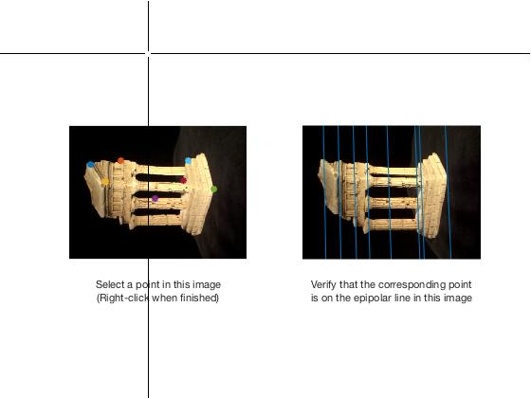

2.2

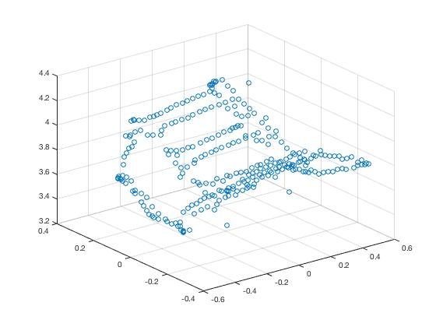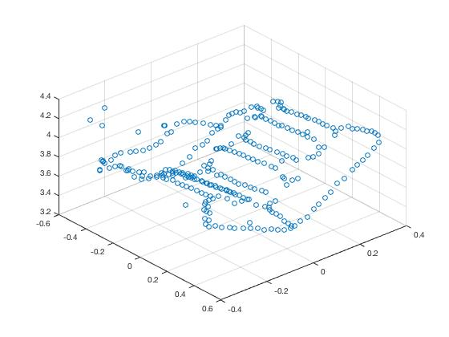

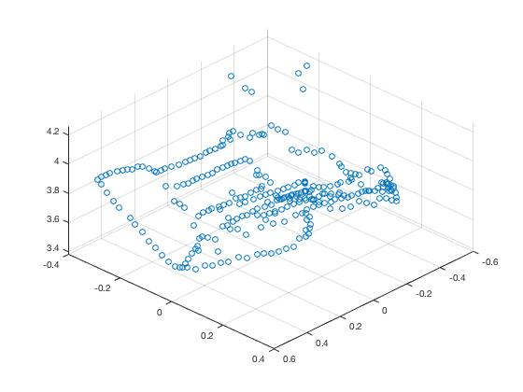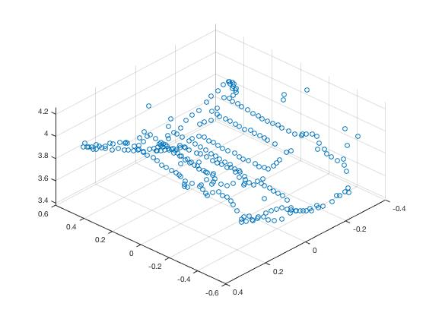

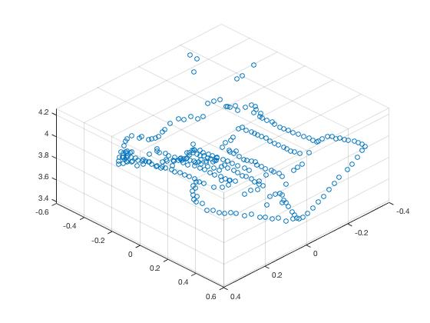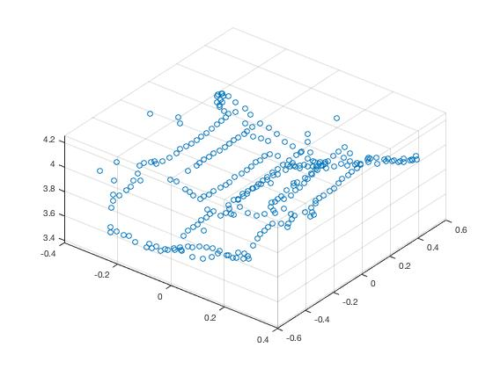

2.3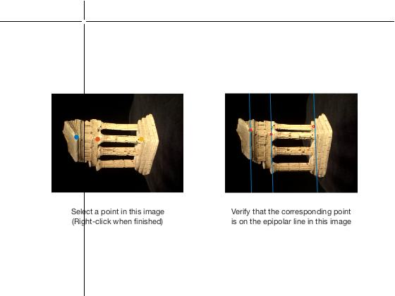

3

10 hours