Computer Vision HW2 Report

Student ID: B09901192

Name: 林沛翰

Part 1. (10%)

• Plot confusion matrix of two settings. (i.e. Bag of sift and tiny image) (5%)

Ans:

|  |  |
| --- | --- |
| **Tiny Image:** |  |
| **Bag of sift:** |  |

• Compare the results/accuracy of both settings and explain the result. (5%)  
Ans:

**Tiny Image: 0.2487**

1. 調低sift的step可以加速training速度以及減少內存的負載。但是，這會使準確度下降，因此我可以透過調高vocab size來增加模型的準確度。  
   因此，我將vacab size設置為700, step 設置為5
2. KNN的K nearest number的選擇也會影響1-2%準確度。因為knn classifier可以在testing過程修改， 所以每次training完就透過調整參數，找出最適合的K nearest number。  
   因此，透過try and error我將K設置為#####(待修改)
3. 此外，normalized的方法是影響效能最多的地方，將近3%-4%。原本我是使用平均法，也就是把image的所有pixel除以pixel value的平均。但是，後來發現使用上圖的standard normalization效能比較好。

**Bag of sift: 0.616**

Part 2. (25%)

• Report accuracy of both models on the validation set. (2%)

Ans:

mynet: Best Accuracy 0.8936(with semi-supervised learning)

I combine an end to end supervised learning and semi-supervised learning.

First train with supervised learning with original train data, and I obtain best validation accuracy with 0.878

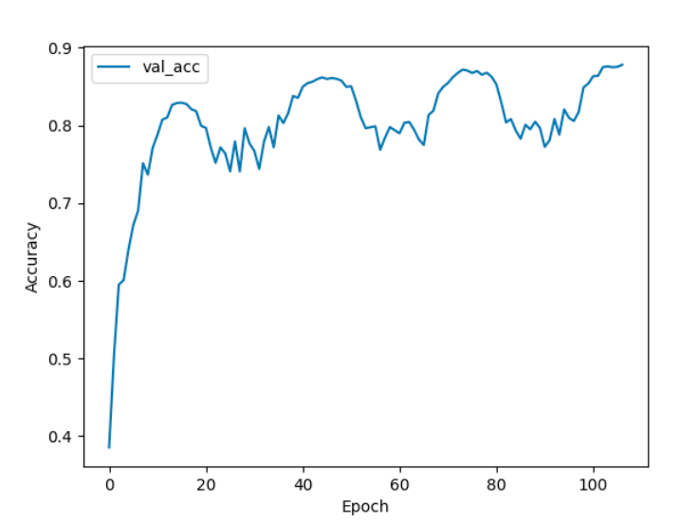

Second, I use semi-supervised learning with unlabeled data to create new training data, and train my model again with supervised learning with new training data. And, I obtain best validation accuracy with 0.8936

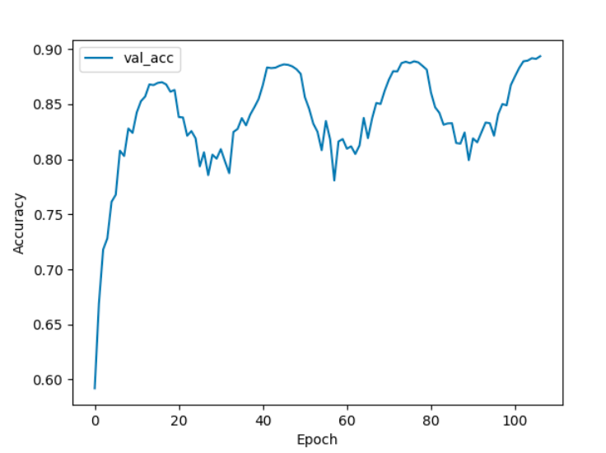

Resnet18: Best Accuracy 0.922

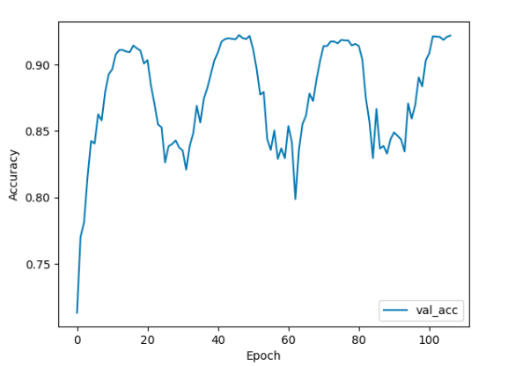

• Print the network architecture & number of parameters of both models. What is the main difference between ResNet and other CNN architectures? (5%)

Ans:

resnet18:

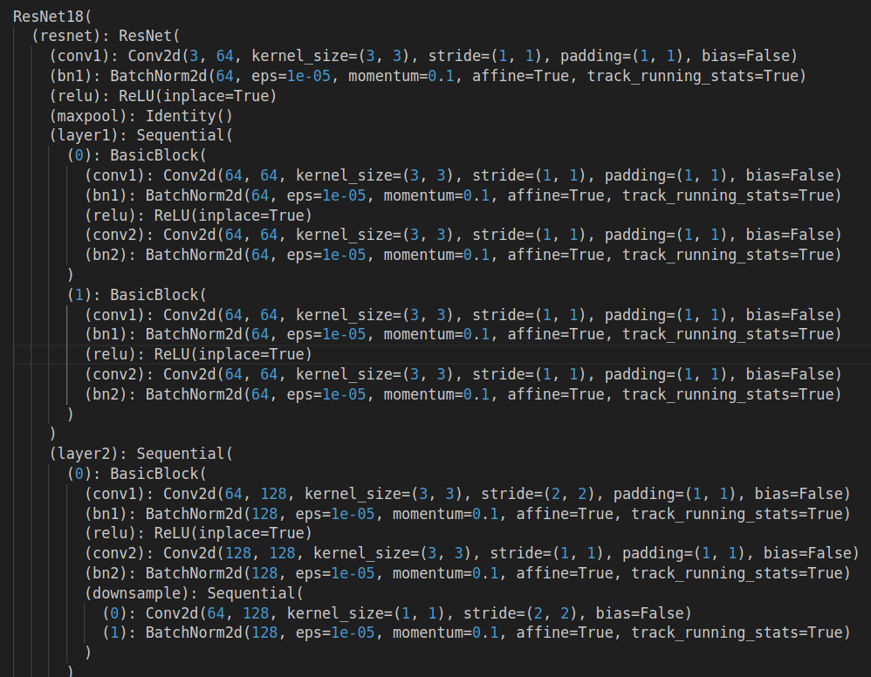

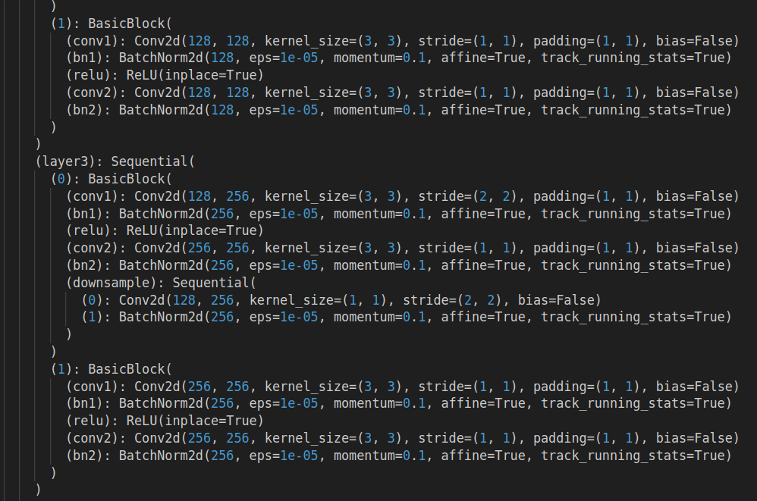

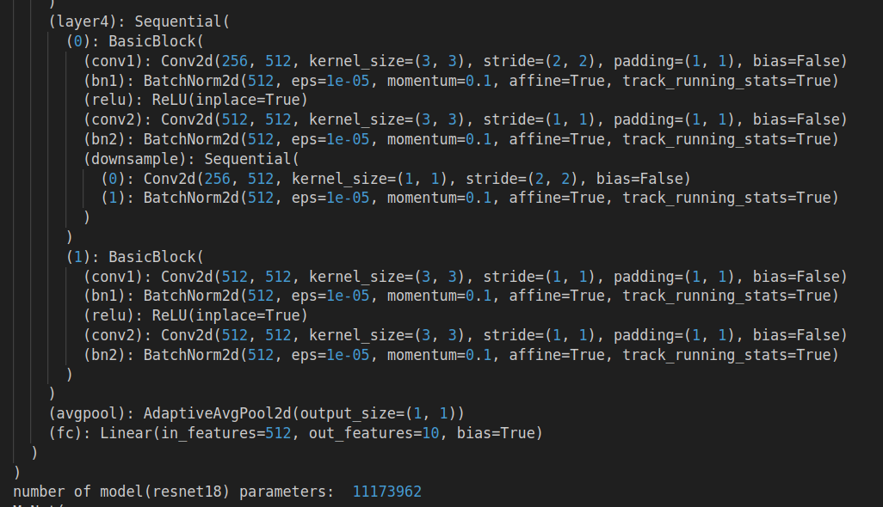

Mynet：

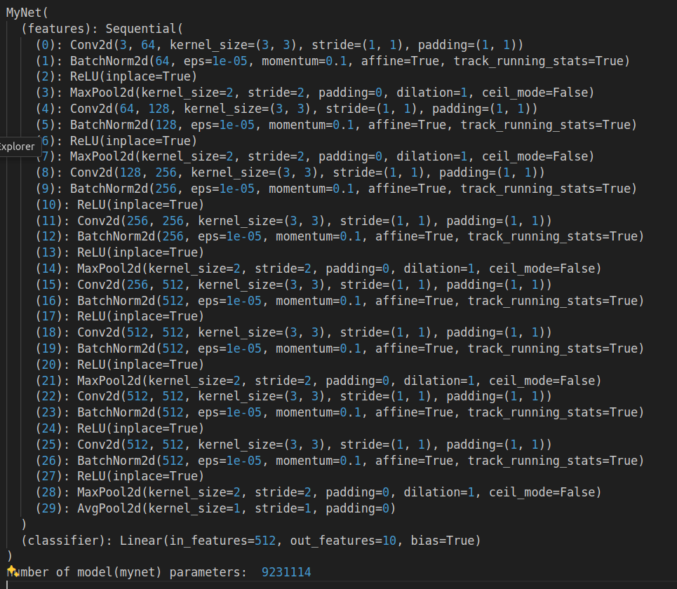

The main difference between ResNet and other convolutional neural network architectures lies in the use of residual connections.

In traditional CNN architectures, each layer is built upon the output of the previous layer. However, as networks become deeper, they encounter the vanishing gradient problem, where gradients become increasingly smaller as they backpropagate through the network. This can hinder the training process and lead to degradation in performance despite increasing depth.

ResNet addresses this issue by introducing residual connections, also known as skip connections or shortcut connections to deal with the vanishing gradient problem.

• Plot four learning curves (loss & accuracy) of the training process (train/validation) for both models. Total 8 plots. (8%)

Ans:

Mynet:

With semi-supervised learning

Accuracy:

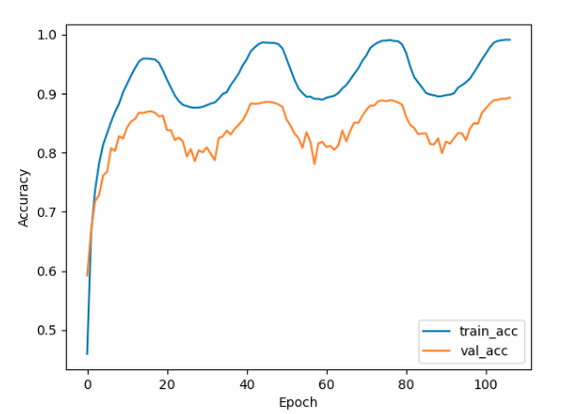

Loss:

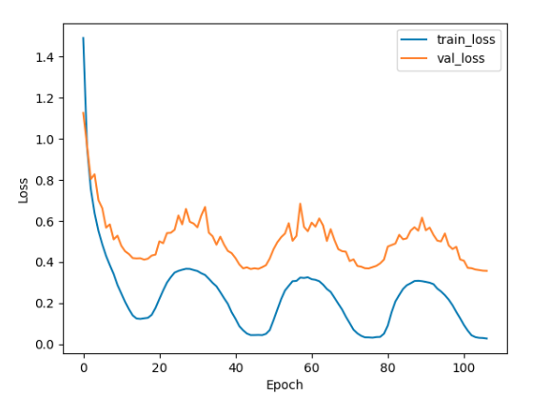

Only with supervised learning

Accuracy:

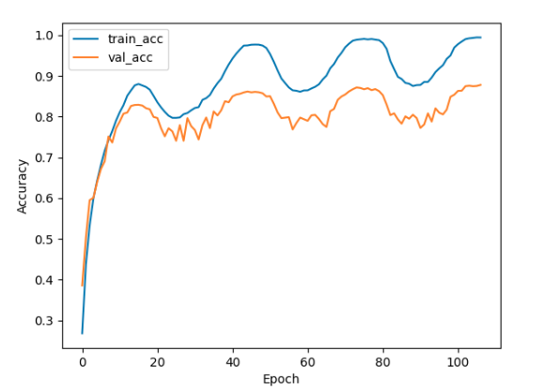

Loss:

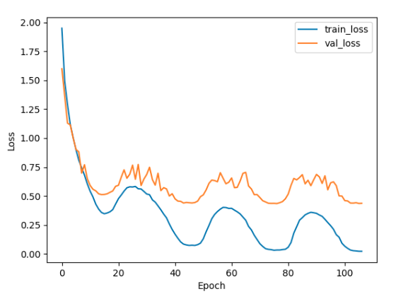

Resnet:

Accuracy:

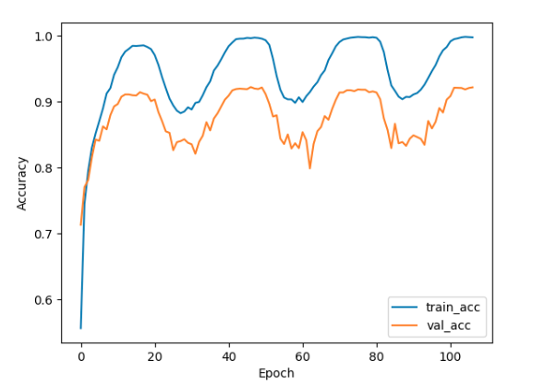

Loss:

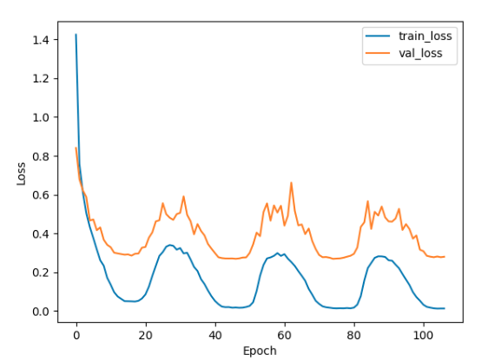

• Briefly describe what method do you apply on your best model? (e.g. data augmentation, model architecture, loss function, etc) (10%)

Ans:

mynet

model

optimizer

scheduler

semi-supervised learning

data augmentation

Resnet: