标1 Test 1

Test 1
READING AND USE OF ENGLISH (1 hour 15 minutes)

Part 1
For questions 1–8, read the text below and decide which answer(A,B, C, or D) best fits each gap. There is an example at the beginning(0)

Mark your answers on the separate answer sheet.

Example:
0 A have B do C get D take

B
0
Why we need to play

Human beings are not the only creatures that like to(0)………fun.Many animals play,as do some birds. However,no other creatures spend so much time enjoying themselves as human beings do.Indeed,we
(1) … … …onto our sense of fun right into adulthood.
So why do human beings spend so much time playing?One reason is that we have time for leisure; animals have very little time to play as most of their life is spent sleeping and(2) fod.
So,is play just an opportunity for us to (3)………inenjoyable activities or does it have a more important
(4)………?According to scientists,(5)………from being fun,play has several very real (6) … … …
for us-it helps our physical,intellectual and social development.It also helps to(7) … … …us for what we have not yet experienced.With very (8) … … …risk,we can act out what we would do in unexpected,or even dangerous,situations.

 |  |  |  |  |  |  |  | Reading and Use of English
1 | A | hold | B | keep | C | save | D | stay
2 | A | searching | B | looking | C | seeking | D | gaining
3 | A | engage | B | combine | C | contribute | D | involve
4 | A | motive | B | purpose | C | intention | D | cause
5 | A | excluding | B | except | C | apart | D | away
6 | A | assets | B | profits | C | services | D | benefits
7 | A | plan | B | prepare | C | practise | D | provide
8 | A | brief | B | short | C | narrow | D | little

Part 2
For questions 9–16, read the text below and think of the word which best fits each gap.Use only one word in each gap.There is an example at the beginning(0).
Write your answers IN CAPITAL LETTERS on the separate answer sheet.

Example:


0

B | E | E | N

A bicycle you can fold up

Folding bicycles have (0)………around for quite some time now.However,an amazing new Japanese version (9) ……be folded with a swiftness and efficiency never seen before.This bike is designed (10) ……that it is possible to fold it up quickly.Once folded,you pull the bike along
(11) … … …ease.

This remarkable bike has a half-folding frame with a hinge in the middle.And,although the basic idea is(12) … … …original,its inventor has created an especially clever variation,combining compactness
(13) … … …convenience with smart design.

Recently,folding bicycles(14)………become very popular in Japan,particularly in congested urban areas like Tokyo,a city(15)………every square centimetre of space is in great demand.Japanese cyclists need to be able to store their bikes in tiny areas at home or the office.And(16)………they should want to take their bicycle on the underground,a folding model is a big advantage.

Part 3
For questions 17–24, read the text below.Use the word given in capitals at the end of some of the lines to form a word that fits in the gap in the same line.There is an example at the beginning(0).
Write your answers IN CAPITAL LETTERS on the separate answer sheet.

Example:
0

E | X | T | R | E | M | E | L | Y

Tea

Tea is an(0)………popular drink with many people.It is estimated that the consumption of tea in England alone exceeds 165 million cups daily. Despite this,the drink was virtually(17)………in England until about | EXTREME  KNOW
400 years ago. The first (18) ………to tea in England comes in a | REFER
diary written in 1660.However,its(19)………really took off after the | POPULAR
(20)………of King Charles Il to Catherine of Braganza.It was her great | MARRY
love of tea that made it(21) … … … . | FASHION
It was believed that tea was good for people as it seemed to be capable of reviving the spirits and curing certain minor (22) It has even been suggested by some historians that it played a significant part in the Industrial Revolution. Tea, they say, increased the number of hours that  (23) ………could work in factories as the caffeine in tea made them more | ILL  LABOUR
(24) and consequently able to work longer hours. | ENERGY

Part 4
For questions 25–30, complete the second sentence so that it has a similar meaning to the first sentence, using the word given. Do not change the word given. You must use between two and five words, including the word given. Here is an example (0).

Example:
0 A very friendly taxi driver drove us into town.
DRIVEN
We a very friendly taxi driver.
The gap can be filled by the words 'were driven into town by,' so you write:
Example:

0 | WEREDRIVENINTO TOWNBY
Write only the missing words IN CAPITAL LETTERS on the separate answer sheet.

25 They didn't sell many programmes at the match.
FEW
Very at the match last Saturday.

26 We got to work late because we decided to drive rather than take the train.
INSTEAD
We got to work late because we decided to drive the train.

27 Last Friday was the first time my car ever broke down, even though it is very old.
NEVER
Until last Friday, my car down, even though it is very old.

Reading and Use of English

28 "All your complaints will be investigated by my staff tomorrow' said the bank manager. LOOK
The bank manager promised that his staf…………………………………allourcomplaintsthe next day.

29 Last year, heavy rain caused the postponement of the tennis tournament.
BECAUSE
Last year, the tennis tournament …………………………………so heavily.

30 Jack does not want to work for his uncle any longer.
CARRY
John does not want forhisuncle.

Test 1

Part 5
You are going to read a magazine article about a famous pianist and the young student who became his pupil. For questions 31–36, choose the answer (A, B, C, or D) which you think fits best according to the text.

Mark your answers on the separate answer sheet.
A musician and his pupil
Paul Williams interviews the famous pianist Alfred Brendel.

Over six decades the pianist Alfred Brendel gradually built up and maintained a dominant position in the world of classical music. He was an intellectual, sometimes austere, figure who explored and recorded the mainstream European works for the piano. He wrote and played a great deal, but taught very little. Those who knew him best glimpsed a playful side to his character, but that was seldom on display in his concerts. It was a disciplined,never-ending cycle of study,travel and performance.
And then,four or five years ago,a young boy, Kit Armstrong,appeared backstage at one of Brendel's concerts and asked for lessons.Initially, Brendel didn't take the suggestion very seriously. He had had very few pupils and he saw no reason to start now.He quotes from another famous pianist:'You don't employ a mountain guide to teach a child how to walk.'But there was something that struck him about the young boy
-then about 14.He listened to him play.Brendel explained,'He played remarkably well and by heart.Then he brought me a CD of a little recital he had given where he played so beautifully that I thought to myself,"Ihave to make time for him." It was a performance that really led you from the first to the last note.It's very rare to find any musician with this kind of overview and the necessary subtlety.'
As Brendel is bowing out of the public eye, so Kit is nudging his way into it—restrained by Brendel, ever nervous about the young man burning out early. Kit, now 19, is a restless, impatient presence away from the lessons -always learning new languages; taking himself off to study maths, writing computer code, or playing tennis. All under the watchful eye of his ever-present mother. On top of

all this he composes. "This was very important,' Brendel says.If you want to learn to read music properly, it is helped by the fact that you try to write something yourself. Then I noticed that Kit had a phenomenal memory and that he was a phenomenal sight reader. But more than this is his ability to listen to his own playing, his sensitivity to sound, and his ability to listen to me when I try to explain something. He not only usually understands what I mean, but he can do it. And when I tell him one thing in a piece, he will do it everywhere in the piece where it comes in later.
Brendel catches himself and looks at me severely. line 5(
'Now I don't want to raise any expectations. I'm very
cross if some newspapers try to do this. There was
One article which named him as the future great
pianist of the 215t century, I mean, really, it's the
worst thing. One doesn't say that in a newspaper.
And it has done a great deal of harm. As usual, with
gifted young players, he can play certain things
amazingly well, while others need more time and
experience. It would be harmful if a critic was there
expecting the greatest perfection.'
It is touching to see the mellowness of Brendel in his post-performing years. He explains, 'When I was very young, I didn't have the urge to be famous in five years' time, but I had the idea I would like to have done certain things by the age of 50. And when I was 50, I thought that I had done most of those things, but there was still some leeway for more, so I went on. Although I do not have the physical power to play now, in my head, there are always things going on, all sorts of pieces that I've never played. I don't play now, but it's a very nice
' new career.

Reading and Use of English

31 What is the writer emphasising in the first paragraph?
A the wide range of music that Brendel has played
B the total dedication of Brendel to his art
C the reluctance of Brendel to take on pupils
D the light-hearted nature of Brendel's character
32 Brendel uses the quotation about the mountain guide to illustrate that A it is not always easy to teach people the basics.
B it is unwise to try to teach new skills before people are ready.
C people can learn new skills without help from others.
D it is unnecessary for an expert to teach people the basics.
33 What made Brendel first decide to accept Kit as a pupil?
A He seemed so young and serious.
B He was so determined and persistent.
C He could play without the music.
D He had an extraordinary talent.
34 Which of Kit's musical abilities does Brendel admire the most? A He is able to write music himself
e 5(
B He is able to understand and respond to advice.
C He can play a piece of music the first time he sees it.
D He is able to remember all the music he has ever played.
35 Why does the writer use the phrase 'catches himself'in line 50?
A He realises he has said too much to a journalist.
B He doesn't enjoy giving interviews to journalists.
C He wants to be careful he doesn't upset any music critics.
D He resents the way that he has often been misquoted.
36 What is Brendel doing in the final paragraph?
A justifying his lack of ambition when he was young B expressing regret at the loss of his physical strength C describing his present state of mind
D explaining which pieces he prefers to play now

Test 1

Part 6
You are going to read a newspaper article about a blind runner. Six sentences have been removed from the article. Choose from the sentences A-G the one which fits each gap (37-42). There is one extra sentence which you do not need to use.

Mark your answers on the separate answer sheet.
Blind Runner
Paul Hardy reports on a blind runner called Simon Wheatcroft, who enjoys
taking part in marathon and ultra-marathon races, running distances
between 42 km and 160 km.

Running marathons, a race of 42 km, has become increasingly popular. This distance poses extreme physical and mental challenges for anyone, but for Simon Wheatcroft, there is another hurdle; he has been blind since he was 18 years old.
For the past two years, Simon, now 29, has been overcoming his disability to compete in marathons and ultra-marathons by training with runners who act as his guides, and also, rather uniquely, by teaching himself to run solo, out on the streets. I got bored exercising indoors, so thought,“T'll have a go at running outside”，'he explains. 37 Then he got bored again and wanted to try running on the roads.
Weeks of gradual exploration followed, walking a route alone. 38 It took him along little-used pavements alongside a busy main road. He also recruited technology to help him form his mental map of the area using a smartphone app to provide feedback through headphones about his pace and distance. This information could then be cross-referenced with his knowledge of the route and any obstacles.

posts. But you only run into a post once before you think "Right. I'm going to remember where that is next time”，'he laughs.
Joining Simon for a training session, it's striking how natural and fluid his movement is; he takes shorter, shallower, more gentle steps than most runners, using his feet to feel his way. His landmarks are minute changes in gradient and slight variations in
the running surface |  | "I have to believe
  40
this route is going to stay consistent, and there won't be things like roadwork signs or big rocks,' he says.

41 'I try to concentrate on the millions
of footsteps that go right and think positively,' he explains. When it comes to racing in ultra-distance events, Simon has to use guides to run sections of the course with him; after all, it would be almost impossible to memorise a 150 km stretch of countryside by heart. However, the physical and practical advantages of training in the fresh air, on his own terms, are vast and have boosted his confidence in his running ability as well as providing inspiration to others.

Now, having covered hundreds of km alone on the route,Simon has been able,gradually,to phase out the app.'When I first started I had to really concentrate to an unbelievable level to know where my feet were falling.Now it has become quite automated.' 39 'I did make a few mistakes early on -like running into

But for Simon the real thrill and motivation for training come from simply being able to compete
on equal terms. |  | I can't hide the fact
  42
I'm blind,'he says,'but at the same time I would rather compete with everybody else and not be put into a special group.Being visually impaired doesn't mean you can't run.'

A These provide the familiarity and E It gives him a great opportunity to run with
consistency essential for the blind runner.everyone.

B Their support gave him extra confidence | F That's | not to say the learning curve has
regarding his changing surroundings. | been | without incident.
C. Simon believes the feelings of liberation G. As a result of this slow experimentation, he
and independence he gets from running was able to memorise a set five-kilometre
solo far outweigh any anxiety over such course.
dangers.
D. He began by training on football pitches behind his house, running between the
goalposts.

Test 1

Part 7
You are going to read an article in which four graduates discuss going to university. For questions 43–52, choose from the graduates (A–D). The graduates may be chosen more than once.
Mark your answers on the separate answer sheet.
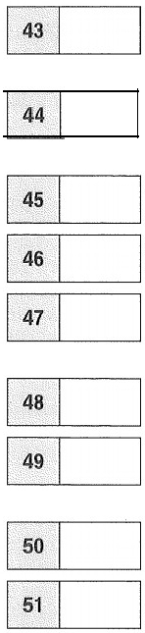
Which graduate
says people should be allowed to consider a range of options apart from university?

says that some people are expected to make important decisions before they are ready?

initially rejected something she was told?

was unaware of the alternatives to university?

says that the type of learning at university is different from that at other institutions?
felt when she was a student that she might not be doing the right course?

says that some people discover that what is studied at university is not useful in the workplace?

was uncertain about her reasons for going to university?

says graduates have an advantage when applying for jobs?

was expected to go to university despite being a fairly average student at school?

52

Why go to university?
Four graduates talk about their experiences.


Sonia
A
While I was doing my physics degree, people would often say I was acquiring skills I'd be able to use in my future career, even if I didn't become a physicist. It sounded like nonsense to me: if I did another job in the end, what could be relevant about knowing what's inside an atom or how to operate a laser? It turns out they were referring to the wealth of other skills you pick up along the way. Communication and problem-solving are just two of these. In contrast to the way you may have been taught before, university teaches you to be innovative and to think for yourself. Going to university is about more than just studying, though! I got to make friends from all over the world, and they have proved to be useful work contacts.

Jane
I went to university because it was the career path expected by school, parents, and classmates (to an extent) and also because I didn't really have a clue about what other options were open to me. It's difficult to know how things would have turned out if I hadn't gone. I do know that the job I do ‘requires' a degree to do it, though there must be alternative ways of developing these skills. The degree, like it or not, is the screening method used by large numbers of employers and as such opens certain doors. It's certainly harder to get into all sorts of careers without a degree. The debates about university education typically revolve around routes into employment, yet for many the degree is barely relevant to the work we end up doing later on. It gives accesss to a certain type of career but the actual degree can often be of little practical value.


C Lydla
There is a lot of pressure on teenagers to know exactly what they want to do with their lives. As a high-achieving student at school, the alternatives to university didn't really appeal to me. So I took up a place at a good university but ended up studying something I wasn't sure I was interested in. Some people know what they want to do from a young age, and for those people, going to university straight out of school may be a great idea. However, many of us are very unsure of our future ambitions aged 18, and should therefore be given as many choices as possible, rather than being pushed into a degree course. Many of my friends went to university straight from school.

D Bethany
I don't really remember making the decision to go to university. Everyone always assumed I would, even though I was never the most gifted academically. Someone asked me during my second year why I had gone, and I remember not being able to answer the question. Maybe it was the way I was raised? Maybe it was the school I went to? But university was the next step. I had a great time there, I must say. It's so much more than the place you go to get a degree. You learn so many life skills that I would urge anyone to give the idea some thought. Since graduation, I've had a string of jobs. University is an excellent decision for some, and may provide the right qualifications to start a career. But for others, going straight into a job is just as appropriate.

Test 1

WRITING (1 hour 20 minutes)

Part 1
You must answer this question. Write your answer in 140–190 words in an appropriate style on the separate answer sheet.
1 In your English class, you have been talking about life in the past. Now, your English teacher has asked you to write an essay.
Write an essay using all the notes and give reasons for your point of view.

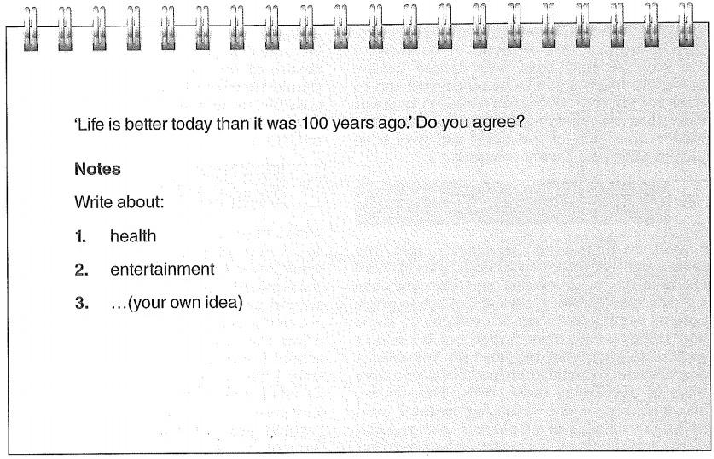

Write your essay. You must use grammatically correct sentences with accurate spelling and punctuation in a style appropriate for the situation.

Writing

Part 2
Write an answer to one of the questions 2–4 in this part. Write your answer in 140–190 words in an appropriate style on the separate answer sheet. Put the question number in the box at the top of the answer sheet.
2 You recently saw this notice on an English-language website called TV Gold:
Reviews wanted!
ATV documentary I learned a lot from.
Have you seen an interesting TV documentary recently that you learned a lot from? Write us a review of the documentary. You should explain what the documentary was about, tell us what you learned from it, and say whether other people would find it interesting too
The best reviews will be posted on the website next month.

Write your review.
3 You see this announcement on an English-language travel website.
.

ARTICLES WANTED
A day in the city!
We are looking for articles about how a visitor could have a great time in a city in your country in just one day.
Write us an article telling us what a visitor can do,what they can see and how they can travel around The best articles willbe posted on our website.
Write your article.
4 Your English teacher has asked you to write a report on a part-time or holiday job that you
have done.The report will appear in the college English-language magazine.
In your report,you should
· describe the job
·explain what you learnt from it
· say whether you would recommend other students to do it.
Write your report.

LISTENING (approximately 40 minutes)

P art 1
You will hear people talking in eight diferent situations.For questions 1-8,choose the best answer (A, B or C).
1 You hear a woman talking on her mobile phone about a missing piece of furniture How does she feel?
A irritated with the removals company
B unsure what's happened
C anxious to find it quickly

2 You hear two students talking about their current course topic. What do they agree about?
A how boring it is
B how difficult it is
C how relevant it is

3 You hear two business people talking about a contract. How does the man feel now?
A frustrated because of the time wasted
B surprised about the cancellation of the contract
C sympathetic towards the other company's problems

4 You hear an artist telling a friend about an art prize he's just won. What is he doing?
A expressing surprise
B admitting that he's excited
C explaining why he thinks he was chosen

Listening

5 You overhear a woman talking to a friend on her mobile phone.
Why is she phoning?
A to explain a delay
B to change some plans
C to make an arrangement

6 You hear a guitarist talking about his profession.
What is the purpose of his talk?
A to warn about the challenges of becoming a musician
B to give step-by-step guidance on setting up a band
C to emphasise the importance of having loyal fans

7 You hear a woman talking to a sales assistant.
Why can't she have a refund for her trainers?
A The receipt is wrong.
B She is not in the right shop.
C The trainers are no longer new.

8 You hear a woman talking about a radio chat show.
What does she like about the show?
A The presenter makes her laugh.
B Information is given in an interesting way.
C Guests reveal quite a lot about themselves.

When lan came back to Britain,he travelled around by
The title of lan's book is
Part 2
You will hear a photographer called Ian Gerrard talking about his career. For questions 9–18, complete the sentences with a word or short phrase.
Ian Gerrard—Photographer

The subject that Lan studied at university was
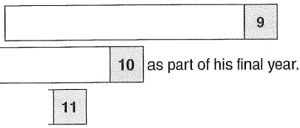
Lan did a presentation on

Lan worked for a

in the USA for a year after leaving
university.

When he travelled around the USA, Lan chose 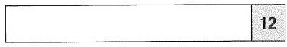 as the
theme for his photographs.

Lan says that

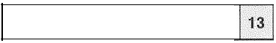

It is the season when he takes the
best photographs.

14
taking photographs.

Ian says he was surprised by how few photographers specialise in shots of
communities.

15

Lan's book will be available in bookshops in

16

next year.

17

Lan has chosen


18

as the theme for his next tour.

Part 3
You will hear five short extracts in which people are talking about the benefits of learning another language. For questions 19–23, choose which benefit (A–H) each speaker has experienced. Use the letters only once. There are three extra letters which you do not need to use.
A It has boosted my intellectual abilities.

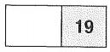
B It has improved my chances in education.
Speaker 1
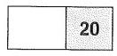
C It has made me sensitive to global issues.
Speaker 2
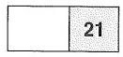
D It has allowed me to gain faster promotion.
Speaker 3
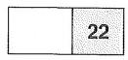
E It has made getting around in other countries easier.
Speaker 4
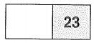
F It has allowed me to help other people.
Speaker 5
G It has advanced my awareness of the way language works.

H It has helped me make friends.

Part 4
You will hear an interview with a woman called Patricia Jones, who is a naturalist. For questions 24-30,choose the best answer (A,B or C).

24 Looking back at her work,Patricia feels
A surprised that her projects stillattract volunteers.
B proud of the wide influence she's had.
C pleased by how she's regarded in Africa.

25 How does Patricia spend her time nowadays? A persuading people to alter their behaviour
B advising governments on conservation
C studying wildlife in its natural habitat

26 How does Patricia feel about zoos? A They all ought to be closed down.
B They should have an educational purpose.
C They stillhave a role to play in conservation.

27 In her new book,Patricia hopes to give A encouragement to young scientists.
B advice on helping endangered animals.
C guidance to other environmentalists.

28 Patricia believes that children should spend time in the natural world because A it is the only way to find out about it.
B it is essential for their development.
C it is a chance to change their view of animals.

29 The organisation called /n Touch encourages young people to A be tolerant of each other.
B actively work for change.
C talk about their problems.

30 What does Patricia particularly want to do next? A to help girls who want to be scientists
B to get scientists to be more responsible C to change people's attitudes to science

Test 1

SPEAKING (14 minutes)
You take the Speaking test with another candidate (possibly two candidates), referred to here as your partner. There are two examiners. One will speak to you and your partner, and the other will be listening. Both examiners will award marks.
Part 1 (2 minutes)
The examiner asks you and your partner questions about yourselves. You may be asked about things like 'your home town,' 'your interests,' 'your career plans,' etc.
Part 2 (a one-minute 'long turn' for each candidate, plus a 30-second response from the second candidate)
The examiner gives you two photographs and asks you to talk about them for one minute. The examiner then asks your partner a question about your photographs, and your partner responds briefly.
Then the examiner gives your partner two different photographs. Your partner talks about these photographs for one minute. This time, the examiner asks you a question about your partner's photographs and you respond briefly.
Part 3 (4 minutes)
The examiner asks you and your partner to talk together. You may be asked to solve a problem or try to come to a decision about something. For example, you might be asked to decide the best way to use some rooms in a language school. The examiner gives you some text to help you but does not join in the conversation.
Part 4 (4 minutes)
The examiner asks some further questions, which leads to a more general discussion of what you have talked about in Part 3. You may comment on your partner's answers if you wish.

