On the scanner
One page for each thing on a full count that is not the plain rack label, pallet label, quantity. Find the one in front of you, and do what it says.
- A pallet with two or more labels — one pallet carries more than one pallet label
- A pallet label that will not scan — the pallet label is torn, iced over or faded, but you can still read the number
- A pallet with no label — there is no pallet label at all, or nothing on it can be read
- A rack label that will not scan — the rack label under the spot is torn, missing, iced or faded
- Several pallets in one bin — there is more than one pallet in a spot
- An empty bin — there is nothing at all in the spot
- Several empty bins in a row — a run of spots next to each other is empty
- A pallet that is not on the list — you scan a pallet label the inventory report does not have
- A bin that is not on the list — you scan a rack label the bin list does not have
- A pallet that was already counted — you scan a pallet label that has already been counted on this count
- Not your aisle, or not your level — you scan a rack label outside the aisle or levels your team was given
- A pallet in a different bin from the report — the pallet you scan is listed somewhere else on the report
- The wrong label in the wrong box — you scan a rack label where the pallet goes, a pallet label where the bin goes, or a label into the quantity
- A very large quantity — you type a quantity at or over the site’s limit, usually 1,000
- A lot code or an expiry date — the count asks for a lot code or an expiry date as well
- A comment on a pallet — the scanner asks for a comment after the quantity
- Fixing a mistake — you typed or scanned something wrong
- No Wi-Fi — the top of the screen says OFFLINE
- Reporting a problem — something needs fixing but nobody is hurt: damage, a blocked spot, broken racking
- SOS — when you need help now — someone is hurt, stuck, equipment is broken, or you need a supervisor right away
- A message from the office — the scanner buzzes and a message appears at the top
- Second counts — My aisle shows Start second counts
- Finishing the aisle, and signing off — every spot on your levels has a count, or your shift or break starts
On the scanner — A pallet with two or more labels
When: one pallet carries more than one pallet label
Some pallets carry two loads on one skid, each with its own label. Each label is counted on its own, with its own quantity, in the same bin. The rack label is scanned once for all of them.
What you see
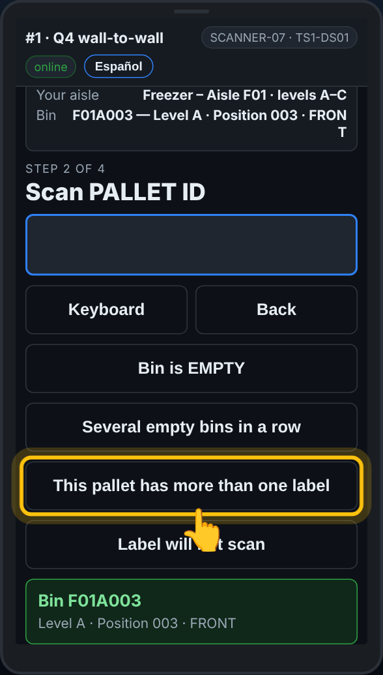  Before anything is scanned, or with only the rack label in: This pallet has more than one label. | 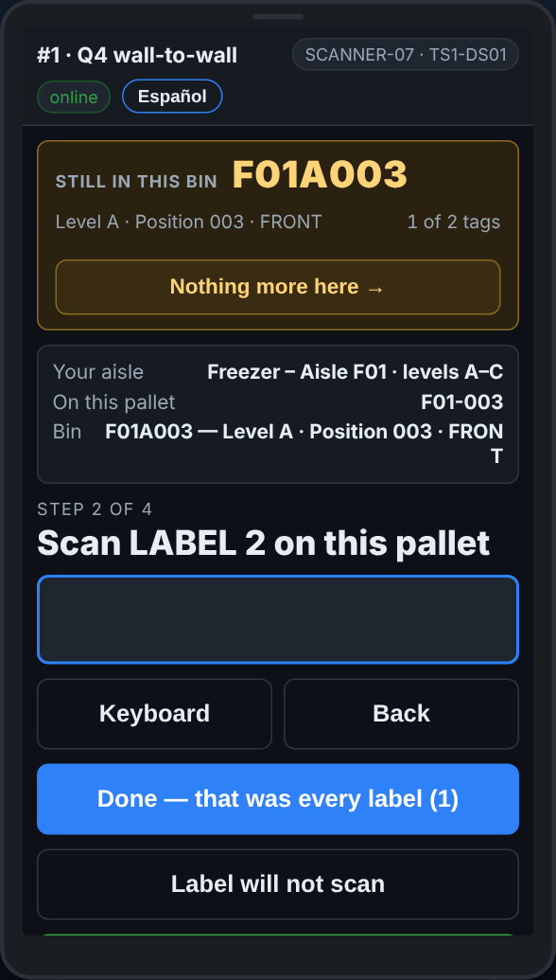  Label 2 on this pallet: each label gets its own quantity. | 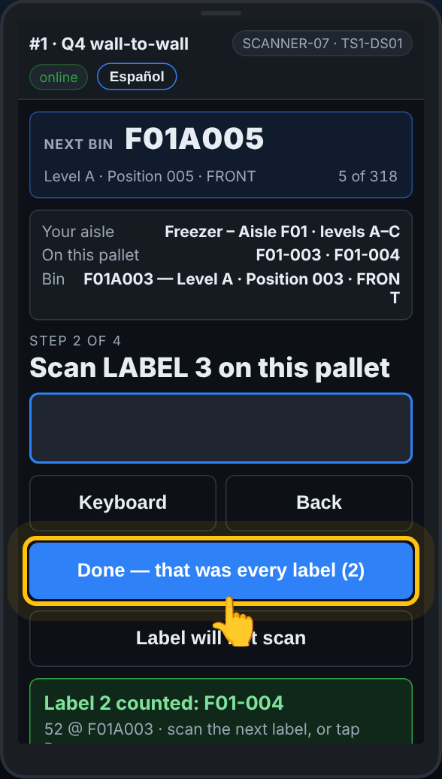  Done — that was every label, with the count of labels on it.

What to do
- Scan the rack label as usual.
- Tap This pallet has more than one label. If you tap it before the rack label, the scanner asks for the bin first: Scan the BIN this pallet is in.
- The screen says Scan LABEL 1 on this pallet. Scan the first label, then type the cases that label covers and press Enter.
- The screen says Scan LABEL 2 on this pallet. Scan the second label and type its cases. Go on for every label.
- Tap Done — that was every label. The button shows how many labels you counted.
Saw the second label too late? The pallet is already saved. At the start of the next line tap Another label on the pallet just counted. The scanner keeps the same bin: scan the other label, type its cases, then Done.
Second label says Pallet not on the list? Tap It is another label on the pallet with … and it is counted with the first one.
What the office sees
Each label is its own row on the pallet report, in the same bin, with its own quantity. The later labels say which label they share a pallet with, so nobody reads the pallet as counted twice.
Do not
- Do not add the two quantities together on one label.
- Do not scan the same label twice, or the rack label again between labels.
On the scanner — A pallet label that will not scan
When: the pallet label is torn, iced over or faded, but you can still read the number
The pallet is still there and still has to be counted. If you can read the number on the label, you type it in and carry on. The line is marked so the office prints a new label.
What you see
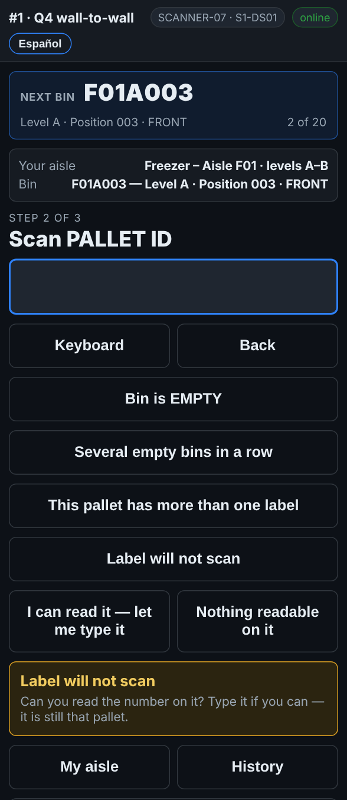  Label will not scan opens two choices: type it, or nothing readable on it. | 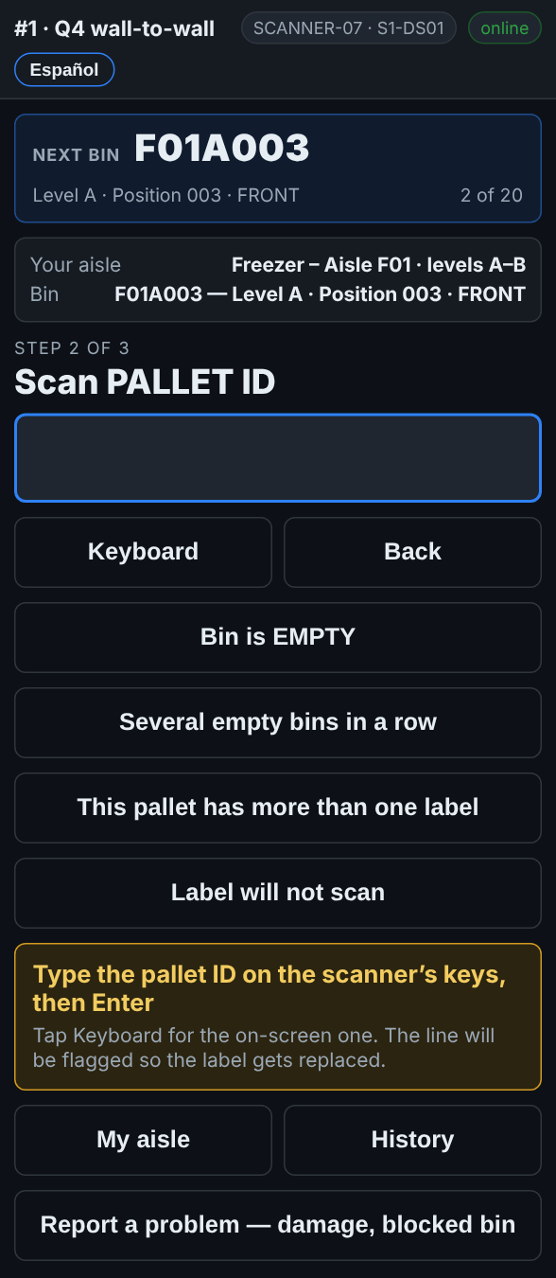  I can read it — let me type it: type the pallet ID on the scanner’s keys, then Enter.

What to do
- Scan the rack label as usual. The screen asks for the pallet.
- Try the trigger once more, from a little further back. Ice and glare often clear at a different distance.
- Still nothing: tap Label will not scan.
- Tap I can read it — let me type it.
- Type the pallet ID on the scanner’s keys and press Enter. Tap Keyboard only if you want the on-screen keyboard.
- Count the cases and type the quantity as usual.
What the office sees
The pallet is counted under the number you typed. The line is marked typed, and the pallet goes on Reports → Fix list under Labels to replace. When a new label is printed and on the pallet, the office taps Label printed & on the pallet.
Do not
- Do not skip the pallet.
- Do not guess a number you cannot read. If you cannot read it, see A pallet with no label.
- Do not type the number of the pallet next to it.
On the scanner — A pallet with no label
When: there is no pallet label at all, or nothing on it can be read
A pallet with no readable label is still stock. You count it anyway, and the scanner gives it a name from the bin it is in, so somebody can walk straight to it later.
What you see
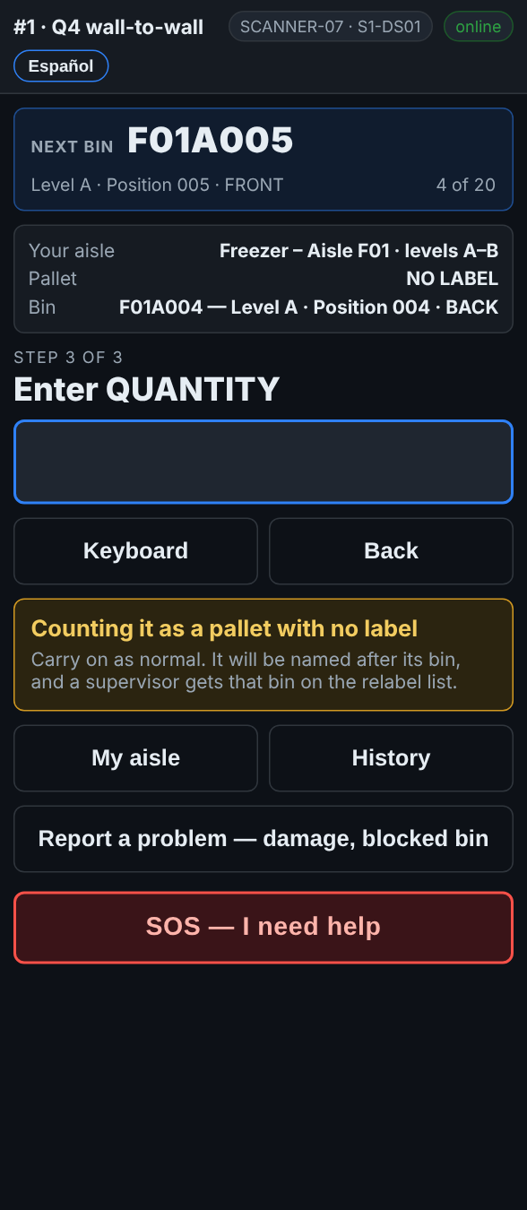
Nothing readable on it: the pallet is counted as NO LABEL, named after its bin when the line is saved.
What to do
- Scan the rack label as usual. The screen asks for the pallet.
- Tap Label will not scan.
- Tap Nothing readable on it. The scanner says Counting it as a pallet with no label.
- Count the cases and type the quantity as usual.
- If something is wrong with the pallet itself, pick it on the comment step, or use Report a problem.
What the office sees
The pallet is saved as NO-LABEL- and the bin, for example NO-LABEL-F01A004-1. A second unlabeled pallet in the same bin is -2. The bin goes on Reports → Fix list under Labels to replace, and the office matches the pallet to what the report expected in that bin. When a label is printed and on the pallet, the office taps Label printed & on the pallet.
Do not
- Do not skip the pallet because it has no label.
- Do not borrow a label number from another pallet.
- Do not write on the pallet to make up a number.
On the scanner — A rack label that will not scan
When: the rack label under the spot is torn, missing, iced or faded
Every team after you walks up to the same spot, so a rack label that will not scan always goes on the relabel list. Most of the time the scanner already knows which bin you are at, and one tap tells it.
What you see
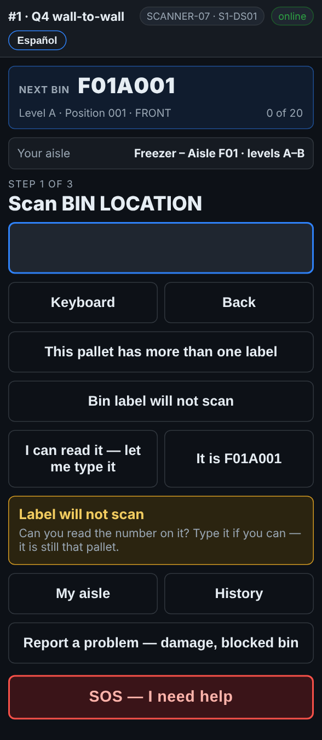  Bin label will not scan: type it, or tap It is … for the bin the guide is on. | 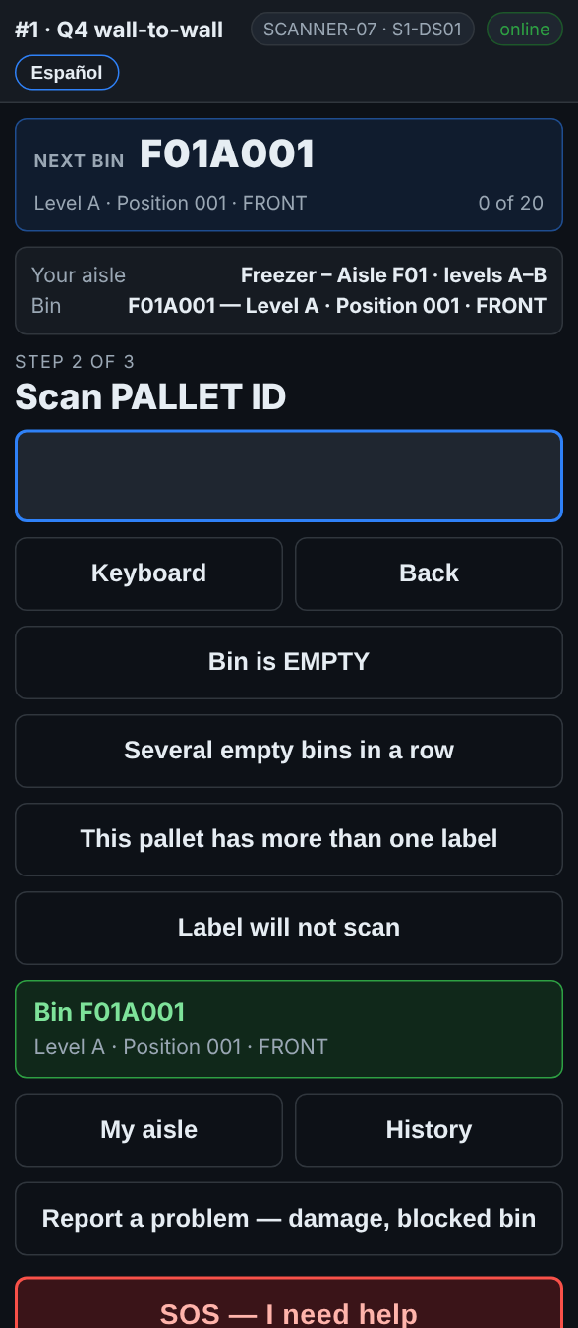  It is F01A001: the bin is taken as if scanned, and the scanner asks for the pallet.

What to do
- When the screen says Scan BIN LOCATION and the rack label will not read, tap Bin label will not scan.
- Look at the button on the right:
– It is F01A001 (the bin Next bin is pointing at): tap it if that is where you are standing.
– I can read it — let me type it: type the bin code on the scanner’s keys and press Enter.
– No readable bin label shows when the scanner has no idea which bin it is. Tap it only if you cannot tell from the labels either side.
- Carry on with the pallet and the quantity as usual.
What the office sees
The line is marked, and the bin goes on Reports → Fix list under Labels to replace, whichever button you used. A bin recorded with No readable bin label is saved as NO-LABEL-BIN- and the aisle, for a supervisor to sort out. When the new label is up, the office taps Label printed & on the rack.
Do not
- Do not scan the rack label of the spot next door instead.
- Do not tap It is … if that is not the spot in front of you.
On the scanner — Several pallets in one bin
When: there is more than one pallet in a spot
Two, three or four pallets in one spot is normal. The scanner keeps you at that spot until every pallet in it is counted, so none is left behind.
What you see
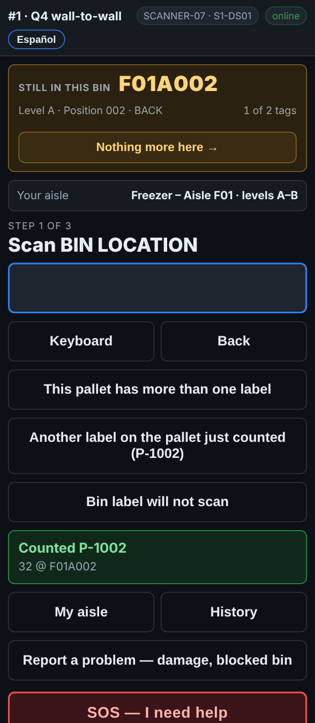
Still in this bin, 1 of 2 tags: the report expects two pallets here.
What to do
- Count the first pallet as usual: rack label, pallet label, quantity.
- The box at the top turns orange: Still in this bin, with a count such as 1 of 2 tags.
- Count the next pallet the same way: rack label, pallet label, quantity.
- When every pallet the report expects is counted, the box goes back to Next bin by itself.
- The scanner expects more but there are none: tap Nothing more here →.
- A spot the report has nothing for stays open after a pallet, because there may be more. Tap Nothing more here → when you have counted them all.
What the office sees
Each pallet is its own line in that bin. A pallet the report expected here and nobody counted shows as MISSING on the pallet report.
Do not
- Do not leave a spot half counted.
- Do not count the pallets in the back row from memory: pull them forward or ask for a lift.
On the scanner — An empty bin
When: there is nothing at all in the spot
An empty spot counts too. If it is not recorded, it looks like a spot nobody reached, and somebody is sent back to it.
What you see
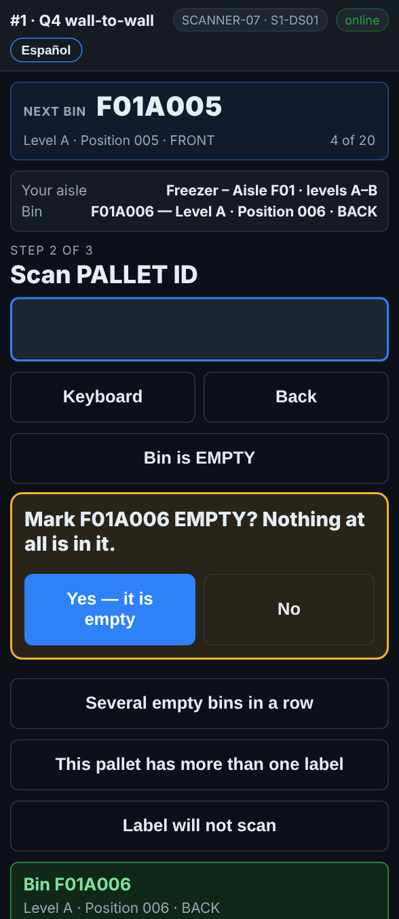
With the rack label in: Bin is EMPTY, then Yes — it is empty.
What to do
- Scan the rack label as usual.
- Tap Bin is EMPTY.
- The scanner asks Mark F01A006 EMPTY? Nothing at all is in it. Tap Yes — it is empty. No takes you back.
- Next bin moves on.
If you tap Bin is EMPTY — scan the bin before scanning anything, scan the rack label next and the bin is saved as empty.
What the office sees
The bin is recorded as checked and empty. If the report expected a pallet there, that pallet shows as MISSING on the pallet report, and a second count may be sent.
Do not
- Do not walk past an empty spot without recording it.
- Do not mark a spot empty if a pallet is there but has no label. See A pallet with no label.
On the scanner — Several empty bins in a row
When: a run of spots next to each other is empty
A row of empty spots can be recorded in one go: the first one and the last one, and the scanner lists every bin in between for you to check.
What you see
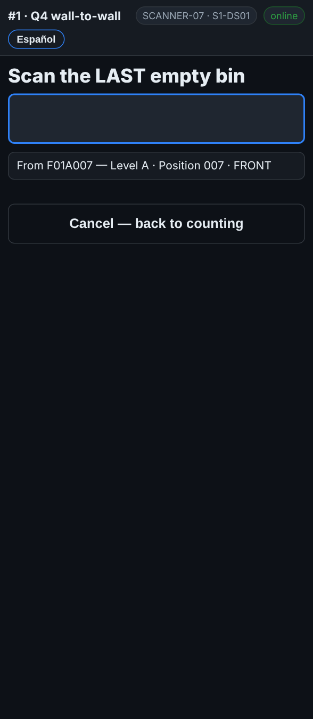  Scan the FIRST empty bin, then the LAST. |   Untick any that are NOT empty, then Mark 3 bins EMPTY.

What to do
- Scan the rack label of the first empty spot as usual. The screen asks for the pallet.
- Tap Several empty bins in a row.
- Scan the first empty bin of the run.
- Scan the last empty bin of the run. Both have to be in the same aisle.
- The scanner lists every bin in between on your levels. Bins already counted are greyed out and say already counted.
- Walk the run and untick any spot that is not empty.
- Tap Mark N bins EMPTY. Cancel — back to counting leaves without saving.
What the office sees
Each bin in the run is recorded as checked and empty, the same as one at a time. A run over 60 bins asks you to check the first and last bin before you save it.
Do not
- Do not mark a run you have not walked.
- Do not leave a spot ticked if there is a pallet in it.
On the scanner — A pallet that is not on the list
When: you scan a pallet label the inventory report does not have
A pallet the report does not know is still a pallet on the shelf. You count it, and the office adds it to the system.
What you see

Pallet not on the list: Count it anyway? YES or NO.
What to do
- The screen says Pallet not on the list and asks Count it anyway?
- Check the label: is it a pallet label, and is it on this pallet?
- Tap YES and count it like any other pallet.
- It was a wrong barcode, a case label or a sticker: tap NO and scan the right label.
- It is a second label on the pallet you just counted: tap It is another label on the pallet with ….
On a count set to strict, the scanner does not offer YES: it says the pallet is not on the list. Ask your supervisor.
What the office sees
The pallet shows as NOT IN MASTER on the pallet report. A supervisor adds it to the system as found stock.
Do not
- Do not tap NO just to make the question go away. Found stock is never a problem.
- Do not scan case labels or item barcodes as the pallet label.
On the scanner — A bin that is not on the list
When: you scan a rack label the bin list does not have
Usually this is a misread or a label from another area. The scanner stops and asks before it counts anything against a bin it does not know.
What you see
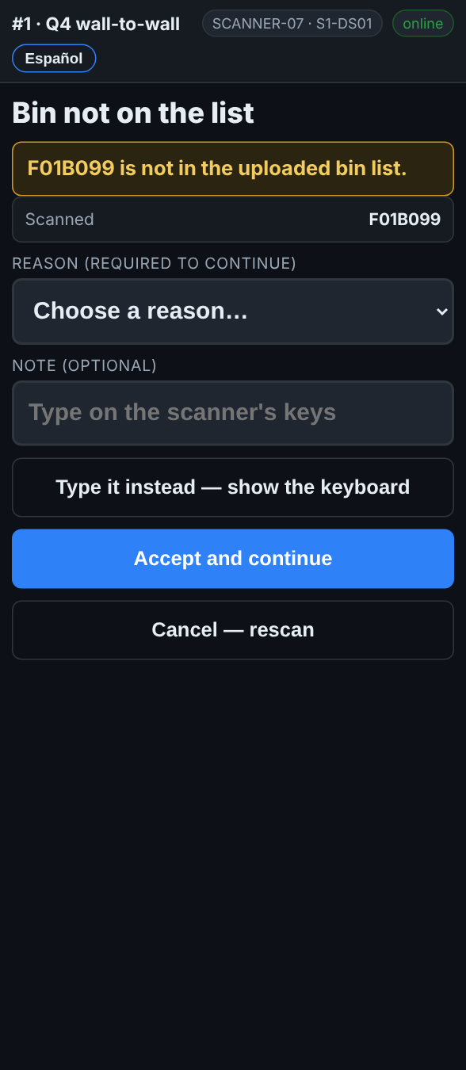
Bin not on the list: a reason is needed to go on.
What to do
- The screen says Bin not on the list.
- Check the rack label. Is it the label for the spot in front of you, or a label from a different area or an old layout?
- A misread or the wrong label: tap Cancel — rescan and scan the right one.
- It really is the spot, and there is a pallet in it: pick a reason, add a note if it helps, and tap Accept and continue.
- Not sure: tap Cancel — rescan and ask your supervisor.
What the office sees
The line is flagged with your reason and the unknown bin, for a supervisor to sort out. A bin that should be on the list gets added.
Do not
- Do not accept a bin you are not sure about.
- Do not use Accept and continue to get past a label you misread.
On the scanner — A pallet that was already counted
When: you scan a pallet label that has already been counted on this count
The scanner tells you where the pallet was counted and by whom. Most of the time it is the same label scanned twice.
What you see
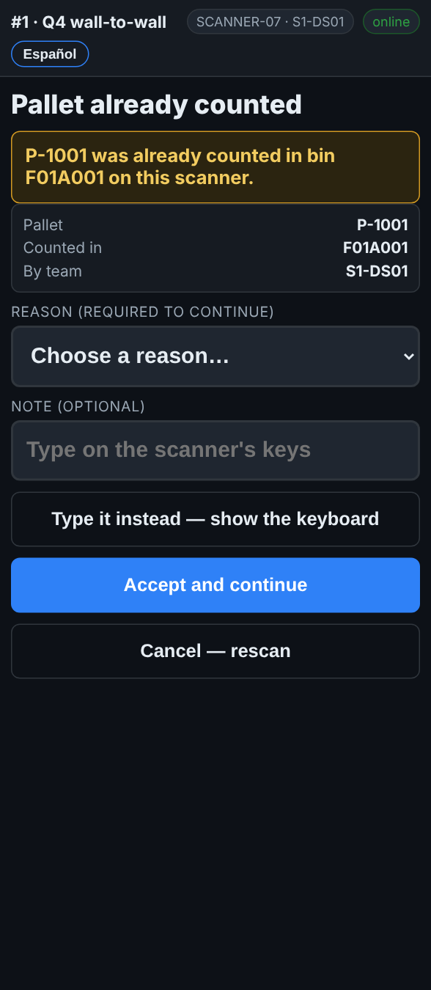
Pallet already counted: where, and by which team.
What to do
- Read the yellow box: it says the bin it was counted in, and on this scanner or by team ….
- You scanned the same label twice, or a pallet you just counted: tap Cancel — rescan and scan the next pallet.
- It is a second label on one pallet: cancel, and use Another label on the pallet just counted instead. See A pallet with two or more labels.
- The pallet really is here, and was counted somewhere else before it moved: pick a reason, add a note, and tap Accept and continue.
What the office sees
An accepted duplicate is flagged. The office sees the pallet counted in two bins and decides which one stands, often with a second count.
Do not
- Do not accept a duplicate because you are not sure. Cancel and ask.
- Do not count a pallet twice to be safe.
On the scanner — Not your aisle, or not your level
When: you scan a rack label outside the aisle or levels your team was given
Your team counts the aisle and the levels on My aisle. A rack label from anywhere else is almost always the label above, below or across the aisle.
What you see
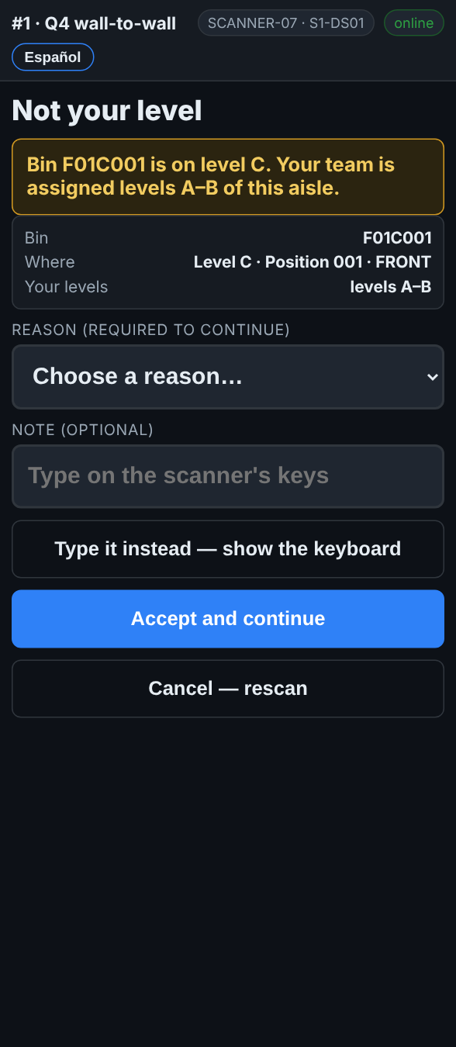  Not your level: the bin is on level C, your team counts A–B. | 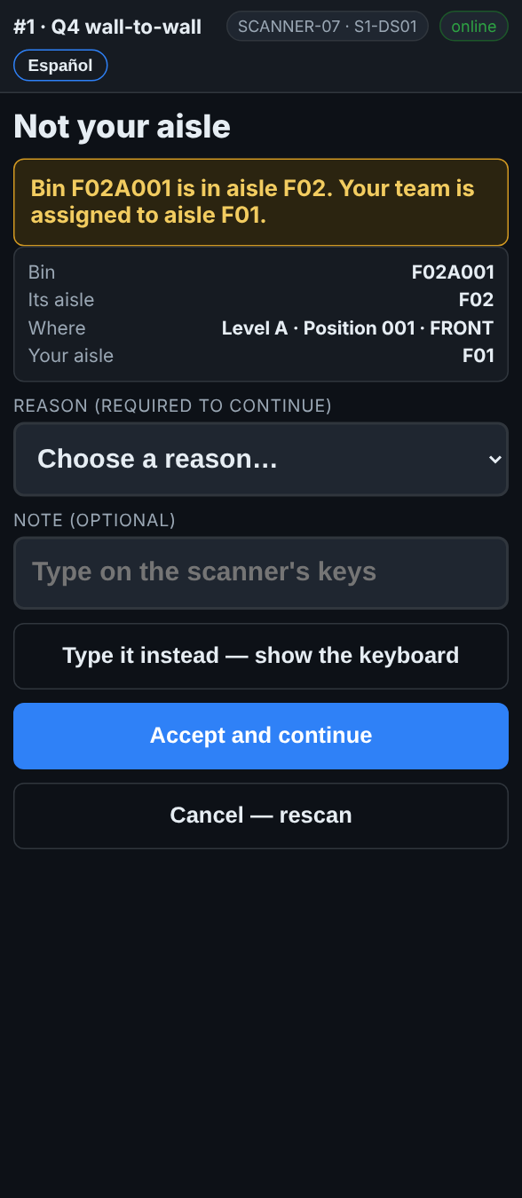  Not your aisle: the bin is in F02, your team is in F01.

What to do
- The screen says Not your level or Not your aisle, with the bin and where you should be.
- Check the label: did you scan the one above or below, or the aisle across?
- Tap Cancel — rescan and scan the label of your spot.
- Only if your supervisor sent you there: pick a reason and tap Accept and continue.
What the office sees
An accepted line is flagged as counted outside the plan, with your reason, so it does not get counted again by the team that owns that aisle without the office knowing.
Do not
- Do not count another team’s aisle unless your supervisor asks.
- Do not reach for a level your equipment does not reach.
On the scanner — A pallet in a different bin from the report
When: the pallet you scan is listed somewhere else on the report
Pallets move. The scanner tells you where the report expected it, and you count it where it really is. There is nothing to choose.
What you see
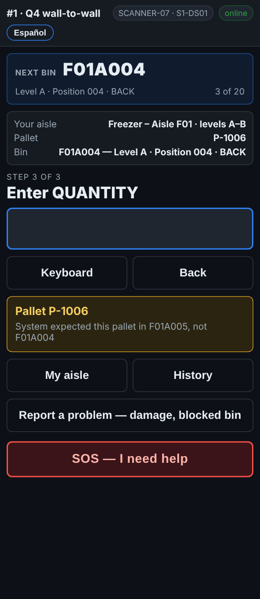
System expected this pallet in F01A005, not F01A004.
What to do
- The yellow message says System expected this pallet in …, not ….
- Count it here, where it is: type the quantity as usual.
- Carry on. Do not move the pallet.
What the office sees
The pallet shows as WRONG BIN on the pallet report, with the bin it was found in. If nothing was found in the bin the report expected, that bin shows its pallet as MISSING.
Do not
- Do not move the pallet back during the count.
- Do not scan the rack label of the bin the report expected.
On the scanner — The wrong label in the wrong box
When: you scan a rack label where the pallet goes, a pallet label where the bin goes, or a label into the quantity
The scanner knows a rack label from a pallet label. When the wrong one goes in, it says so and records nothing.
What you see
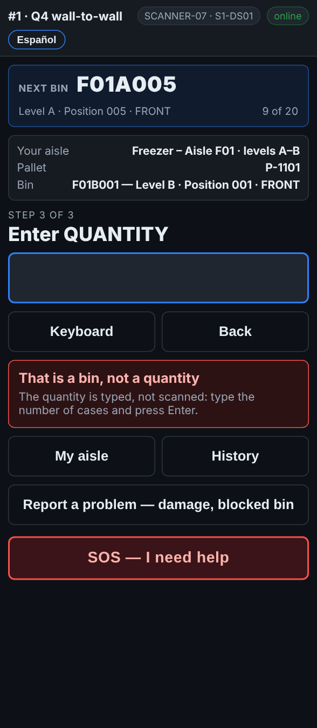
That is a bin, not a quantity: the quantity is typed, not scanned.
What to do
- Read the red message. It says what you scanned and what it wanted:
– … is a bin, not a pallet: scan the pallet label.
– … is a pallet label, not a bin: scan the rack label of the spot the pallet is in.
– That is a bin, not a quantity: type the number of cases and press Enter.
- Scan or type the right thing. Nothing was recorded by the wrong scan.
What the office sees
Nothing. A wrong scan never reaches the office.
Do not
- Do not scan a label to fill the quantity box.
- Do not tap Back to get rid of the message: just scan the right label.
On the scanner — A very large quantity
When: you type a quantity at or over the site’s limit, usually 1,000
A big number is easy to mistype. The scanner asks you to type it again before it keeps it.
What you see
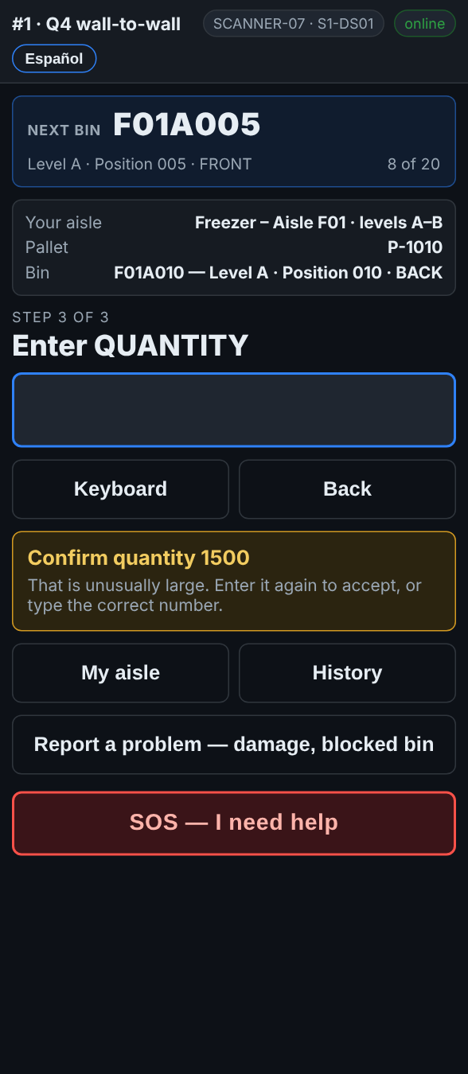
Confirm quantity 1500: type it again to accept, or type the right number.
What to do
- The yellow message says Confirm quantity ….
- Count again if you are not sure.
- The number is right: type it again and press Enter.
- It was a typo: type the right number and press Enter.
What the office sees
The quantity you confirmed. The limit is set by the office under Settings.
Do not
- Do not type the same wrong number twice to get past the message.
On the scanner — A lot code or an expiry date
When: the count asks for a lot code or an expiry date as well
Some counts ask for the lot and the expiry on each pallet. Both can be missing on a real pallet, so both can be skipped.
What you see
On these counts the steps say* Scan LOT CODE and Enter EXPIRY (YYYY-MM-DD) *after the quantity.
What to do
- Scan LOT CODE: scan the lot barcode on the pallet label, or type it. No lot on the label: tap Skip.
- A lot different from the report shows a yellow message, The report says this pallet is lot …. Check you scanned the lot, then carry on.
- Enter EXPIRY (YYYY-MM-DD): type the date, for example 2027-03-15. No date: tap Skip.
- A date that has passed shows That date has passed — flag it to a supervisor. Tell your lead.
What the office sees
The lot and expiry on each line. A lot that does not match the report, and an expired date, are flagged on the pallet report.
Do not
- Do not scan the pallet label or the rack label into the lot box: the scanner refuses it.
- Do not make up a date.
On the scanner — A comment on a pallet
When: the scanner asks for a comment after the quantity
Most pallets need no comment. When something is wrong with the pallet itself, one tap on a quick reason tells the office.
What you see
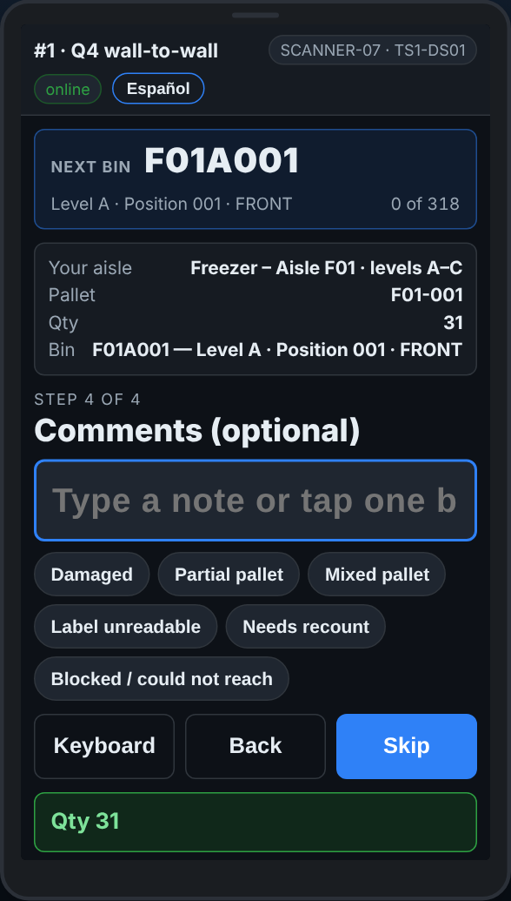
Comments: tap a quick reason, or Skip.
What to do
- After the quantity the screen says Comments (optional).
- Something is wrong with the pallet: tap the reason that fits, such as Damaged or Partial pallet.
- Nothing to say: tap Skip. On count day it also moves on by itself after a few seconds.
- If the screen says Comments (required), pick a reason before going on.
What the office sees
The comment on the line, on the pallet report.
Do not
- Do not stop to type long notes. Tap a reason, or use Report a problem for something that needs fixing.
On the scanner — Fixing a mistake
When: you typed or scanned something wrong
Before the line is saved, Back goes one step back. After it is saved, History lets your team take a wrong line out, and the scanner sends you back to that bin to count it again.
What you see
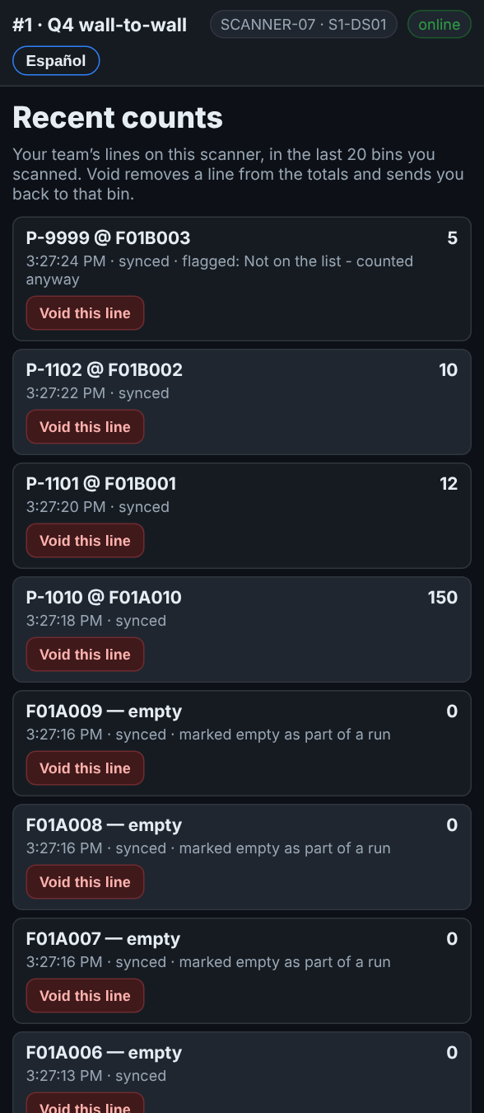  History: your team’s lines on this scanner, in the last 20 bins you scanned. | 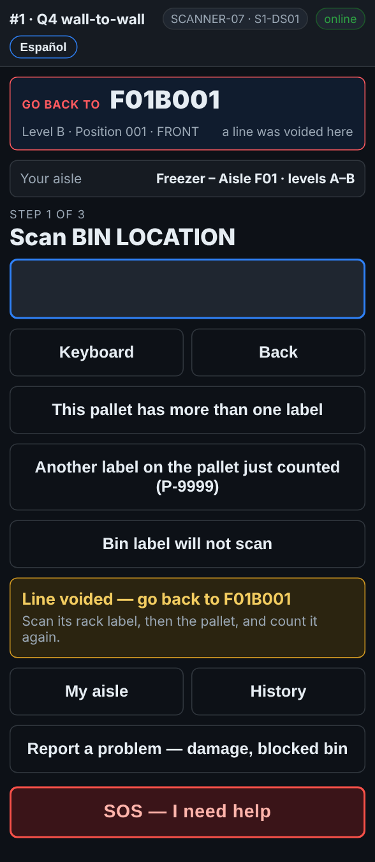  After a void: Go back to F01B001, scan its rack label and count it again.

What to do
Not saved yet
- Tap Back. Each tap goes one step back: from the quantity to the pallet, from the pallet to the bin.
Already saved
- Tap History. It shows your team’s own lines on this scanner, in the last 20 bins you scanned. Another crew’s lines are not there.
- Find the wrong line and tap Void this line.
- The scanner goes back to the scan screen. The box at the top says Go back to and the bin, in red.
- Go to that bin. Scan its rack label, then the pallet, and count it again.
- Once a count lands in that bin, the box goes back to Next bin.
What the office sees
A voided line is taken out of the totals, but it is never deleted: the office can still see it was voided.
Do not
- Do not void another team’s line: it is not in your History.
- Do not void a line and walk on: the scanner sends you back for a reason.
On the scanner — No Wi-Fi
When: the top of the screen says OFFLINE
The Wi-Fi drops in the freezer and at the back of the dock. The scanner keeps every line and sends it when the signal is back. Keep counting.
What you see
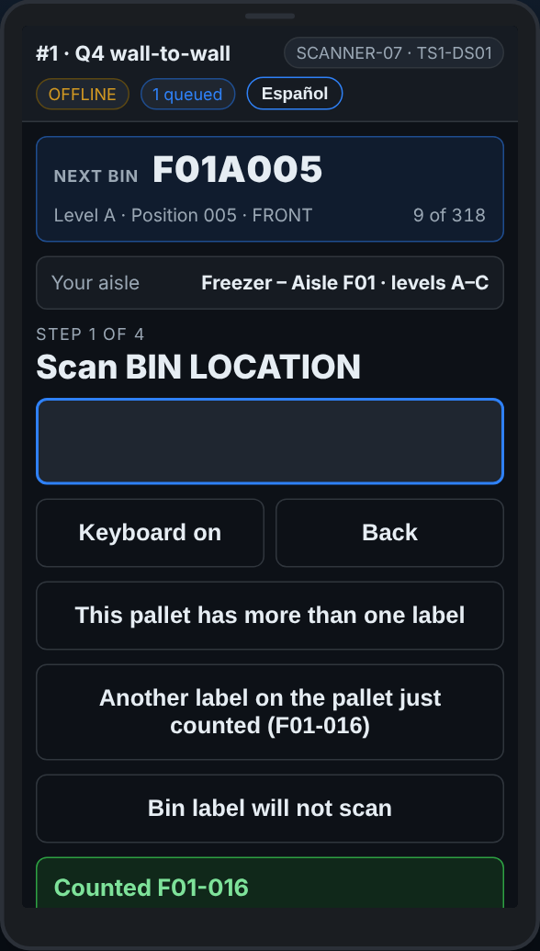
OFFLINE, with the number of lines waiting to send.
What to do
- Keep counting as normal. Every line is saved on the scanner.
- The chip next to OFFLINE says how many lines are waiting, for example 3 queued.
- When the signal is back the lines send themselves. The chip says online and the count goes away.
- Before you sign off, walk somewhere with signal so the queue empties. The scanner warns you if lines have not reached the office.
What the office sees
The lines arrive when the scanner is back online, with the time they were scanned, not the time they arrived.
Do not
- Do not count the same pallets again because the Wi-Fi dropped.
- Do not clear the browser or uninstall the app with lines queued.
- An SOS with no signal is not sent: the scanner says so. Go and find someone.
On the scanner — Reporting a problem
When: something needs fixing but nobody is hurt: damage, a blocked spot, broken racking
Report a problem puts it on the office’s fix list with the exact bin or pallet. It is not an emergency button: for help now, use SOS.
What you see
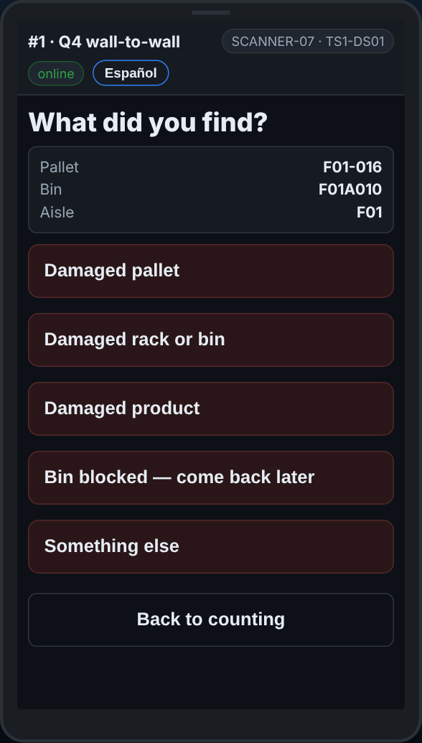
What did you find? Pick what it is, then scan the bin or pallet to confirm.
What to do
- Tap Report a problem — damage, blocked bin.
- Pick what you found, then what is wrong with it.
- Add a note if it helps. Tap Type it instead — show the keyboard to type it.
- Scan the bin or the pallet the scanner asks for, so the office goes to the right one. Its label will not scan: tap Label will not scan — type it.
- Tap Back to counting and carry on.
What the office sees
Your report is on Reports → Fix list, with the bin, the pallet, your team and the time. Somebody fixes it and ticks it off.
Do not
- Do not use Report a problem for an injury or anything dangerous. Use SOS.
On the scanner — SOS — when you need help now
When: someone is hurt, stuck, equipment is broken, or you need a supervisor right away
SOS tells the office at once, with your team, your aisle and the last bin you scanned. When a supervisor picks it up, your scanner tells you who.
What you see
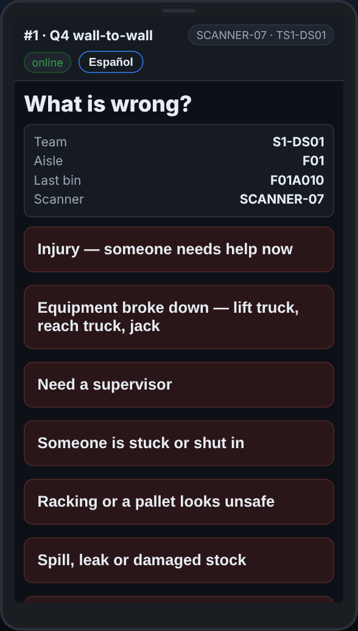  SOS — what is wrong? Pick it, and the office is told at once. | 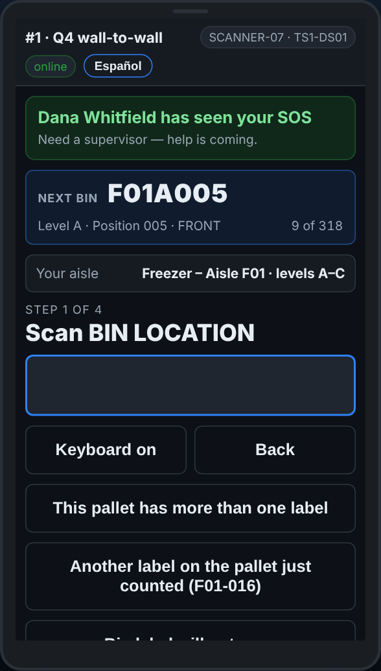  When a supervisor picks it up, the scanner says who has seen it.

What to do
- Tap the red SOS — I need help.
- Pick what is wrong. Add a note if there is time.
- Stay where you are if it is safe. The office sees your team, aisle and last bin.
- When a supervisor presses I am on it, your scanner says who has seen it.
- No signal: the scanner says the SOS was not sent. Go and find someone.
What the office sees
A loud alert on the Dashboard under Alerts, and in the Teams channel if the site has one, with your team, aisle, last bin and what you picked.
Do not
- Do not wait for the scanner if someone is in danger: shout, and go for help.
- Do not use SOS for a damaged pallet or a blocked spot: use Report a problem.
On the scanner — A message from the office
When: the scanner buzzes and a message appears at the top
Your lead can send a message to your scanner: come to the dock, skip an aisle, take a break. It stays on the screen until you say you have read it.
What you see
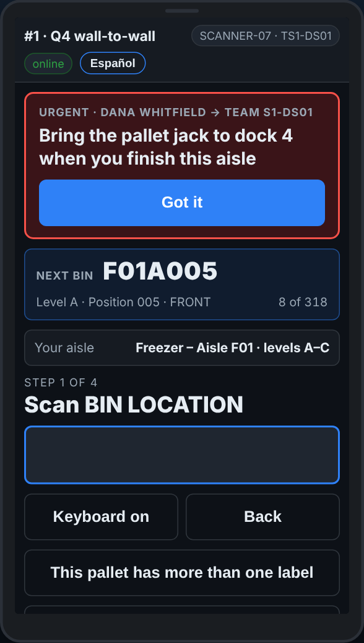
A message at the top: read it, then Got it.
What to do
- Read the message at the top of the screen. A red one is urgent.
- Tap Got it.
- Do what it says. You can keep scanning while it is on the screen.
What the office sees
That your scanner has read it, and when.
Do not
- Do not tap Got it without reading the message.
On the scanner — Second counts
When: My aisle shows Start second counts
When a first count does not agree with the report, the office sends a different team back to that spot to count it again, blind. You are not told the first count.
What you see
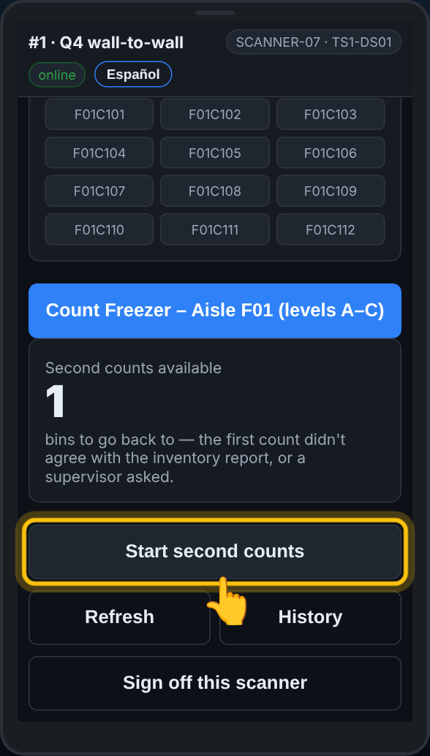  My aisle: Second counts available, and Start second counts. | 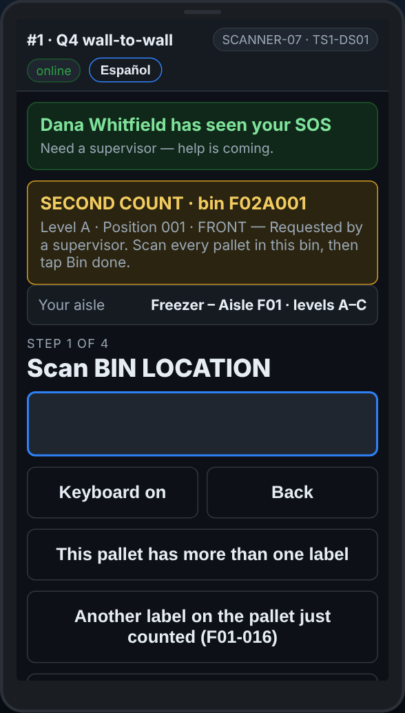  A second count: go to the bin and count everything in it. It moves on once every pallet expected there is counted.

What to do
- On My aisle, tap Start second counts.
- The banner at the top says which bin to go to.
- Count everything in that spot: rack label, pallet label, quantity, for every pallet.
- Once every pallet the report expects in that spot is counted, the scanner finishes the second count by itself: Bin … done — every pallet expected there is counted, and the next one comes up.
- Fewer pallets there than that, or none at all: tap Bin done — nothing more here when you have counted what is there. An empty spot: Bin is EMPTY.
- You cannot get to it right now: tap Leave for another team.
- Scanned a different bin by mistake? The scanner says This second count is for bin …. Scan the right one.
What the office sees
Your second count beside the first one on Second counts. When yours agrees with neither the first count nor the report, a third team may be sent.
Do not
- Do not ask what the first count was.
- Do not count only the pallet that was wrong: count everything in the spot.
On the scanner — Finishing the aisle, and signing off
When: every spot on your levels has a count, or your shift or break starts
The scanner tells you when every bin in your aisle has a count. Your supervisor marks the aisle done in the office, and your next aisle appears by itself.
What you see
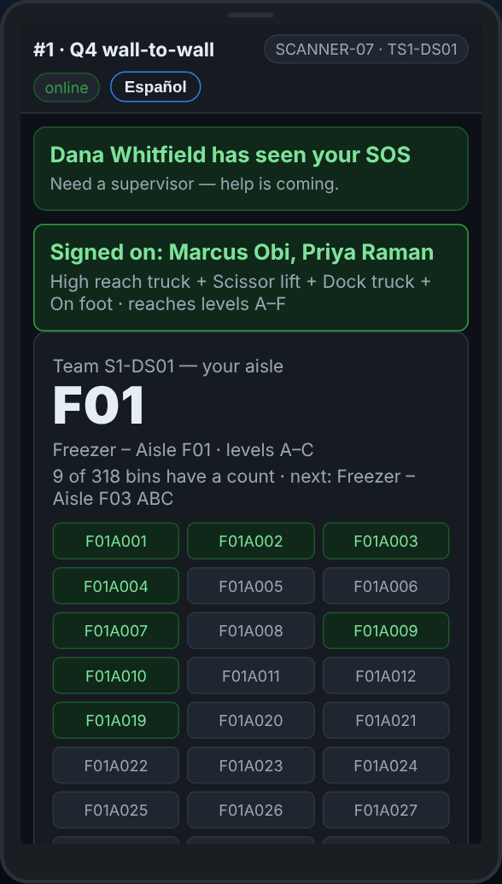  Every bin has a count: tell your supervisor. | 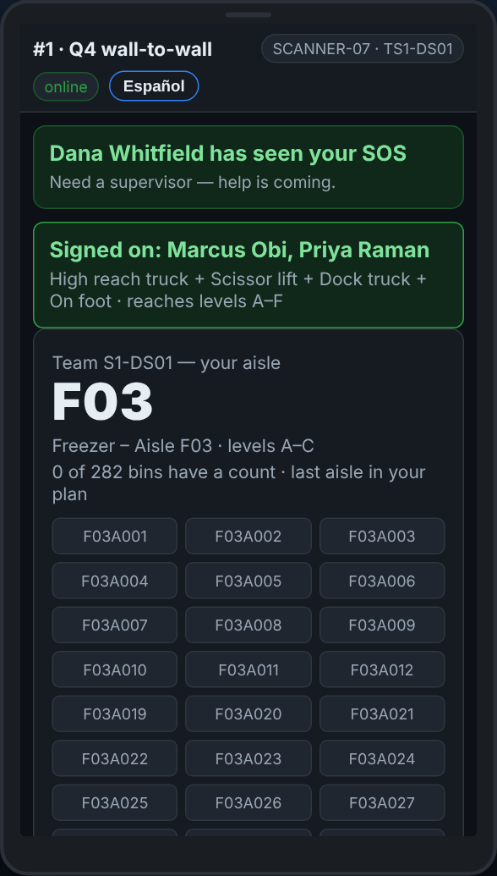  Once the supervisor marks it done, the next aisle is on My aisle.

What to do
- The box at the top says Every bin in … has a count — tell your supervisor.
- Tell your supervisor. There is no button for this on the scanner: they mark the aisle done on the Team plan.
- Your next aisle shows on My aisle. Tap Refresh if it has not appeared yet.
- Break or end of shift: tap Sign off this scanner on My aisle. If lines are still waiting to send, it asks first.
- Put the scanner on its charger. The next crew signs on with their own team card and badges.
What the office sees
The aisle as complete on the Team plan, and your team’s next aisle as counting.
Do not
- Do not hand the scanner to the next crew still signed on as your team.
- Do not sign off with lines queued: walk to the signal first.

