Assignment 3 – MECHTRON 3TB4

Q1

module Q1(

input clk,

input in,

input reset,

output reg out

);

reg [3:0] state; // init state is 4’b101

always @(posedge clk or posedge reset)

begin

if(reset == 1’b1)

begin

out <= 1’b0;

state <= 4’b101;

end

else

begin

case(state)

4’b1110: begin // 1 zero

out <= 1’b0;

if(in == 1’b0) state <= 4’b1100;

else state <= 4’b1;

end

4’b1100: begin // 2 zeros

out <= 1’b0;

if(in == 1’b0) state <= 4’b1000;

else state <= 4’b1;

end

4’b1000: begin // 3 zeros

out <= 1’b0;

if(in == 1’b0) state <= 4’b0;

else state <= 4’b1;

end

4’b0: begin // 4 zeros

out <= 1’b1;

if(in == 1’b0) state <= 4’b0;

else state <= 4’b1;

end

4’b1: begin // 1 one

out <= 1’b0;

if(in == 1’b0) state <= 4’b1110;

else state <= 4’b11;

end

4’b11: begin // 2 ones

out <= 1’b0;

if(in == 1’b0) state <= 4’b1110;

else state <= 4’b111;

end

4’b111: begin // 3 ones

out <= 1’b0;

if(in == 1’b0) state <= 4’b1110;

else state <= 4’b1111;

end

4’b1111: begin // 4 ones

out <= 1’b1;

if(in == 1’b0) state <= 4’b1110;

else state <= 4’b1111;

end

default: begin // init

out <= 1’b0;

if(in == 1’b0) state <= 4’b1110;

else state <= 4’b1;

end

endcase

end

end

endmodule

Q2

% ------- FIXED POINT Q1.7 ----------

% product is Q1.7

F = fimath('ProductMode','SpecifyPrecision','ProductWordLength',8,'ProductFractionLength',7);

y_fix = sfi(0,8,7); % initial state of 0

gain_fix = sfi(-0.982,8,7);

res_fix = zeros(100,2);

res_fix(:,1) = 1:100;

for i=1:100

res_fix(i,2) = y_fix;

y_fix = mpy(F,gain_fix,y_fix)+sfi(1,8,7);

end

figure(1);

plot(res_fix(:,1),res_fix(:,2));

title('fixed point step response');

% -------- FLOATING POINT ---------

y_float = 0.0;

gain_float = -0.982;

res_float = zeros(100,2);

res_float(:,1) = 1:100;

for i=1:100

res_float(i,2) = y_float;

y_float = gain_float*y_float+1.0;

end

figure(2);

plot(res_float(:,1),res_float(:,2));

title('floating point step response');

% -------- DIFFERENCE ------------

res_diff = zeros(100,2);

res_diff(:,1) = 1:100;

res_diff(:,2) = res_float(:,2) - res_fix(:,2);

figure(3);

plot(res_diff(:,1),res_diff(:,2));

title('difference');

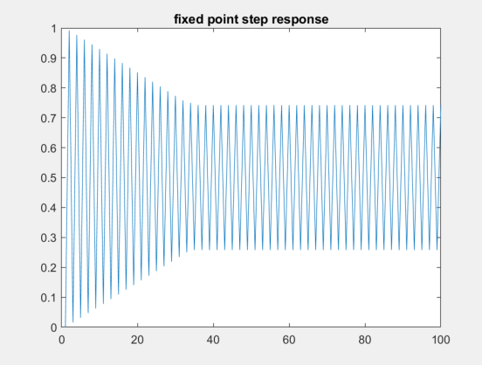

Figure 1: step response of fixed point system

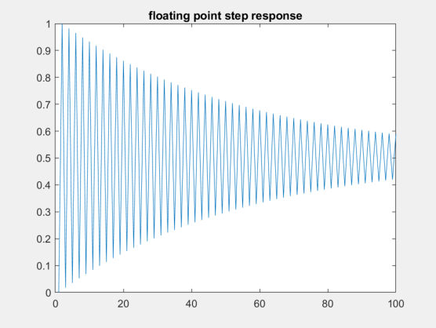

Figure 2: step response of floating point system

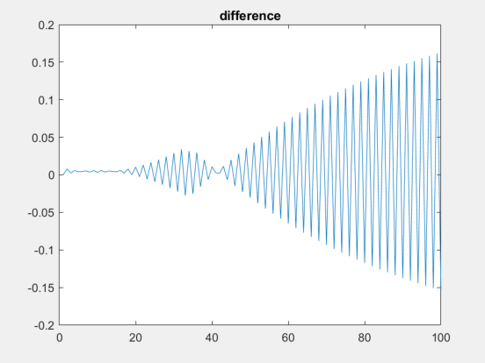

Figure 3: difference between two responses