Assignment 3

Problem 1

function f = phi(xhat,yhat)

a = -1;

b = 1;

tol = 1e-5;

func = @(x,y) 1./sqrt((xhat-x).^2+(yhat-y).^2);

Y = @(y) adsimpson(@(x) func(x,y),a,b,tol,0,100);

f = adsimpson(Y,a,b,tol,0,100);

end

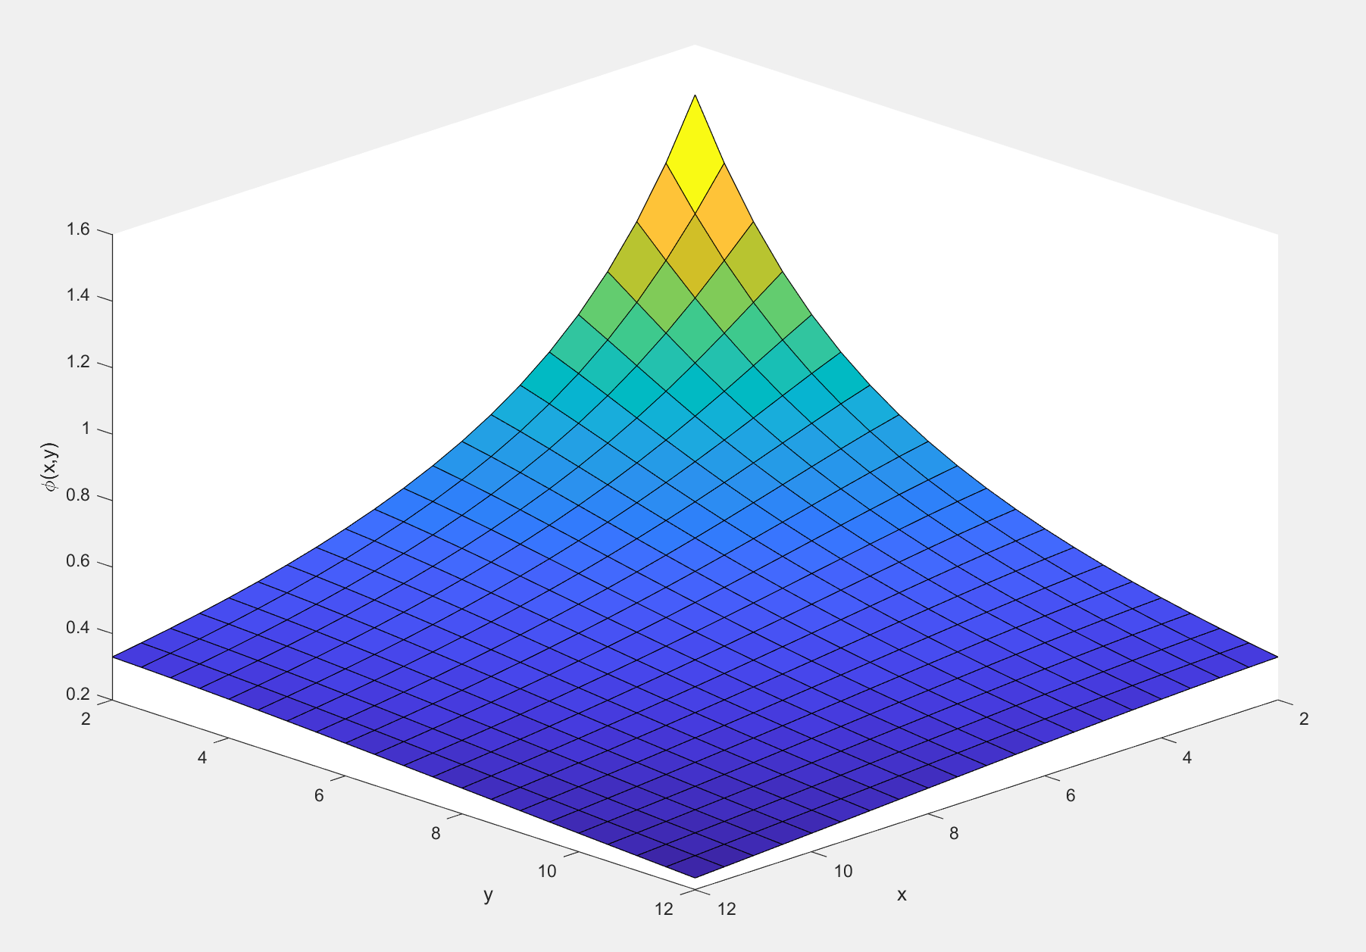

Figure 1: plot of phi

Problem 2

1. midpoint.m

function [Q] = midpoint(f,a,b,n)

format long

h = (b-a)/n;

if n == 0; Q = 0;

else; Q = f(a+h/2)*h + midpoint(f,a+h,b,n-1); %using recursion

end

end

trapezoid.m

function [Q] = trapezoid(f,a,b,n)

format long

h = (b-a)/n;

if n == 0; Q = 0;

else; Q = (f(a)+f(a+h)).*h./2 + trapezoid(f,a+h,b,n-1); %using recursion

end

end

simpson.m

function [Q] = simpson(f,a,b,n)

format long

h = (b-a)/(2*n);

if n == 0; Q = 0;

else; Q = (f(a)+4*f(a+h)+f(a+2*h))*h/3 + simpson(f,a+2*h,b,n-1); %using recursion

end

end

b)

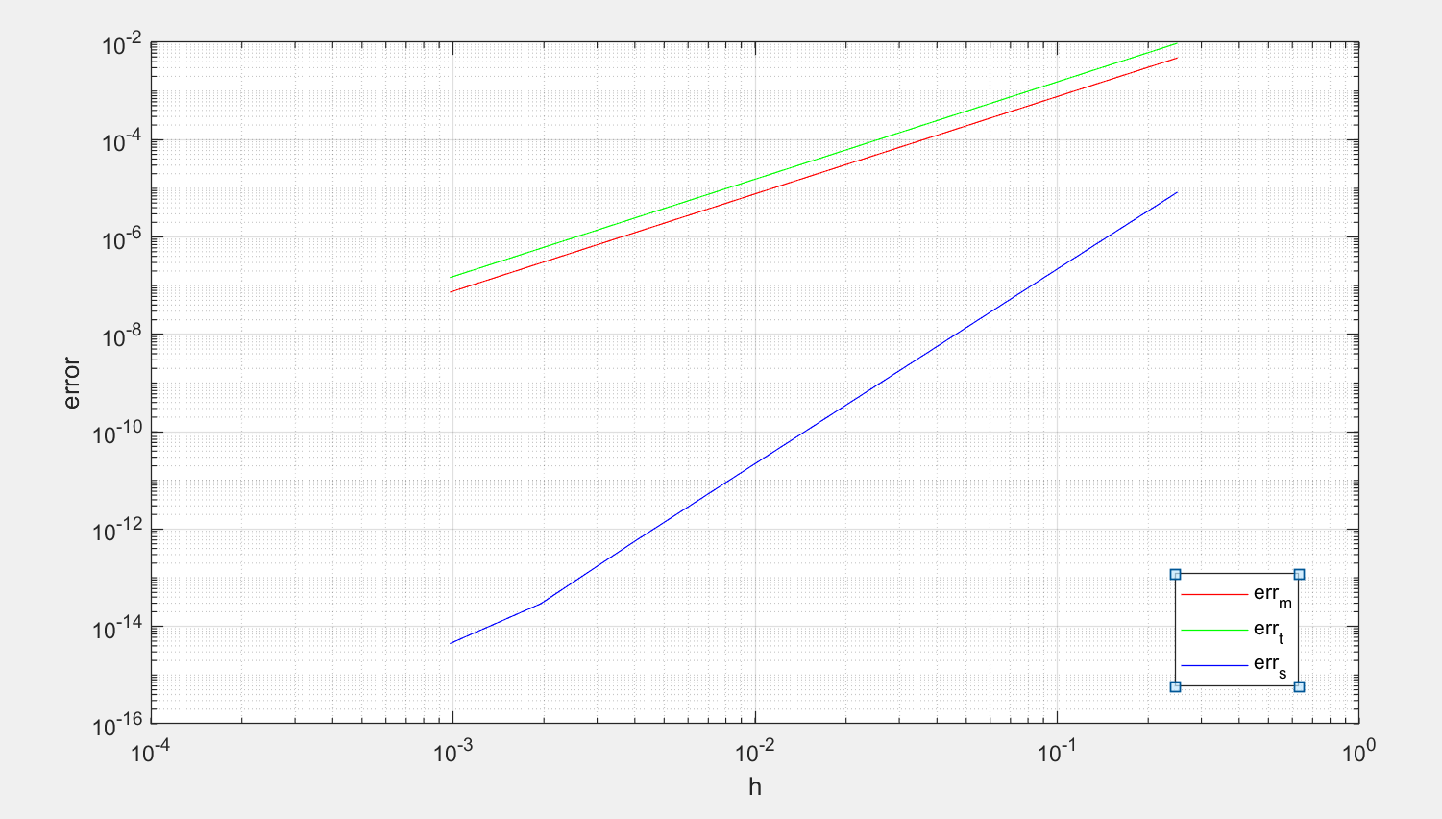

Figure 2: error plot for three integration methods

All integration methods increase in precision with the decrease in h but simpson’s method seems to be the most accurate out of all methods. Both error from midpoint and trapezoid method decrease in error at the same rate but simpson’s method decreases in error the fastest.

c)

The process behind the method is by comparing the values estimated by either midpoint, trapezoid or simpson with an accurate value, in this case the output of integral, error can be calculated. After error is calculated and because h = (b-a)/n, c and p can be calculated by calculating 2 arbitrary sets of h and error and solving for c and p

function [c,p] = findconstants(rule,f,a,b)

%assume this is exact

Q_true = integral(f,a,b);

n = 5;

h_5 = (b-a)/n;

err_5 = Q_true - rule(f,a,b,n); % error for n = 5

n = 10;

h_10 = (b-a)/n;

err_10 = Q_true - rule(f,a,b,n); % error for n = 10

% let c of each error eqn equal to each other, isolate for p

p = log(err_10/err_5)/log(h_10/h_5);

c = err_5/(h_5^p);

end

Output:

midpoint: c=0.076143 p=1.995746

trapezoid: c=-0.152991 p=1.997566

simpson: c=-0.002082 p=3.976895

Problem 3

n = 18580

err = 9.997591643440273e-11

Problem 4

a)

Table 1: coefficients for each planet orbit

|  |  |  |  |  |  |
| --- | --- | --- | --- | --- | --- |
| Planet | $$a$$ | $$b$$ | $$c$$ | $$d$$ | $$e$$ |
| Jupiter | $$-1.185397$$ | $$0.022029$$ | $$-0.495039$$ | $$-0.145054$$ | $$26.982216$$ |
| Saturn | $$-1.166745$$ | $$0.035963$$ | $$0.116729$$ | $$-1.089852$$ | $$90.381602$$ |
| Uranus | $$-1.194134$$ | $$0.011627$$ | $$1.827051$$ | $$-0.259256$$ | $$367.268144$$ |
| Neptune | $$-1.167128$$ | $$0.020704$$ | $$-0.392687$$ | $$-0.423158$$ | $$903.808671$$ |
| Pluto | $$-1.003337$$ | $$0.238833$$ | $$11.847098$$ | $$12.717063$$ | $$1290.679928$$ |

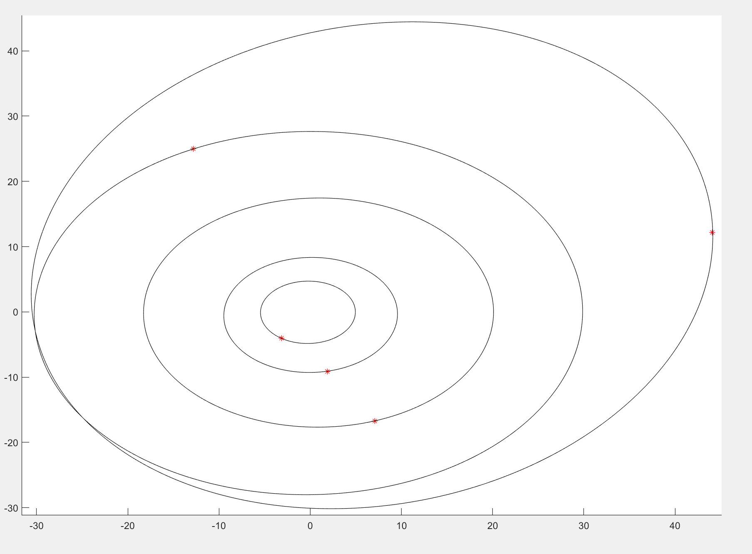

Figure 3: orbit path for each planet

To calculate the location of each planet at a certain time. the respective orbit functions must be parameterized so that it describes the x and y position of the planet at a given time. using this new function, the position of each planet can be calculated.