Week 5 Visualizations Activity

Xinghan Liu

2023/06

## [1] "I am using the dataset called 'renamed' to do this visualizations activity"

data_foruse <-renamed[renamed$Age != "70-74" & renamed$Age != "75-79" & renamed$Age != "80 or older",]  
summary(data_foruse)

## HeartDisease BMI Smoking Alcohol   
## Min. :0.00000 Min. :12.02 Min. :0.0000 Min. :0.0000   
## 1st Qu.:0.00000 1st Qu.:24.13 1st Qu.:0.0000 1st Qu.:0.0000   
## Median :0.00000 Median :27.44 Median :0.0000 Median :0.0000   
## Mean :0.05359 Mean :28.62 Mean :0.3937 Mean :0.0765   
## 3rd Qu.:0.00000 3rd Qu.:31.89 3rd Qu.:1.0000 3rd Qu.:0.0000   
## Max. :1.00000 Max. :94.85 Max. :1.0000 Max. :1.0000   
## Stroke PhysicalHealth MentalHealth DiffWalking   
## Min. :0.00000 Min. : 0.000 Min. : 0.00 Length:243095   
## 1st Qu.:0.00000 1st Qu.: 0.000 1st Qu.: 0.00 Class :character   
## Median :0.00000 Median : 0.000 Median : 0.00 Mode :character   
## Mean :0.02538 Mean : 3.121 Mean : 4.41   
## 3rd Qu.:0.00000 3rd Qu.: 2.000 3rd Qu.: 5.00   
## Max. :1.00000 Max. :30.000 Max. :30.00   
## Sex Age Race Diabetic   
## Length:243095 Length:243095 Length:243095 Length:243095   
## Class :character Class :character Class :character Class :character   
## Mode :character Mode :character Mode :character Mode :character   
##   
##   
##   
## PhysicalActivity GenHealth SleepTime Asthma   
## Length:243095 Length:243095 Min. : 1.000 Length:243095   
## Class :character Class :character 1st Qu.: 6.000 Class :character   
## Mode :character Mode :character Median : 7.000 Mode :character   
## Mean : 6.998   
## 3rd Qu.: 8.000   
## Max. :24.000

#Using histogram to show the frequency of the Age  
ggplot(data_foruse, aes(Age)) +  
 geom_bar(fill = "#0073C2FF")

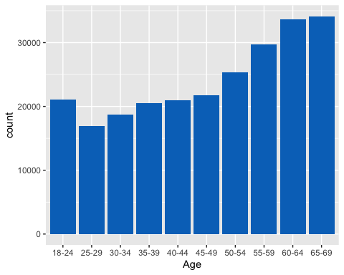

#Using scatter plot to show the correlation between MentalHealth and BMI  
ggplot(aes(x=MentalHealth,y=BMI),data=data_foruse)+  
 geom_point(alpha=1/500)

