CQV-SWR - 508
Digital Standing Wave Meter
Introduction:
*200w digital standing wave meter
* Direct reading of multiple parameters of forward and reverse power standing waves
*4.3-inch IPS color LCD display (resolution 480*272)
*High standing wave alarm function (standing wave alarm point can be customized)
*Delayed shutdown function (shutdown time can be customized)
*Launch auto-start function
*Battery under-voltage protection function
*Simulate progress bar function
*Power fine-tuning function (±20%)
*Standing wave fine-tuning function (±20%)
*Chinese menu (foreign trade version English menu)
1. Technical specifications
*Operating frequency: 1.8-54Mhz
*Measurement range: 0.5-200W (it is recommended not to exceed 120w for long-term use in FM, CW, AM, FT8 modes)
*Standing wave range: 1-99.9 (default alarm is greater than 2.0, the alarm point can be manually set through the menu)
*Charging interface: Type_c DC5v/1A (charging voltage max5.5v)
*Battery model: 3.7v/4000mAh (the battery voltage will flash when the battery voltage is lower than 3.4v and the alarm will automatically shut down when the battery voltage is lower than 3.35v)
*Interface type: UHF (SL16)
*Casing size: 132mm*100mm*82mm (excluding protruding parts)
*Bare metal weight: about 800 grams
2. Interface description

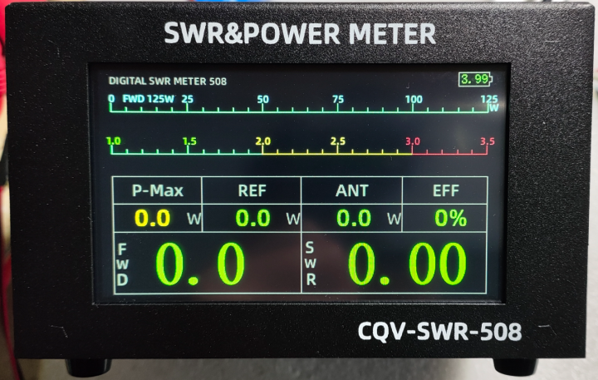
1
100
8
9
2

3
4

5

7
6

- Gear display: 25W/125W/250W
- Power progress bar: indicates current power
- Standing wave progress bar: indicates the current standing wave
- Maximum power: the maximum power of the radio when transmitting (hold for 2 seconds)
- Forward power: the transmitting power of the radio
- Reflected power: The signal power reflected back to the radio station due to poor matching
- Antenna power: forward power minus reflected power.
- Standing wave ratio: the ratio of reflected power to forward power
- Antenna efficiency: percentage of antenna power and forward power
10. Battery voltage: current battery voltage value

3
2
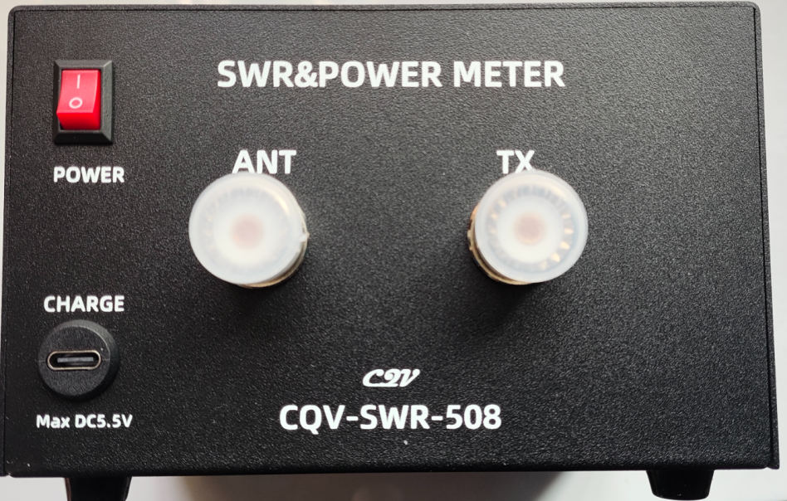
1

4

- Power switch: I press to turn on, O press to turn off (hard switch)
- ANT: Connect the antenna
- TX: Connect to the radio
- Charging port: type_c interface, input voltage DC Max 5.5v, current greater than 1 amp.
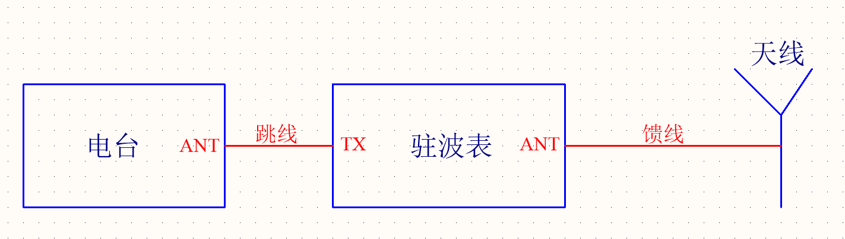
3. Connection diagram

Radio station Jumper wire Standing wave meter feeder Antenna

4. Display menu description

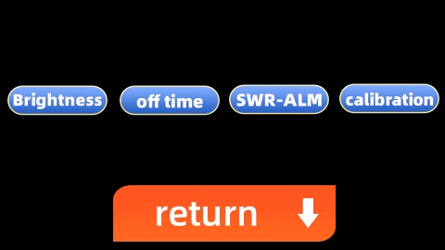
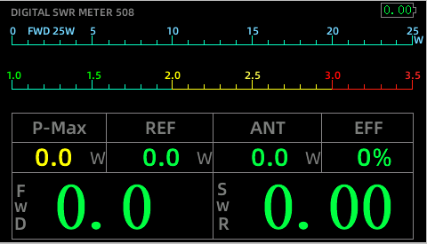

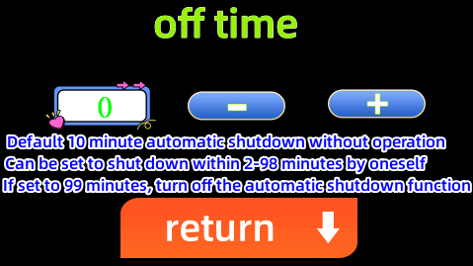
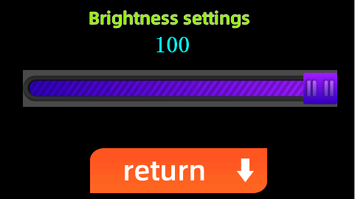

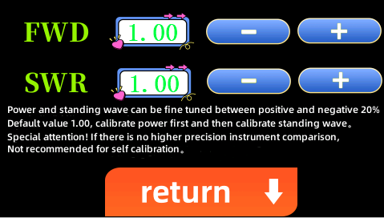
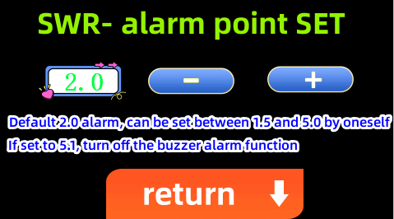

5. Function description
- Turn on the power switch and enter the work interface. The default setting is 25w when the power is turned on. If the transmission power exceeds 25w, it will automatically switch to the appropriate level. In order to avoid the gears jumping back and forth, the software is set to only upshift and not downshift (the default is to turn the power off and on again. 25w gear, return to the default 25w gear after operating the menu).
- Touch the screen on the work page to enter the menu setting interface.
- Brightness setting interface: Drag the slider to adjust the brightness, move to the left to decrease the brightness, the minimum brightness is 1; move to the right to increase the brightness, the maximum is 100, click Return to save the adjusted brightness and return to the menu interface.
- Shutdown time setting interface: Click the "-" sign to shorten the automatic delayed shutdown time, to a minimum of 2 minutes; click the "+" sign to increase the delayed shutdown time, up to 98 minutes. Note that if it is set to 99 minutes, the automatic delayed shutdown function will be turned off. Clicking Return will save the shutdown time and return to the menu interface.
- Standing wave alarm point setting interface: click the "-" sign to lower the alarm point, the lowest is 1.5; click the "+" sign to increase the alarm point, the highest is 5.0. Note that if it is set to 5.1, the alarm function will be turned off. Clicking Return will save the current set alarm point and return to the menu interface.
- Power fine-tuning: click the "-" sign to reduce the display power, the minimum can be reduced by 20%; click the "+" sign to increase the display power, the maximum increase is 20%,
Standing wave fine-tuning: click the "-" sign to reduce the display power, the minimum can be reduced by 20%; click the "+" sign to increase the display power, the maximum increase is 20%
Clicking Return will save the current setting value and return to the menu interface.
Note: Calibrating the power will affect the standing wave. You must calibrate the power first and then calibrate the standing wave. Without higher-precision equipment, there is absolutely no need to calibrate yourself.
7. Charging: Using a branded mobile phone charger and a high-quality data cable can shorten the charging time. Note that some fast charging heads do not match and may have no output and cannot be charged. You can change a few more charging heads or connect to a computer USB port for charging. The voltage icon will appear during charging. turns red, and the voltage icon is green when not charging. (The power consumption of the LCD screen is relatively large, and the power may not be fully charged when it is turned on. As long as the voltage display is greater than 4.2v, the charger can be disconnected. After the power is turned off, the charger can be connected to charge normally, but there is no display. It is recommended not to use it for a long time. Recharge once every six months)
6. Things to note
*The maximum input voltage of the charging port is DC 5.5v. The current is greater than 1A.
*Input power exceeding 120w may cause permanent damage to the standing wave meter. SSB mode can reach 200w in a short period of time.
* After delaying automatic shutdown and entering sleep mode, it will automatically turn on when connected to a charger or radio transmitter. Pay special attention to that if you turn off the rear switch in sleep mode, you must wait for 1 minute before it can be turned on normally (the standby current in sleep mode is microampere level) Yes, although the switch is turned off, the electricity stored in the internal capacitor will remain in the sleep mode. You have to wait until the electricity in the capacitor is discharged before exiting the sleep mode. The power consumption in the sleep mode is very low. You can use it for a long time without turning off the switch on the back.)
*Due to continuous version upgrades, the color of the appearance and interface layout will not be changed without further notice.

8. Warranty instructions
Amateur DIY items, performance, description, cannot be compared with regular industrial products, nor does it bear any guarantee or joint liability. If you don't mind, please don't bother, but we provide lifelong after-sales service, and you are responsible for the return shipping. LCD screen, battery, casing, M Consumable parts such as seats are not covered by the warranty.

9. Update instructions
2024.1.8
Initial version number V1.0

By：BG5CQV

73!

