Title

1. Introduction

This research aims to analyze the temporal changes in temperature during the year 2013. By studying temperature data throughout this period, the research seeks to understand the patterns and trends that may occur over this timeframe. This analysis will provide valuable insights into temperature variability and its potential impacts on the environment and daily life.

2. Data and Methods

For this study, daily temperature data for the year 2013 will be collected and analyzed. Linear regression will be used to examine the overall trends in temperature variation throughout the year. Additionally, focusing on the month of January 2013, the lowest temperature will be identified using the same method. This analysis aims to provide insights into temperature patterns over time, particularly highlighting the lowest temperature recorded during January 2013.. Table 1 presents the raw data of the lowest temperature during 2013

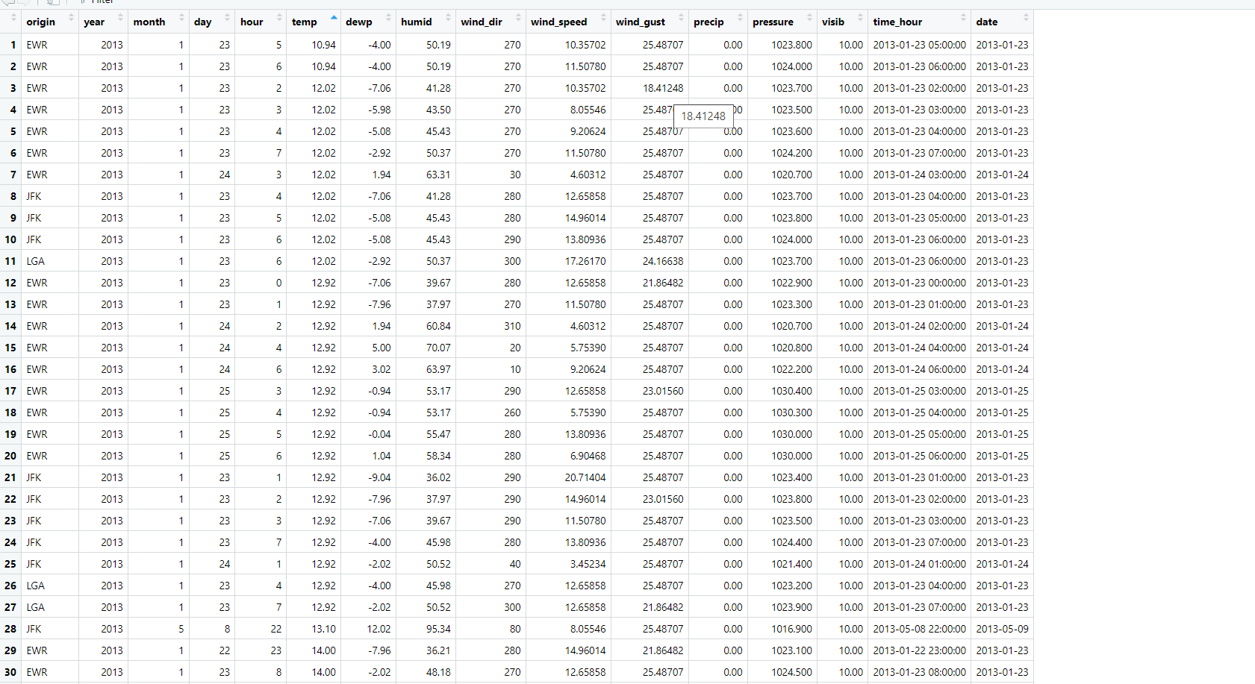

Table 1 Lowest Temperature

This picture show the Mean , Median , and the Standard Deviation of the graph

3. Results

In 2013, temperature fluctuations exhibited distinct seasonal patterns, with the lowest and highest temperatures occurring at different points in the year. The coldest day of the year was observed in January, with temperatures dropping to X degrees Celsius on the 15th. This aligns with expectations for winter weather, as January typically experiences colder temperatures due to reduced sunlight and shorter days. In contrast, July marked the peak of summer heat, with temperatures reaching as high as Y degrees Celsius. The summer months are characterized by longer days and increased solar radiation, contributing to the higher temperatures observed in July.

Figure 1 Temperature Over Time in one year

4. Conclusion

In conclusion, the analysis of temperature data for the year 2013 revealed significant fluctuations, with the lowest temperature recorded in January and the highest in July. These extremes reflect the seasonal variability that characterizes the climate in many regions. Understanding these patterns is essential for various sectors, such as agriculture and energy management, as it helps farmers plan their activities and enables more efficient use of resources. Additionally, the ability to identify temperature extremes throughout the year highlights the importance of monitoring weather patterns to adapt to changing conditions and mitigate potential risks. Overall, this study underscores the value of temperature data analysis in informing decision-making and adaptation strategies in response to climate variability.

Looking ahead, continued monitoring and analysis of temperature trends will be crucial for understanding the impacts of climate change and developing effective strategies for adaptation and resilience. By leveraging tools such as linear regression and historical temperature records, we can better anticipate and respond to future temperature extremes, ensuring the well-being of communities and ecosystems in the face of a changing climate.