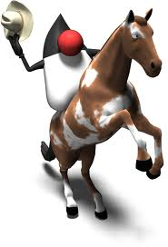

Java Lesson: Processing
Last Updated: 7/9/2025
mr Hanley

Objective: Student will understand that Processing is a version of Java made for simple graphics display. Student will be able to draw simple shapes in Processing such as ovals, rectangles and drawing text to the screen.

Processing is a free graphics library and integrated development environment (IDE) built for the electronic arts, new media art, and visual design communities with the purpose of teaching non-programmers the fundamentals of computer programming in a visual context.
Processing uses the Java programming language, with additional simplifications such as additional classes and aliased mathematical functions and operations. It also provides a graphical user interface for simplifying the compilation and execution stage.
The project was initiated in 2001 by Casey Reas and Ben Fry, both formerly of the Aesthetics and Computation Group at the MIT Media Lab. In 2012, they started the Processing Foundation along with Daniel Shiffman, who joined as a third project lead. Johanna Hedva joined the Foundation in 2014 as Director of Advocacy.
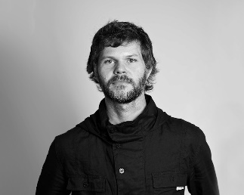  Casey Reas |   Ben Fry

Processing is great because it allows us to draw graphics using java without needing to use a lot of the more confusing java code to adjust the windows and buffers behind the scenes.

Processing is a free download from the Processing Foundation.
Welcome to Processing! / Processing.org
Current Windows Version is 4.4.4 as of 7/9/2025
It usually sits in this folder "C:\Program Files\processing-4.3" or something like it and to run it I double click on the file "C:\Program Files\processing-4.3\processing.exe"

This will launch this screen
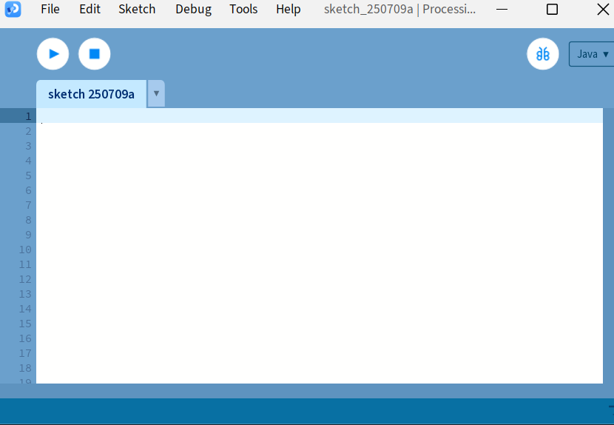
I omitted the console window which shows information at the bottom of the screen.

The two main methods in a processing sketch
Processing Programs are called sketches and they utilize two main methods(you can add your own also)

Warmup.pde (Processing sketches use .pde extension instead of .java)
//My First Warmup Sketch
//Mr Anderson Assignment, draw a line, a box and when the mouse is moved, draw some ovals

void setup(){
size(800,800); //x and y size of the screen
}
void draw(){
background(178, 190, 181); //r, g, b from 0-255
//draw the first line from mr Anderson's
stroke(255,229,28); //color I am drawing in
line(20,30,80,10); //starting x,y and ending x,y
//Now the rectangle
//Set stroke to green
fill(105,190,40); //fill is the inside color of the shape
stroke(255,0,0); //stroke is the border color of the shape
strokeWeight(3); //thickness of border
rect(400,80,25,100); //upp left x, upp left y, width, height (uses stroke and fill)
}
void mouseMoved() { //This is called whenever the mouse is moved in the window
noFill(); //we want an empty oval
stroke(0,0,255); //0 red, 0 green all blue
strokeWeight(2); //pretty thin
circle(mouseX, mouseY, 40); //upper left x, y and then the width/height of bounding
//box(circumference)
}
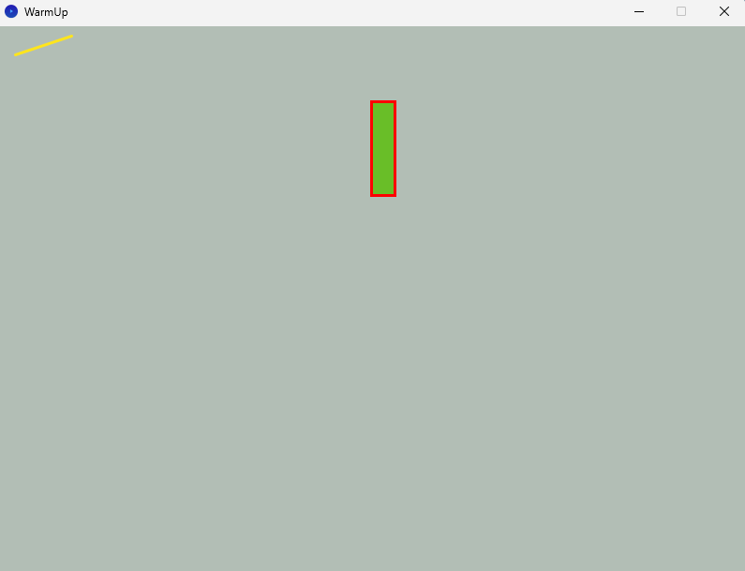

Summary of useful commands

setup: initializes window, usually includes setup(800,700); to indicated windows width and height
fill: sets the color to be used on the inside of shapes
background: sets color of window
stroke: sets color of shape outlines
strokeweight: sets the width of the border for shapes
rect: draws a rectangle with rect(upperleftX,upperleftY,width,height);

circle: draws an oval with circle(upperleftx,upperlefty, diameter);

nofill: sets it so the image is translucent
You try:
Create a sketch (800,700) that makes the background cyan
Draws a black oval at 100,100 that is size 50, 50 and draws a red rectangle with black border (width 5) at 400,400 that is 100 by 150

void setup(){
Size(800,700);
}
Void draw(){
background(0,255,255); //cyan
fill(0,0,0);
circle(100,100,50,50);

//rectangle
stroke(0,0,0);
stokeweight(5);
fill(255,0,0);
rect(400,400,100,150);
}

