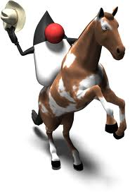

Java Lesson: Overview of Java Programs
FILLED OUT
mr Hanley

Objective: The objective of this lesson is to introduce the student to how a java program runs on a computer. The student should understand how a java program uses variables to keep track of information temporarily during the running of a program.

It is the mission of the java programmer to create a program to serve some particular task or solve a problem.

In order to do this, a programmer must define two major items in their program data and methods.
Examples of data
text message, weight of item purchased at store, gpa, web site

Examples of methods
posting on Instagram, sending text, calculating volume, changing color of a button

Program Logic: Program logic is often created as a step by step process using a flowchart. Here are some common flowchart symbols

Ellipse: Start and End a Process

Rectangle: Processing/calculation

Funky Pencil Thing: Console display

Parallelogram: Input/Output, used for console input using scanner

Diamond: decision making
Java Class: A file which contains data and methods. A class may contain as many variables and methods as are necessary for the problem at hand.

A class is saved and edited in a .java file NOTE: Class name and .java must match EXACTLY, including case.

For example, I created a java program to implement the tax calculation problem in a file called TaxCalc.java

