

Java Lesson: Selection Statements
Last Updated: 2/12/2017
mr Hanley

Objective: The objective of this lesson is to introduce the student to the java commands for choosing between different blocks of code, notably the if statement as well as the relational and logical operators.
Every computer programming language has the ability to select between
____________________
Java offers the one way and two way selection statements in addition to the switch case multiway statement.
Consider the following flowchart:
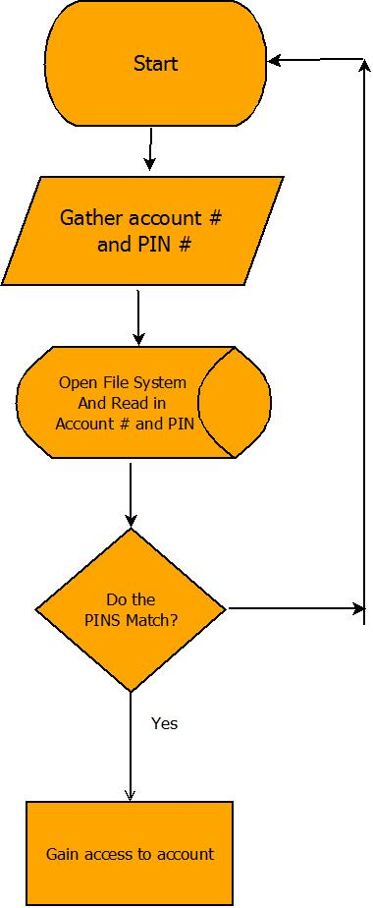
What does this flowchart model?
The if statement

Example1: Assuming you are in a java program with a Scanner object called input created, declare a variable called fTemp (float) and read in the variable from the keyboard. Tell the user via SOPln whether or not the temperature is below freezing.

The if..else statement

Example 2: Assuming you are in a java program with a Scanner object called input created, declare a variable called num (short) and read in the variable from the keyboard. Tell the user via SOPln whether the number is gt 10 or less then or equal to 10.

Example3: When do you need curly braces, what gets printed by the following code fragment?
int cost = 15, given = 18;
if(given >= cost)
System.out.println(“Transaction approved!”);
if(given < cost)
System.out.println(“Insufficient Funds”);
System.out.println(“There is a problem”);

Conclusion:

The relational operators:

The logical operators:

Example4:
double gpa = <some value>
boolean hasInfraction = <true if have received a referral for poor behavior>
int numberTardies = <some value for the number of times late to school>
Write an expression for senior_priv which is true if the student has a 85 or greater, has no infractions and has been tardy at most 3 times
boolean senior_priv =

Reading in and testing Strings:

Example 5: Assigning a letter grade. Read in a number from the keyboard, print out either A, B, C, D or F.

Nested if statements:

Example 6: Read an integer from the keyboard, tell whether it is divisible by 9 and 4, 9 but not 4, 4 but not 9 or neither 9 or 4.
Using Nested Ifs | Using Logical Operators

