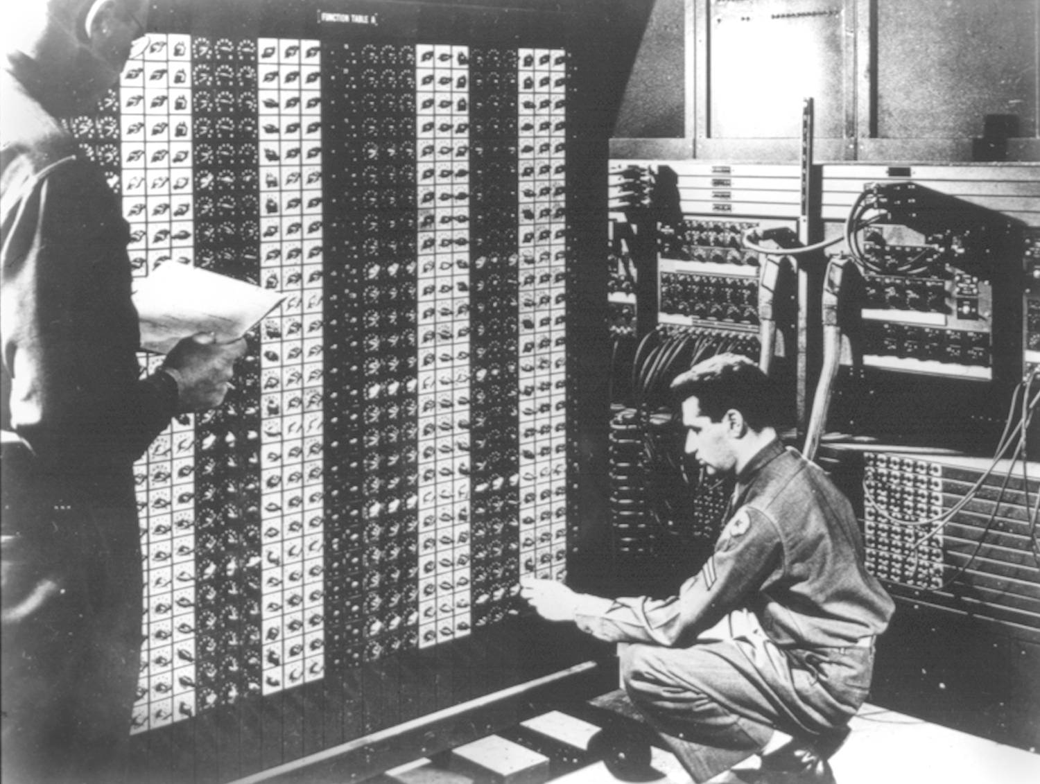 

**Advanced Placement Computer Science**

[**Shenendehowa HS**](http://www.shenet.org/shen-high-school/)[**mr Hanley**](http://hanley.co.nr)

**Unit 4: Object Oriented ProgrammingFILLED_OUT**

**Lesson: Advanced Features Ver 3.0**

***Last Updated:*** *11/13/2017*

Lesson: Parameter Passing Mechanisms

*Last Updated: 100/11001/1100*

In addition to writing classes using private variables and public accessors and mutators, here are 3 common features that are built into classes.

1. Exception Handling: A way of responding to error conditions  
     
   In your class, add the statement throws with a type of Exception  
     
   In your client, add a try catch block  
   java will search for a try catch block in previously called methods
2. static or class variables:  
   variables SHARED by all instances of the class
3. public String toString()   
   represents object as a single string  
   Useful for debugging!!!!

/**

* ---------------------------------------------------------------------------

* S-h-e-n-e-n-d-e-h-o-w-a--H-i-g-h--S-c-h-o-o-l--T-e-c-h-n-o-l-o-g-y--D-e-p-t

* ---------------------------------------------------------------------------

* FILE: RectangleV2.java

* DATE: 11/23/2013

* PURPOSE: Demonstrate the Comparable interface, toString, static

* variables and exception handling

* @author mr Hanley

* @version 1.0

* ----------------------------------------------------------------------------

* h-a-n-l-e-y.c-o-.-n-r------t-e-a-m-2-0-.-c-o-m------------------------------

*/

import java.awt.Color;

import java.awt.Graphics;

public class RectangleV2 implements Comparable {

//++++++++++++++++++++++++++++++++++++++++++++++++++++++++++++++++

//++++++++++++ S T A T I C V A R I A B L E S ++++++++++++++++

//++++++++++++++++++++++++++++++++++++++++++++++++++++++++++++++++

public static int rectCount = 0;//Yo yo yo, this is SHARED BY ALL //RECTANGLESV2

//----------------------------------------------------------------

//---------------- I N S T A N C E V A R I A B L E S ------------

//----------------------------------------------------------------

private int x, y, width, height, rotation; //rotation is 0 deg

private Color outCol, fillColl;

private boolean filled;

private FillType ft;

//////////////////////////////////////////////////////////////////

//////// C O N S T R U C T O R S ///////////////////////

//////////////////////////////////////////////////////////////////

public RectangleV2() {

x = y = 0;

width = 50;

height = 25;

outCol = Color.BLACK;

fillColl = Color.CYAN;

filled = true;

ft = FillType.solid;

rectCount++;  
}

public RectangleV2(Color outColIn, Color fillCollIn) {

x = y = 0;

width = 50;

height = 25;

outCol = outColIn;

fillColl = fillCollIn;

filled = true;

ft = FillType.solid;

rectCount++;

}

public RectangleV2(int xIn, int yIn, int w, int h) {

x = xIn;

y = yIn;

width = w;

height = h;

outCol = Color.black;

fillColl = Color.MAGENTA;

filled = true;

ft = FillType.solid;

rectCount++;

}

//AAAAAAAAAAAAAAAAAAAAAAAAAAAAAAAAAAAAAAAAAAAAAAAAAAAAAAAAAAAAAAAAA

//AAAAAAAAAAAAAAA A C C E S S O R S AAAAAAAAAAAAAAAAAAAAAAAAAAAAA

//AAAAAAAAAAAAAAAAAAAAAAAAAAAAAAAAAAAAAAAAAAAAAAAAAAAAAAAAAAAAAAAAA

//Compareto is based on position, row major

public int compareTo(Object other) {

Rectangle otherR = (Rectangle) other; //typecast

if (y != otherR.getY()) {

return y - otherR.getY();

}

//Else go to the column

return x - otherR.getX();

}

public int getX() {

return x;

}

public int getY() {

return y;

}

public int getW() {

return width;

}

public int getH() {

return height;

}

public Color getOutCol() {

return outCol;

}

public Color getFillCol() {

return fillColl;

}

public int getArea() {

return width * height;

}

public String toString() {

return "[" + x + "," + y + " Width = " + width + " Height = " + height + " Total number of rect= "+rectCount +"]";//Brian

}

public void draw(Graphics g) {

//Draw the first rectangle

//System.out.println("Here");

g.setColor(getOutCol());

//System.out.println("x = "+getX()+"width"+width);

g.drawRect(getX(), getY(), width, height);

g.setColor(getFillCol());

g.fillRect(getX() + 1, getY() + 1, width - 1, height - 1);

}

//MMMMMMMMMMMMMMMMMMMMMMMMMMMMMMMMMMMMMMMMMMMMM

//MMMMMMMMMMMMMMM M U T A T O R S MMMMMMMMMM

//MMMMMMMMMMMMMMMMMMMMMMMMMMMMMMMMMMMMMMMMMMMMM

public void setX(int inX) throws IllegalArgumentException {

if (inX < 0) {

throw new IllegalArgumentException("Bad x value of " + inX);

}

x = inX;

}

public void setY(int inY) {

y = inY;

}

public void setWidth(int w) {

width = w;

}

public void setHeight(int h) {

height = h;

}

}