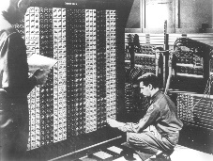 

**Advanced Placement Computer Science**

[**Shenendehowa HS**](http://www.shenet.org/shen-high-school/)[**mr Hanley**](http://hanley.co.nr)

**Unit 6: Arrays/ArrayList**

**Lesson: For Each Loop**

***Last Updated:*** *2/1/2022*

It didn’t take long for programmers to find the need to loop through arrays and ArrayLists and other data structures one element at a time.  
  
To avoid having to use an index, the ________________ was created.

To use it, you must have an Collection or Array  
  
public static void main(String[] args) {

String[] words = {"nihilistic", "apoplectic", "versatile", "juggernaut", "loquacious"};

for(String s: words){

System.out.println(s);

}

//You try.

//Make an ArrayList of the vowels

//Use a for each loop to print to the screen