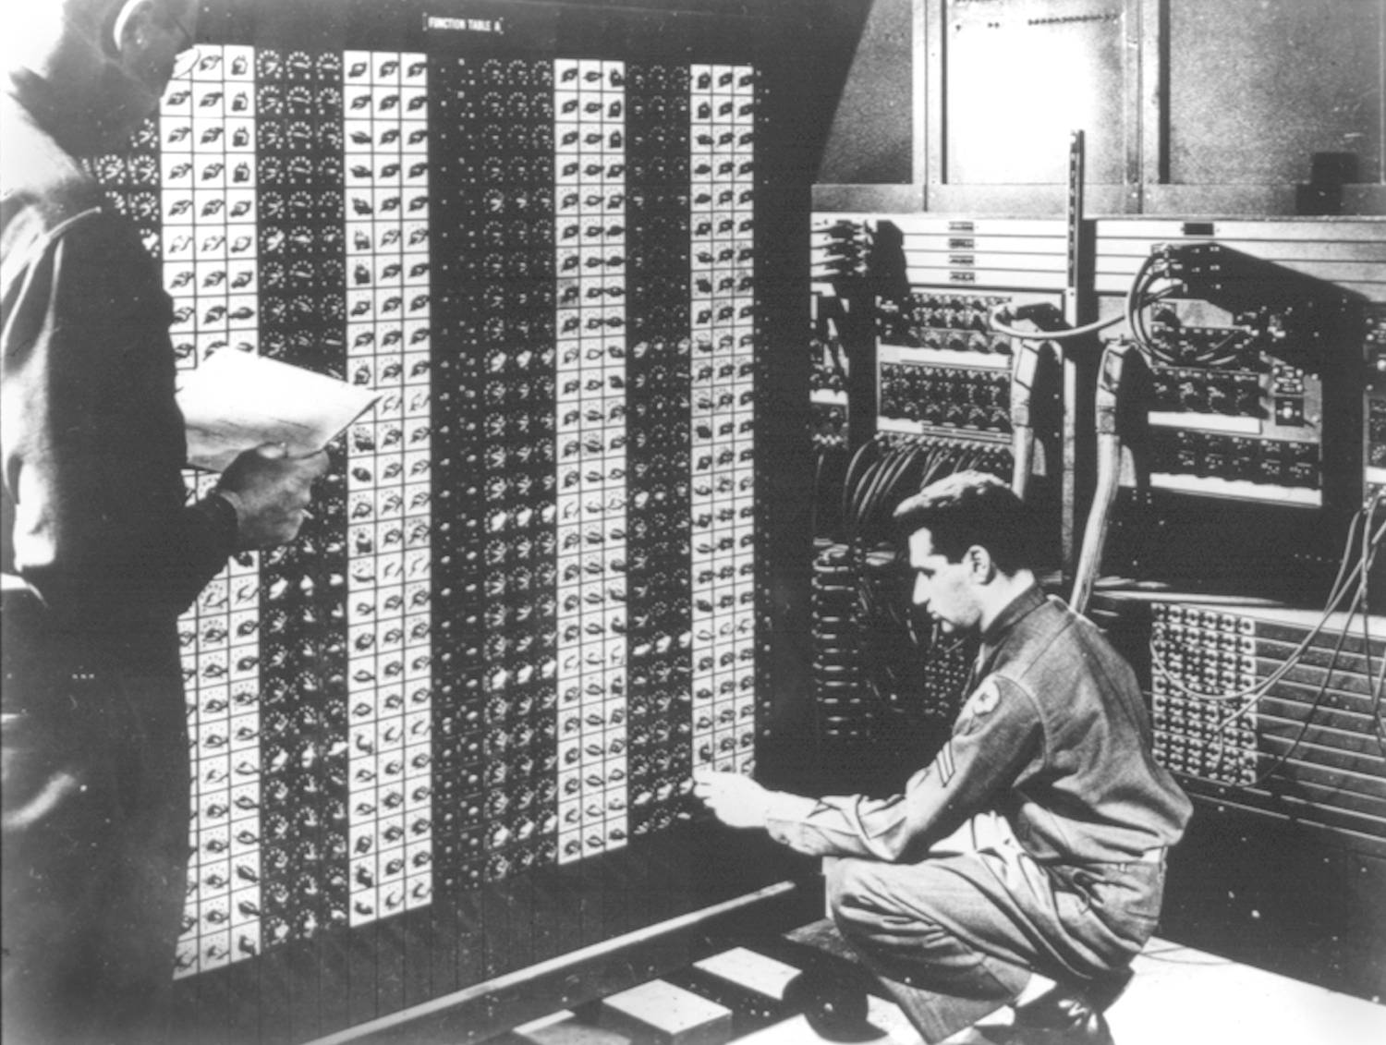 

**Advanced Placement Computer Science**

[**Shenendehowa HS**](http://www.shenet.org/shen-high-school/)[**mr Hanley**](http://hanley.co.nr)

**Unit 4: Object Oriented Programming**

**Lesson: Classes**

***Last Updated:*** *10/24/2017*

Lesson: Parameter Passing Mechanisms

*Last Updated: 100/11001/1100*

Modern programs are often organized into separate ____________________, each with its own responsibilities.

This began in the 1980’s with the desire to recreate more _________________________________

Classes act as software blueprints, allowing programmers to use some classes to create multiple objects, which contain their own ______________________ and _____________________

While there is only one class, one can create multiple ___________________.

|  |  |
| --- | --- |
| Class | Object |
| One definition, contains logic that all objects share. Sometimes called behaviors. | **Can have multiple instances, each has its own unique data. Share all behaviors via the class** |
| Some classes are built on top of existing classes, this is called __________________ | **Executing programs use objects primarily, not classes. Objects send each other messages.** |
|  | **State of an object =  _________________________________________** |

How does a typical class manage information? There are 4 things inside classes

public class SomeClass {

//Variable Section, typically private so only this class can modify  
  
  
 //Constructors, special methods that ____________________________ objects of this type

//NOTE:

public SomeClass() {  
  
  
 }

public SomeClass(String nm) {

}

//Accessors – must be public

//Mutators – must be public

}  
public class UserOfSomeClass {  
 public static void main(String[ ] args) {  
 SomeClass s1 = new SomeClass(); //instanciate an object called s1  
 s1.setName(“Arthur”);  
 s1.setAge(16);  
 System.out.println(s1.getAge());  
 //Use the overloaded constructor to create an object for s2 named “Sara”

//Set her age to 17  
 //Print out her information

}

Access specifiers

**private**

**public  
  
  
protected**What is a constructor?

What is a member variable?  
  
  
  
What are overloaded methods?

For example, the following structure may apply to a java program;

FILE: Client.java  
Contains: main method, which will use 3 Contacts called c1, c2 and c3

main() starts the program and has a main loop

FILE: Contact.java

Contains: no main method, has variables which pertain to a cell phone contact

1. public class Contact { //Represents a cell phone contact (Name and Phone Number)







































42. public class Client {
43. public static void main(String[] args) {







52. }

54) }