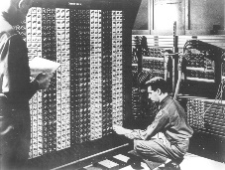 

**Advanced Placement Computer Science**

[**Shenendehowa HS**](http://www.shenet.org/shen-high-school/)[**mr Hanley**](http://hanley.co.nr)

**Unit 9: Recursion**

**Lesson: The coolness that is recursion**

***Last Updated:*** *1/15/2022*

Lesson: Parameter Passing Mechanisms

*Last Updated: 100/11001/1100*

“Men have become the tools of their tools” Henry David Thoreau

A recursive method is

public int factorial(int x)

{

if

return

else

return

}

But how does this work?

Anything that can be done recursively can be done

Factorial Example

public int factorial(int x)

{

}

General Form of a Recursive Function:

Where recursion excels:

Where recursion stinks:

You try:

Write a recursive function to sum the digits of a number

Fibonacci Recursive Function (more than one base case)

See <https://www.youtube.com/watch?v=ahXIMUkSXX0&t=3s> or search fibonacci