[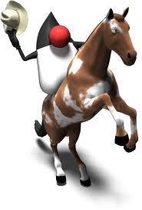](https://www.youtube.com/watch?v=dQw4w9WgXcQ) [](http://www.shenet.org/shen-high-school/)

**Java Lesson: Overview of Java Programs  
Last Updated: 1/6/2017**[**mr Hanley**](http://hanley.co.nr)

**Objective:** The objective of this lesson is to introduce the student to how a java program runs on a computer. The student should understand how a java program uses variables to keep track of information temporarily during the running of a program.

It is the mission of the java programmer to create a program to serve some particular task or solve a problem.

In order to do this, a programmer must define two major items in their program __________________________ and _______________________________.

Examples of

Examples of

Program Logic: Program logic is often created as a step by step process using a flowchart. Here are some common flowchart symbols

**Java Class:** A file which contains data and methods. A class may contain as many variables and methods as are necessary for the problem at hand.

A class is saved and edited in a .java file NOTE: Class name and .java must match EXACTLY, including case.

For example, I created a java program to implement the tax calculation problem in a file called TaxCalc.java