[](https://www.youtube.com/watch?v=dQw4w9WgXcQ) [](http://www.shenet.org/shen-high-school/)

**Java Lesson: Data Types/Vars  
FILLED OUT**[**mr Hanley**](http://hanley.co.nr)

**Objective:** The objective of this lesson is to introduce the student to data storage inside computer programs. The student should know that; all data in a computer is stored in a binary format (either 1’s or 0’s), numbers are stored as either integers or floating point values, there are booleans and chars, which are integers that represent an ASCII code. Student should know that a series of ASCII codes (array) make up a String. Student should be able to declare and assign these types of variables.

Information in a computer is stored in a digital format.  
  
Computers spend all day interacting with data; crunching numbers, transferring web sites from servers to clients, rendering 3D images of buildings and space ships.

Programmers must know how to build a data model to represent the entity they are asking the computer to process.

We need to know the options for representing data using java.

First, computers store data as a series of on and off states.

These states can be described using the binary number system.

In the binary number system, each digit is a power of 2.

For example, the following sequence of on and off states represents the decimal (base 10) number 23

|  |  |  |  |  |  |  |  |
| --- | --- | --- | --- | --- | --- | --- | --- |
|  |  |  |  |  |  |  |  |
| **27=128** | **26=64** | **25=32** | **24=16** | **23=8** | **22=4** | **21=2** | **20=1** |

What sequence of on/off states would be used to represent the number 2010?

|  |  |  |  |  |  |  |  |
| --- | --- | --- | --- | --- | --- | --- | --- |
|  |  |  |  |  |  |  |  |
| **128** | **64** | **32** | **16** | **8** | **4** | **2** | **1** |

Computers utilize these 4 basic types

1. Integer: Does not allow decimals
2. Floating Point: Allows for decimals
3. boolean: values that can be true or false
4. char: individual codes that represent symbols in ASCII (see chart)

A fifth basic type can be thought of by combining chars using an array  
This type is called a String  
  
Data Type Ranges

Java recognizes the types shown in the table below.

|  |  |  |  |  |
| --- | --- | --- | --- | --- |
| TYPE | CONTAINS | SIZE | MAX | MIN |
| boolean | boolean value | 8 bits | true | false |
| char | Unicode char | 16 bits | \uFFFF | \u0000 |
| byte | signed integer | 8 bits | 127 | -128 |
| short | signed integer | 16 bits | 32767 | -32768 |
| int | signed integer | 32 bits | 2147483647 | -2147483648 |
| long | signed integer | 64 bits | 8.223372 E +18 | -9.223372 E +18 |
| float | floating point | 32 bits | 3.402823 E +38  1.402398 E -45 | -3.402823 E +38  -1.402398 E -45 |
| double | floating point | 64 bits | 1.797693 E +308  4.940656 E -324 | -1.797693 E +308  -4.940656 E -324 |

Here are some variable naming rules;

1. No spaces
2. Can’t start with a number
3. No java keywords

It is good practice to name your variables starting with lowercase and using Camel case afterwards (capitalizing each new word)

Example int hoursWorked;

boolean hasGraduated;  
Let’s practice declaring and assigning variables  
public class VarPractice {  
 public static void main(String[] args) {  
 //Declare variables to hold hourly salary at taco bell and assign 8.25

float hourlySal = 8.25;  
  
 //Declare the variables necessary in the following problems

1. Declare variables and assign values to store 5 temperatures that can range from –15 to 120 and can have fractional parts(decimals).  
   double temp1, temp2, temp3, temp4, temp5;
2. Store 5 different temperatures  
   temp1 = -13;  
   temp2 = 15.8;  
   temp3 = -97.68;  
   temp4 = 21.6;  
   temp5 = 34.6;
3. Declare another variable that can store decimals and assign into it the average of the 5 temperatures from above.  
   double avg = (temp1 + temp2 + temp3 + temp4 + temp5)/5.0;
4. Declare a variable that can store the amount of money that bananas cost per pound($ and cents)  
   float costBanLb = .49;
5. Declare a variable that can store the number of lbs of bananas a person will purchase (fractional possible)  
   float lbsBan = 3.3;
6. Declare and assign a variable the amount of money owed by the banana purchaser by using the variables above  
   float amtDue = costBanLb * lbsBan;
7. Set up boolean variables to keep track of whether or not a student has taken the following courses;   
   Design and Drawing for Production, Design and Drawing for Engineering, Digital Electronics, Computer Integrated Manufacturing, Java and AP Computer Science.

boolean ddp, dde, de, cim, java, apcs; //declaration

1. Assign DDE, DDP, CIM and Java to true and Digital and AP Computer Science to false  
   ddp=true; //these are used as flags to know when something is done or not  
   dde=true;  
   de=true;  
   cim=true;  
   java = apcs = false; //can assign multiple variables in one line if same type and are assigning the same value
2. Declare variables to keep track of the number of students in homeroom 134, 129 and 140. Assign them values  
   int hr134, hr129, hr140;  
   hr134 = 30; //124hr is not a valid variable name since it starts with a #  
   hr129 = 27;  
   hr140 = 26;
3. Assign two points and come up with the distance between the points and the midpoint

double x1, y1, x2, y2; //need 4 variables  
x1 = 4.5; y1 = -7; x2 = 8; y2 = 0;  
  
double distance = Math.sqrt ( (x1-x2) * (x1-x2) + (y1–y2) * (y1-y2) );  
double midX, midY;  
midX = (x1+x2) / 2;  
midY = (y1+y2) / 2;

}

}

**THE ASCII TABLE(American Standard Code for Information Interchange)**  
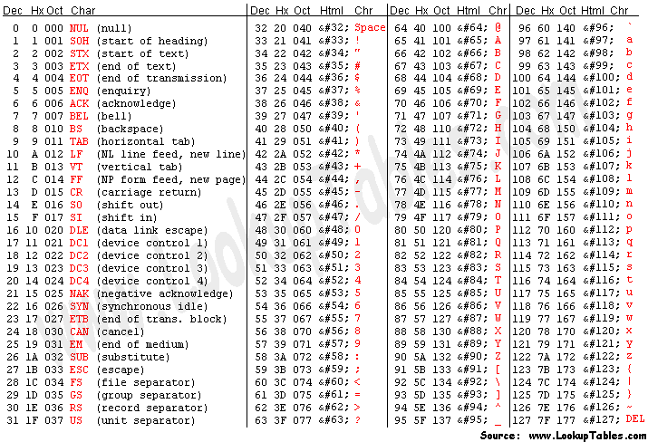

**Extended ASCII (not standard)**

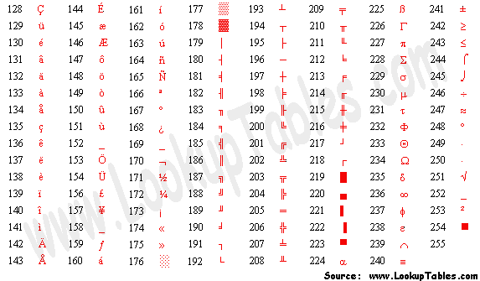

Write out your first name followed by a space and then your last name (capitalize the first letter of your first and last names) Then look up and write the ASCII code for each letter and the space!  
For Example, **m r space H a n l e y**

**109 114 32 72 97 110 108 101 121**