Connor Hanley
LIN 373
Venkat
August 17, 2022
GPT-3 and Esperanto Agglutination
Introduction
Esperanto is a constructed language, made by Dr Ludwik Zamenhof, a Russian-Polish Jew, in 1887. The goal of the language was to create a sort of interlingua between the different ethnic groups surrounding him, and so the language itself is planned to be regular in its grammatical form, to draw vocabulary from a wide-range of European sources, and to be pronounceable by the Average Member of the nearby community. Later on, near the turn of the century, the language became particularly popular with burgeoning new religious movements like Bahai’i, and new emancipatory political projects. One unique feature from Esperanto’s grammar is the ability to create, in a regular way, new words from stems by appending certain suffixes. For example: any word ending in -i is a verb in the infinite form, and any word ending -o is a singular noun, so paroli: “to speak”, parolo: “speech”, paroleto: “small-talk”, parolilo: “speaker”, etc. This rule holds for most words, aside from a special category of words that have a variety of roles: hodiaux/hodiaŭ (“today”), and ankaux/ankaŭ (“also, as well, too”).
Hypothesis and Method
To determine if GPT-3 is able to reproduce this pattern, I devised a small and simple test consisting of two parts. The first, what I call the “prompted” section, involves me listing 3 words in Esperanto, all bearing the same root, and then asking “what is the next word?”:
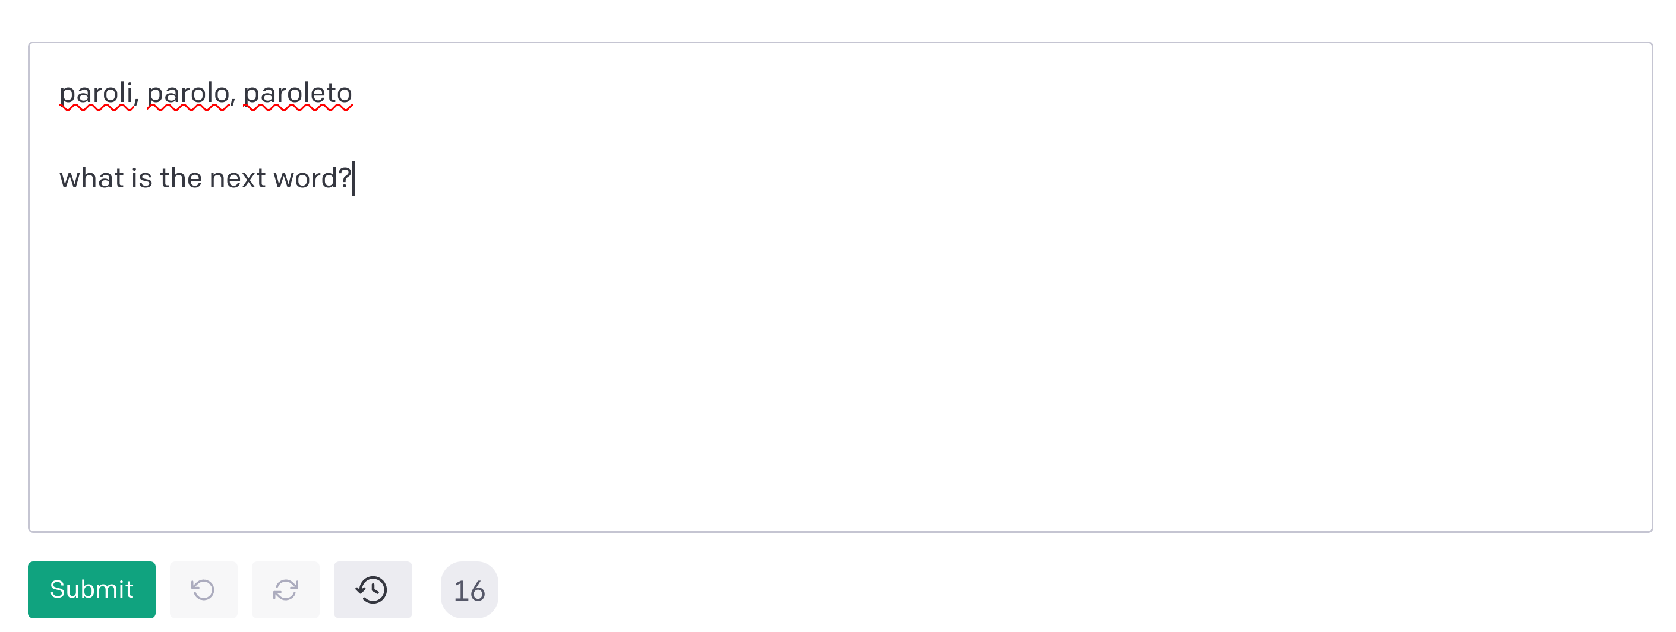
The next step is to simply record the response of GPT-3, so any changes are saved. The second part is what I call “unprompted”. After resetting the text-box, removing any history that might be remembered, I just gave three forms of the word with no question:
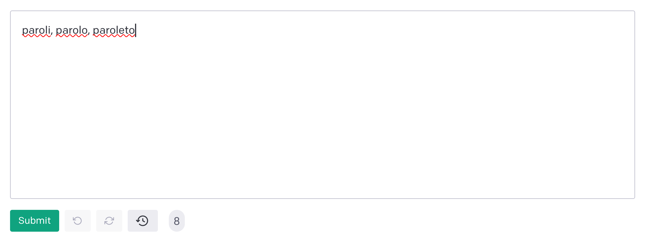

Again, all changes made were recorded.
As noted above, to make the experiment controlled, instead of prompting GPT-3 over time with a series of questions, each new word triplet was accompanied by a complete reset of the terminal, allowing for a fresh start, as this experiment is not testing GPT-3’s ability to learn the agglutination on Esperanto, but rather to test its ability to reproduce agglutination as is. A successful response was any response that: 1) did not repeat a word already given in the prompt (e.g., given “paroli, parolo, paroleto what is the next word?”, GPT-3 responds “paroleto”), and 2) the new word shares the same root with the prompt, but has a different suffix (e.g., given “paroli, parolo, paroleto”, GPT-3 responds “parolanto”).
Out of those which I determined to be successful, I then measured the word based upon it’s probability to appear in a corpus of 2400,nto words, which is used to, firstly: to determine if the word is misspelled using Peter Norvig’s simple spell-checking algorithm (his original contained here, my implementation in the Rust programming language here); and secondly, determine the “rarity” of the word, or an approximation of GPT-3’s ability to produce lexically diverse Esperanto.
Results
WORDS | PROMPTED | UNPROMPT. | WORDS | PROMPTED | UNPROMPT.
baki, bakado, bakaĵo | y | n | idea, ideo, idearo | n | n
celo, cele, celi | n | n | jungi, jungaĵo, jungitaro | n | n
ĉagreni, ĉagreno, ĉagrena | n | n | ĵeti, ĵeto, ĵetadi | y | n
danci, danco, dancado | n | n | kalo, kala, kalaĵo | n | n
eblo, ebleco, ebligi | n | n | labori, laboro, laboristaro | y | n
fabelo, fabela, fabeladi | n | y | maĉo, maĉilo, maĉado | n | n
gajeta, gaje, gajigisto | y | n | nacio, naciado, naciigi | n | n
ĝardenilo, ĝardenisto, ĝardeneto | n | n | obeema, obeo, obeado | n | n
haki, hakilo, hakileto | y | n | vagi, vagadi, vagisto | n | n
ĥimero, ĥimera, ĥimerulo | y | n | zinki, zinkilo, zinkado | n | n
On first glance, these results seem to be disheartening for my hopes that GPT-3 would be able to easily reproduce different word-forms; however, I think that it did very well given the lack of information I gave it in each prompts. GPT-3 was correctly able to produce an non-repeated, novel word formed with the same root but a different suffix 25% of the time given a prompt. It fared even worse in the unprompted portion, producing a an acceptable response only 5% of the time.

