::: recorded reflection :::
winter 2012
vis147 final
a97501672
hanley weng
ta: stephanie lie

:: • ::

concept

Throughout our lives, we hear many fine and complex sounds, but rarely do we listen to them. From the rustle of crickets to our minute interactions and multiple layers of human communication, we have attenuated to sound in a prioritative linear manner - not unlike our perception of time. This undeviating perception of audio and progress is contrastive to our own subconscious minds which biologically evolve, and at any one moment, are a representation of all our past experiences shaping our current perception of the world. For a brief moment; go beyond the four-dimensional constraints we have imposed on ourselves and the universe we reside in and imagine a spherical model of time, viewing even a small instance of this would reveal a speck of the present - encompassing all its historical events, and reflecting all that is being heard, all that has been and hasn’t been heard, and all that has yet to be perceived.

Established here is a passive interaction paradigm for the non-linear exploration of the cacophony of notes that are played throughout the annals of time. Audio is archived in real time in a specific environment. This audio is accumulated, degrading in prominence with time, and played back to those who choose to listen, along with an augmentation of the live sound that brings forth sounds that aren’t normally perceived. Listeners can traverse through the abstract model of time in an environment by speeding, pausing, slowing, and rewinding through it with natural hand gestures (read through a wireless smartphone). Additional spinning and flashing components represent the atmosphere, from the restfulness of a library, to the liveliness of a party - whizzing and flashing in response to the speed of conversation. Like the non-linear model of times, these components affects, and are affected by, its environment and the creatures within, establishing a reciprocative cycle.

Recorded reflections allows one to trace back rare ripples of sound, as ephemeral moments intersect to form the melodies of time.

specifications

functional diagram
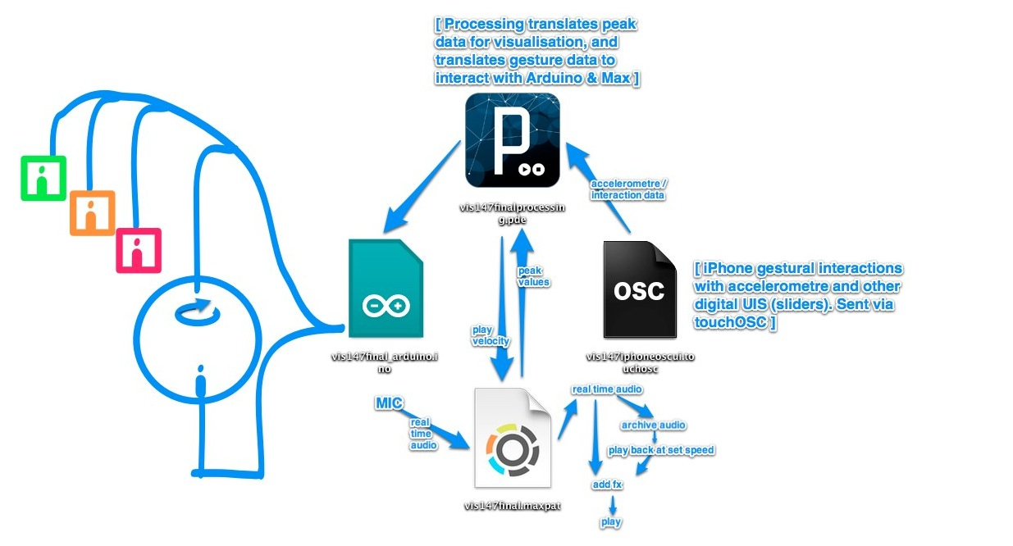

schematic
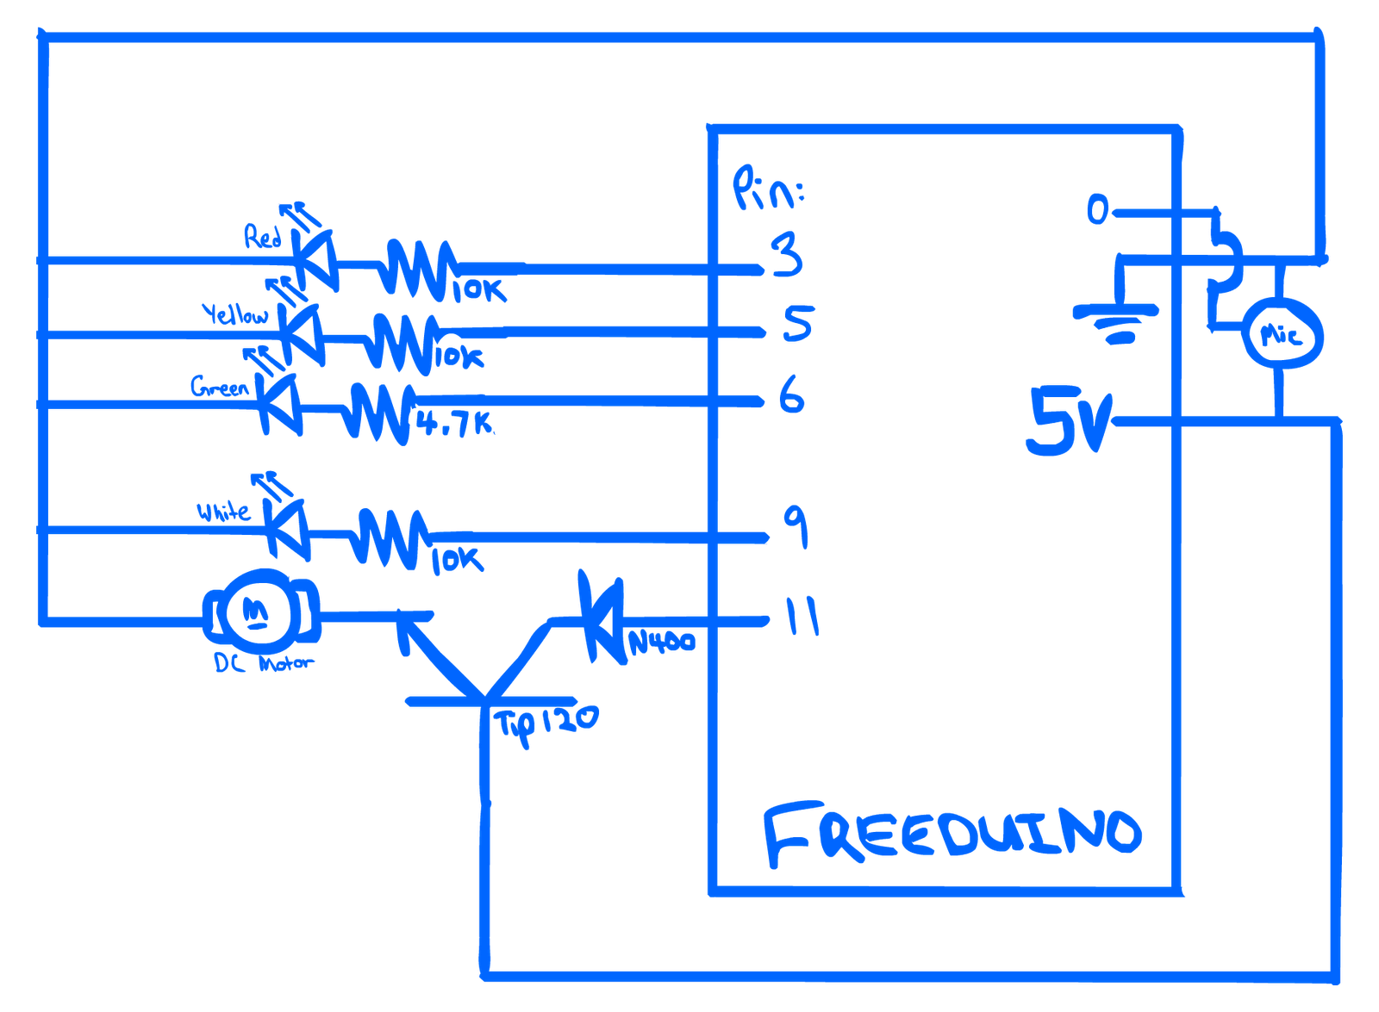

code
[ zip } arduino. processing. touchosc. maxpatch.

documentation

process album
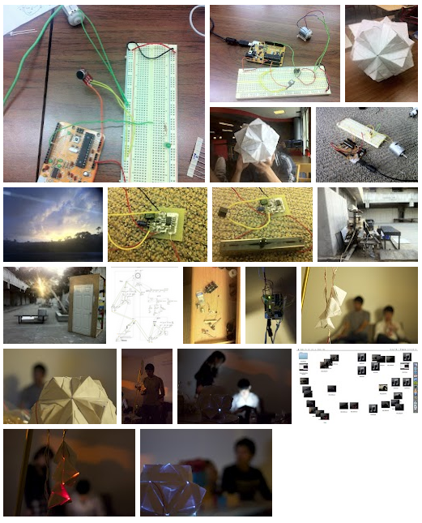
goo.gl/L2IS2

outcome
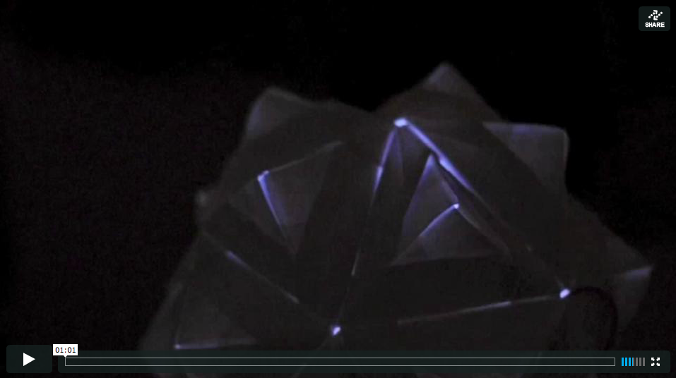
vimeo.com/39046816

audio sample :
goo.gl/M6k2H

:: • ::

