**1 Value-based MADRL**

(1) The joint-reward curve increases gradually during the early episodes, but then it decreases precipitously. The following diagram shows.

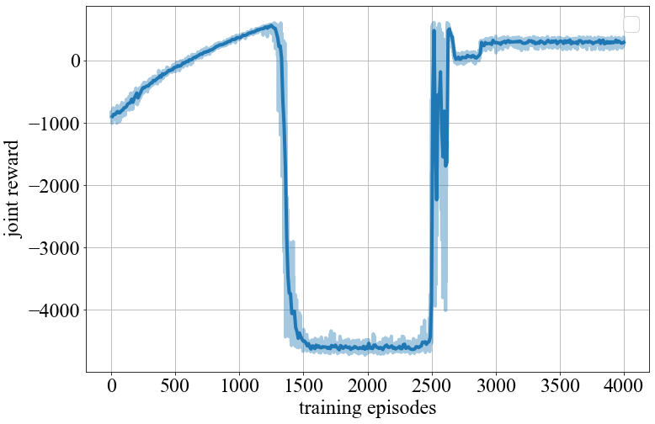

**Possible Reasons**:

* The estimation of state-action values is not accurate.

**Adjustment Methods**:

* Increase the action exploration (to prevent action networks from converging to inaccurate values).
* Decrease the learning rate of action networks (to prevent action networks from converging to inaccurate values).
* Increase the update frequency of target networks (to prevent action networks from converging to inaccurate values).
* Increase networks’ complexity (to enhance networks’ fitting ability)