**Plots**

**Content**: Number of daily Infections (for varying r0, shape_gamma (k), scale_gamma ($θ$))

*Number of days = 30*

$R0=$***0.5 $R0=1$ $R0=$ 2 $R0=$ 4 $R0=8$***

***k = 9, $θ$ = 0.5***

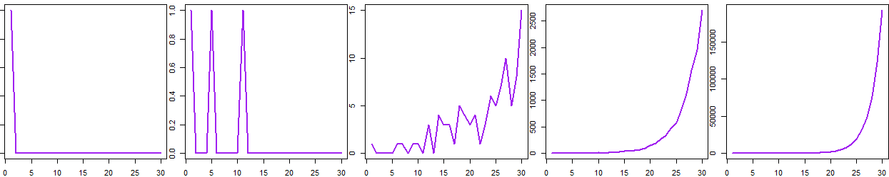

***k = 7.5, $θ$ = 1.0***

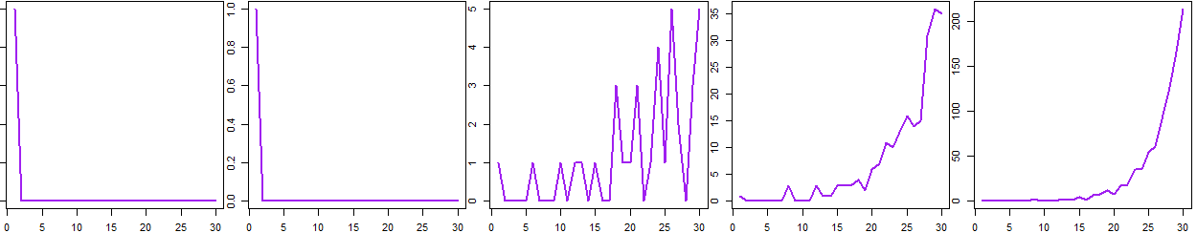

***k = 6, $θ$ = 1.0***

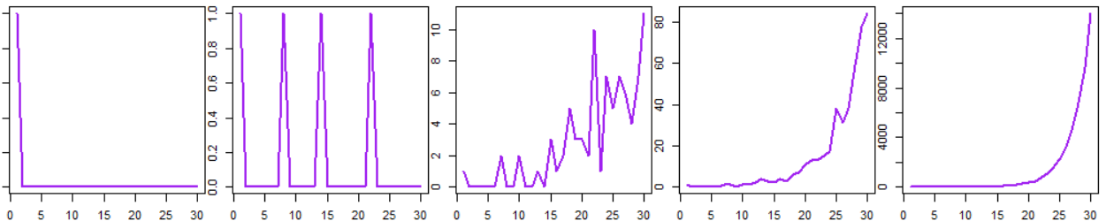

$R0=$***0.5 $R0=1$ $R0=$ 2 $R0=$ 4 $R0=8$***

***k = 3, $θ$ = 2***

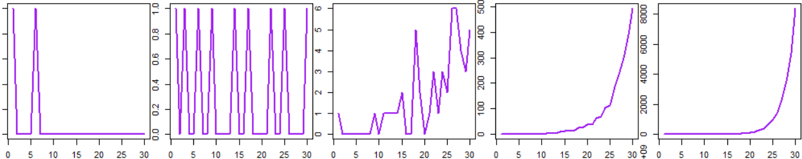

***k = 1.5, $θ$ = 2***

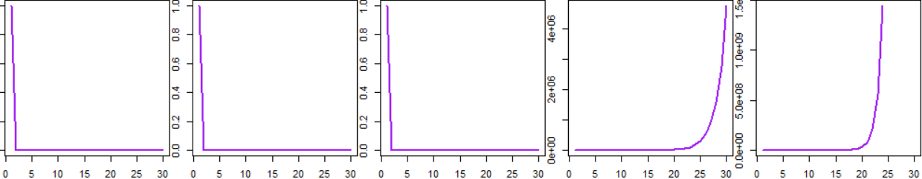

***k = 2, $θ$ = 2***

