Assignment 4 Facade Pattern Report
Online Order Processing Facade
Field | Value
Student | Amirkhan Tulkibayev
Group | SE-2522
Course | Software Design Patterns
Language | Java 17
Pattern | Facade

GitHub repository https://github.com/hann-qaz/Assignment4_facade_pattern
Project summary The project provides a small API for placing and cancelling online orders. The Facade coordinates five independent subsystem classes and performs rollback when payment or shipping fails.

1 Introduction
I chose an online order processing subsystem. Placing one order requires several dependent steps: reserve stock, charge the customer, schedule delivery, save the order, and send a notification. A direct client must know this order and undo completed steps after a failure. OrderFacade instead exposes placeOrder and cancelOrder. It hides internal identifiers and rollback order, while the public subsystem classes remain available to advanced clients.

Client comparison
Without a Facade the client would coordinate every step and every compensation action.
inventory.reserve(orderId, items);
paymentId = payment.charge(orderId, token, total);
shipmentId = shipping.scheduleDelivery(orderId, address);
With the Facade the client states the business action in one call.
OrderResult result = orderFacade.placeOrder(cart, customer);

Responsibilities
Class | Responsibility
OrderFacade | Coordinates the workflow and rollback; exposes the small client API.
InventoryService | Checks stock, creates reservations, and releases reserved items.
PaymentProcessor | Charges payments and records refunds.
ShippingService | Schedules and cancels deliveries.
NotificationService | Sends confirmation, cancellation, and failure messages.
OrderRepository | Stores confirmed orders and updates their status.

2 UML Class Diagram
DemoClient depends on OrderFacade. The Facade holds references to the subsystem services and delegates work to them. The one-way relationships are important: subsystem classes do not store a reference to the Facade and do not know that it exists.
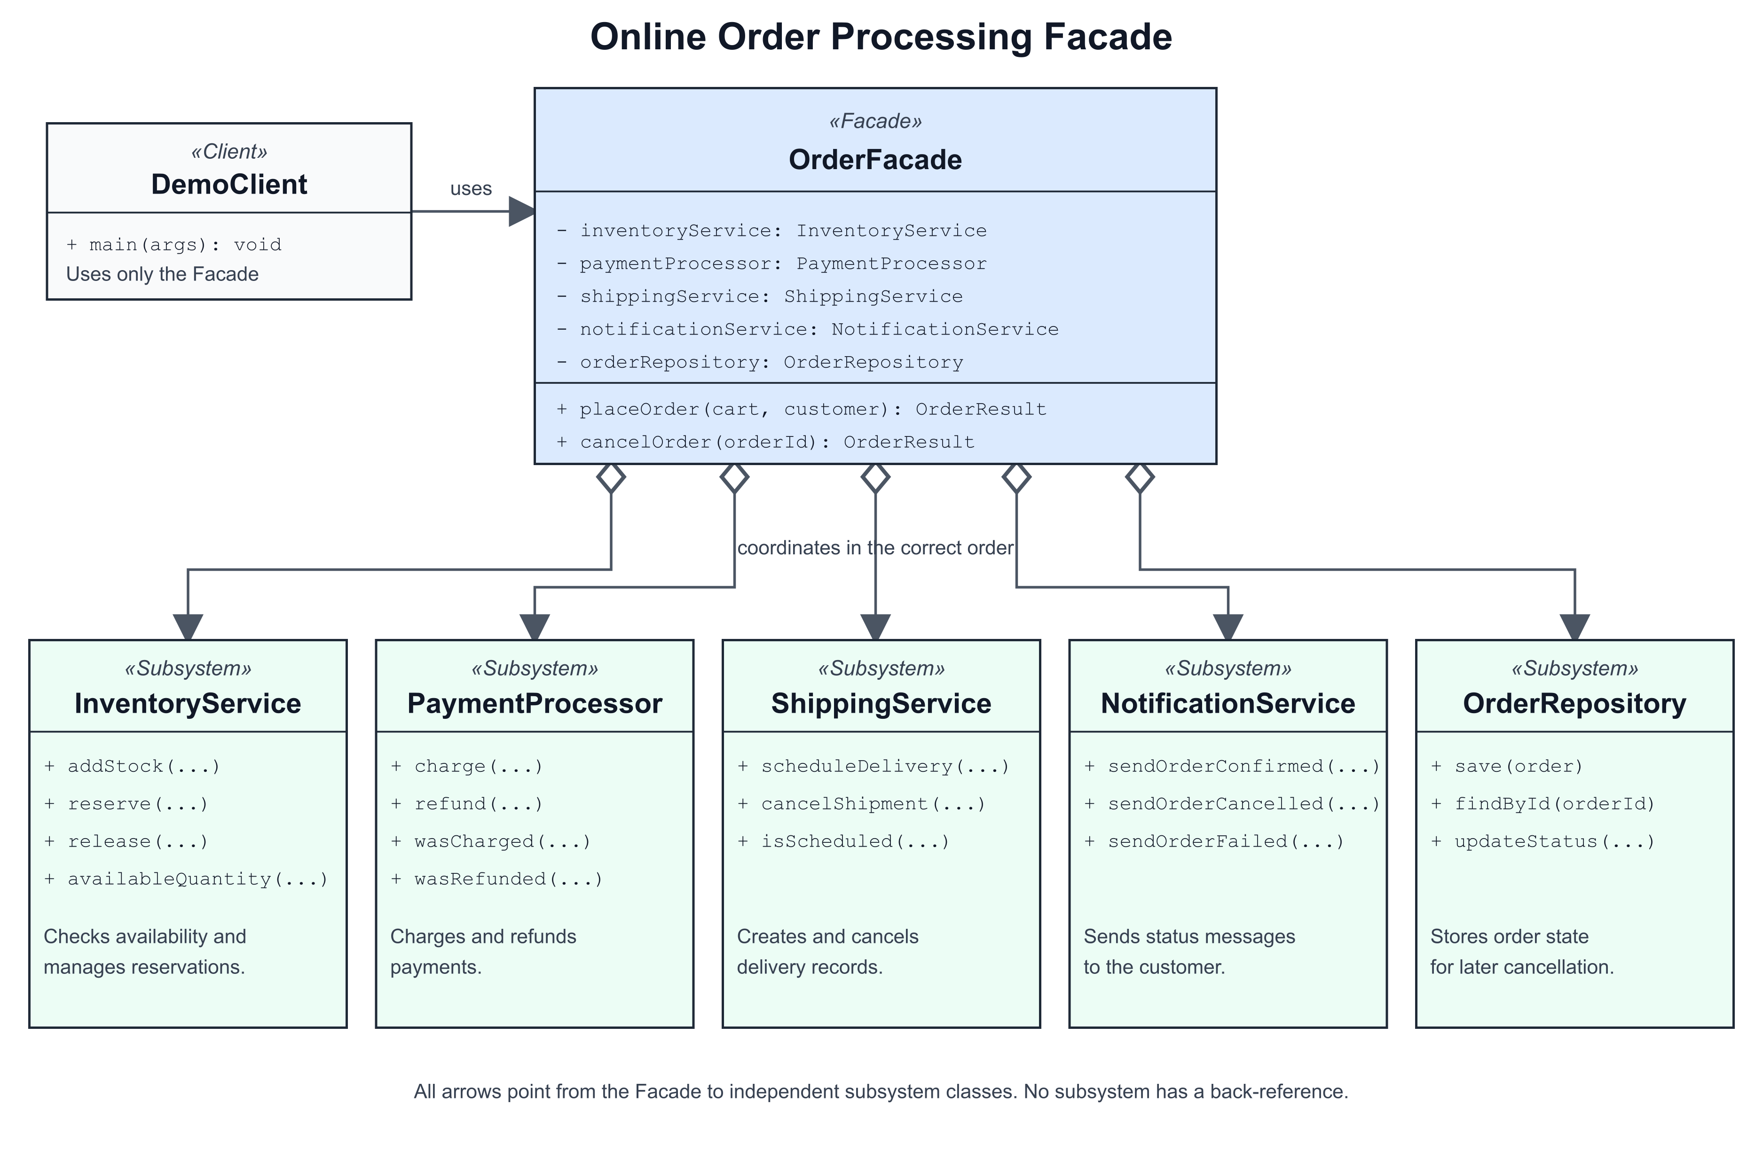
Figure 1 Facade pattern class diagram

Workflow and rollback
Situation | Facade action
Success | Reserve stock, charge payment, schedule shipping, save order, notify customer.
Insufficient stock | Stop before payment and notify the customer.
Payment declined | Release the stock reservation and notify the customer.
Shipping failed | Refund payment, release stock, and notify the customer.
Cancellation | Cancel shipping, refund payment, release stock, update status, and notify.

3 Clean Code Principles
The following principles are visible in the implementation. Each excerpt includes a short annotation that explains the design choice.

3.1 Meaningful names
Names describe business actions instead of technical steps. A reader can understand the client code without opening subsystem classes.
OrderResult placedOrder = orderFacade.placeOrder(cart, customer);
// placeOrder states the full business intention.

3.2 Single Responsibility
OrderFacade coordinates the workflow but does not calculate stock, process card data, or create delivery records. It delegates each task.
inventoryService.reserve(orderId, cart.items());
paymentId = paymentProcessor.charge(orderId, customer.paymentToken(), cart.total());
// The Facade coordinates; each service performs its own work.

3.3 No leaking of subsystem details
The public method accepts simple domain objects and returns OrderResult. It does not return PaymentRecord, Shipment, or a repository object.
public OrderResult placeOrder(Cart cart, Customer customer)
// The client receives one stable result type, not subsystem types.

3.4 Small focused subsystem classes
Each subsystem class has one clear reason to change. For example, payment rules can change without changing inventory or notification code.
public String charge(String orderId, String paymentToken, BigDecimal amount)
public boolean refund(String paymentId)
// PaymentProcessor contains payment operations only.

3.5 Explicit error handling and rollback
Known subsystem failures are handled where coordination happens. Completed steps are compensated in reverse order so the system does not keep money or stock after a failed delivery.
catch (ShippingException exception) {
paymentProcessor.refund(paymentId);
inventoryService.release(orderId);
return failOrder(customer, orderId, exception.getMessage());
}
// Refund and release restore a consistent state.

4 Testing
Seven JUnit 5 tests verify the normal workflow, the rollback paths, and important edge cases. Each test creates fresh in-memory services, so the tests are fast, independent, repeatable, and self-validating.
Test scenario | Expected result
Successful order | All subsystem results and the confirmation are correct.
Payment declined | Stock is restored; shipping is not scheduled.
Shipping failure | Payment and stock are restored.
Insufficient stock | Processing stops before payment.
Cancellation | Resources are restored and status becomes cancelled.
Second cancellation | The request is rejected without repeated rollback.
Repeated product lines | Combined quantity is checked before reservation.

5 Conclusion
OrderFacade simplifies a real multi-step subsystem into two client methods. It hides construction order, service call order, internal identifiers, persistence steps, notification selection, and rollback. The Facade does not replace or block the subsystem. InventoryService, PaymentProcessor, ShippingService, NotificationService, and OrderRepository remain independent and directly accessible when an advanced client needs lower-level control.
This design follows the lecture definition of Facade: a unified, higher-level interface makes a set of subsystem interfaces easier to use while reducing client coupling.

Repository
https://github.com/hann-qaz/Assignment4_facade_pattern

References
- Assignment 4 Facade Pattern Instructions
- Lecture 6 The Facade Design Pattern

