Assignment 5 Strategy Pattern Report
Navigation Route Planning
Student Amirkhan Tulkibayev
Group SE-2522
Course Software Design Patterns
Language Java 17

The project uses interchangeable route algorithms and demonstrates runtime strategy switching without transport-selection branches in the Context.

1 Introduction
This project applies the Strategy pattern to route planning. I implemented four interchangeable ways to plan the same trip: car, walking, bicycle, and public transport. Every algorithm receives the same RouteRequest and returns a RoutePlan, but each one calculates time with its own speed and extra delay. The client can replace the algorithm while the program is running.

2 UML Class Diagram
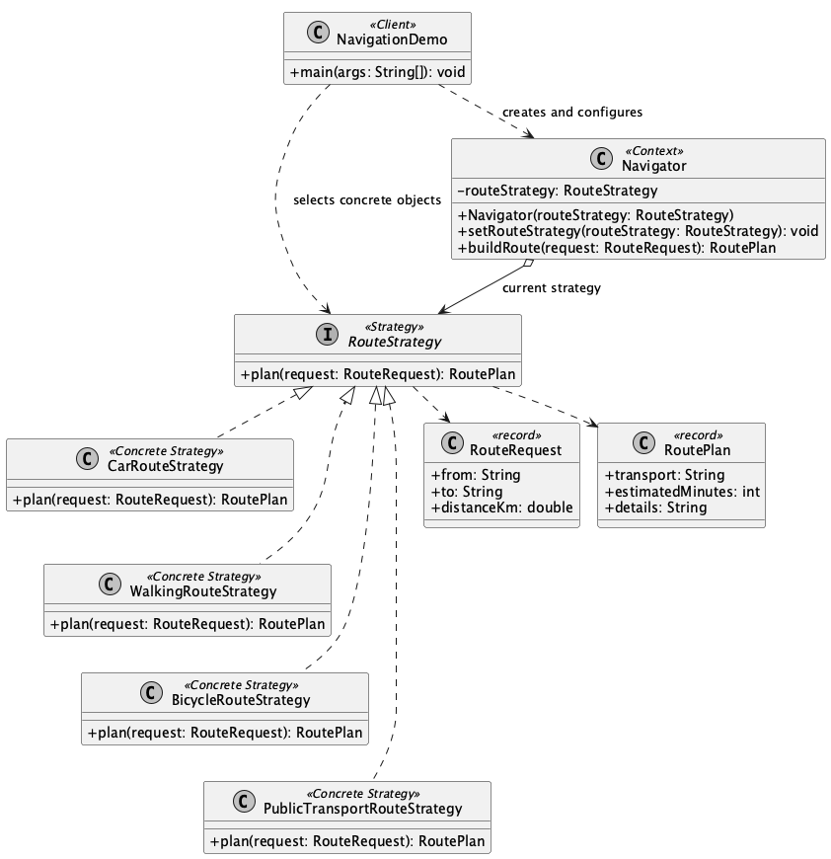
Figure 1 Strategy pattern structure
- RouteStrategy is the common Strategy interface.
- CarRouteStrategy, WalkingRouteStrategy, BicycleRouteStrategy, and PublicTransportRouteStrategy are Concrete Strategies.
- Navigator is the Context. It stores a RouteStrategy reference and delegates route planning.
- NavigationDemo is the Client. It creates strategies and switches them at runtime.

3 Clean Code

3 1 Polymorphism Replaces Strategy Selection Conditionals
Before
switch (transportType) {
case "car" -> calculateCarRoute(request);
case "walk" -> calculateWalkingRoute(request);
case "bicycle" -> calculateBicycleRoute(request);
}
After
public RoutePlan buildRoute(RouteRequest request) {
return routeStrategy.plan(request);
}
Navigator delegates through the common interface, so it has no conditional logic for choosing an algorithm. The if statements in RouteRequest only validate input; they do not select a strategy.

3 2 Meaningful Names Reveal Intent
Before
class TypeA { Result doIt(Data x) { ... } }
After
class WalkingRouteStrategy implements RouteStrategy {
public RoutePlan plan(RouteRequest request) { ... }
}
WalkingRouteStrategy, RouteRequest, estimatedMinutes, and buildRoute explain the domain without extra comments.

3 3 Each Class Has One Responsibility
Before
class Navigator {
// car + walking + bicycle + bus formulas
}
After
public class BicycleRouteStrategy implements RouteStrategy {
public RoutePlan plan(RouteRequest request) {
// only the bicycle calculation
}
}
Each Concrete Strategy owns one route algorithm. Changing bicycle speed cannot affect the walking or car calculation.

3 4 The Context Is Algorithm Agnostic
Before
private final CarRouteStrategy strategy = new CarRouteStrategy();
After
private RouteStrategy routeStrategy;
public void setRouteStrategy(RouteStrategy routeStrategy) {
this.routeStrategy = Objects.requireNonNull(routeStrategy);
}
Navigator depends only on the RouteStrategy interface. It does not know concrete strategy types or their formulas.

3 5 The Design Is Open for Extension
Before
case "bus" -> calculateBusRoute(request);
After
public class PublicTransportRouteStrategy implements RouteStrategy {
public RoutePlan plan(RouteRequest request) { ... }
}
Public transport was added as a separate class. Navigator, RouteStrategy, and the existing strategies did not change. The Client only passes the new object to the Context.

4 Strategy and State
The course comparison asks a useful question. Strategy answers which algorithm should perform a task, while State answers which lifecycle stage an object is in. In Strategy, the caller or configuration normally chooses the behavior. In State, the Context or a state object usually controls transitions and changes how events are handled.
This navigation problem needs Strategy because car, walking, bicycle, and public transport are alternative algorithms for one trip. They are not ordered stages, there are no transition rules, and the caller may choose any route method at any time. Runtime switching alone does not make the design State.

5 Conclusion
The Strategy pattern adds several small classes, but it makes the design flexible and easy to test. Navigator stays simple, each algorithm can change independently, and another route type can be added without modifying existing classes. The extra classes are a reasonable trade-off for clear responsibilities and safe extension.

6 GitHub Repository
https://github.com/hann-qaz/Assignment_5_Strategy_Pattern

References
1. Ospanov, Almas. Lecture 7 The Strategy Pattern. Astana IT University, 2026.
2. Bekenov, Yerassyl. Strategy vs State Untangling Two Look-Alike Design Patterns. Astana IT University, 20 October 2026.

