Hanna Toghraee

NEA Project

Application Structure
This application is based on a hierichilal classes.
The parent state class holds the shared infrormation between different pages which is basically the logged in user , logout state and notificatin and reminder that we may need to show on navigation bar of each page.

Database
We use slite as database and have created a dedicated class to handle all database related fundctions.

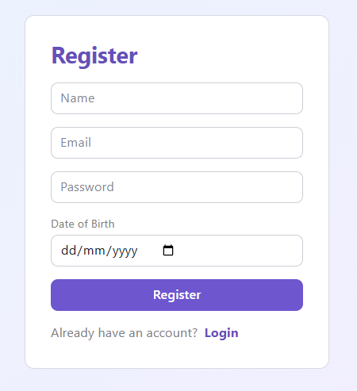
Register
Signup page is the first place that users can register into fitness tracker application.
The register page, collects name , email , password and DOB from users and stores them in the database.

The backend code to handle the register .
We use a class for Register with its own variables and methods.
Properties (variables) :
reg_name: str = "" | User’s Name
reg_email: str = "" | Email Address
reg_password: str = "" | Password
reg_date_of_birth: str = "" | DOB
error: str = "" | To handle errors

Methods (functions)
def set_reg_name(self, value: str): | Setter to fill the variable from user’s input
def set_reg_email(self, value: str): | Setter to fill the variable from user’s input
def set_reg_password(self, value: str): | Setter to fill the variable from user’s input
def set_reg_date_of_birth(self, value: str): | Setter to fill the variable from user’s input
def check_already_logged_in(self): | Redirects user to home page if already logged in and have accessed the register page
def handle_register(self): | Main function that handles the registration

The handle_register function does check if all the fields are entered by the user. If not it returns. If they are all entered, it will call the database method to add a user with all parameters that was collected from user. After database add, the current info set to current object propertis
def handle_register(self):
"""Runs when the Register button is clicked."""
self.error = ""
# Basic validation - make sure all fields are filled in.
if not (self.reg_name and self.reg_email and self.reg_password):
self.error = "Please fill in name, email and password."
return
try:
user_id = db.create_user(
password=self.reg_password,
email=self.reg_email,
name=self.reg_name,
date_of_birth=self.reg_date_of_birth or None,
)
except db.DuplicateUserError as e:
self.error = str(e)
return

# Registration successful, so set the user_id and name in the state so that the user is logged in
self.user_id = user_id
self.name = self.reg_name
self.reg_password = ""
return rx.redirect("/home")

Login
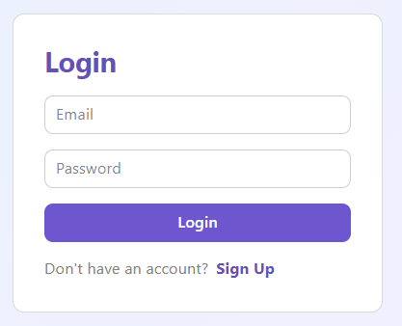
The Login page is where returning users sign back into the fitness tracker application.
The login page collects the email and password from the user, checks them against the database, and if they match it logs the user in and sends them to the Home page.

The backend code to handle the login.
We use a class for Login with its own variables and methods.

Properties (variables) :
login_email: str = "" | Email the user types in
login_password: str = "" | Password the user types in
error: str = "" | To handle errors (shown as a red message)

Methods (functions)
def set_login_email(self, value: str): | Setter to fill the variable from user’s input
def set_login_password(self, value: str): | Setter to fill the variable from user’s input
def check_already_logged_in(self): | Redirects user to home page if they are already logged in and open the login page
def handle_login(self): | Main function that handles the login

The handle_login function asks the database to check the email and password. If they don’t match it stores an error message and stops. If they do match, it saves who is logged in (the user_id and name) into the shared State, clears the password from memory, and redirects the user to the Home page.
def handle_login(self):
#Runs when the Login button is clicked
self.error = ""
try:
user = db.authenticate_user(self.login_email, self.login_password)
except db.InvalidCredentialsError as e:
self.error = str(e)
return
# Success: store who's logged in state.
self.user_id = user["user_id"]
self.name = user["name"]
self.login_password = ""
return rx.redirect("/home")

Home Page (Dashboard)
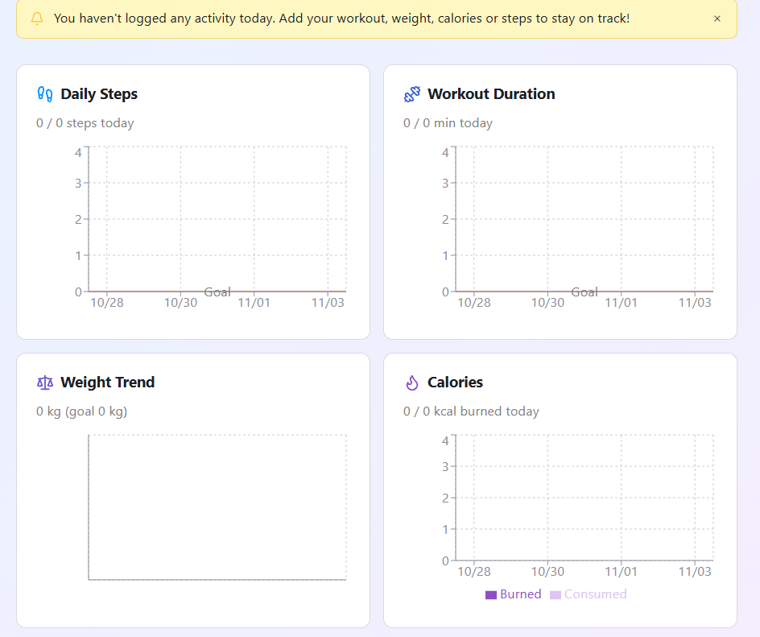
The Home page is the dashboard the user sees once they are logged in. It shows today’s progress against each of their goals and draws charts for historic data.
For each goal type (steps, workout minutes, calories and weight) it shows how far the user has got today compared with their target, and a chart of the recent history.

The backend code to handle the Home page.
We use a class for Home with its own variables and methods.

Properties (variables) :
steps_target / steps_current: float = 0 | Daily step goal and steps logged today
workout_target / workout_current: float = 0 | Workout minutes goal and minutes done today
calories_target / calories_current: float = 0 | Calories goal and calories today
weight_target / weight_start / weight_current: float = 0 | Weight goal, starting weight and current weight
weight_series: list[dict] = [] | Data points for the weight chart
steps_series: list[dict] = [] | Data points for the steps chart
workout_series: list[dict] = [] | Data points for the workout chart
calories_series: list[dict] = [] | Data points for the calories chart

Methods (functions)
def _short_date(iso_date: str) -> str: | Converts “2026-09-13” into “09/13” for chart labels
def load_home(self): | Main function that loads goal progress, chart data and notifications

The load_home function runs every time the Home page is opened. If nobody is logged in it sends the user to the Login page. Otherwise it reads the user’s goals and today’s totals from the database, fills in the progress numbers, builds the data for the four charts, and refreshes the notifications for the bell icon.

def load_home(self):
"""Runs every time the Home page is opened - loads everything the
page needs to display: goal progress, chart data, and notifications.
"""
if self.user_id <= 0:
return rx.redirect("/login")

goals = db.get_goals(self.user_id)
today = date.today().isoformat()
summary = db.get_progress_summary(self.user_id, today)
current_weight = db.get_latest_weight(self.user_id) or 0

# Today's totals are real regardless of whether a goal has been set
# for that metric, so they're always read from the database here.
# Only the *target* (and, for weight, the starting point) depends on
# a Goal row actually existing - those stay at their default of 0
# until the user sets one, which is what makes a card show "x / 0".
self.steps_current = summary["steps_today"]
self.workout_current = summary["workout_minutes_today"]
self.calories_current = summary["calories_burned_today"]
self.weight_current = current_weight

if "steps" in goals:
self.steps_target = goals["steps"]["target_value"]

if "workout_duration" in goals:
self.workout_target = goals["workout_duration"]["target_value"]

if "calories" in goals:
self.calories_target = goals["calories"]["target_value"]

if "weight" in goals:
self.weight_target = goals["weight"]["target_value"]
self.weight_start = goals["weight"]["start_value"] or current_weight

# Build each chart's data by pulling raw rows from the database and
# reshaping them into the {"date": ..., <value>: ...} dicts the
# recharts components expect.
self.weight_series = [
{"date": _short_date(row["date"]), "weight": row["weight_kg"]}
for row in db.get_weight_series(self.user_id)
]
self.steps_series = [
{"date": _short_date(row["date"]), "steps": row["steps"]}
for row in db.get_daily_steps_series(self.user_id)
]
self.workout_series = [
{"date": _short_date(row["date"]), "minutes": row["minutes"]}
for row in db.get_daily_workout_minutes_series(self.user_id)
]
self.calories_series = [
{
"date": _short_date(row["date"]),
"consumed": row["consumed"],
"burned": row["burned"],
}
for row in db.get_daily_calories_series(self.user_id)
]

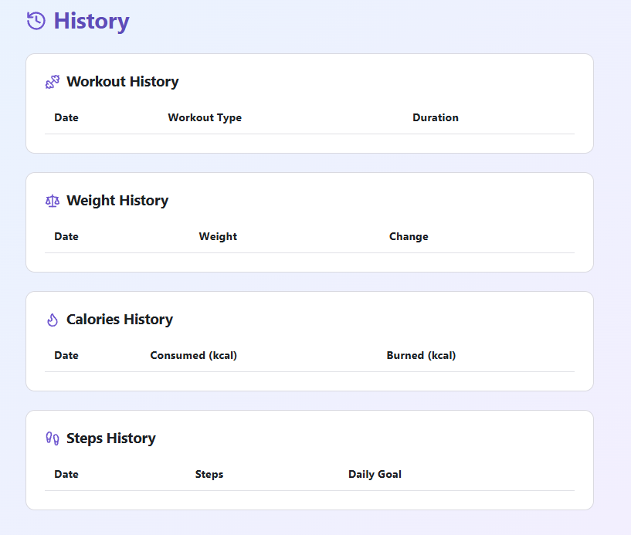
History

The History page shows the user everything they have logged before, split into four tables: Workout, Weight, Calories and Steps.
The weight table also works out the change since the previous entry, and the steps table shows the user’s current daily step goal next to each row for a quick comparison.

The backend code to handle the History page.
We use a class for History with its own variables and methods.

Properties (variables) :
workout_history: list[dict[str, str]] = [] | Rows for the workout history table
weight_history: list[dict[str, str]] = [] | Rows for the weight history table
calorie_history: list[dict[str, str]] = [] | Rows for the calorie history table
step_history: list[dict[str, str]] = [] | Rows for the step history table

Methods (functions)
def load_history(self): | Main function that loads all four histories and formats them for display

The load_history function fetches all four histories from the database and turns the raw rows into display-ready text. The weight history needs a loop because each row is compared with the older one to show the change in user’s weight, and the steps table also looks up the current step goal to show alongside each entry.

def load_history(self):
"""Runs when the page loads - fetches all four histories and turns
the raw database rows into display-ready text.
"""
if self.user_id <= 0:
return rx.redirect("/login")

self.workout_history = [
{
"date": row["date"],
"workout_type": row["workout_type"],
"duration": f"{row['duration_minutes']} min",
}
for row in db.get_workout_history(self.user_id)
]

# The weight table also shows how much the weight changed since the
# entry before it. The rows come back newest-first, so the "previous"
# entry (the older weigh-in) is the next one along in the list.
weight_rows = db.get_weight_history(self.user_id)
weight_list = []
for position in range(len(weight_rows)):
this_weight = weight_rows[position]["weight_kg"]

# Work out the change compared with the older entry, if there is one.
is_oldest_entry = (position == len(weight_rows) - 1)
if is_oldest_entry:
change_str = "-" # nothing older to compare against
else:
older_weight = weight_rows[position + 1]["weight_kg"]
change = this_weight - older_weight
sign = "+" if change >= 0 else "-" # always show the sign, e.g. "+1.2 kg"
change_str = f"{sign}{abs(change):.1f} kg"

weight_list.append({
"date": weight_rows[position]["date"],
"weight": f"{this_weight:.1f} kg",
"change": change_str,
})
self.weight_history = weight_list

self.calorie_history = [
{
"date": row["date"],
# calories_consumed/burned can be NULL if only one was logged that day
"consumed": str(row["calories_consumed"]) if row["calories_consumed"] is not None else "-",
"burned": str(row["calories_burned"]) if row["calories_burned"] is not None else "-",
}
for row in db.get_calorie_history(self.user_id)
]

# The steps table also shows the user's current daily step goal
# alongside each entry, for quick comparison.
goals = db.get_goals(self.user_id)
steps_goal = str(int(goals["steps"]["target_value"])) if "steps" in goals else "-"
self.step_history = [
{
"date": row["date"],
"steps": str(row["step_count"]),
"daily_goal": steps_goal,
}
for row in db.get_step_history(self.user_id)
]

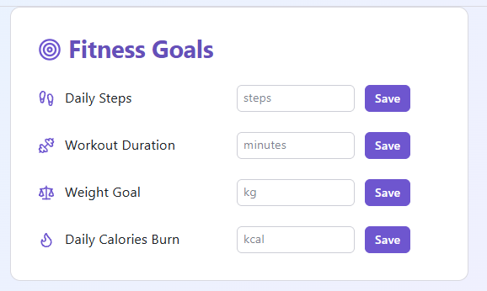
Fitness Goals

The Fitness Goals page lets the user set a target for each of the four goal types: workout duration, weight, calories and steps.
Each goal type has its own input box and its own Save button, so the user can set or change one goal without touching the others.

The backend code to handle the Fitness Goals page.
We use a class for Fitness Goals with its own variables and methods.

Properties (variables) :
workout_duration_goal: str = "" | Target workout minutes the user types in
weight_goal: str = "" | Target weight the user types in
calories_goal: str = "" | Target calories the user types in
steps_goal: str = "" | Target steps the user types in
message: str = "" | Confirmation / error message

Methods (functions)
def set_workout_duration_goal(self, value: str): | Setter to fill the variable from user’s input
def set_weight_goal(self, value: str): | Setter to fill the variable from user’s input
def set_calories_goal(self, value: str): | Setter to fill the variable from user’s input
def set_steps_goal(self, value: str): | Setter to fill the variable from user’s input
def load_goals(self): | Fills each box with the user’s current goal when the page loads
def save_workout_duration_goal(self): | Validates and saves the workout duration goal
def save_weight_goal(self): | Validates and saves the weight goal (also stores the starting weight)
def save_calories_goal(self): | Validates and saves the calories goal
def save_steps_goal(self): | Validates and saves the steps goal

Each save function checks that the number the user typed is a valid positive number, then calls db.upsert_goal() which either creates the goal or overwrites the existing one for that goal type. The weight goal is slightly different because it also records the user’s current weight as the starting point, so progress can be worked out later.

def save_workout_duration_goal(self):
self.message = ""
try:
target = float(self.workout_duration_goal)
except ValueError:
self.message = "Workout duration goal must be a number."
return
if target <= 0:
self.message = "Workout duration goal must be a positive number."
return
db.upsert_goal(self.user_id, "workout_duration", target, None, date.today().isoformat(), None)
self.message = "Goals saved."

def save_weight_goal(self):
self.message = ""
try:
target = float(self.weight_goal)
except ValueError:
self.message = "Weight goal must be a number."
return
if target <= 0:
self.message = "Weight goal must be a positive number."
return
# The weight goal's "start_value" is the user's current weight when
# the goal is set - used later to calculate % progress towards it.
current_weight = db.get_latest_weight(self.user_id)
db.upsert_goal(
self.user_id, "weight", target, current_weight, date.today().isoformat(), None
)
self.message = "Goals saved."

def save_calories_goal(self):
self.message = ""
try:
target = float(self.calories_goal)
except ValueError:
self.message = "Calories goal must be a number."
return
if target <= 0:
self.message = "Calories goal must be a positive number."
return
db.upsert_goal(self.user_id, "calories", target, None, date.today().isoformat(), None)
self.message = "Goals saved."

def save_steps_goal(self):
self.message = ""
try:
target = float(self.steps_goal)
except ValueError:
self.message = "Steps goal must be a number."
return
if target <= 0:
self.message = "Steps goal must be a positive number."
return
db.upsert_goal(self.user_id, "steps", target, None, date.today().isoformat(), None)
self.message = "Goals saved."

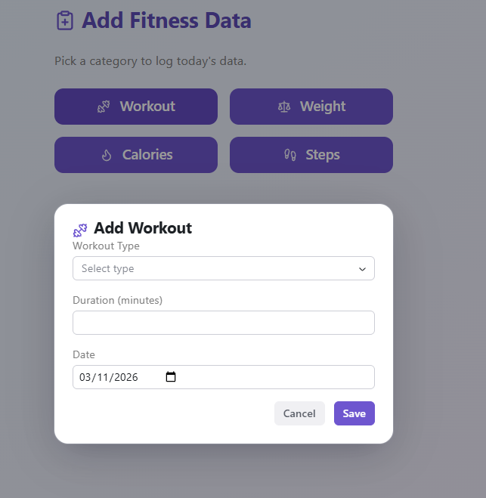
Add Fitness Data

The Add Fitness Data page is where the user records new activity. It has four separate pop-up forms (Workout, Weight, Calories and Steps), each saving to its own table in the database.
Each pop-up has its own open/closed flag, its own input fields, and its own error message, so the forms work independently of each other.

The backend code to handle the Add Fitness Data page.
We use a class for Add Fitness Data with its own variables and methods.

Properties (variables) :
workout_dialog_open: bool = False | Whether the Workout pop-up is open
weight_dialog_open: bool = False | Whether the Weight pop-up is open
calories_dialog_open: bool = False | Whether the Calories pop-up is open
steps_dialog_open: bool = False | Whether the Steps pop-up is open
workout_type / workout_duration / workout_date: str = "" | Fields for the Workout form
weight_value / weight_date: str = "" | Fields for the Weight form
calories_consumed / calories_burned / calories_date: str = "" | Fields for the Calories form
steps_value / steps_date: str = "" | Fields for the Steps form

Methods (functions)
def set_..._dialog_open(self, value: bool): | Open/close a pop-up and clear its old error message
def set_<field>(self, value: str): | Setters to fill each form field from the user’s input
def load_defaults(self): | Pre-fills all four date fields with today’s date when the page loads
def save_workout(self): | Validates and saves a workout record, then closes the pop-up
def save_weight(self): | Validates and saves a weight record, then closes the pop-up
def save_calories(self): | Validates and saves a calories record, then closes the pop-up
def save_steps(self): | Validates and saves a steps record, then closes the pop-up

The save_workout function is a good example of how all four save functions work. It checks that the fields are filled in, makes sure the duration is a valid positive whole number, stores the record in the database, clears the form, and closes the pop-up on success. We also have save_weight, save_steps, save_calories methods that are similar and shown in below.

def save_workout(self):
"""Runs when Save is clicked in the Workout dialog."""
self.workout_message = ""
if not (self.workout_type and self.workout_duration and self.workout_date):
self.workout_message = "Fill in workout type, duration and date."
return
try:
duration = int(self.workout_duration)
except ValueError:
self.workout_message = "Duration must be a whole number."
return
if duration <= 0:
self.workout_message = "Duration must be a positive number."
return
db.add_workout_record(self.user_id, self.workout_type, duration, self.workout_date)
self.workout_duration = ""
self.workout_message = ""
self.workout_dialog_open = False # close the dialog on success

def save_weight(self):
"""Runs when Save is clicked in the Weight dialog."""
self.weight_message = ""
if not (self.weight_value and self.weight_date):
self.weight_message = "Fill in weight and date."
return
try:
weight = float(self.weight_value)
except ValueError:
self.weight_message = "Weight must be a number."
return
if weight <= 0:
self.weight_message = "Weight must be a positive number."
return
db.add_weight_record(self.user_id, weight, self.weight_date)
self.weight_value = ""
self.weight_message = ""
self.weight_dialog_open = False

def save_calories(self):
"""Runs when Save is clicked in the Calories dialog."""
self.calories_message = ""
if not self.calories_date:
self.calories_message = "Pick a date."
return
try:
# Both fields are optional - only convert the ones the user
# actually filled in.
consumed = int(self.calories_consumed) if self.calories_consumed else None
burned = int(self.calories_burned) if self.calories_burned else None
except ValueError:
self.calories_message = "Calories must be whole numbers."
return
if consumed is None and burned is None:
self.calories_message = "Enter consumed and/or burned calories."
return
if (consumed is not None and consumed < 0) or (burned is not None and burned < 0):
self.calories_message = "Calories cannot be negative."
return
db.add_calorie_record(self.user_id, consumed, burned, self.calories_date)
self.calories_consumed = ""
self.calories_burned = ""
self.calories_message = ""
self.calories_dialog_open = False

def save_steps(self):
"""Runs when Save is clicked in the Steps dialog."""
self.steps_message = ""
if not (self.steps_value and self.steps_date):
self.steps_message = "Fill in step count and date."
return
try:
steps = int(self.steps_value)
except ValueError:
self.steps_message = "Steps must be a whole number."
return
if steps < 0:
self.steps_message = "Steps cannot be negative."
return
db.add_step_record(self.user_id, steps, self.steps_date)
self.steps_value = ""
self.steps_message = ""
self.steps_dialog_open = False

Account Settings
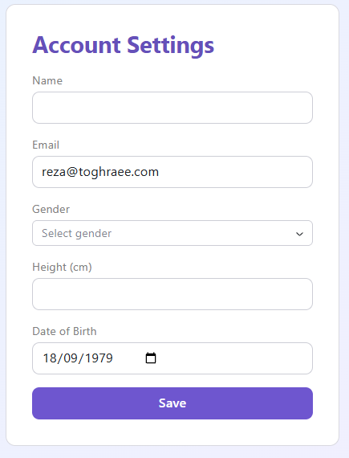
The Account Settings page lets the logged-in user view and edit their profile details: name, email, gender, height and date of birth.
When the page loads it fills the form with the user’s current details, and the Save button writes any changes back to the database.

The backend code to handle the Account Settings page.
We use a class for Account Settings with its own variables and methods.

Properties (variables) :
name: str = "" | User’s name
email: str = "" | Email address
gender: str = "" | Gender
height_cm: str = "" | Height in cm (kept as text until saving)
date_of_birth: str = "" | Date of birth
message: str = "" | Green “Saved.” confirmation
error: str = "" | Red validation / error message

Methods (functions)
def set_name(self, value: str): | Setter to fill the variable from user’s input
def set_email(self, value: str): | Setter to fill the variable from user’s input
def set_gender(self, value: str): | Setter to fill the variable from user’s input
def set_height_cm(self, value: str): | Setter to fill the variable from user’s input
def set_date_of_birth(self, value: str): | Setter to fill the variable from user’s input
def load_user(self): | Loads the user’s current details into the form when the page opens
def save(self): | Validates the form and saves the changes to the database

The save function checks that the name and email are filled in, and that the height (if entered) is a valid positive number. It then calls db.update_user() with the new details. If the email already belongs to another account the database raises a DuplicateUserError, which is caught and shown to the user.

def save(self):
"""Runs when the Save button is clicked."""
self.message = ""
self.error = ""
if not (self.name and self.email):
self.error = "Name and email are required."
return

height_value = None
if self.height_cm:
try:
height_value = float(self.height_cm)
except ValueError:
self.error = "Height must be a number."
return
if height_value <= 0:
self.error = "Height must be a positive number."
return

try:
db.update_user(
user_id=self.user_id,
name=self.name,
email=self.email,
gender=self.gender or None,
height_cm=height_value,
date_of_birth=self.date_of_birth or None,
)
except db.DuplicateUserError as e:
self.error = str(e)
return

self.message = "Saved."

