Session for AAGAB_23638

Dataset
Name: AAGAB_23638
Dose | N | Mean | Std. Dev.
0 | 12 | -0.004 | 0.118
0.1 | 3 | -0.207 | 0.129
1 | 3 | -0.72 | 0.144
10 | 3 | -0.435 | 0.416
Test 1 Dose Response: <0.0001
Test 2 Homogeneity of Variance: 0.023
Test 3 Variance Model Selection: 0.0808

Maximum Likelihood Approach
Model | BMDL | BMD | BMDU | P-Value | AIC | Scaled Residual at Control | Scaled Residual near BMD | Recommendation and Notes
Linear | 1.932 | 2.08 | 2.211 | 0.004 | -0.873 | -0.133 | -2.538 | Questionable  |Residual near BMD| > 2.0  Goodness of fit p-value < 0.1
Polynomial 2 | 0.713 | 2.079 | 50.84 | 0.004 | -0.873 | -0.133 | -2.538 | Questionable  |Residual near BMD| > 2.0  Goodness of fit p-value < 0.1
Power | - | 2.019 | - | 0.001 | 1.147 | -0.133 | -2.529 | Unusable  Did not successfully execute.
Hill | - | 0.096 | - | - | -7.016 | 0.342 | -0.323 | Unusable  Did not successfully execute.
Exponential 3 | - | - | - | <0.001 | 25.47 | -0.041 | - | Unusable  Did not successfully execute.
Exponential 5 | - | - | - | <0.001 | 27.47 | -0.041 | - | Unusable  Did not successfully execute.
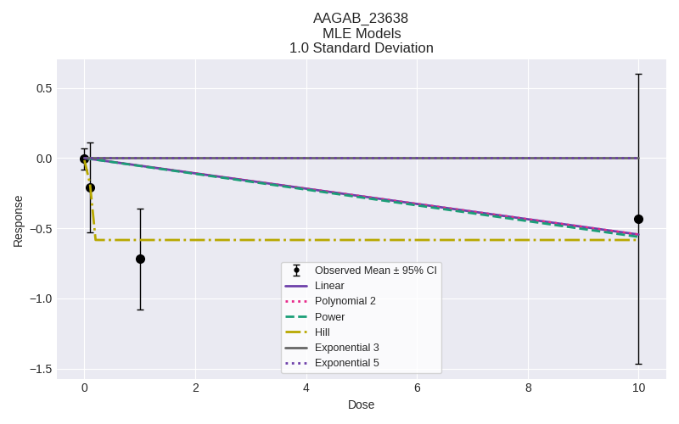

Selected Model
No model was selected as a best-fitting model.

Recommended citation
Please adapt as appropriate; the citations below capture the package version and timestamps for easier reproducibility of the analysis.
U.S. Environmental Protection Agency. (2024). pybmds (24.1; bmdscore 24.1) [Software]. Available from https://pypi.org/project/pybmds/. Executed on March 27, 2026.

