# Management control

Management control is the process by which managers influence other members of the organization to implement the organization’s strategies

Totally internal, No place in financial statement

* SWOT
* Mission
* Business strategy: how a company creates value for customers and differentiates itself from competitors in the marketplace
* Business Goals: Measurable aspirations that Managers set for a business goals are set by the business strategy including Performance Goals & Measures
* Actions

What is their strategy?

Values and visions?

What did they want to be known for?

What did they tell their employees, their customers, and their suppliers?

Contradiction? You see this, but you do it

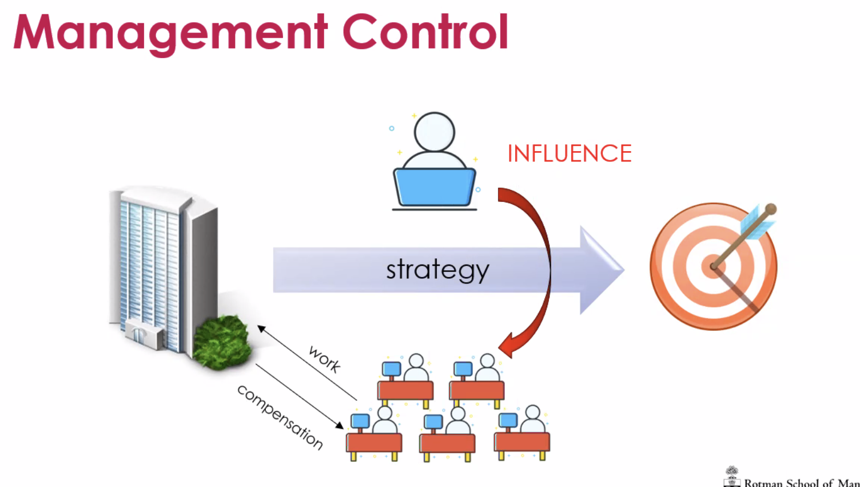

Ensure Management is clear about the direction and decision

KPI

Target:

* e.g. budget, development plan -> decided by management themselves and organization -> everyone is clear about
* Careful when management is solely setting -> gaming, deliberately set it low so they can excess it

**Good organization**

* Articulate a **vision** that addresses the values of the participants
* Allow each individual to appreciate **how he or she can contribute** to the achievement of that vision -> their role; Know their role, what can they do to make a difference, contribute to that
* provide enthusiastic support for effort -> tone at the top
* encourage public recognition and reward for all success -> bonus
  + Public recognition, reward -> bonus, other positive reinforcement, promotion, ranking

# Elements of a good MCS

* Creating shared beliefs and missions
  + properly documented and communicated
* Setting challenging goals
  + Attainable goals
* Linking incentives to accomplishment
  + Incentives <-> bonus
* Declaring certain actions off-limits
  + A clear understanding of what is unacceptable -> code of conduct

Who’s to blame?

* Bias, emphasis in MCS

When you develop A MCS -> assess the risks, What could go wrong,

# 

# Identifying Strategic Risk

* Operations Risk
* Asset impairment risk
* Financial impairment risk
* Competitive risk
* Franchise Risk

# Operations risk

* Breakdown in a core operating, manufacturing and processing capability
  + Who’s to blame
  + How to make sure doesn’t happen again
* operations risk becomes a strategic risk in the event of critical product or process failures
  + After the failure
* eg. AOL - failure in server network to handle growing demand causes lawsuits and embarrassing media attention

Think about what they should be really worried about, significant in business

E.g. bp safety

# Asset impairment risk

* An asset is impaired when it loses a significant portion of its current value because of a reduction in the likelihood of receiving those future cash flows
* Asset impairment risk = strategic risk if there is a deterioration in financial value or physical condition of assets that are important

Strategic risk -> impact your ability to earn money e.g. inventory -> what mechanism to control or be aware of

# 

# Financial impairment risk

* Decline in the market value of a significant balance sheet asset held for resale or as collateral
  + eg. Dollar value of currency is devalued
* Credit risk (on a/r) is a financial impairment of an asset

Hedging protects both sides

Inventory -> not able to sell in short time

# Competitive risk

* Changes in the competitive environment that could impair the business’s ability to successfully create value and differentiate its products or services
  + example change in customer tastes or desire, change in regulation or public policy

Doing same, better, worse

What is the exposure, advantage, -> come up management control

What is your value proposition? What you are better at -> What management control focus on

# Franchise Risk/Reputation risk

* When the value of the entire business erodes due to a loss in confidence by critical constituents
* Also known as reputation risk - problems or actions negatively affect customer perceptions of value in using the business’s goods or services
  + example: Enron and Arthur Anderson

What can go wrong to affect your reputation?

CEO apologize on behalf of a bad decision -’> what can put on management to prevent that

# How to Organize your Business

* Group of people and resources focused on a specific market
  + by product
  + by customer
  + by geography

Flaz - organization structure

Responsibility accounting - Responsibility centers

Each organization can be divided by any means

Consolidated financial statement

Business leader, responsible for that unit

Reporting

Not necessarily be very clear

Direct cost, Shared cost, Allocate between -> Not perfect

Based on orders, customers, …

But for internal purposes,

Evaluating someone performance

Counterproductive to motivate

# Accountability

* Must determine the span of control
  + how many subordinates and functions report to each manager in the organization

When you assign managers to units What can they do

*Centralize*

* *Limit on what they can do*
* *Management approval*

*Decentralize*

* *What exactly can they make decisions on behalf of the organization*
* *Agency risk*

# ​​Responsibility

* Cost Center Accountability
* Profit Center Accountability
* Centralized versus Decentralized

Control sales, profit,or both + investment decisions

Depends on whether you have an impact on revenue / cost, revenue and cost

The measurement of your performance will make sense

There are no rules for management accounting

How to best organize

# Agency Risk

Probability of loss due to an agent's pursuance of his or her own interests instead of those of the principal. Also called agency cost.

In this case, the manager will do what best serves their own self-interest

Maximize my salary, bonus

Focus on something elase

How do you take that account - Inherent bias -> more measures

More than financial -> non financial -> balance score card

**About recognizing the agency risk**

# Dangerous Triad

Three conditions exist simultaneously

* pressure
* opportunity
* rationalization

Ethical fading -I know kpi, know do x to get bonus

I figure the opportunity and I rationalize it -everyone is doing

E.g. wells fargo

CEO

# Controlling Human Behaviour

Tell people what to do, eg. Military

VERSUS

hold people accountable for outcomes

* encourage new ideas and new ways of creating value

How much they make

Founder of Uber - Business model, but bad at managing people

What does the old, new ceo look like

New CEO Change?

Was there some kind

**Culture?**

**Back to flamehoze**

**-** Part of control system (CEO)

- organization structure

- how decisions are made

- what are expectations

- culture

# Implement strategy to inspire their employees

* Creating shared beliefs and missions
* Setting challenging goals
* Linking incentives to accomplishment
* Declaring certain actions off-limits

CEO and push down to management

**Tone at the top**

* What was the tone at the top
* Whistleblowing mechanism, were people utilizing it
* What was turnover, people destroy
* Speaks to tone at the top and culture be created

Goal should be clear

People know expect of them and return

Code of conduct

# Codes of Business Conduct

Off-limits behaviors typically include

* conflicts of interest
* activities that contravene anti-trust laws
* disclosure of confidential company information
* trading in company securities based on nonpublic information
* illegal payments to government officials

Clear Their expectation of employees, and do they understand

AI - monitor behavior, gain information

# Performance Goal

* Formal aspiration that defines purpose or expected levels of achievement
* Specify the ends that managers wish to achieve and the means by which to achieve them
* They communicate what managers expect them to do

Executive compensation

* Percentage based on financial, stock
* Short-term and long-term

KPI - you need to make there is an infrastructure to make sure it works

Got the information

# Goals, Objectives & Targets

Incorporate measurement standards and time frames against which to gauge progress and success

E.g. budget

Can you then say performance should based on that

Incorporate the best assumption

# What information for Performance Measurement & Control

* Nonfinancial measures
* Financial Measures

How to set them:

* standards
* Benchmark
* Variance information

What other measures should be taken to help them?

**Remember to link back to strategy, value, vision**

**Balanced score card**

**Setting: look at past performance, average, other info**

Any difference is what we call variance

* How that can be communicated -> timely basis
* Don’t get the bonus? lose job?

# Information Can be Used for

* Decision-making -> pricing, supplier choice, division split/consolidate
* Control -> control your manager, get information about them
* Signalling -> e.g. ESG -> communicate to public
* Education & learning
* External communication

“Internal” no place in financial statement

# 

# 

# Examples of Managements Control Systems

Budgets

* Profit plans
* Weekly, monthly, annual, 5-year

Key Financial Measures

* Sales
* Profit or net income
* Cash flow
* Investment in new assets
* ROCE
* Profitability
* Asset Turnover

Performance Incentives

* Balanced Scorecards
* Traditional Financial only
* Subjective only

Balance score card

* Could be some version of that

# Selecting Performance Measures

* Does it align with **strategy**
* Can it be **measured effectively**
* Is the measure linked to **value**

# Internal Controls

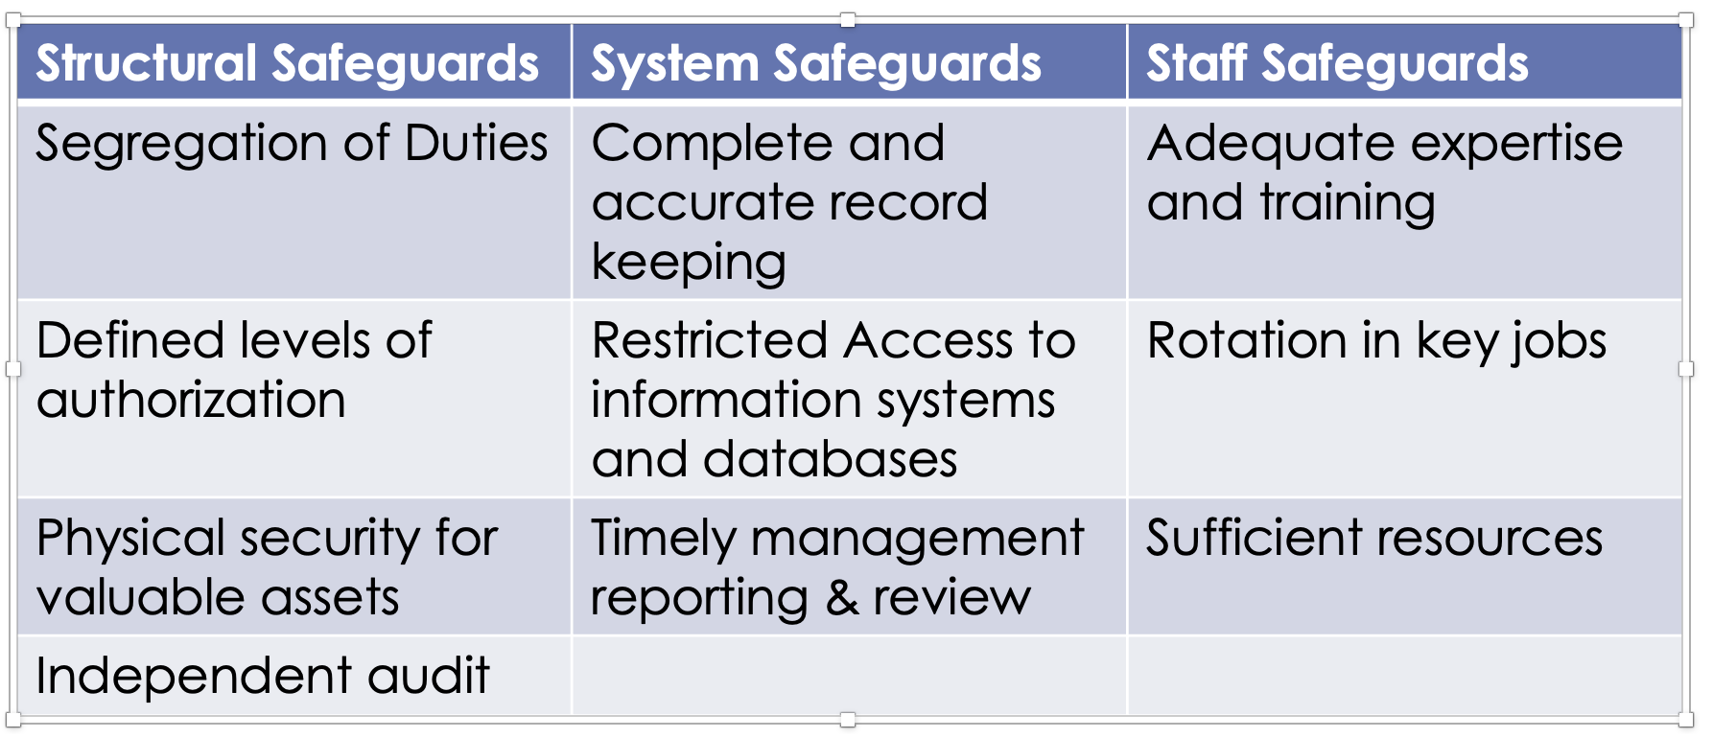

Protect the integrity

Management control is more about decision-making - autonomy, individual

**Exam**

Hard copy

Comfortable with the company

Investigation

* various leaders
* What’s cost it, prevent, impact
* Media coverage

Take a step back

What was their strategy, value

Say vs do -> disconnect?

**Safety culture** big part

Environment, business impact

5 questions

10, 10, 30, 20, 30

2 hours - spend time accordingly

Really comfortable with cases, like Wells Forgo

Understand business

* What is company about
* Value proposition
* What did they go wrong
* Happen in February, what they changed

Remember,

Disguish is **depth**

* What’s their strategy
  + Explain what it is, how it relates to the industry, what happens

Tone at the top

**Depth:**

* **Bring in theory**

E.g. ceo

flame hoz

Core control system

* **Compare**:

With wells fargo, bp