DriverPass System Design Document

Hanna Alemu
CS 255 Project Two
10/25/2026

UML Diagrams

UML Use Case Diagram
The use case diagram shows the six actors that interact with DriverPass (Customer, Secretary, Driving Instructor, Administrator, DMV, and Payment Processor) and the 18 things they can do in the system. Purchasing a package always includes processing a payment, and scheduling, modifying, or canceling an appointment always includes recording an entry in the change log, which gives Liam the accountability he asked for. Reset Password extends Log In because it only happens when a user forgets their password.
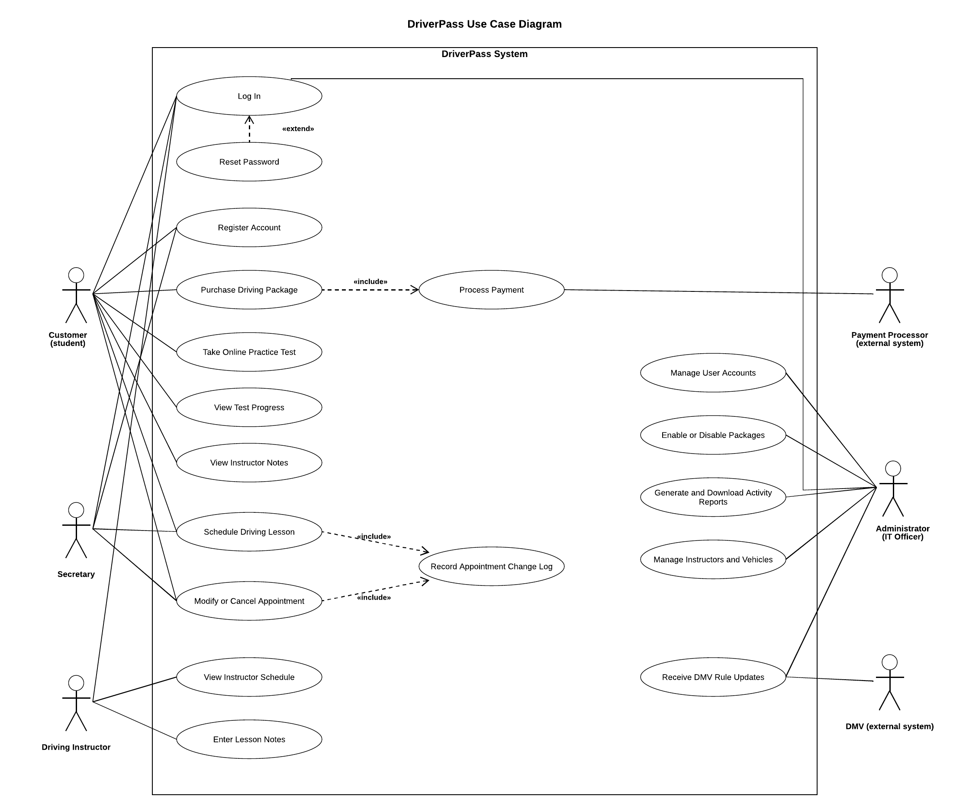

UML Activity Diagrams
Schedule Driving Lesson. This diagram follows a customer or the secretary booking a two-hour lesson. The system first checks whether the customer has sessions left on their package, then shows only open time slots. If the selected slot was just taken by someone else, the system refreshes the calendar instead of double-booking. Once the slot is confirmed, the system assigns a driver and car, saves the reservation, reduces the remaining session count, and in parallel records the change log entry and sends a confirmation email.
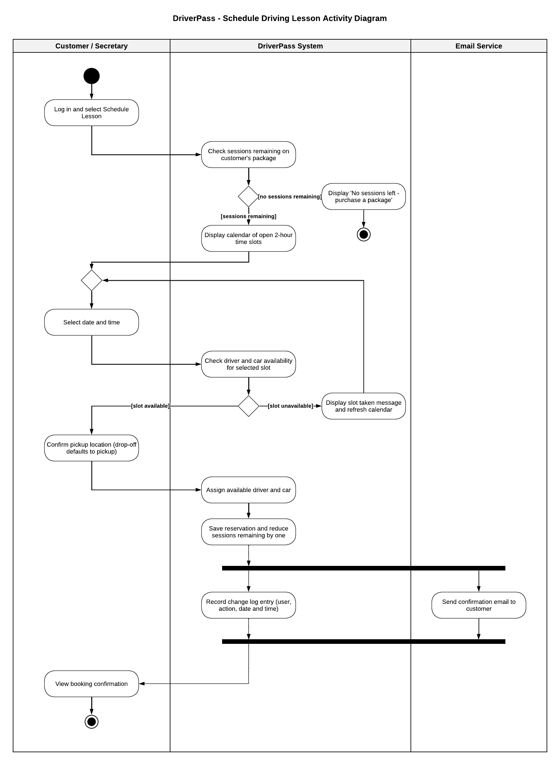
Register Account. This diagram follows a new customer registering online. The system validates the required fields and checks that the username or email is not already in use before showing only the packages Liam has enabled. Payment goes to the outside payment processor. If the card is declined, the customer can retry or cancel. If it is approved, the system creates the account, assigns the number of sessions that matches the package, discards the card security code, and sends a welcome email.
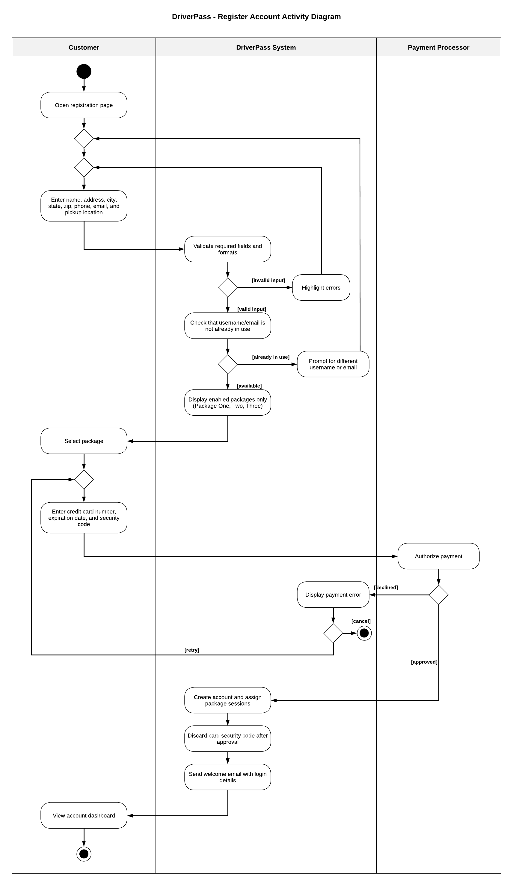

UML Sequence Diagram
The sequence diagram shows the Schedule Driving Lesson use case as messages between the customer and the parts of the system: the web portal, the reservation service, the database, the activity log, and the email service. The first alt fragment stops the process if the customer has no sessions remaining. The second alt fragment handles the case where two people try to book the same slot at once. The database locks the slot during the check, so only one reservation succeeds and the other user is shown a "slot taken" message. Every successful booking ends with a log entry and a confirmation email.
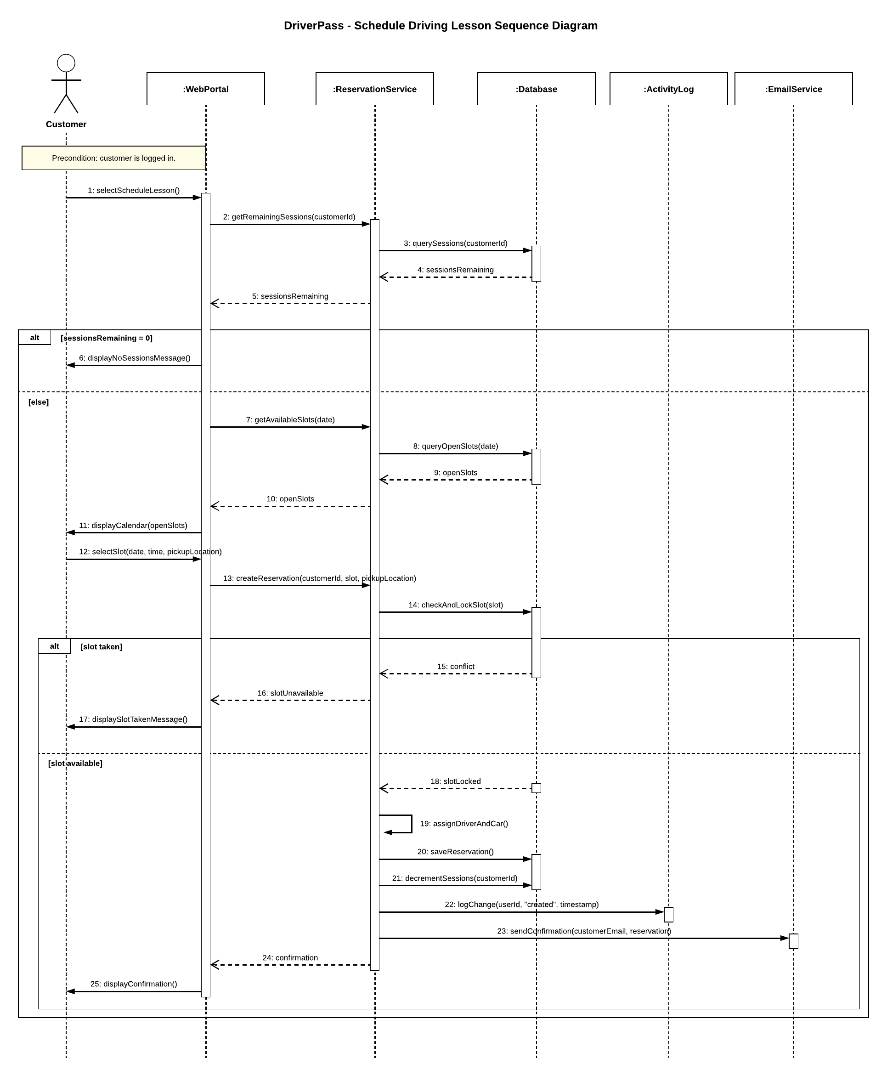

UML Class Diagram
The class diagram shows the main objects in the system and how they relate. User is an abstract parent class that holds the login details and role shared by everyone, and Customer, Secretary, Instructor, Administrator, and Owner inherit from it. Reservation sits at the center, connecting a customer to one instructor and one car for a two-hour slot, with an optional lesson note. The Package, Payment, OnlineTest, TestAttempt, ActivityLog, and DMVUpdate classes cover the remaining requirements from Project One. Payment only stores the last four digits of the card and the processor’s transaction ID, since PCI rules don’t allow the security code to be saved.
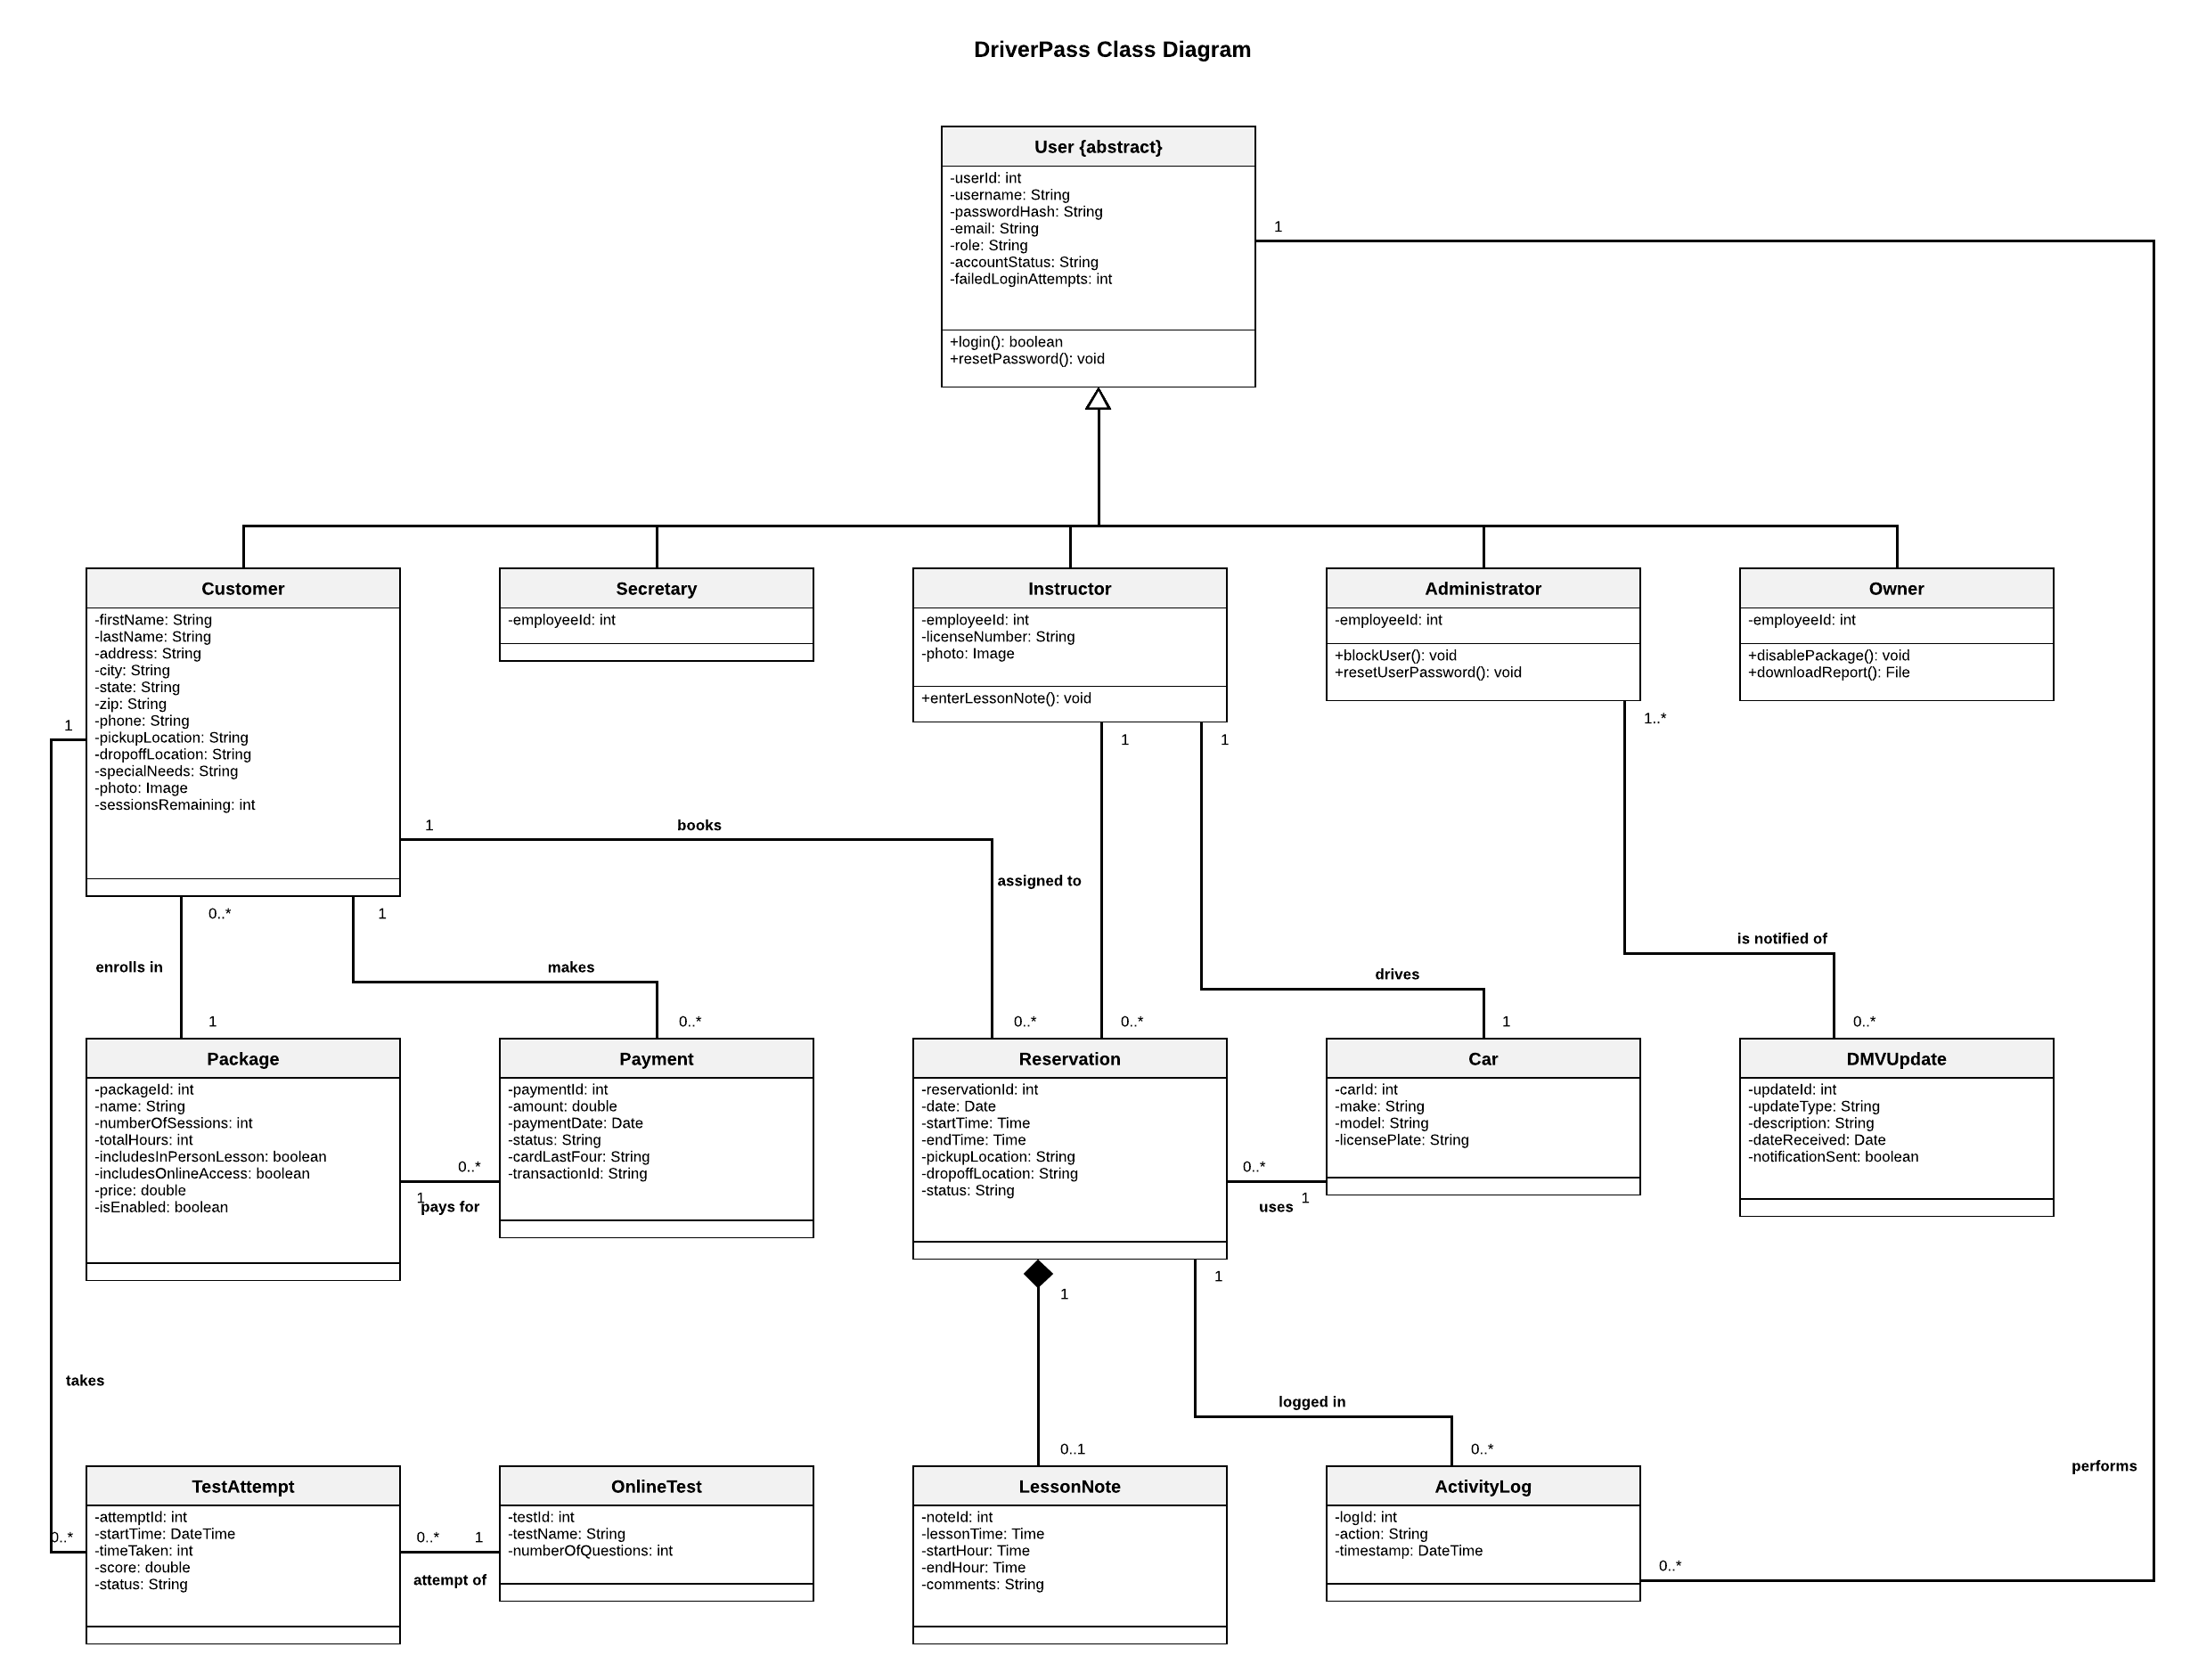

Technical Requirements
DriverPass wants a web-based system that runs in the cloud so they don’t have to manage servers, backups, or security themselves. The requirements below are based on the nonfunctional requirements from Project One and on the components shown in the sequence and class diagrams.

Hardware
Client side. Users don’t need any special hardware. Customers, the secretary, Liam, and Ian only need a computer, tablet, or phone with a modern web browser and a reliable internet connection. The office needs at least one workstation for the secretary to register walk-in and phone customers, plus a printer, since Liam wants to print activity reports.
Instructors. Each driving instructor needs a smartphone or tablet with mobile data so they can check their schedule, see the student’s pickup location and photo, and enter lesson notes from the car.
Server side. DriverPass won’t buy or maintain any servers. All server hardware is provided by the cloud provider as virtual machines. A small setup, such as two application servers behind a load balancer, is enough for 10 cars and their customers, and the cloud provider can add capacity automatically if the business grows.

Software
Front end. A responsive web application built with HTML, CSS, and JavaScript, using a framework such as React. It has to work in Chrome, Edge, Firefox, and Safari on desktop and mobile, with no installation. The main pages are login, registration, the scheduling calendar, the student page from Liam’s sketch (test progress, student information, driver notes, and special needs), reports, and admin user management.
Back end. An application server running on Linux, written in a language such as Java (Spring Boot) or Node.js. It is organized into the same components used in the sequence diagram: the web portal handles requests, the reservation service holds the scheduling rules (session counting, two-hour slots, and driver and car assignment), the activity log records every change, and the email service sends confirmations and password resets. Role-based access control on the server makes sure each user only reaches the pages and data their role allows.
Database. A managed relational database, such as PostgreSQL or MySQL. Each class in the class diagram becomes a table, and the associations become foreign keys, for example a reservation references one customer, one instructor, and one car. Reservations are saved inside a database transaction that locks the selected slot, which is what prevents double booking when a customer and the secretary pick the same time.
Third-party services. A PCI-compliant payment processor (such as Stripe) for credit card payments, so card numbers never have to be stored by DriverPass. An email service (such as Amazon SES or SendGrid) for confirmations, notifications, and time-limited password reset links. A connection to the DMV’s data feed or API that checks for new rules, policies, and sample questions, saves them as DMVUpdate records, and notifies Liam and Ian. A report export feature that creates Excel-compatible (.xlsx or .csv) files so Liam can review data offline.

Tools
Lucidchart for the UML diagrams in this document. Git with GitHub for version control, so the team can work on the interface, database, and business logic at the same time without overwriting each other’s work. An IDE such as Visual Studio Code or IntelliJ. A task tracker such as Jira to follow the schedule in the Gantt chart. Automated testing tools (for example JUnit or Jest) to test the scheduling rules, like never booking a driver twice or letting a customer go over their package’s session limit, plus a separate staging environment for the testing phase before delivery.

Infrastructure
Hosting. A cloud provider such as AWS or Microsoft Azure hosts the application servers and the managed database. The database runs across more than one availability zone and is backed up automatically every day with point-in-time recovery. This supports the 99.9% uptime goal and means DriverPass doesn’t have to handle backups in-house.
Security. All traffic uses HTTPS with a TLS certificate, and sensitive customer data is encrypted in the database. The database is placed in a private network and can only be reached by the application servers, not directly from the internet. Passwords are stored as salted hashes (for example with bcrypt), accounts lock after 5 failed login attempts, and users are logged out after a period of inactivity.
Monitoring and logging. The cloud provider’s monitoring tools track errors and performance and send alerts to Ian when something goes wrong, such as repeated failed logins, a failed payment, or a lost connection to the DMV. The activity log is stored in the database and can’t be edited by regular users, so Liam’s reports always show who created, modified, or canceled each reservation.
Environments. Separate development, staging, and production environments, so new features and fixes can be tested before they reach customers.

