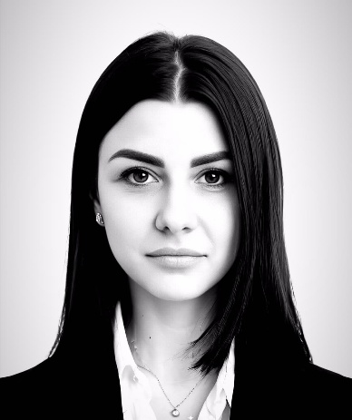
НANNA BALABANOVA

PERSONAL DETAILS
Location: Kyiv, Ukraine Date of birth:07.03.1997 Marital Status: Married
E-mail:Anna.balabanova0703@gmail.com Mobile No.: +380505045619

ACADEMIC DETAILS

now | Master of Cyber Security  State University of Trade and Economics
2014-2018 | Bachelor of sciences in Economic cybernetics  Kyiv National University of Trade and Economics (Ukraine)

WORK EXPERIENCES
Jan-2024 – now Leadind analyst of Information security
UKRSIBBANK BNP Paribas Group
- Attracting individual customers to the Premium market;
- Selling a full range of banking products to customers
- Managing own portfolio and client risks;

Jun-2024 – Jan 2026 Information security analyst
UKRSIBBANK BNP Paribas Group
- Attracting individual customers to the Premium market;
- Selling a full range of banking products to customers
- Managing own portfolio and client risks;

Jan 2022 – Jun 2024 Personal financial consultant for individual business
UKRSIBBANK BNP Paribas Group
- Transaction analysis to identify anomalies and potential fraud schemes.
- Development of rules and scenarios for monitoring systems
- Conducting investigations into fraud incidents and preparing reports for management.
- Development and optimization of anti-fraud processes in accordance with regulatory requirements.

Feb 2020 – Jan 2022 Corporate Client Service Manager
UKRSIBBANK BNP Paribas Group
- Opening deposit accounts and ancillary banking products
- Facilitating customer awareness and education of bank services, including digital banking capabilities
- Introducing customers to other branch team members or bank partners who are able to provide solutions for their financial needs
- Processing transactions and other account servicing requests

Mar 2017 – Oct 2019 Corporate Client Service Manager
PRIVATBANK
- Searched for new customers
- Expansed of the clients base
- Analyzing data
- Preparing reports
LANGUAGES PROFESSIONAL SKILLS

- English (B1)
- Ukrainian & Russian (Native speaker) • High level of MS Office (Excel, Word);
HTML, CSS, JS, SQL
INTERESTS AND PERSONAL QUALITIES
Hobbies: gym, tourism.

