* short: presenters will coordinate in chat for presentations
  + ~5 mins
* long: fixed number of people present on a certain day

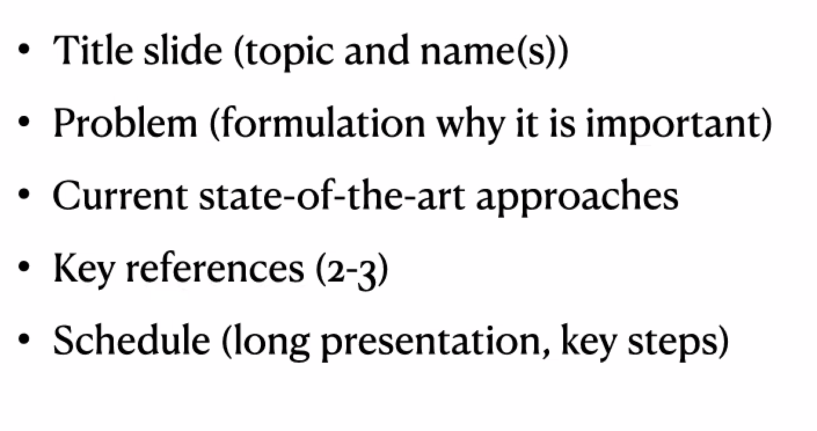

**Short Presentation**

* Title Slide (topic and name)
  + Pearl's Causality
* Problem (formulation and why it is important)
  + credited with creation of Bayesian networks and causal inference, both used for reasoning
  + used by all disciplines to quantify the probability of events
* Current state-of-the-art approaches
  + ladder of reasoning
  + software such as samiam
  + expanding to counterfactual reasoning and unit selection
* key references

1. <https://amturing.acm.org/award_winners/pearl_2658896.cfm>
2. <https://books.google.com/books?hl=en&lr=&id=AvNID7LyMusC&oi=fnd&pg=PA1&ots=F0WLXlrt48&sig=E_FhzMumFhJXpYUQ3OtJSzn8GwA#v=onepage&q&f=false>
3. <https://scholar.google.com/citations?view_op=view_citation&hl=en&user=bAipNH8AAAAJ&citation_for_view=bAipNH8AAAAJ:u-x6o8ySG0sC>

* schedule (long presentation, key steps)
  + Week 3-5: literature review
  + Week 6: work on long presentation
  + Week 7: presentation + paper work
  + Rest of quarter: work on paper

**Feedback**

* include examples – Pearl uses lots of examples

**Paper**

* 5-7 pages
* introduction
* background (probability, graphs, need for causality, BN, d-sep, markov)
* identifiability
* use (necessity and sufficiency)
* extensions and applications
* figures

1. simple graph
2. BN example
3. BN with CPTs
4. d-separation
5. ladder of reasoning
6. back-door criterion
7. do calculus
8. do calculus

**Long Presentation**

* 20 minutes
* ~~background on causality and what it really means~~
* ~~probability and graphs~~
* ~~Markovian~~
* ~~d-separation~~
* ~~types of logic~~
* ~~identifiability~~
* ~~front door, back door, do calculus~~
* ~~probability of necessity, sufficiency, etc~~
* structural equation models and structural causal models
* ~~unit selection~~
* ~~explainable ai~~
* applications
* references:

1. Baron, Sam. (2023). Explainable AI and Causal Understanding: Counterfactual Approaches Considered. Minds and Machines. 33. 1-31. 10.1007/s11023-023-09637-x.
2. Borsboom, Denny. (2017). A network theory of mental disorders. World Psychiatry. 16. 5-13. 10.1002/wps.20375.
3. Li, Ang & Pearl, Judea. (2019). Unit Selection Based on Counterfactual Logic. 1793-1799. 10.24963/ijcai.2019/248.
4. Menni, Cristina & Klaser, Kerstin & May, Anna & Polidori, Lorenzo & Capdevila, Joan & Louca, Panayiotis & Sudre, Carole & Nguyen, Long & Drew, David & Merino, Jordi & Hu, Christina & Selvachandran, Somesh & Antonelli, Michela & Murray, Benjamin & Canas, Liane & Molteni, Erika & Graham, Mark & Modat, Marc & Joshi, Amit & Spector, Tim. (2021). Vaccine side-effects and SARS-CoV-2 infection after vaccination in users of the COVID Symptom Study app in the UK: a prospective observational study. The Lancet. Infectious diseases. 21. 10.1016/S1473-3099(21)00224-3.
5. Pearl J. Causality. 2nd ed. Cambridge University Press; 2009.
6. Pearl, Judea. (2009). Causal Inference in Statistics: An Overview. Statistics Surveys. 3. 96-146. 10.1214/09-SS057.
7. Wenjuan, Wei & Feng, Lu & Chunchen, Liu. (2018). Mixed Causal Structure Discovery with Application to Prescriptive Pricing. 5126-5134. 10.24963/ijcai.2018/711.
8. Zhang, Yang & Feng, Fuli & He, Xiangnan & Wei, Tianxin & Song, Chonggang & Ling, Guohui & Zhang, Yongdong. (2021). Causal Intervention for Leveraging Popularity Bias in Recommendation.

**Feedback**