Normalisasi Visual: manual_fox_baby_en.pdf

3.1 User Interface
User Manual The lanyard is made of insensitive material. Please do not use the SpO2 value measured, it has a higher accuracy and standard.
Nomer File: SPA-BM/PROD-45 it if any person is allergic to lanyard. Do not wrap the lanyard repeatability. ● The device cannot be used during charging
Revisi: 04 around neck to avoid an accident. 1.1 Features ● If the device or component is intended for single-use, then the

3.2 Overview
should follow the local laws and regulations, to avoid B. Small in volume, light in weight, convenient to carry. and technical parameters of the equipment known to the
User Notice polluting to the local environment. And the packaging C. Low power consumption. manufacturer.
Dear users, thank you very much for purchasing the Pulse Oximeter materials must be placed in the region where the children are 1.2 Indication for Use ● If necessary, our company can provide some information
(herein after referred to as device). out of reaching. The Pulse Oximeter can be used in measuring the pulse oxygen (such as circuit diagrams, component lists, illustrations, etc.),
It is a medical device, which can be used repeatedly. ● The device cannot be used with the equipment not specified saturation and pulse rate through finger. The product is fit for so that the qualified technical personnel of the user can repair
The manual describes, in accordance with the device’s features and in the manual. Only the accessories appointed or family, hospital, oxygen bar, community healthcare, physical care the device components designated by our company.

6.1 Specification

2.0 Installation

4.2 Maintenance
protect both the users and equipment. Refer to the respective ● Check the device before use to make sure that there is no 1.3 Environment requirements ● As to the fingers which are too cold or too thin or whose

4.3 Care
Please read the user manual very carefully before using this device. performance. When there is obvious damage, please replace a) Temperature: -40°C ~ +60°C please insert the thicker fingers such as thumb or middle
The user manual which describes the operating procedures should the damage parts before use. b) Relative humidity: ≤95% finger deeply enough into the probe when measuring.
be followed strictly. Failure to follow the user manual may cause ● Functional testers cannot be used to assess the accuracy of c) Atmospheric pressure: 500 hPa ~ 1060 hPa ● The finger should be placed correctly (see attached figure 3),
measuring abnormality, device damage and human injury. The the Pulse Oximeter. Operating Environment as improper installation or improper contact position for
manufacturer is NOT responsible for the safety, reliability and ● Some functional testers or patient simulators can be used to a) Temperature: +10°C ~ +40°C sensor will influence the measurement.
performance issues and any monitoring abnormality, human injury verify whether the device works normally, for example, b) Relative Humidity: ≤75% ● The light between the photoelectric receiving tube and the
and device damage due to user’s negligence of the operation INDEX-2LFE Simulator (software version: 3.00), please refer to c) Atmospheric pressure: 700 hPa ~ 1060 hPa light-emitting tube of the device must past through the

1.2 Safety Guidelines
such faults. ● Some functional testers or patient simulators can measure 1.4.1 Attention optical obstacles like rubberized fabric, to avoid inaccurate
Owing to the forthcoming renovation, the specific products you the accuracy of the device copied calibration curve, but they Point out conditions or practices that may cause damage to the results.
received may not be totally in accordance with the description of cannot be used to evaluate the device accuracy. device or other properties. ● Excessive ambient light may affect the measured results, such
this User Manual. We would sincerely regret for that. ● When using the device, please keep it away from the ● Before using the device, make sure that it locates in normal as surgical light (especially xenon light sources), bilirubin
Warnings equipment which can generate strong electric field or strong working state and operating environment. lamp, fluorescent lamp, infrared heater, and direct sunlight,
Remind that it may cause serious consequences to tester, user or magnetic field. Using the device in an inappropriate ● In order to get a more accurate measurement, it should be etc. In order to prevent interface from ambient light, make
environment. environment may cause interference to the surrounding radio used in a quiet and comfortable environment. sure to place the sensor properly and cover the sensor with
● Explosive hazard - DO NOT use the device in environment with equipment or affect its working. ● When the device is carried from cold environment to warm or opaque material.
inflammable gas such as anesthetic. ● When storing the device, keep it away from children, pets, humid environment, please do not use it immediately, wait ● Frequent movement (active or passive) of the subject or
● DO NOT use the device while examining by MRI or CT, as the and insects to avoid affecting its performance. four hours at least is recommended. severe activity can affect the measured accuracy.
induced current may cause burn. ● Do not place the device in places exposed to direct sunlight, ● If the device is splashed or coagulated by water, please stop ● The SpO2 probe should not be placed on a limb with the blood
● Do not take the information displayed on the device as the high temperature, humidity, dust, cotton wool, or easy to operating pressure cuff, arterial ductus or intraluminal tube.
sole basis for clinical diagnosis. The device is only used as an splash water, to avoid affecting its performance. ● DO NOT operate the device with sharp things. ● The measured value may be inaccurate during defibrillation
auxiliary means in diagnosis. And it must be used in ● The measured accuracy will be affected by the interference of ● High temperature, high pressure, gas sterilizing, or immersion and in a short period after defibrillation, as it has not
conjunction with doctor’s advice, clinical manifestations and electrosurgical equipment. disinfection for the device is not permitted. Refer to user defibrillation function.

4.4 Cleaning
● The maintenance to the device non-detachable lithium simultaneously, danger may occur which is arisen from the disinfection. Please turn off the device before cleaning and ● The device is calibrated to display functional oxygen
battery can only be performed by qualified service personnel overlap of leakage current. disinfection. saturation.

6.2 Standard Compliance
temperature, fire, or explosion) may occur when replacing the recommended to use the device. ● The device may not be suitable for all users, if you can’t get a comply with the requirements of IEC 60601-1.
battery by the personnel not fully trained. Users are not ● This device is not intended for treatment. satisfactory result, please stop using it. ● Please select medical power adapter to charge it, when
permitted to maintain or refit the device by themselves or ● The intended operator of the device may be a patient. ● Data averaging and signal processing have a delay in the connecting the special adapter with the socket, make sure
replacement of the battery. ● Avoid maintaining the device during using. upgrade of SpO2 data values. When the data update period is there is no shelter near the socket and it is easy to plug and
● Uncomfortable or painful feeling may appear if using the 1. Overview less than 30 seconds, the time for obtaining dynamic average unplug, otherwise the power will not be cut off in time when
device ceaselessly, especially for the microcirculation The oxygen saturation is the percentage of HbO2 in the total Hb in values will increase, which is arisen from signal degradation, necessary, causes damage.
disturbance users. It is not recommended that the sensor is the blood, so-called the O2 concentration in the blood, it is an low perfusion or other interference, it depends on the PR 1.4.2 Clinical Restriction
used on the same finger for more than 2 hours. important physiological parameter for the respiratory and value. A. As the measure is taken on the basis of arteriole pulse,
● For some special users who need a more careful inspection on circulatory system. A number of diseases relating to respiratory ● The device has 3 years’ service life, date of manufacture: see substantial pulsating blood flow of subject is required. For
the test site, please don’t place the device on the edema or system may cause the decrease of SpO2 in the blood, furthermore, the label a subject with weak pulse due to shock, low ambient/
tender tissue. some other causes such as the malfunction of human body’s self- ● The maximum temperature at the SpO2 probe – tissue body temperature, major bleeding, or use of vascular
● Please do not stare at the red and infrared light emitter (the adjustment, damages during surgery, and the injuries caused by interface should be less than 41OC which is measured by the contracting drug, the SpO2 waveform (PLETH) will
infrared light is invisible) after turning on the device, including some medical checkup would also lead to the difficulty of oxygen temperature tester. decrease. In this case, the measurement will be more
the maintenance staff, as it may be harmful to the eyes. supply in human body, and the corresponding symptoms would ● During measuring, when abnormal conditions appear on the sensitive to interference.
● The device contains silicone, PVC, TPU, TPE, and ABS appear as a consequence, such as vertigo, impotence, vomit etc. screen, please pull out your finger and reinsert it to measure B. The measurement will be influenced by intravascular
materials, whose biocompatibility has been tested in Serious symptoms might bring danger to human’s life. Therefore, again. staining agents (such as indocyanine green or methylene
accordance with the requirements in ISO 10993-1, and it has prompt information of patient’s SpO2 is of great help for the doctor ● Do not contort or drag the wire of the device. blue), skin pigmentation.
passed the recommended biocompatibility test. The person to discover the potential danger, and is of great importance in the ● The plethysmography waveform is not normalized, as a signal C. The measured value may be normal seemingly for the
who is allergic to silicone, PVC, TPU, TPE, or ABS cannot use clinical medical field. inadequacy indicator, when it is not smooth and stable, the tester who has anemia or dysfunctional hemoglobin (such
the device. accuracy of the measured value may degrade. When it tends as carboxyhaemoglobin (COHb), methaemoglobin
to be smooth and stable, the measured value read is the (MetHb), and sulfhaemoglobin (SuHb)), but the tester
may appear hypoxia, it is recommended to perform 6.1 Measurement E. The device need not to be calibrated during maintenance. Caution, consult Pulse rate
further assessment according the clinical situations and A. Insert the finger into the probe as shown in Figure 3. 6.3 Transport and Storage accompanying PRbpm (bpm)
symptoms. A. The packed device can be transported by ordinary documents
D. Pulse oxygen only has a reference meaning for anemia conveyance or according to transport contract. During Type BF applied Pulse oxygen
and toxic hypoxia, as some severe anemia patients still transportation, avoid strong shock, vibration and splashing part %SpO2 saturation (%)
show better pulse oxygen measured value. with rain or snow, and it cannot be transported mixed with 1. The finger clip Low-power
E. Contraindication: No. toxic, harmful, corrosive materials. falls off (no indication
2. Principle B. The packed device should be stored in room with no corrosive finger
Figure 3 Sketch map for finger placement gases and good ventilation. Temperature: -40°C~+60°C; inserted)
B. Wait a few seconds, the device directly shows Relative Humidity: ≤95%. - - - 2. Probe error

5.0 Troubleshooting
Note: when inserting the finger, the light emitting from the Trouble Possible Reason Solution inadequacy
sensor must be directly irradiated to the side of the indicator
fingernail. 1. T
ro
in
rl
e r is not
1. Please insert the
Serial Number Use-by date
Figure 1 Operating principle Note: during measuring, do not shake the finger and keep inserted. finger properly Recycling USB
quiet, not move. 2. The finger is and measure garbage WEEE

3.5 Medical Calculation
data process is established taking use of Lambert Beer Law After turning the device on, the pulse sound is open. Long press the The values patient is 2. Let the patient The sound The pulse
according to Spectrum Absorption Characteristics of Reductive button can close the pulse sound and the pulse sound indication cannot be moving. keep calm. prompt sound
Hemoglobin (Hb) and Oxyhemoglobin (HbO2) in glow & near- icon disappears. Long press button again, the pulse sound is turned displayed 3. The device is 3. Please use the indication indication
i O n x fr y a h r e e m d o z g o l n o e b s in . O In p s e p ra e t c i t o io n n p T ri e n c c h ip n l o e l o o g f y t h is e a d d e o v p ic t e e d is : i n P h a o c t c o o e r l d e a c n tr c i e c o 6. n 3 a n S d o p u u n l d se p s r o o u m n p d t i n se d t ic ti a n t g io n appears. n st o a r b m ly a . lly or n en o v t i u ro se n d m i e n n t d en ev v i i c ro e n in m n e o n r t m . al IP22 I P n r t o e t r e n c a t t io io n n al Fi O n u g t e r T n h o e t ins fi e n r g te e d r is
with Capacity Pulse Scanning & Recording Technology, so that two a. Sound prompt includes the sound prompt of measure required by the 4. Please contact the Temperature Fragile, handle
b h e u a m m a s n n o a f il d ti i p ff e th re ro n u t g w h a p v e e r l s e p n e g c t t h iv e o f c la li m gh p t s f in c g a e n r -t b y e p e f o s c e u n s s e o d r. T o h n e to n d 90 at % a , ’ s o r g t o h in e g p u b l e s y e o r n a d te t i h s e n o li t m b i e t t s w ( e w e h n e 5 n 0 t b h p e m S p a O nd 2 1 is 2 0 b e b l p o m w , 4. m Th a e n d u e a v l. i ce after sales. l A im tm it o a s t p io h n e ric w Th it is h w ca a r y e u p
m i t n h f e r o o a r u s m u g r h a e t t d io r e n s a ig t a m n c a q e l u n c i t r a e in n d e b l t e e h c r t o o r b u o t g n a h i i c n c e w i d r h c i u b ch i y t s a w a n i p l d l h o m b t e i o c s r s e o h n p o s r w i o t n i c v e e s o s n e o l r e s . m cr e e n e t n , t p h o e w e so r. u nd prompt occurs), the sound prompts of low- w ab o n r o ks rm ally. p lim re i s t s a u ti r o e n
3. Functions b. In the open state of sound prompt, when the measure data 1. T
ra
i n
tt
ry
or
1. P
te
se
ri e
a rge H
lim
um
ita
id
ti
ty
fr
rain
away
A. SpO2 value display is beyond the normal measure range, the device would
almost drained 2. Please install the Recyclable Manufacture
B. PR value and bar graph display give prompt sound and the corresponding value glitter.
The device away. battery again. date
E F. .
L t
A D
h o
u is
e w
t p
b -
m a
a t
t t
m t
e t
e r
c o
y r
s d
t e
l d t
a d
a i
g a
e f
i i o
o :
c a t
o lo
i n o
l w
n e
- w b
a to tt e w r o y r i k n dication appears when
b v
in
u l
t u t
e o
n s
, t
i a l
l n
g d
li
t t
h e
e r.
S o o
u u
ld
n n d d
p p
r r o o
m m
us
p p
t t
f i
c u
o n
n c
t d i o i
n s
a w p
p i
l e l
a b
r e
s , r
e b
n u
e t
h e
d e
tu
on.
b e 2
i i
n n
s c
t o a r
l r l
e e
c d
ly
’ s
i s 3. P
l c o e
le
c n a
t l
e s
r e .
ic
a ct the
9.
e:
ci
ic
ti
ic
a r
ib
i t

1.3 Explanation of Symbols
G. Charging function If low-power sound prompt occurs, please charge the battery. malfunction SpO2 [see note 1]
H. Display direction can be changed automatically 6.4 Charging 1. The device Display range 0% ~ 99%
I. PR sound indication: sound prompt for over-limit, low battery Power adapter can be selected to charge for the device. It indicates enters into the Measured range 0% ~ 99%
4. Installation that the device is charging when the indicator is light, the charging energy saving 1. Normal. Accuracy [see note 2] 70% ~ 99%: ±2%;
4.1 Appearance is finished when the indicator is off. The display mode. 2. Please charge the 0% ~ 70%: unspecified.
disappears 2. Low battery. battery.
6. Maintain, Transport, and Storage Resolution 1%
suddenly. 3. The device 3. Please contact the
6.1 Cleaning and Disinfection PR
works after-sales.
Pulse s P P o u u u l l n s s e e d r w in a a t d e v ic e v a f a o t l i r u o m e n A Sp la O rm 2 v a so lu u e n d indication T b h e e im de m v e ic r e se m d u in st t o b e liq t u u i r d n . e d off before cleaning, and it should not abnormally. D M is e p a l s a u y r e ra d n r g a e n ge 3 3 0 0 b b p p m m ~ ~ 2 2 4 4 9 9 b b p p m m
Pulse bar graph Use 75% alcohol to wipe the device enclosure, and use liquid soap 1. The battery is Accuracy ±2bpm or ±2%, whichever is
Button or isopropanol to wipe the watchband for disinfection, nature dry The device not charged 1. Please charge the greater
or clean it with clean and soft cloth. Do not spray any liquid on cannot be fully. battery. Resolution 1 bpm
Figure 2 Appearance and Measurement Interface the device directly, and avoid liquid penetrating into the device. used for full 2. The device 2. Please contact the Accuracy under low Low perfusion 0.4%:
USB interface: connect with USB cable 6.2 Maintenance time after works after-sales. perfusion [see note 3] SpO2: ±4%,
Button: power on, pause sound prompt A. Check the main unit and all accessories periodically to charge. abnormally. PR: ±2 bpm or ±2%, whichever
4.2 Connection of USB cable make sure that there is no visible damage that may affect The battery is greater
Insert the micro end of the USB cable into the device, the other patient’s safety and monitoring performance. It is cannot be Light interference Under normal and ambient light
end into computer or power adapter. recommended that the device should be inspected weekly fully conditions, the SpO2 deviation
4.3 Structure, accessories, and software description at least. When there is obvious damage, stop using it. charged The device works Please contact the ≤1%
A. Structure: main unit, USB cable, power adapter (optional). B. Please clean and disinfect the device before/ after using it even after abnormally. after sales. Pulse intensity Continuous bar graph display,
B. Accessories: one USB cable, one power adapter according to the user manual (6.1) 10-hour the higher display indicates the
(optional), one user manual, one lanyard. C. Please charge the battery in time when low battery charging stronger pulse.
Please check the device and accessories according to the appears. time. Upper and lower limit of measured values
list to avoid that the device cannot work normally. D. Recharge the battery soon after over-discharge. The SpO2 0% ~ 99%
C. Software description device should be recharged every three months when it is 8. Symbols PR 30 bpm ~ 249 bpm
Release version: V2.0 not used for some time. It can extend the battery life Symbols Meaning Symbols Meaning Optical sensor [see note 4]
5. Operating following this guidance. Red light Wavelength: about 660 nm
 | Caution, consult  accompanying  documents | 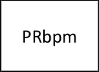 | Pulse rate  (bpm)
 | Type BF applied  part | 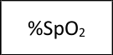 | Pulse oxygen  saturation (%)
 | 1. The finger clip  falls off (no  finger  inserted)  2. Probe error  3. Signal  inadequacy |  | Low-power  indication
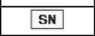 | Serial Number | 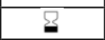 | Use-by date
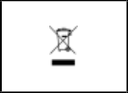 | Recycling  garbage WEEE  (2002/96/EC) | 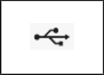 | USB
 | The sound  prompt  indication | 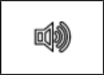 | The pulse  sound  indication
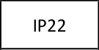 | International  Protection | 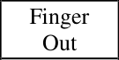 | The finger is  not inserted
 | Temperature  limitation |  | Fragile, handle  with care
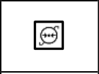 | Atmospheric  pressure  limitation | 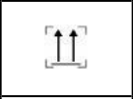 | This way up
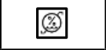 | Humidity  limitation |  | Keep away  from rain
 | Recyclable | 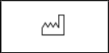 | Manufacture  date
 | Alarm inhibit | 
 | Possible Reason | 
 | 1. The finger is not  properly  inserted.  2. The finger is  shaking or the  patient is  moving.  3. The device is  not used in  environment  required by the  manual.  4. The device  works  abnormally. | 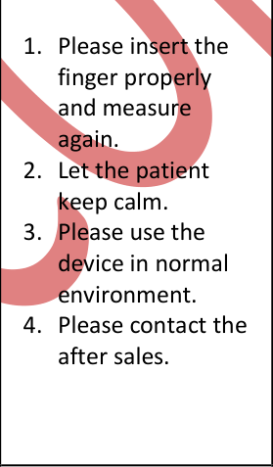
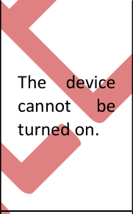 | 1. The battery is  drained away or  almost drained  away.  2. The battery is  installed  incorrectly.  3. The device’s  malfunction | 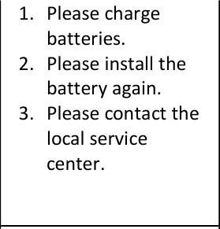
 | 1. The device  enters into the  energy saving  mode.  2. Low battery.  3. The device  works  abnormally. | 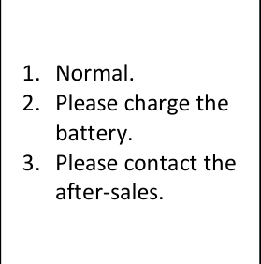
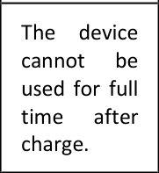 | 1. The battery is  not charged  fully.  2. The device  works  abnormally. | 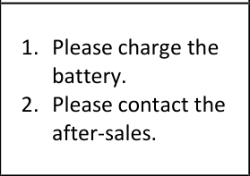
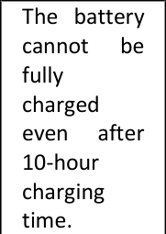 | The device works  abnormally. | 
 |  | 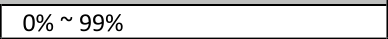

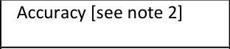 |  | 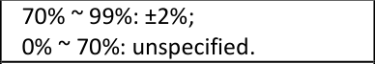

 | PR

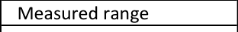 |  | 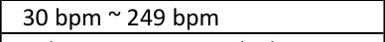
 |  | 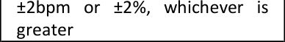

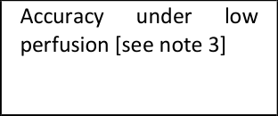 |  | 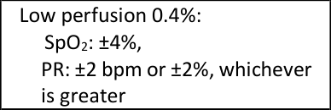
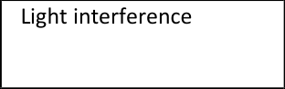 |  | 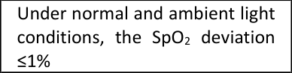
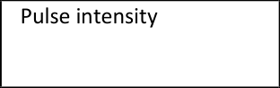 |  | 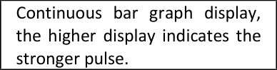
 | Upper and lower limit of measured values


 | Optical sensor [see note 4]
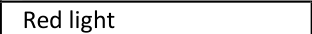
 | ymbol |  |  | Meaning |  |  | Symbol |  |  | Meaning
Optical output power: <6.65 mW
Infrared light Wavelength: about 905 nm
Optical output power: <6.75 mW
Safety class Internally powered equipment,
type BP applied part
International protection IP22
Working voltage DC 3.6V ~ 4.2V
Working current ≤ 80 mA
Power supply A rechargeable lithium battery
(3.7 V) (The red wire on the
battery denotes anode, the
black wire on the battery
denotes cathode).
Battery life Charge and discharge: no less
than 500 times.
Adapter specification Output voltage: DC 5V
Output current: 1000 mA
Dimension and Weight
Dimension 46(L) x 40(W) x 29(H) mm
Weight About 35 g (including a lithium
battery)
Display
Display Size 1.25inch
Appendix 1
State Sound prompt Sound prompt
condition delay signal generation
delay
Low voltage 1s 20ms
sound prompt
SpO2 sound 330ms 20ms
prompt
Pulse rate sound 330ms 20ms
prompt
Probe error 16ms 20ms
sound prompt

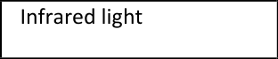 |  | 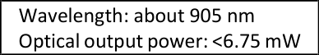
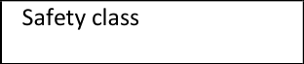 |  | 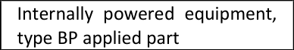



 |  | 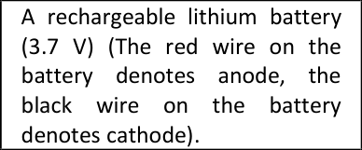
 |  | 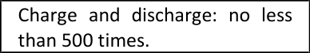
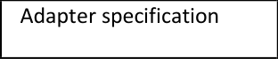 |  | 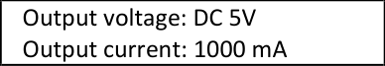
 | Dimension and Weight

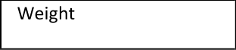 |  | 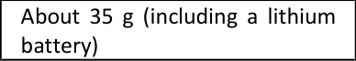
 | Display

 | Sound prompt  condition delay | 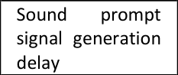
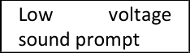 | 1s | 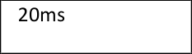
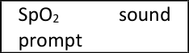 | 330ms | 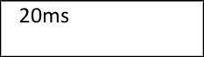
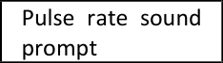 | 330ms | 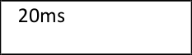
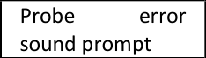 | 16ms | 