Classification

Dataset res.PCA

.

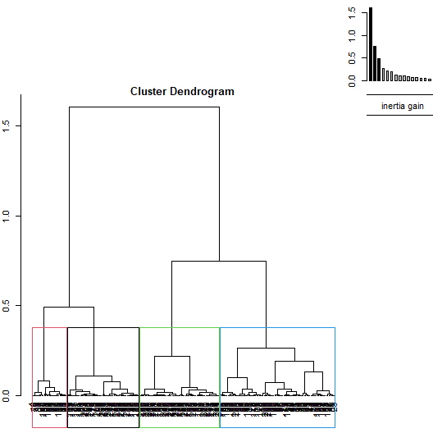

**Figure 1.1 - Hierarchical tree.**

The classification made on individuals reveals 4 clusters.

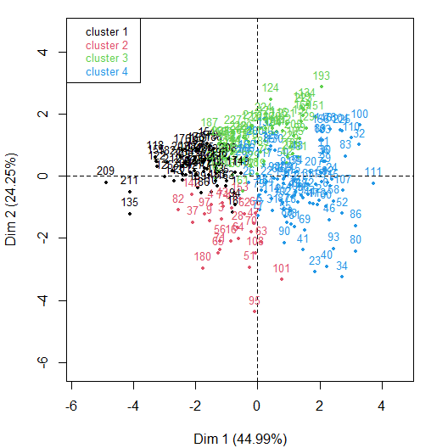

**Figure 1.2 - Ascending Hierarchical Classification of the individuals.**

The **cluster 1** is made of individuals such as *209*. This group is characterized by :

* high values for the variables *Adhesion*, *Proliferation_DMSO* and *CollagenIV* (variables are sorted from the strongest).
* low values for the variables *Mean_PXR*, *Mean_Vimentin*, *Mean_Ecad*, *Survival_20.uM* and *Survival_10.uM* (variables are sorted from the weakest).

The **cluster 2** is made of individuals such as *95*. This group is characterized by :

* high values for the variables *Survival_20.uM* and *Survival_10.uM* (variables are sorted from the strongest).
* low values for the variables *Mean_Vimentin*, *Mean_PXR*, *Mean_Ecad*, *Proliferation_DMSO* and *Proliferation_10.uM* (variables are sorted from the weakest).

The **cluster 3** is made of individuals sharing :

* high values for the variables *Proliferation_DMSO* and *Mean_Vimentin* (variables are sorted from the strongest).
* low values for the variables *Survival_20.uM*, *Adhesion*, *CollagenIV*, *Survival_10.uM*, *CollagenI* and *Mean_Ecad* (variables are sorted from the weakest).

The **cluster 4** is made of individuals such as *34*. This group is characterized by :

* high values for the variables *Mean_Ecad*, *Mean_PXR*, *Survival_20.uM*, *Mean_Vimentin*, *Survival_10.uM* and *Proliferation_20.uM* (variables are sorted from the strongest).
* low values for the variables *Proliferation_DMSO* and *Adhesion* (variables are sorted from the weakest).

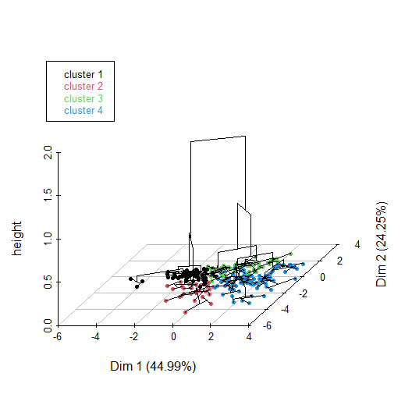

**Figure 1.3 - Hierarchical tree on the factorial map.**

The hierarchical tree can be drawn on the factorial map with the individuals colored according to their clusters.