Classification

Dataset res.PCA

.

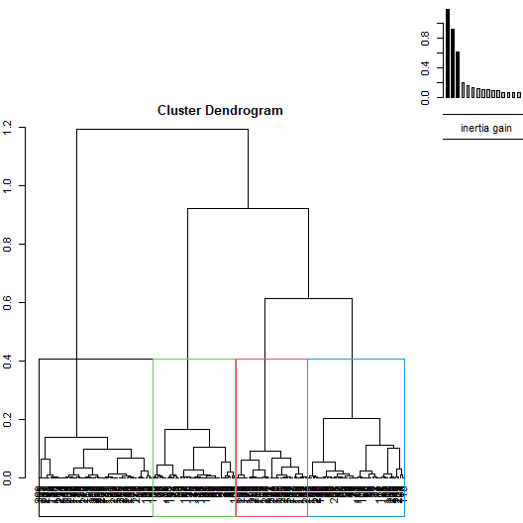

**Figure 1.1 - Hierarchical tree.**

The classification made on individuals reveals 4 clusters.

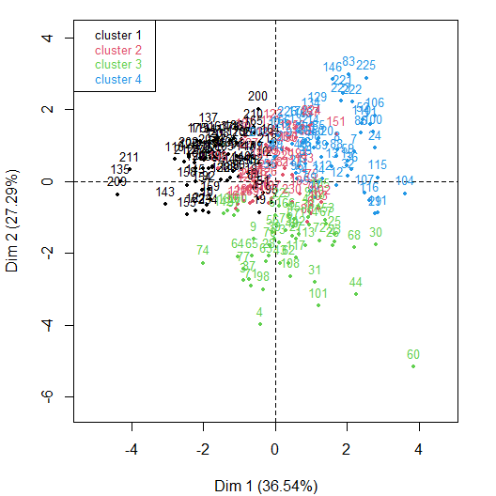

**Figure 1.2 - Ascending Hierarchical Classification of the individuals.**

The **cluster 1** is made of individuals such as *209*. This group is characterized by :

* high values for the variables *Cell_Number*, *Proliferation_DMSO*, *CollagenIV* and *CollagenI* (variables are sorted from the strongest).
* low values for the variables *Mean_PXR*, *Survival_20µM*, *Mean_Ecad*, *Survival_10µM*, *Mean_Vimentin* and *Proliferation_20µM* (variables are sorted from the weakest).

The **cluster 2** is made of individuals sharing :

* high values for the variables *Mean_Vimentin*, *Osteopontin* and *Hyaluronic_Acid* (variables are sorted from the strongest).
* low values for the variables *Cell_Number*, *Mean_Ecad*, *CollagenIV* and *CollagenI* (variables are sorted from the weakest).

The **cluster 3** is made of individuals such as *4* and *60*. This group is characterized by :

* high values for the variables *Survival_20µM*, *Proliferation_20µM*, *Survival_10µM* and *Fibronectin* (variables are sorted from the strongest).
* low values for the variables *Proliferation_DMSO*, *Mean_Vimentin*, *CollagenI*, *Cell_Number*, *Mean_PXR*, *Mean_Ecad* and *CollagenIV* (variables are sorted from the weakest).

The **cluster 4** is made of individuals sharing :

* high values for the variables *Mean_Ecad*, *Mean_PXR*, *CollagenI* and *Laminin* (variables are sorted from the strongest).
* low values for the variable *Cell_Number*.

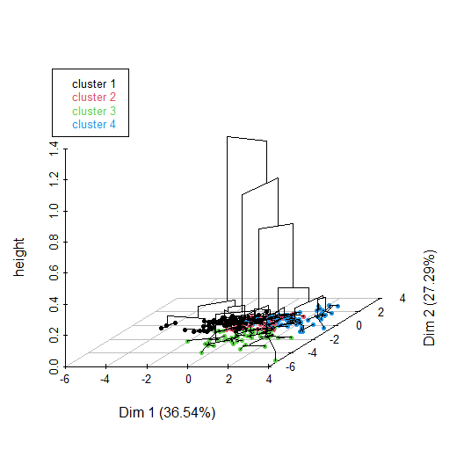

**Figure 1.3 - Hierarchical tree on the factorial map.**

The hierarchical tree can be drawn on the factorial map with the individuals colored according to their clusters.