A repeated measures ANOVA was conducted to examine the effect of distance (1-, 2-, 3-, 4-, 6-, and 10-step) and musicianship on participants’ relatedness responses. There was no significant difference between musicians’ and non-musicians’ responses, *F*(1, 62) = .022, *p* = .88. There was a significant main effect of distance, *F*(5, 310) = 77.47, *p* < .001, η2 = .383. Post hoc analyses, Bonferroni-adjusted for multiple comparisons, showed significant decreases in perceived relatedness from 1- to 2-steps (*p* = .016), 2- to 3-steps, (*p* < .001), 4- to 6- steps (*p* < .001), and 6- to 10-steps (*p* = .015). No significant difference was found between 3- and 4-steps (*p* = 1.00).

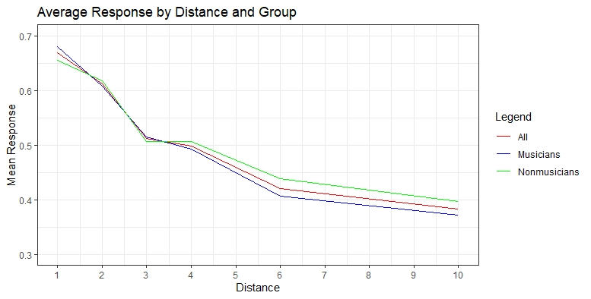

A second repeated measures ANOVA was conducted to examine the effect of distance (1-, 2-, 3-, 4-, 6-, and 10-step) and musicianship on participants’ reaction times. There was no significant difference between the reaction times of musicians and non-musicians, *F*(1, 62) = .001, *p* = .98. There was also no significant effect of distance on reaction time, *F*(5, 310) = 0.75, *p* = .584.

A close up of a map

Description generated with high confidence