Model Evalutaion and Selection

EfficientNet-B2 vs Swin-UNet

Summary of findings
Two architectures were run on the same tile and acquisition pair: EfficientNet-B2 and Swin-Unet (model_comparison.ipynb). Scored against the full ICNF ground-truth layer for the tile, without restricting to fires that the chosen before and after scenes could plausibly detect, EfficientNet-B2 leads on every pixel-based metric (Table 1): precision 0.471 against 0.316, recall 0.855 against 0.807, F1 0.607 against 0.454, and IoU 0.436 against 0.294. Both models clear the 'always predict burned' baseline (precision 0.020, recall 1.000, F1 0.039) by a wide margin, which indicates that the gap between them reflects a genuine difference in what each network has learned, rather than one model benefiting more than the other from the underlying class imbalance.
Table 1. Pixel-level metrics for both models against the full, uncorrected ICNF ground-truth layer.
Metric | EfficientNet-B2 | Swin-UNet
TP | 978,854 | 923,492
FP | 1,099,536 | 1,997,588
FN | 166,090 | 221,452
Precision | 0.471 | 0.316
Recall | 0.855 | 0.807
F1 | 0.607 | 0.454
IoU | 0.436 | 0.294

Decision
Decision: EfficientNet-B2 is adopted as the production model for this tile and acquisition pair. Swin-UNet's predictions are not carried forward into the post-processing analysis in the sections that follow.

Justification
The ICNF ground-truth layer used in the first pass of the comparison bakes in all 182 fires recorded for the tile in 2025, including fires that started before the chosen before-scene, already a scar by the time of the baseline image, and fires that started after the chosen after-scene, not yet visible in either image. Scoring these as missed detections penalises both models for events that neither image pair could register as a change, and depresses recall and inflates the false-negative count for reasons unrelated to model quality. Restricting ground truth to the 126 fires whose start and end dates fall inside the 2025-07-07 to 2025-10-15 observation window, and adding MCC alongside the existing metrics (MCC is the headline metric in the project's evaluation protocol, used instead of relying on F1 or IoU alone because both can look inflated when the positive class is a small minority of the tile, here around 1.7%), the same ordering holds, and the case for EfficientNet-B2 becomes sharper rather than weaker: MCC = 0.647 against 0.501 (Table 2). Recall rises for both models once the date filter is applied, EfficientNet-B2 from 0.855 to 0.912 and Swin-UNet from 0.807 to 0.849, which confirms that a meaningful share of the false negatives in the uncorrected comparison were undetectable fires rather than genuine misses.
Table 2. Pixel-level metrics for both models against the date-windowed, protocol-aligned ground truth (126 fires, 10 m eroded).
Metric | EfficientNet-B2 | Swin-UNet
TP | 977,653 | 909,873
FP | 1,100,737 | 2,011,207
FN | 94,167 | 161,947
MCC | 0.647 | 0.501
Precision | 0.470 | 0.312
Recall | 0.912 | 0.849
F1 | 0.621 | 0.456
IoU | 0.450 | 0.295

A paired test on the pixels where the two models disagree (McNemar's test) supports treating this gap as systematic rather than as noise in which pixels happened to differ: EfficientNet-B2 is correct on 69.6% of the 2,499,856 disputed pixels (chi-squared = 382,810, continuity-corrected). At this sample size, statistical significance is close to guaranteed regardless of effect size, so the discordant-pixel counts themselves, rather than the p-value, are what support the conclusion that EfficientNet-B2 resolves more than two thirds of the pixels the two models disagree on.

Where the gap comes from
Pixel-level metrics treat a 2 ha fire and a 2,000 ha fire equally, and cannot on their own say whether one model's advantage is concentrated in large fires, small fires, or spread evenly across both. Stratifying recall by fire size for the 12 evaluable fires in the tile (10 m eroded, area above roughly 66 ha, the threshold below which a fire is too small relative to the chip size to evaluate reliably) shows the two models are broadly comparable on the largest, most clearly defined fires, and Swin-UNet is occasionally slightly ahead: Bragança, 249 ha, 0.981 against 0.993; Montalegre, 237 ha, 0.967 against 0.986 (Table 3, Figure 2). The tile-wide gap in Tables 1 and 2 is therefore not a story about EfficientNet-B2 catching large fires that Swin-UNet misses.
Table 3. Per-fire recall by model for the 12 evaluable fires (10 m eroded), ordered by fire area.
Fire (municipality) | Area (ha) | EfficientNet-B2 recall | Swin-UNet recall
Montalegre | 4,196.6 | 0.924 | 0.885
Vinhais | 3,159.9 | 0.880 | 0.891
Montalegre | 1,101.9 | 0.980 | 0.788
Ribeira de Pena | 945.3 | 0.518 | 0.277
Chaves | 554.4 | 0.944 | 0.886
Vila Pouca de Aguiar | 489.5 | 0.869 | 0.636
Montalegre | 264.8 | 0.986 | 0.961
Bragança | 248.5 | 0.981 | 0.993
Montalegre | 237.1 | 0.967 | 0.986
Vinhais | 146.5 | 0.983 | 0.950
Montalegre | 128.6 | 0.964 | 0.734
Macedo de Cavaleiros | 90.3 | 0.975 | 0.990

It is better understood as a precision story. Across the tile, Swin-UNet produces roughly 1.8 times more false-positive pixels than EfficientNet-B2 (2,011,207 against 1,100,737) for broadly comparable recall (0.849 against 0.912). The error maps (Figure 1) show the spatial pattern behind this: Swin-UNet's false-positive pixels (green) are scattered across the tile rather than concentrated around fire boundaries, which is consistent with the two models' differing morphological closing radius (Swin-UNet 3 px, EfficientNet-B2 1 px). A larger closing radius bridges gaps inside a fragmented detection, which can help recall, but it also expands every detected blob's boundary outward, which costs precision broadly rather than at any single fire. This is a specific, testable explanation for the gap rather than a restatement of it: re-running Swin-UNet's post-processing alone at a 1 px closing radius, without re-running inference, would confirm or rule it out directly.
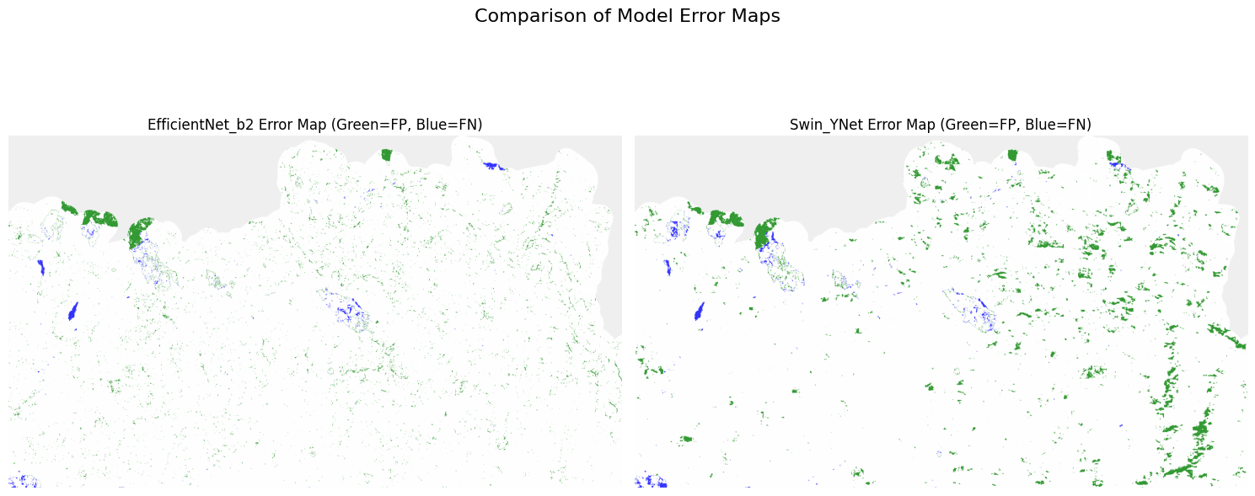
Figure 1. Error maps for EfficientNet-B2 (left) and Swin-UNet (right) against the date-windowed ground truth. Green marks false positives, blue marks false negatives.
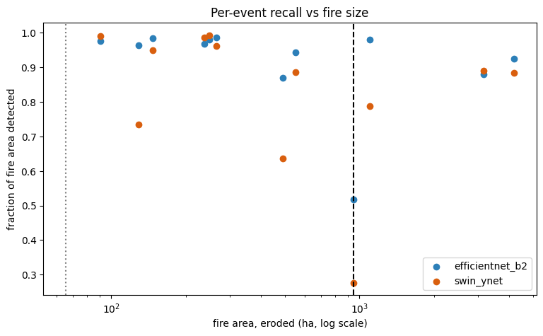
Figure 2. Per-fire recall against fire area (log scale, 10 m eroded) for the 12 evaluable fires. The dotted line marks the evaluable-size floor (about 66 ha); the dashed line marks the headline threshold (945 ha).
One result in Table 3 does not fit this pattern and is worth treating separately rather than folding into the headline comparison. Ribeira de Pena (945 ha, at the boundary of the headline size threshold) is the one fire where both models perform far worse than anywhere else in the evaluable set, including fires twice its size (EfficientNet-B2 0.518, Swin-UNet 0.277). Because both models fail together on this fire, the more likely explanation is something specific to this event or scene, for example the fire still being active past the after-date or a local imagery artefact, rather than a weakness in either network, so it is reported here as a flag for follow-up rather than treated as evidence against either model.

Limitations
Several aspects of this comparison constrain how far the result above should be generalised.
Both models were run on a single before/after scene pair for the whole tile, rather than per acquisition pair as the evaluation protocol specifies. Repeating the comparison once per acquisition pair would mean repeating full-tile inference for each additional pair, roughly 7 minutes per run for EfficientNet-B2 and 39 minutes for Swin-UNet on the hardware used here, which was judged not justified for a two-model comparison on one tile.
The after-scene (15 October 2025) was selected once for the whole tile, which means 9 of the 12 evaluable fires are scored against imagery 36 to 83 days after their recorded end date, beyond the 30-day ceiling the protocol specifies for matching a fire to its after-scene. Excluding all 9 would remove the two largest fires in the evaluable set (Montalegre, 4,197 ha; Vinhais, 3,160 ha) and leave only 3 small events, which would weaken the comparison's statistical power considerably. Restricting the per-fire recall figures to only the 3 fires that satisfy the 30-day rule gives a mean recall of 0.977 for EfficientNet-B2 and 0.828 for Swin-UNet, against 0.914 and 0.831 across the full 12-fire evaluable set: the gap between the two models is not narrowed by restricting to protocol-compliant fires, and the recall-against-staleness scatter (Figure 3) shows no clear monotonic relationship between days since the fire ended and recall over the 5 to 83 day range observed here. This is reported as a deviation from the protocol as written, checked empirically, rather than a fix to it.
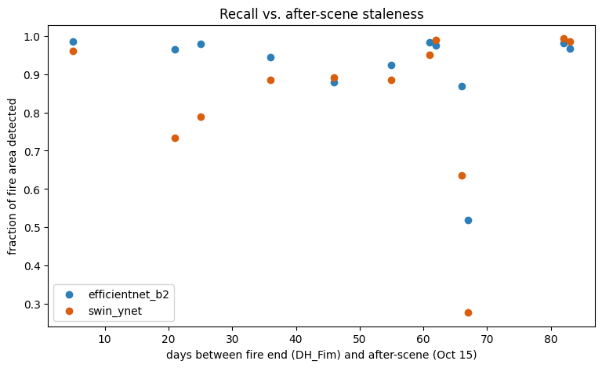
Figure 3. Per-fire recall against days between fire end date and the after-scene (15 October 2025), for the same 12 fires.
Fire polygons were eroded by a fixed 10 m before scoring, to remove boundary ambiguity, following the project's evaluation protocol. No sensitivity check was run at other erosion distances, so it is not established how much of the precision and recall gap between the two models is attributable to this boundary choice itself rather than to the models.
Scene eligibility for inference was decided at the level of the whole scene (fully clear or partially clear, based on swath coverage and aggregate cloud percentage), which would not catch localised cloud, cloud shadow, or smoke contamination within an otherwise eligible scene. Either model's input could be affected at the pixel level without this being visible in the scene-level metadata used here.
Only fully clear scenes were used for this run, narrower than the protocol allows, since it also permits partially clear scenes. This made no practical difference here, as fully clear scenes were available for both the chosen before and after dates, but the run as configured is narrower than what the protocol authorises.

Post-Processing Optimisation: Justification
The remaining sections optimise EfficientNet-B2's post-processing pipeline, the model selected above. Table 4 pools every configuration tested across the three post-processing levers (window overlap alone, voting strictness alone, and the minimum-size filter applied on top of a fixed overlap and vote threshold) and ranks them by MCC, following the same approach used efficientnet_evaluation.ipynb Section 7, ‘Optimum setting’. All eight top-ranked rows apply a large minimum-size threshold (625 to 975 px) on top of 50% overlap and a 75% vote threshold, since adding more filtering keeps raising MCC within the range tested.
As Section 4 sets out, this ranking is a useful starting point but should not be read as the final recommendation for the minimum-size filter. MCC is an area-weighted aggregate, and it is largely insensitive to what a higher threshold does to the detection of fires smaller than about 20 ha. The sections that follow work through each lever in turn and state where the evidence supports adopting this ranking directly, and where, as with minimum size, further evidence changes the recommended operating point.
Table 4. Top eight configurations tested across all post-processing levers, ranked by Matthews correlation coefficient (MCC).
Rank | Setting | Burned area (ha) | Precision | Recall | F1 | MCC
1 | Overlap 50%, vote ≥ 75%, min size 975 px | 10,701 | 0.892 | 0.898 | 0.895 | 0.893
2 | Overlap 50%, vote ≥ 75%, min size 925 px | 10,720 | 0.891 | 0.898 | 0.894 | 0.892
3 | Overlap 50%, vote ≥ 75%, min size 875 px | 10,738 | 0.889 | 0.898 | 0.893 | 0.891
4 | Overlap 50%, vote ≥ 75%, min size 825 px | 10,780 | 0.886 | 0.898 | 0.892 | 0.890
5 | Overlap 50%, vote ≥ 75%, min size 775 px | 10,845 | 0.882 | 0.899 | 0.890 | 0.888
6 | Overlap 50%, vote ≥ 75%, min size 725 px | 10,897 | 0.878 | 0.900 | 0.889 | 0.887
7 | Overlap 50%, vote ≥ 75%, min size 675 px | 10,946 | 0.875 | 0.901 | 0.888 | 0.886
8 | Overlap 50%, vote ≥ 75%, min size 625 px | 11,004 | 0.872 | 0.902 | 0.887 | 0.885
For comparison, the setting recommended in Section 4 (overlap 50%, vote ≥ 75%, min size 100 px) scores precision = 0.748, recall = 0.909, F1 = 0.821, MCC = 0.821, lower on every metric above than the rows in Table 4. The reasoning behind that recommendation, and why a lower MCC is accepted here, is given in Section 4.

2. Window Overlap

Summary of ‘best’
Four window overlaps were tested: 0%, 25%, 50% and 75%. MCC is highest at 50% overlap (MCC = 0.762, F1 = 0.756, precision = 0.646, recall = 0.912) and falls slightly at 75% overlap. Precision increases substantially between 0% and 50% overlap, as repeated voting cancels out scattered false alarms produced by individual windows. Recall stays high throughout (0.909 to 0.925) and is not strongly affected by the choice of overlap.

Optimal setting
Decision: 50% window overlap with a plain majority vote.
This is the highest-MCC overlap tested, and it is also the point at which the precision gained from additional overlap begins to level off relative to its computational cost. Increasing overlap to 75% raises run time considerably (Section 2.3 of the efficientnet_evaluation.ipynb ) for a comparatively small change in F1, before any vote-strictness or size filtering is applied.

Strategy name
Spatial vote aggregation across overlapping inference windows.

Optimal decision
Run inference at 50% window overlap and combine the resulting predictions by majority vote, rather than at 0% overlap (no aggregation), 25%, or 75%.

Justification
MCC is used as the ranking criterion throughout the efficientnet_evaluation.ipynb because it accounts for all four cells of the confusion matrix and is not inflated by class imbalance in the way F1 can be. Recall changes little across the four overlaps tested (0.909 to 0.925), so in practice the choice between them is determined mainly by precision, and 50% overlap captures most of the precision gain available from voting before returns diminish at 75%.

Observations and alternatives considered
The efficientnet_evaluation.ipynb records, in Sections 2.1 and 2.2, that overlapping windows and voting reduces scattered false alarms, so precision and the summary scores increase with overlap while recall stays high, and that the plain majority vote tends to peak around 50% overlap. The cost analysis in Section 2.3 shows that run time increases steeply as overlap approaches 75%, since the number of windows processed grows, while memory use stays roughly constant. This is a secondary consideration worth noting alongside the MCC result, since both point in the same direction.
An alternative considered was to recommend 75% overlap on the basis that its finer, 16-window vote granularity might be useful once a stricter vote threshold is applied later in the pipeline (Section 3). For the plain majority vote alone, however, 75% overlap does not improve on the MCC achieved at 50% and adds noticeably more computation, so it was not adopted at this stage. Section 3 shows that the additional resolution available at 75% overlap only becomes useful once a non-default vote threshold is introduced.
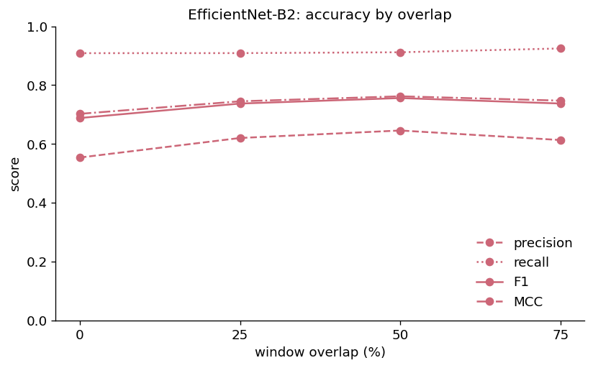
Figure 4. Precision, recall, F1 and MCC for EfficientNet-B2 across the four window overlaps tested.

3. Voting Strictness

Summary of ‘best’
At 50% overlap, raising the vote threshold from 50% to 75% increases MCC from 0.700 to 0.762. At 75% overlap, MCC increases at every threshold tested (50%, 60%, 70%, 80%), reaching its highest value across the whole sweep, 0.796, when at least 80% of the windows covering a pixel are required to vote burned.

Optimal setting
Decision: 75% window overlap with a vote threshold of at least 80%.
This is the highest-MCC configuration found in the strictness sweep, and it is the one point in this analysis where 75% overlap outperforms 50% overlap. The finer, 16-window vote granularity available at 75% overlap appears to matter only once the threshold is set strictly enough to make use of it.

Strategy name
Vote-fraction threshold applied to decide whether a pixel is classified as burned.

Optimal decision
Require at least 80% of the windows covering a pixel to vote burned, using the 75% overlap raster, rather than the looser 50% majority used as the baseline elsewhere in the efficientnet_evaluation.ipynb .

Justification
Within the sweep tested, MCC and F1 increase with stricter voting at both overlaps, and the 75% overlap curve reaches the highest point of either curve at its strictest setting. Because the sweep stops at 80%, this is the best point demonstrated rather than a confirmed interior maximum: the F1 and MCC curves in Section 3.1.1 are still rising at the right-hand edge of the range tested, so a stricter threshold, for example 85% to 90%, might perform marginally better and would be worth testing before this setting is finalised.

Observations and alternatives considered
The efficientnet_evaluation.ipynb records, in Section 3.1.1, that a stricter vote increases F1 and MCC, and that 75% overlap keeps improving across the finer range tested, reaching the highest scores overall because its 16-window coverage gives the strict vote more information to work with. Section 3.2.1 shows this visually: false positives thin out while the true fires remain intact as the threshold is tightened.
The recall cost of this lever is modest. Going from a 50% to an 80% vote threshold at 75% overlap reduces recall by 4.2 percentage points (0.935 to 0.893), and this cost is spread fairly evenly rather than concentrated in particular fire sizes, in contrast to the minimum-size filter discussed in Section 4. For this reason, a looser threshold was not adopted to protect recall in this section; the trade-off here does not raise the same concern about small fires that motivates a different approach to minimum size.
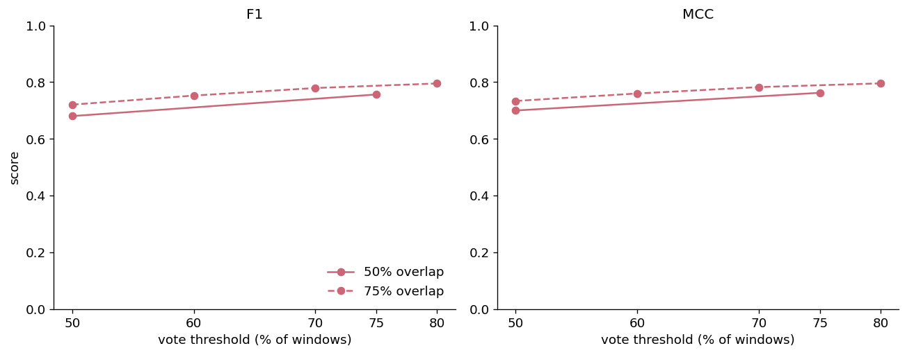
Figure 5. F1 and MCC against vote threshold, compared at 50% and 75% window overlap.

4. Minimum Pixel Size

Summary of ‘best’
Across the full minimum-size sweep (50% overlap, vote thresholds of 50% and 75%, sizes from 25 to 975 px), MCC increases with the size threshold throughout the range tested and does not level off by 975 px (MCC = 0.893 at a 75% vote threshold and 975 px, the highest value recorded, as shown in Table 4).

Optimal setting
Decision: a vote threshold of at least 75% with a minimum blob size of 100 px (1 ha).
This setting does not follow the MCC ranking in Table 4. That ranking favours increasingly large thresholds for a reason unrelated to detection quality: aggregate recall is dominated by a small number of very large fires, so MCC is largely insensitive to what happens to fires below about 20 ha as the threshold rises. The evidence for this is set out below.

Strategy name
Minimum connected-component (blob) size filter applied to the voted burned mask.

Optimal decision
Discard predicted burned blobs smaller than 100 px (1 ha) from the 50% overlap, 75% vote-threshold raster, rather than the larger thresholds, 500 to 975 px, favoured by MCC alone.

Justification
The error maps produced indicated that increasing minimum pixel size reduced false positives and this was supported by the MCC table as an optimisation strategy. However, this did not take into account the impact of excluding smaller classes of fire from the model detection.

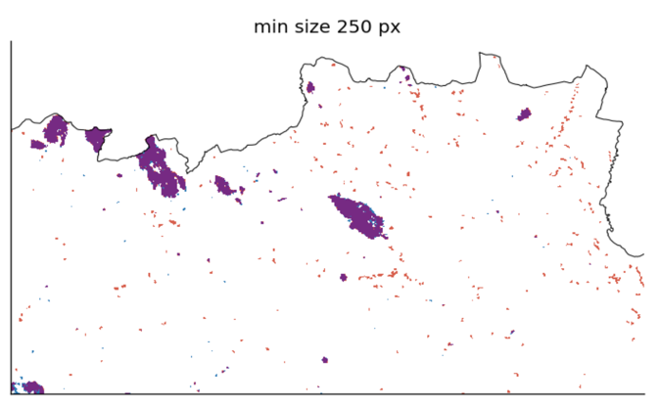
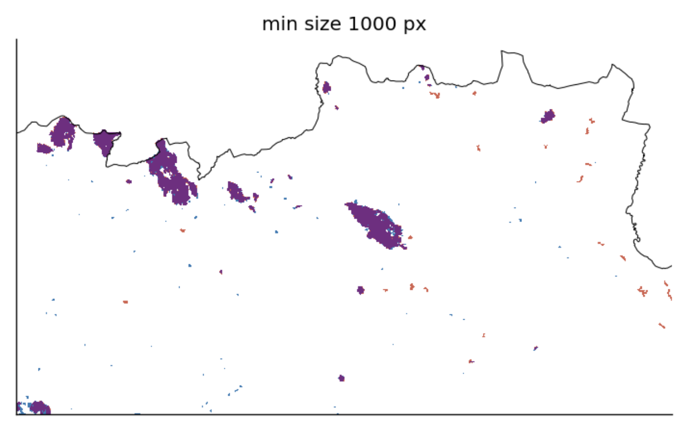
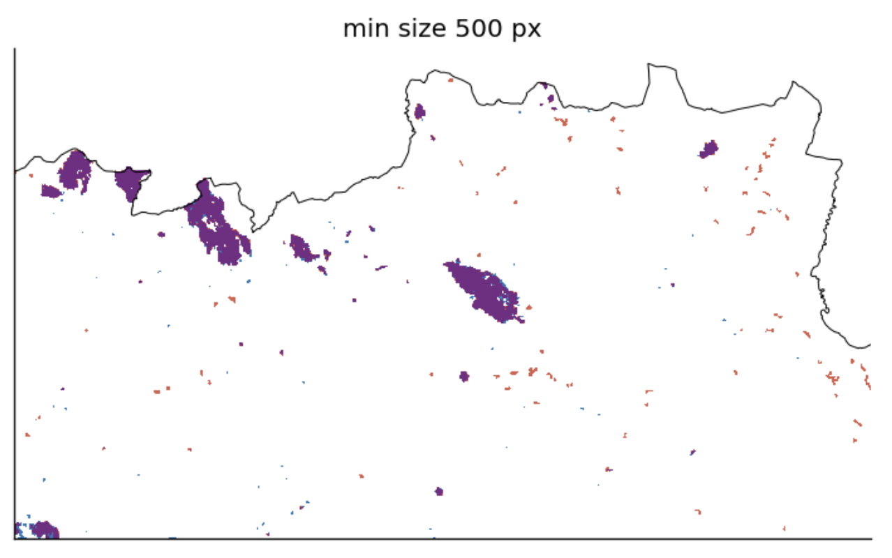
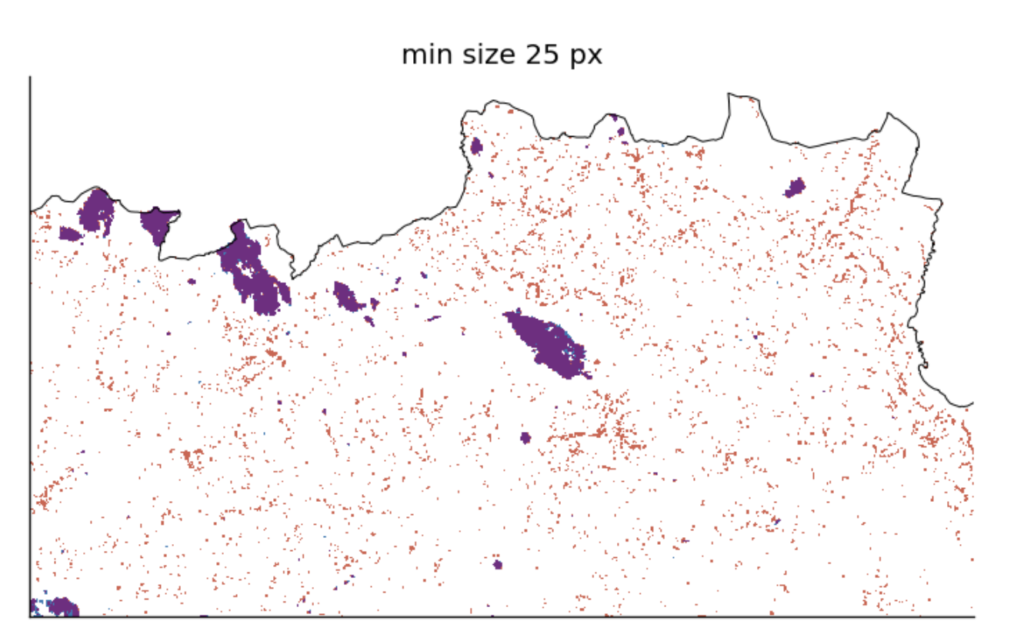

The count-based and area-based ‘fires missed’ calculations (Section 4.1.3) give contrasting accounts of the same filter (Table 5). Counted as individual ground-truth patches, up to 92.7% of fires are classed as missed once the threshold reaches 1000 px. Counted by area, only 2.34% of true burned hectares are missed at the same threshold, while precision and MCC continue to improve across the same range. This contrast arises because the ground-truth fire-size distribution is strongly right-skewed (n = 383 patches, ranging from 1 to 319,798 px, median 9 px): a small number of large fires account for almost all of the burned area, so a patch-count metric is dominated by very small patches that contribute little to total area, while an area-weighted metric such as MCC registers their loss only slightly.
Second, a per-fire recall check by official ICNF fire-size class (Table 6) shows that the minimum-size filter does not mainly remove false positives in the 1 to 20 ha range; it removes correct detections the model had already made. Comparing the unfiltered, vote-only prediction against the same prediction after a 500 px filter, recall for the 1 to 10 ha class falls from 0.796 to 0.341, and the 10 to 20 ha class falls from 0.912 to 0.700, while every class of 20 ha or larger is unaffected, since predicted blobs at that scale already exceed 500 px regardless of filtering. At 100 px, the same comparison shows a recall loss of only 1.3 percentage points for the 1 to 10 ha class (0.796 to 0.783) and no measurable loss for the 10 to 20 ha class, so most of the small-fire detection already present in the raw prediction is retained. The 100 px threshold also corresponds exactly to 1 ha, matching the boundary already used by the ICNF size classification, so the filter excludes only the sub-hectare class, which the raw recall figures show was already poorly detected before any filtering (0.385), rather than the 1 to 20 ha range the model detects reasonably well.
Table 5. Fires missed by the minimum-size filter, counted by patch and by area, at five threshold values (50% overlap, 75% vote threshold).
Min size (px) | Precision | MCC | Fires missed by count (%) | Area missed (%) | Area missed (ha)
25 | 0.651 | 0.765 | 59.0 | 0.09 | 9.3
250 | 0.807 | 0.852 | 85.1 | 0.99 | 105.2
500 | 0.861 | 0.880 | 89.8 | 1.59 | 169.4
750 | 0.879 | 0.887 | 91.4 | 1.94 | 205.9
1000 | 0.892 | 0.893 | 92.7 | 2.34 | 248.8

Read together, the rows of Table 5 show why a single accuracy figure is not sufficient justification for this lever on its own. As the threshold rises, precision and MCC both improve steadily, which on its own would support choosing the largest threshold tested. The proportion of individual fires counted as missed rises even faster, from 59.0% to 92.7%, which on its own would argue against any filtering at all. The proportion of burned area missed, by contrast, stays below 2.5% throughout, because the patches being excluded are almost all very small. None of these three figures is wrong; they describe different things, and the size-class breakdown in Table 6 is needed to determine which fires are actually being lost as the threshold increases.
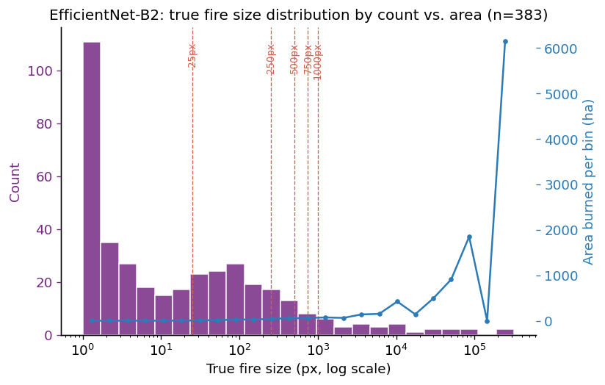
Figure 6. True fire-size distribution by count (bars, log-scaled bins) and cumulative area burned per bin (line, secondary axis). Dashed lines mark the previously tested threshold values (25, 250, 500, 750 and 1000 px); the right-skew shown here is the basis for the contrast between count-based and area-based missed-fire rates in Table 5.

Observations and alternatives considered
The efficientnet_evaluation.ipynb 's own commentary on this lever, in Sections 4.1.1 to 4.1.4, raises the same tension addressed above. Section 4.1.1 notes that precision, F1 and MCC all increase with threshold while aggregate recall changes very little, since real fires are far larger than the threshold being tested, and suggests the sweep should be extended to higher thresholds to find where it levels off. This was done here, up to 975 px, and MCC was found still to be increasing with no interior maximum within the range tested. Section 4.1.4's marginal-efficiency calculation, precision gained per percentage point of area sacrificed, is highest in roughly the 75 to 300 px range and falls away past about 600 px, which is consistent with staying well below the 625 to 975 px range favoured in Table 4.
Three alternative thresholds were considered before settling on 100 px. The pooled MCC ranking in Table 4 was set aside for the reasons explained above. A threshold of 300 px, at the upper end of a range previously proposed as a way to limit the drop in recall, was also set aside: at 300 px, recall for the 1 to 10 ha class has already fallen by 37.2 percentage points relative to the unfiltered prediction (0.796 to 0.424), so the upper end of that range gives away most of the protection that the lower end preserves. Removing the filter altogether (0 px) was set aside because it leaves the largest number of scattered single- and two-pixel false positives with no corresponding benefit, and the raw per-fire detection rate for the smallest size class, 0.385, confirms that sub-hectare fires are not reliably detected in any case, so little further benefit is gained by setting the threshold below 100 px.

Supporting evidence: raw and filtered recall by ICNF fire-size class
Table 6. Per-fire recall (10 m-eroded polygon mask) before and after the minimum-size filter, by official ICNF size class. The filter cost columns give the percentage points of recall lost to filtering alone, isolated from the underlying detection capability of the model.
ICNF class | Raw recall (no filter) | Filtered at 100 px | Filtered at 500 px | Cost at 100 px (pp) | Cost at 500 px (pp)
0 to 1 ha | 0.385 | 0.281 | 0.148 | 10.4 | 23.7
1 to 10 ha | 0.796 | 0.732 | 0.341 | 6.4 | 45.5
10 to 20 ha | 0.912 | 0.882 | 0.700 | 3.0 | 21.2
20 to 50 ha | 0.992 | 0.992 | 0.992 | 0.0 | 0.0
50 to 100 ha | 0.977 | 0.976 | 0.976 | 0.1 | 0.1
100 to 500 ha | 0.940 | 0.940 | 0.940 | 0.0 | 0.0
500 to 1000 ha | 0.694 | 0.690 | 0.673 | 0.4 | 2.1
1000+ ha | 0.935 | 0.935 | 0.933 | 0.0 | 0.2
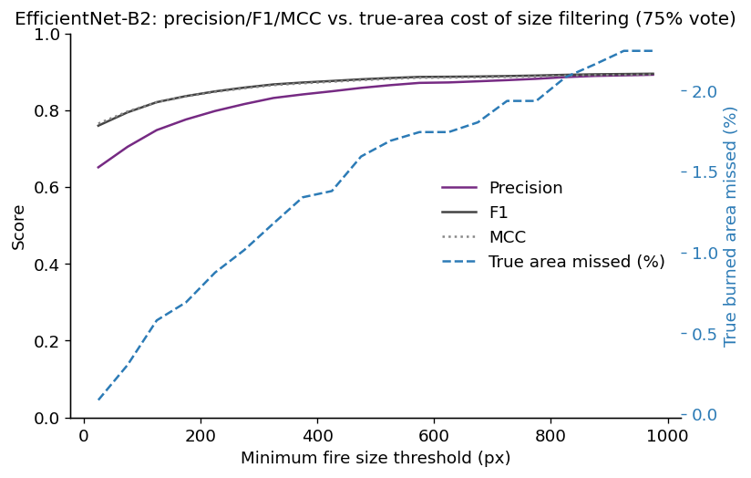
Figure 7. Precision, F1 and MCC (left axis) against cumulative true-area missed (right axis, dashed) across the full minimum-size sweep. The area cost stays under 2.5% even at the highest threshold tested, which is why an area-weighted aggregate metric alone is not sufficient to choose this threshold.

5. ROC / Precision-Recall Curves

Summary of ‘best’
The ROC and precision-recall curves are built from the raw vote fraction, before any threshold is applied, at 50% and 75% window overlap. ROC AUC is high at both overlaps (0.971 at 50%, 0.978 at 75%), while average precision (AP) is lower and shows a larger difference between the two settings (0.677 at 50%, 0.748 at 75%). On both curves, 75% overlap performs better.

Optimal setting
Decision: use the vote fraction computed at 75% overlap as the underlying score, and report average precision rather than ROC AUC as the headline measure of how well that score discriminates burned from unburned pixels.
This is not an operating-point decision in the sense of Sections 2 to 4, since no single vote threshold is chosen here (that is addressed in Section 3). Instead, it confirms that the vote fraction is a useful ranking score before any threshold is applied, and identifies which summary statistic should be reported alongside it.

Strategy name
Threshold-free evaluation of the raw vote-fraction score, using ROC and precision-recall curves.

Optimal decision
Report average precision rather than ROC AUC as the headline discrimination measure, and prefer the score computed at 75% overlap over the score computed at 50% overlap.

Justification
Burned pixels form a small minority of the tile, and ROC AUC is known to overstate performance under heavy class imbalance, because the false-positive-rate axis is normalised by a very large negative class, so a moderate number of false positives barely changes it. Average precision is computed from precision, which is sensitive to exactly this imbalance, and it shows a wider, more discriminating range (0.677 to 0.748) than ROC AUC (0.971 to 0.978) for the same two settings. The difference between overlaps is also consistent with the MCC ranking in Section 2: 75% overlap produces the better-separated score even though it was not the MCC-optimal plain-vote setting, in line with Section 3's finding that 75% overlap becomes useful once a stricter operating point, whether a vote threshold or a precision-recall-based criterion, is applied to it.

Observations and alternatives considered
The efficientnet_evaluation.ipynb records, in Section 5.1.1, that the ROC areas “look near-perfect, but that is the imbalance flattering the result; the precision-recall average precision is the trustworthy number for this rare-event problem, and it improves with overlap.” This analysis sits upstream of the threshold decisions made elsewhere in this document: it does not select an operating point, but it justifies treating the vote fraction as a discriminative score worth thresholding at all, and it supports the use of MCC and average precision, rather than plain accuracy or ROC AUC, as the metrics relied on in Sections 2 to 4.
Reporting ROC AUC as the headline figure was considered, since it is a more commonly recognised statistic in some contexts, but this was not adopted given the evidence that it overstates performance here. Average precision is the more defensible figure to carry forward into the discussion section of the main report.
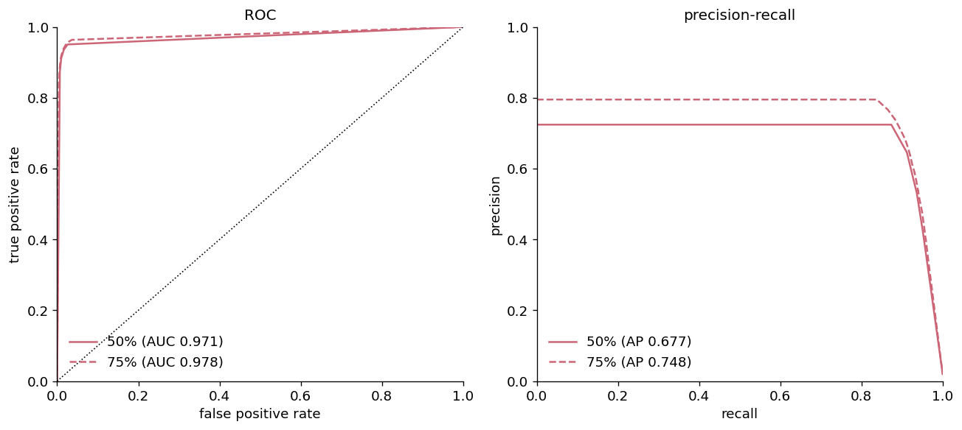
Figure 8. ROC (left) and precision-recall (right) curves built from the raw vote fraction, at 50% and 75% window overlap.

Cross-strategy note
Window overlap and voting strictness are each chosen at a clear MCC maximum within the range tested, and these choices agree with the overview ranking in Table 4. Minimum size is the one lever where the ranking in Table 4 and the recommended setting differ, because MCC, as an area-weighted aggregate, gives little weight to the harm this filter does to fire-size classes that contribute a small share of total burned area. This difference should be stated explicitly in the discussion section of the main report, since a reader comparing this document with the efficientnet_evaluation.ipynb 's own Section 7 ‘Optimum setting’ output might otherwise read it as inconsistent rather than as a deliberate, evidence-based departure.

