**Biology 302: Ecology Laboratory**

**Using Stable Isotopes to Assess Food Web Ecology in a Tailwater Fishery**

**Stable Isotopes**

Stable isotopes are alternative forms of atoms that differ in the number of neutrons contained in their nuclei. Stable isotopes maintain the same chemical properties of their elements, but differ in their atomic mass. These are non-radioactive atoms (as opposed to those that experience radioactive decay with a certain half-life, such as carbon-14 to carbon-12 used for radiometric dating), that are used by ecologists, climatologists, fisheries biologists, paleoecologists, soils scientists, and many others. Stable isotopes are commonly used to track changes in climate, track migratory patterns of birds, butterflies, mammals, and more, match organisms to their environments and/or diets (e.g., breeding birds, anadromous fishes), assess food web bioenergetics, document ecosystem changes through time, measure soil carbon budgets and soil microbial activity, etc. Some commonly used stable isotopes include hydrogen (2H/1H), carbon (13C/12C), oxygen (18O/16O), and nitrogen (15N/14N). Researchers often examine isotopic ratios, designated as **delta values**, to answer their questions of interest (Peterson and Fry 1987). For example, δ18O is a measure of 18O and 16O stable isotope ratios, and is commonly used to assess hydrographic properties of sediment carbonates, such as salinity and temperature, to estimate microenvironmental conditions at the time of sediment deposition (Wanamaker et al. 2007). Another example is the use of δ13C and δ15N to infer animal diets and evaluate ecosystem trophic structure (Hershey et al. 2017).

Stable isotopes are measured as a function of the ratio of the more common isotope to the less common isotope, relative to same ratio measured in a global standard. This value is multiplied by 1,000, and the results are therefore reported in parts per thousand, called **permil** or **per mil**, which is represented by the symbol **‰**. Note that this is different from a percent sign, %, which is shorthand for parts per hundred (per *cent*, from the Latin *centum*, meaning 100).

Using carbon from a plant as an example, we would place our sample in an **elemental analyzer** along with a sample of the global standard for carbon, Vienna Pee Dee Belemnite (VDPB). The elemental analyzer combusts the sample, and a **mass spectrometer** counts the number of atoms of the rare isotope (13C) and the number of atoms of the common isotope (12C) in the plant’s tissues. The instruments then repeat the measurements on our standard. We calculate the isotopic signature of our sample from those counts. Organic carbon (the carbon produced by living organisms) is almost always isotopically negative. For example, the tissues of plants range from a δ13C of -10‰ to -24‰, depending on the kind of plant and its environment. This is because plants preferentially use the lighter isotope of carbon, which is the most common in nature (more than 98% of the global carbon pool). The negative value simply shows that there is less of the heavier (rare) isotope relative to the lighter (common) one in the plant’s tissues when compared to the standard. We will use the property whereby one isotope of an element is used more frequently than another, called **fractionation**, to understand a food web in one of our local streams.

**Trophic Levels**

Organisms need energy to fuel the myriad metabolic processes inside their cells. Producers can convert light (or thermal) energy into usable chemical energy, whereas consumers must obtain energy through their diets. Organisms can be grouped into **trophic levels** that are descriptive of how they attain their energy. The lowest trophic level consists of the **producers** (or autotrophs) within a system (i.e., plants and algae). The next level up is made up of **primary consumers** (or heterotrophs) in the system (i.e., herbivores, planktivores) that gain energy by consuming producers. **Secondary consumers** (i.e., carnivores) comprise the third trophic level, and attain energy by consuming primary consumers. Depending on the ecosystem, there can be **tertiary consumers** (sometimes carnivores, sometimes omnivores), and **apex predators** that feed on primary, secondary and tertiary consumers if there is enough energy in the system to support that many trophic levels. A general rule of thumb is that approximately 10% of the energy at one trophic level makes it to the next highest trophic level, although that varies from system to system (Molles and Sher 2019).

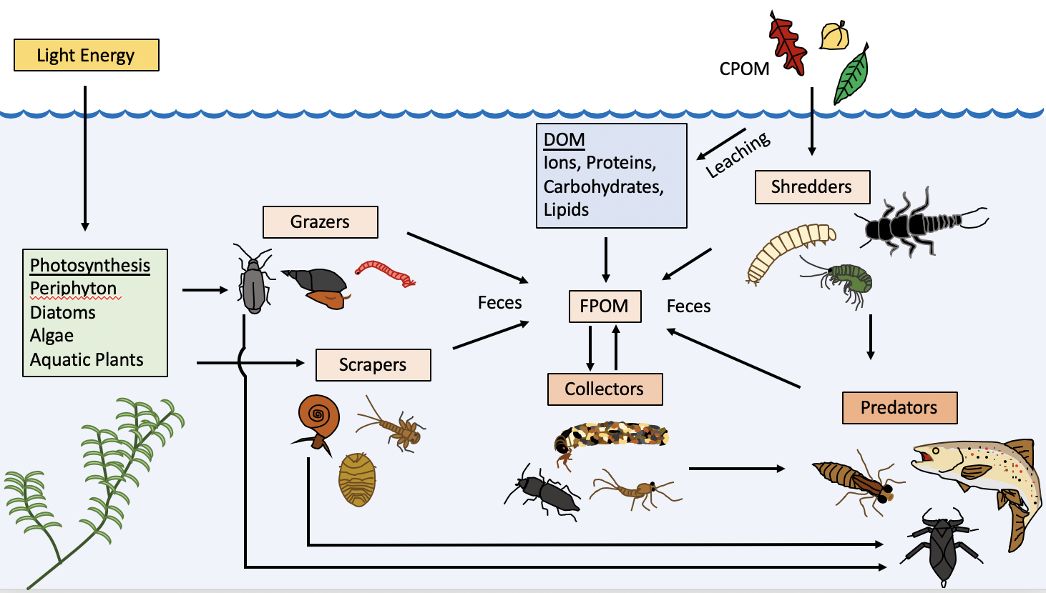We will examine stable isotopes among trophic levels in a tailwater fishery (the catch-and-release section of the Taylor River, just below Taylor Park Reservoir). Freshwater aquatic ecosystems can sometimes be slightly different in terms of energy flow because some materials from the terrestrial environment are incorporated as **allochthonous material** (e.g., dead leaves, fallen branches/trees, otherwise known as **course particulate organic matter** or **CPOM**) that are consumed by **shredders** (e.g., crane flies, some caddisflies, some stoneflies, some midges), so there is a large **detritus**-based component to many freshwater stream food webs. Shredders convert CPOM into **FPOM (fine particulate organic matter)** that may be consumed by downstream **collectors** (e.g., some caddisflies, some beetles, some dipterans, some midges). Physical breakdown of CPOM can also result in **DOM** **(dissolved organic matter)** that can be consumed by zooplankton (e.g., diatoms, water fleas). Freshwater ecosystems also contain **autochtonous material** (e.g., microbes, plankton, algae) that originate within the stream. **Scrapers** (e.g., some snails, some caddisflies, some midges, some fish) and **grazers** (e.g., mayflies, some beetles, some snails, suckers water fleas) often consume these materials. Of course, there are secondary consumers, tertiary consumers, and apex predators within these ecosystems as well (e.g., dragonflies, some midges, insectivorous fishes, piscivorous fishes, birds of prey [such as eagles, cranes and osprey], and some mammals). A hypothetical freshwater stream food web is diagramed in Fig. 1. The organisms we will see should be different than these, but the same groups (shredders, collectors, scrapers, predators) should be represented.

Fig. 1. A graphical representation of a typical stream food web depicting energy flow across multiple trophic levels (modified after Merritt and Cummins 1996)

**Sampling Techniques**

Because we seek to collect organisms from several trophic levels, we will need to employ an array of sampling methods. These are outlined as follows:

*Plankton sampling*

 We will use a plankton tow net to conduct oblique plankton tows (Fig. 2). These nets have a conical shape with mesh sides that allows outflow of water while keeping plankton within the screen. The focal point of this conical net is a collection jar that accumulates plankton. It is typically important to standardize the distance of the tow, to be able to calculate the volume of water sampled. We will try a meter at first, knowing that it may require longer tows if we do not get much plankton. It is also important to try and keep the net at the same depth for the duration of the tow to sample the same plankton community for the duration of the tow. Once the tow is complete, wash any plankton that is clinging to the sides of the net down into the collection jar with a wash bottle. These samples will need to be sorted in the laboratory.

Fig. 2. Depiction of an oblique plankton tow

*Macroinvertebrate sampling*

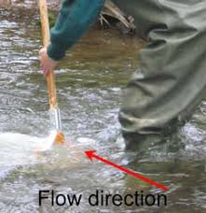 We will sample aquatic macroinvertebrates using different techniques. The first is the use of a kick net. The technique is relatively simple: Place the net perpendicular to the flow of the river, then kick your feet along the bottom, so that rocks are overturned and the current will carry any dislodged macroinvertebrates into the mouth of the net (Fig. 3). Do this for 30 seconds, then transfer the sample into a plastic tray where it can be picked through and the macroinvertebrates removed using forceps (it is important not to touch these bare-handed so oils do not contaminate the samples). Sort the macroinvertebrates into categories (grazers, scrapers, shredders, predators).

Fig. 3. Kick net technique

fba.org.uk

The other method we will use to sample aquatic macroinvertebrates is a drift net. The idea is similar to that of a kick net, with the difference being that these nets are set in the current, and checked after some amount of time without necessarily kicking the substrate in front of them. Some scientists check these every hour for a 24 hour period, then repeat for different days or seasons, but we will set them when we arrive at the site, and take them down when we are finished with the other sampling. Macroinvertebrates will be collected and sorted as described above. There is a good chance that we will get algae, aquatic plants, or even CPOM off the drift nets as well.

*Fish sampling*

A subset of the class will spend their time angling for trout in an attempt to catch an apex predator from this system for our analysis. This is a catch and release area, only artificial flies and lures may be used, and anglers must have a valid Colorado fishing license. If successful, we will take a fin clip (they regrow) and release the fish back into the river.

We will need to store our samples in properly labeled Ziploc bags for transportation to Western (on ice), where they will be frozen until we are able to sort samples in the laboratory.

**Laboratory Techniques**

*Sorting samples*

Because we are evaluating food web dynamics, it is important that our samples be properly sorted into the major categories of a stream food web: detritus, producers, primary consumers, secondary consumers, tertiary consumers, and apex predators. Once sorted, each category should be placed in a separate Ziploc or Whirl-Pak bag and frozen until they can be processed further. More instructions on how to prepare samples will be provided at a later date.

**Literature Cited**

Hershey, AE, RM Northington, JC Finlay, BJ Peterson (2017) Stable isotopes in stream food webs. *Methods in Stream Ecology Volume 2: Ecosystem Function,* pp 3-20.

Merritt, R., and K. Cummins (1996) An introduction to the aquatic insects of North America. 3rd edition. Kendall/Hunt Publishing Company, Dubuque, IA.

Molles, MC, Jr., AA Sher (2019) Ecology Concepts and Applications. McGraw Hill Higher Education. 592 pages.

Peterson, BJ, B Fry (1987) Stable isotopes in ecological studies. *Ann. Rev. Ecol. Syst.* 18:293-320.

Wanamaker, AD, Jr., KJ Kreutz, HW Borns Jr., DS Introne, S Feindel, S Funder, PD Rawson, BJ Barber (2007) Experimental determination of salinity, temperature, growth, and metabolic effects on shell isotope chemistry of *Mytilus edulis* collected from Maine and Greenland. *Paleoceanography* 22:PA2217