The Effects of Climate Change on Temperature-Related Mortality in New York City

Author Note

I acknowledge the World Climate Research Programme's Working Group on Coupled Modelling, which is responsible for CMIP, and I thank the climate modeling groups (listed in Table 1 of this paper) for producing and making available their model output. For CMIP the U.S. Department of Energy's Program for Climate Model Diagnosis and Intercomparison provides coordinating support and led development of software infrastructure in partnership with the Global Organization for Earth System Science Portals. I thank Ethan Coffel for his guidance and helpful discussions.

Abstract

Heatwaves cause significant increases in the average daily mortality of a region and thus pose a serious and growing public health risk, particularly in the context of anthropogenic climate change (Kalkstein & Greene, 1997; Kovats & Hajat, 2008; Meehl & Tebaldi, 2004). Although net winter mortality currently exceeds that of summer, rising global average temperatures will cause increases in heat-related mortality that will not be offset by declines in cold-related mortality. This study uses temperature, dew point, and mortality data from 1987 to 2000 in New York City to develop a model projecting daily temperature-related mortality anomalies and predict how climate change may affect daily mortality in the 21st century. The resulting model was run on seven general circulation models from the years 2020-2080; an analysis of the developed model’s projections shows a significant overall increase in annual temperature-related mortality, suggesting a need to address the rising risk of extreme heat caused by climate change.

**The Effects of Climate Change on Temperature-Related Mortality in New York City**

**Introduction**

**Climate Change**

Currently anthropogenic climate change presents an urgent and growing threat to our societies and the ecosystems around us. Since the late 19th century, global average temperatures have risen by approximately 0.8 degrees Celsius, and are warming at an increasing rate (“GISS Surface,” 2016). By 2100 alone, a net increase of 0.5 to 8.6 degrees Fahrenheit in average global temperatures (“Overview of Climate Change,” 2016), and up to 12 degrees Fahrenheit in the U.S., are expected (“Future of Climate Change,” 2016). There is evidence that climate change increases the likelihood or severity of extreme weather events, including droughts, cyclones, and especially heat waves (Herring, Hoerling, Kossin, Peterson, & Stott, 2015). These extreme weather events often risk human safety and affect the agricultural sectors, public infrastructure, and water supply, among other factors.

**Climate Projection Models**

In order to project changes in our climate, current methods employ general circulation models (GCMs). GCMs are models that quantitatively simulate the planet’s climate system over time by numerically describing a wide range of atmospheric, oceanic, and land surface processes. These processes include changes in atmospheric dynamics, radiation, and ocean currents. The earth and its atmosphere are represented by a three dimensional grid, with each grid box being 1-5 degrees longitude or latitude wide. Physical processes that occur at a small scale, such as cloud formation and atmospheric turbulence and convection, cannot be resolved by the models directly. Instead, statistical representations of their net effect, called parameterizations, are used. Differences in these parameterizations, particularly those describing cloud formation, contribute the most to the uncertainty and differences across individual GCMs. In this study, seven general circulation models from the Coupled Model Intercomparison Project Phase 5 (CMIP5) were used for climate data projections from 2020 to 2080 (Taylor, Stouffer, & Meehl, 2012); our developed model was subsequently run on the CMIP5 models’ data to produce climate-mortality projections for the future.

**Heat Waves and Mortality**

Currently, the number of winter deaths exceed that of summer. However, current climate projections suggest a higher frequency of longer and more severe heat waves in the future, with a lower frequency of extreme-cold events (Meehl & Tebaldi, 2004; Kovats & Hajat, 2008; Peterson, Stott, & Herring, 2012). As high temperatures are currently the primary weather-related cause of human death, increases in average global temperatures indicate that extreme heat will pose an even greater hazard to public health in the future (Kovats & Hajat, 2008). The effect of recent heat waves in the last two decades demonstrate the need to further study the effects of heat stress on human mortality. Most notably, the European heatwave of 2003, reported to have been the hottest summer in Europe since 1540 (Beniston & Diaz, 2004), was found by most estimates to have caused 30,000 heat-related deaths during the summer; one study concluded that this number was closer to 70,000 excess deaths (Robine et al., 2008). Other heat waves, including those of Chicago in 1995 (Dematte et al., 1998), Russia in 2010 (Barriopedro, Fischer, Luterbacher, Trigo, & Garcia-Herrera, 2011), Pakistan in 2015, and India in 2015 and 2016 have led to death tolls numbering in the thousands. And in the context of anthropogenic climate change, the probability of similar events occurring will likely double (Kovats & Hajat, 2008). Yet despite the predicted increasing regularity and severity of heat waves, “best practice guidelines had not been developed in Europe or the United States until recently,” (Kovats & Hajat, 2008, p. 42) suggesting the need for additional investigation on the potential impact of future heat waves.

Humidity, in addition to extreme high temperatures, plays a role in the climate-mortality relationship. High humidity inhibits the evaporation of the body’s sweat, thus impairing the regulation of internal body temperatures, which may reach up to 106 degrees Fahrenheit (Merrill, Miller, & Steiner, 2008). As the body is unable to release its metabolic heat to the environment, skin and core body temperatures remain elevated for too long, and lethal hyperthermia is induced (Sherwood, Huber, & Emanuel, 2010). Prolonged exposure to high temperatures may lead to other heat illnesses such as heat cramps and heat exhaustion. Though heat illness constitutes a portion of heat-related mortality, higher temperatures also place a strain on other systems in the body, thus increasing the likelihood of numerous other seemingly unrelated causes of death (Kalkstein & Greene, 1997). In particular, renal, respiratory (Kovats & Hajat, 2008), and cardiovascular (Kalkstein & Greene, 1997) systems may be adversely affected. In addition, the effects of both hot and cold extreme temperatures on mortality may not always be readily apparent, instead occurring after the end of a temperature event (Kovats & Hajat, 2008).

Rising average global temperatures may result in decreases in extreme cold events and cold-related mortality (Peterson et al., 2012; Li, Horton, & Kinney, 2013). However, given expected changes to our climate, this effect may be unable to compensate for increases in heat-related mortality (Medina-Ramon & Schwartz, 2007; Yu et al., 2012; Li et al., 2013). In this study we use historical weather and mortality data to develop a model predicting daily temperature-related mortality anomalies, and then use climate model projections to determine net future changes in annual temperature-related mortality.

**Methods**

**Observational Data Sources**

Dew point, temperature, and mortality data were used from a period of 1987 to 2000 in New York City. Additional temperature data from 1973 to 2015 was used for a portion of our preliminary analysis, but ultimately was not used to train our model. Observational mortality data was from the Health Effects Institute Research Report 94 (Samet et al., 2000). Dew points and temperatures were collected from a National Oceanic and Atmospheric Administration (NOAA) station at LaGuardia Airport. As temperature data was taken by the hour, daily minimum, mean, and maximum temperatures were used. Portion of the observational data is shown in the pages following the end of this paper (see “SAMPLE DATA”).

**Adjustments to Mortality and Climate Data**

Moving averages of the daily mean temperature and mortality for 1987 to 2000 were calculated with lags of 5 and 30, respectively. A moving average of temperatures took into account the effect of multi-day heatwaves, rather than singular hot days. In calculating mortality anomalies, it was necessary to account for two factors (see Figure 1): First, the seasonal cycles in mortality, and second, the significant decrease in mortality from 1996 and the years onward. Thus, mortality anomalies could not be reasonably calculated by subtracting the mean mortality over the entire time period from the observed mortality. To compensate for these two factors, mortality anomalies were defined as the observed mortality subtracted by the smoothed mortality (with a lag of 30).

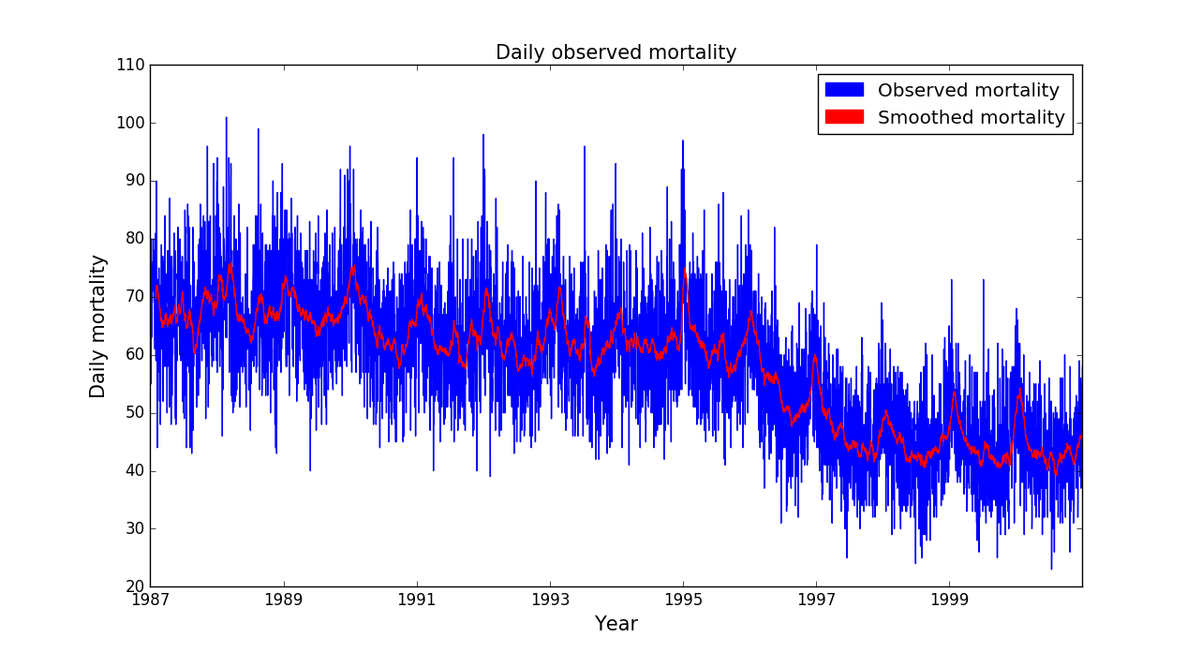

***Figure 1:* Daily observed mortality over time.**

**GCM Data Source**

Seven GCMs from CMIP5 were used in our analysis for temperature and dew point projections (Taylor, Stouffer, & Meehl, 2012). Model projections from the years of 1988 to 2000 and 2020 to 2080 were used. The mortality and temperature data were adjusted using the same moving averages as the observational data.

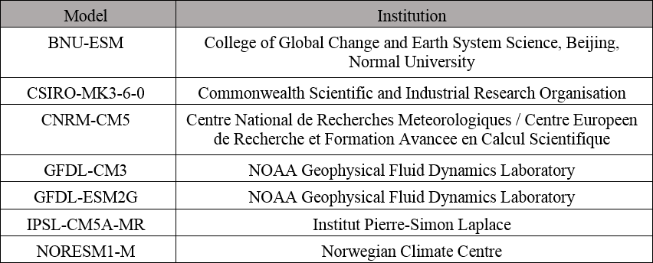

***Table 1:* CMIP5 Models used in this study.**

**Results**

**Temperature Events and Mortality**

Using the interval from 1987-2000, the average mortality anomaly (defined as the smoothed mortality subtracted from the observed mortality) was found for the individual days before, during, and after 5-day heat waves and cold events, as shown in Figure 2. Five day events were defined as five consecutive days during which the daily mean temperatures (unsmoothed) were either above the 95th, 90th and 50th percentiles, or below the 50th and 10th percentiles of daily mean temperatures during the entire period. We found that the number of heat-related deaths increased during the first several days of a heat wave. In addition, heat waves above the 95th percentile were followed by a spike in heat-related mortality within ten days following the end of the heat wave.

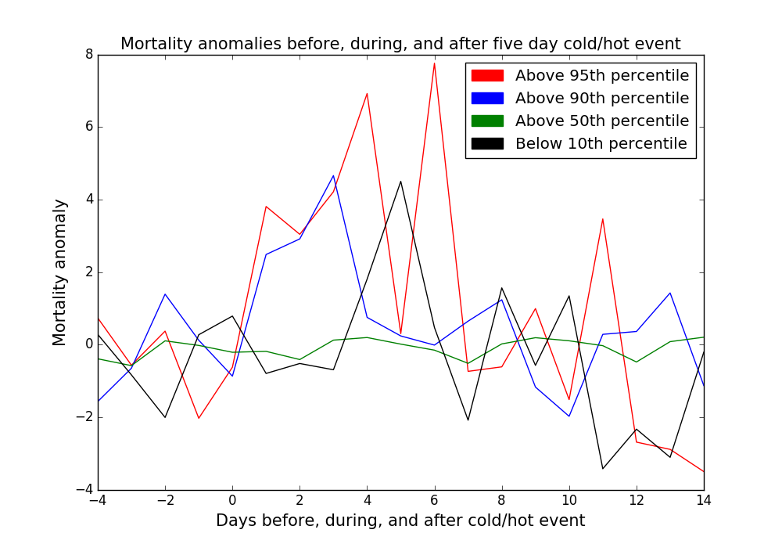

***Figure 2:* Average mortality anomalies for each of the days before, during, and after a five day temperature event. Days during the event are labelled 0-4.**

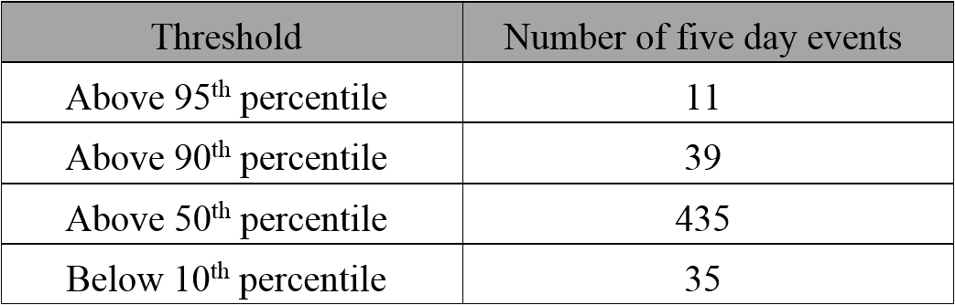

***Table 2*: Number of occurrences found for each temperature event in Figure 2**.

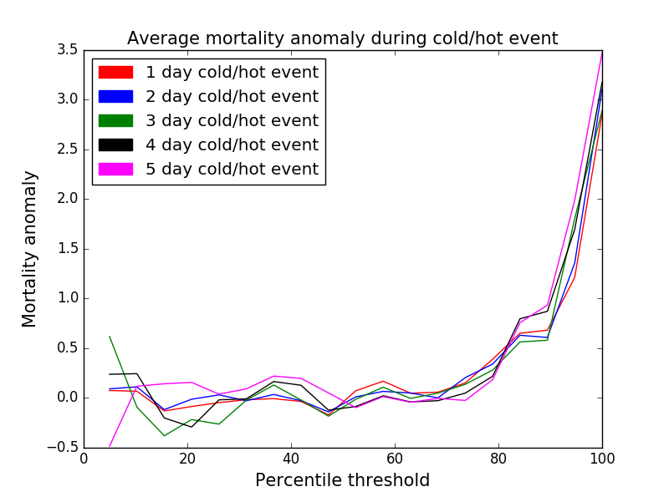

***Figure 3*: For percentiles of 50% or above, thresholds are a minimum temperature. For percentiles below 50%, thresholds are a maximum temperature. If no such instance of consecutive days under or above a threshold existed, a default value of 0 was substituted.**

Figure 3 shows the average mortality anomaly across the entire duration of heat waves that ranged from one day to five days in length, and were either above or below thresholds ranging from the 5th to 100th percentile (Figure 3). Potential overlap between multi-day heat waves was not accounted for in calculations for Figure 2 or 3. Our results demonstrate that mortality anomalies increase at both ends of extreme temperatures, regardless of the length of the temperature event. It is also important to note that increase in mortality anomalies is far more pronounced for extreme hot temperatures than cold.

**Changes in Seasonal Temperature**

Observational temperature data from 1973-2015 was analyzed for each year, by season. The absolute minimum and maximum temperatures, along with the average daily minimum, mean, and maximum temperatures, were found for each of the four seasons on a yearly basis. Each of these five temperature measures were fit with a linear regression and the slope of every temperature measure for each season—winter, spring, summer, and fall—was produced.

|  |  |  |  |  |  |
| --- | --- | --- | --- | --- | --- |
|  | Change in daily minimum temperature (ºF/day) | Change in seasonal minimum temperature (ºF/day) | Change in daily mean temperature (ºF/day) | Change in daily maximum temperature (ºF/day) | Change in seasonal maximum temperature (ºF/day) |
| DJF (Dec, Jan, Feb) | 0.0734 | 0.1628 | 0.0664 | 0.0594 | 0.0566 |
| MAM (Mar, Apr, May) | 0.0339 | 0.0356 | 0.0233 | 0.0310 | -0.0073 |
| JJA (Jun, Jul, Aug) | 0.0735 | 0.0604 | 0.0562 | 0.0447 | 0.0520 |
| SON (Sep, Oct, Nov) | 0.0869 | 0.0913 | 0.0705 | 0.0532 | 0.0350 |

***Table 3*: Slope of linear fit on daily and seasonal minimum, mean, and maximum temperatures.**

Table 3 indicates that absolute minimum temperatures are increasing at a rate faster than that of all other temperature measures. This was later reflected in our developed model’s projections, which predict that summer heat-related mortality will increase, even relative to decreases in winter cold-related mortality.

**Temperature and Various Order Fits**

Mortality anomalies and smoothed observational temperatures (with a lag of 5) were fit with polynomials ranging from a first to seventh order (see Figure 4). With the exception of the fourth order polynomial, these fits showed a large amount of variability, and in particular there was little signal for extreme cold temperatures (see Figure 4).

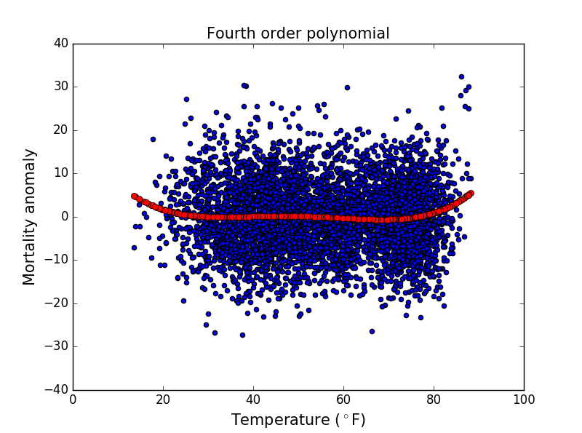

***Figure 4***

Figure 4 emphasizes the increase in mortality anomalies at both extremes of cold and hot temperatures.

**Model with Temperature and Dew Point Data**

We used Python library *scikit’s* LinearRegression to train our model with 80% of the observational temperature, mortality, and/or dew point data on days for which the temperature exceeded the 95th percentile of all observational temperatures. Our model was run on the remaining 20% of dew point and temperature data to observe projected mortality anomalies. Training the model with *both* temperature and dew point data, rather than solely temperatures, adds far more variability to the projected mortality, even in instances where the temperature is the same (see Figure 6).

(a.) (b.)

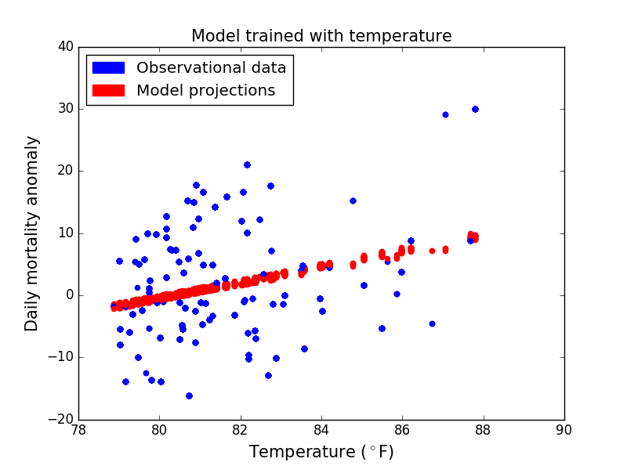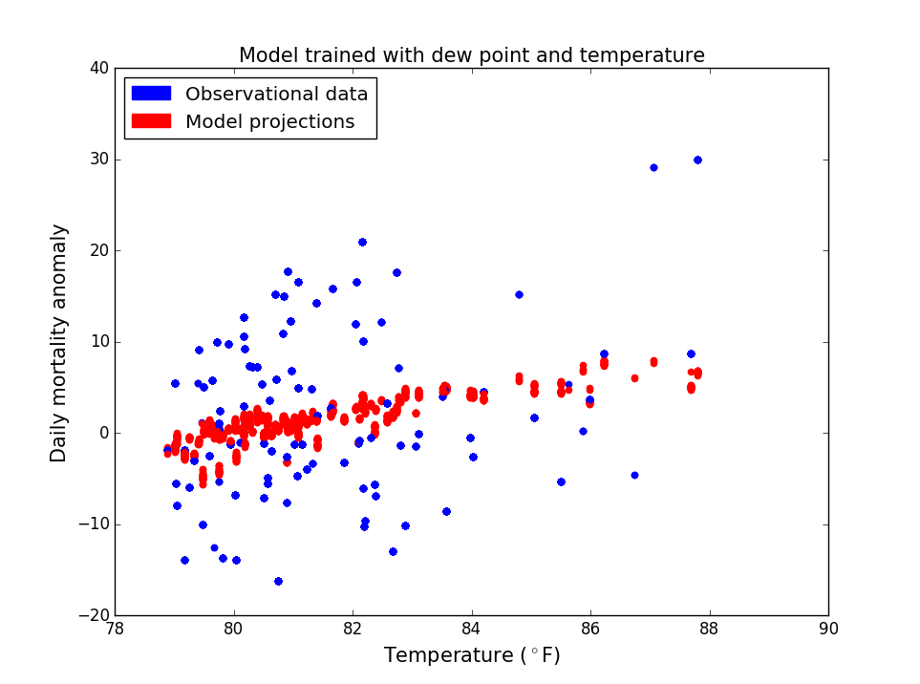

***Figure 6*: Model trained with mortality and temperature data (a.) versus model trained with the addition of dew point data (b.). Graphs of the model trained over various portions of observational data are graphed over each other. Blue indicates observational data and red indicates model’s projections using the same (blue) observational temperature data.**

**Model Trained on Selected Portions of Data**

Figure 7 shows our model trained on the same portion of observational data, as previously described for Figure 6. However, the model was then run using days from a CMIP5 model’s historical data (CSIRO-MK3-6-0) for which temperatures exceeded the 95th percentile of all the model’s historical temperatures. Figure 7(a.) shows the superimposition of 52 different projections; for each projection, the model was trained with a different portion—exactly 80%—of the observational data within the historical interval (e.g. the first 51 days versus the last 51 days within the observational data set). On the other hand, Figure 7(b.) shows the model trained on only one of the “80% portions” of data used in Figure 7(a.). The difference between Figure 7(a.) and 7(b.) demonstrates that changes to the starting and ending point of the time interval from which the model is trained can significantly alter the model’s projections for mortality anomalies.

(a.) (b.)

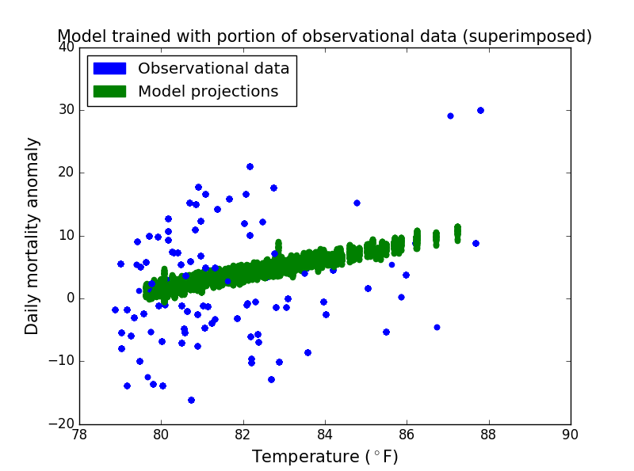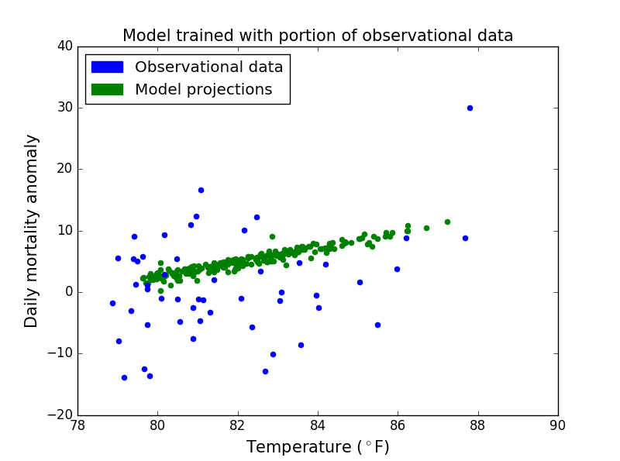

***Figure 7*: Green indicates projections and blue indicates observational data. Superimposition of model trained multiple times with different portions of data (a.) versus with one portion of data (b.).**

**Projected Temperatures**

The average temperature projection for every CMIP5 model for the summer and winter of every year (and for both historical and future periods) were calculated and analyzed.

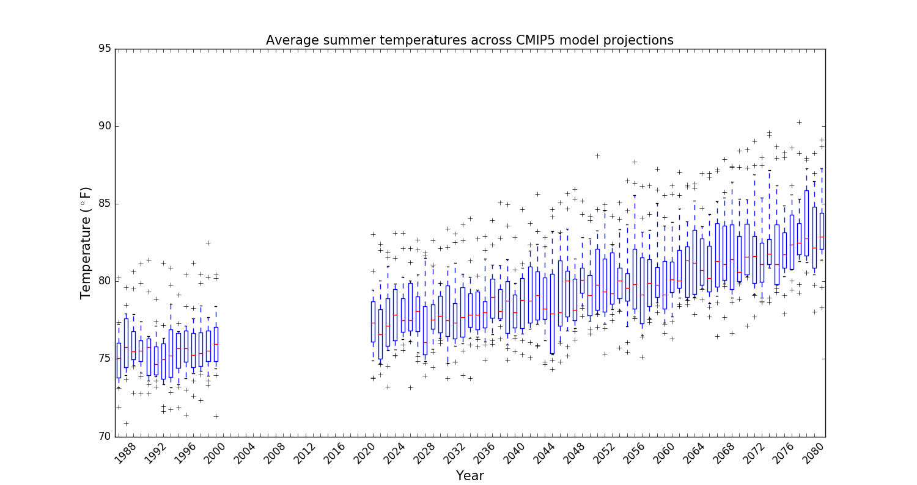

***Figure 8:* Box and whisker plots of mean yearly summer temperatures from all seven CMIP5 models.**

*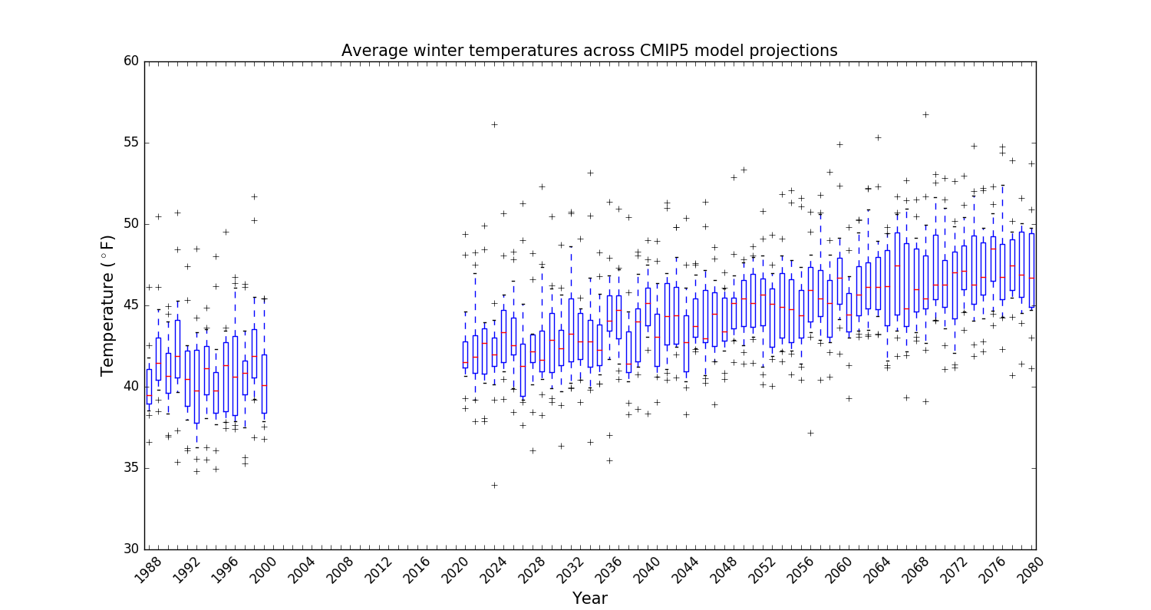****Figure 9*: Box and whisker plots of mean yearly winter temperatures from all seven CMIP5 models.**

Over time, variability across the models’ average temperature projections for the winter/summer season increases. The rising uncertainty in these climate projections largely comes from an amplification of the differences between the CMIP5 models, which can include different climate sensitivities, or responsiveness to greenhouse gas concentrations such as carbon dioxide.

**Projections for Future Mortality**

Both observational and CMIP5 model data were split into two sets, one for summer (JJA) and winter (DJF), in order to develop separate seasonal models. For the summer, the 90th percentile of daily mean observational summer temperatures with a lag of 5 was calculated, and the days above this threshold were selected to train and run our model on. In contrast, the winter model was trained using all observed winter climate data (with a lag of 5) and mortality anomalies. It was not trained on data limited by any particular threshold, as temperatures during the 2020-2080 period rose too quickly for there to be sufficient data points under a reasonable threshold, which would have been based off of observational winter temperatures.

Our resulting model was run over each of the CMIP5 models’ historical projections for the same time period (1987-2000) in order to compare with the measured values for mortality anomalies. Our model was then separately run over the winter and summer seasons of 2020 to 2080 for each CMIP5 model (Figure 10).

In order to determine the relative difference between mortality anomalies across winter and summer, our projected winter mortality anomalies were subtracted from projected summer mortality anomalies (Figure 10). All subtracted values across the seven CMIP5 models were compiled and represented as box plots (Figure 11).

(a.) (b.)

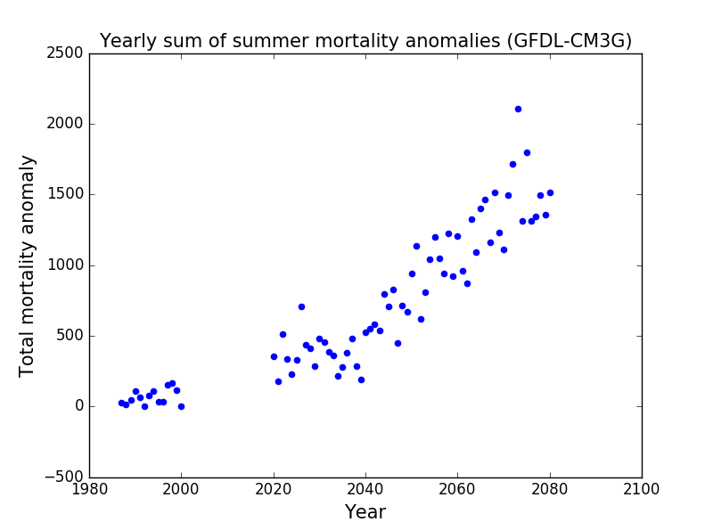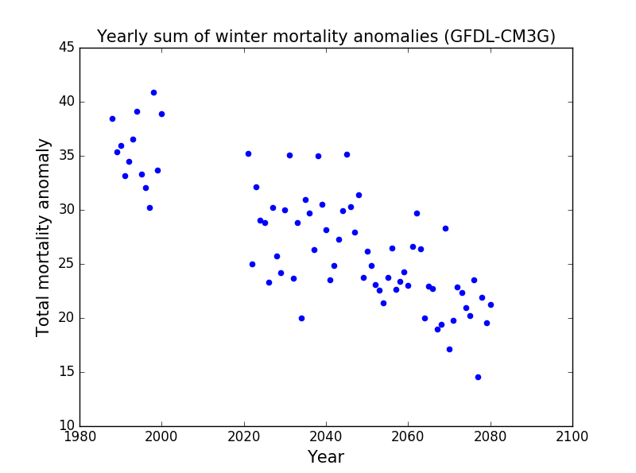

(c.)

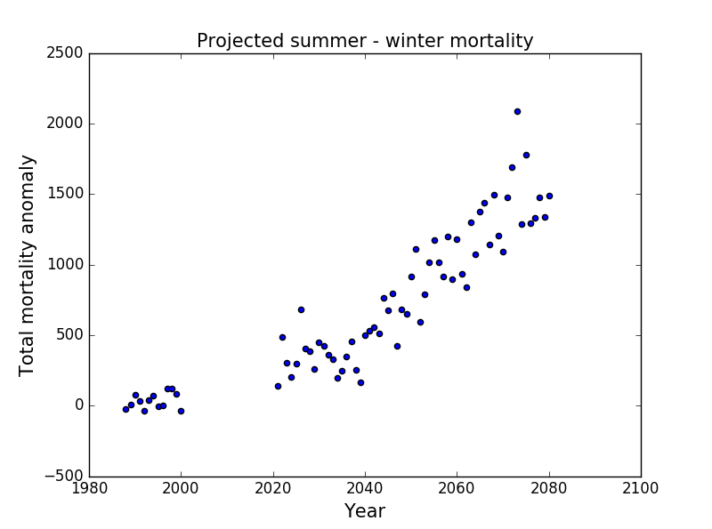

***Figure 10*:**

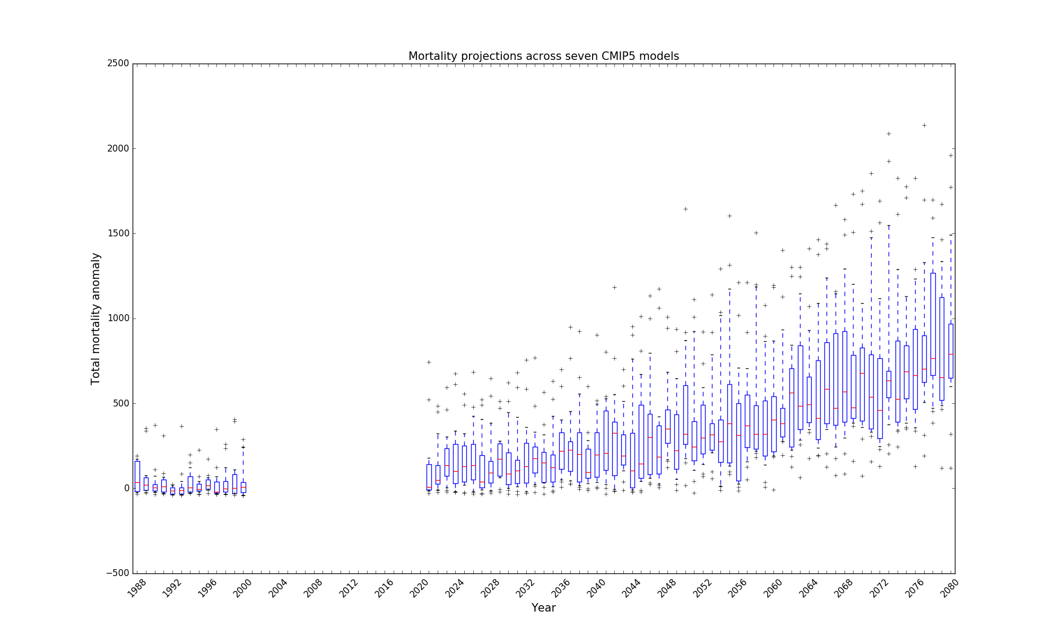

**Figure 11: Model’s yearly total mortality projections across all climate models compiled into boxplots; whiskers are calculated to the 10th and 90th percentiles**

It is important to note that variation in the mortality projections increases further into the future, since factors that cause uncertainty across the various climate models are amplified. However, the number of annual temperature-related mortalities still clearly rises rapidly over time.

**Discussion/Conclusion**

Our study used historical weather and mortality data along with seven GCMs to predict daily temperature-related mortality anomalies. Our model’s projections shows that although decreases in cold-related mortality are significant, they will be unable to compensate for the rise in excess deaths caused by extreme heat. We find this to be true across all projections for the seven CMIP5 models. The projected increase in summer mortality demonstrates a highly likely rise in annual temperature-related mortality, results that are in accordance with the findings of multiple previous studies (Medina-Ramon & Schwartz, 2007; Yu et al., 2012; Li et al., 2013).

While our results strongly suggest that heat related deaths will significantly increase in the future, it is also important to consider that in reality, these increases may not occur on the level of severity that our model predicts. The CMIP5 models assume a worst-case scenario based on the current trajectory of our climate; however, potential reductions in greenhouse gas emissions may alleviate the rise in excess deaths.

Our model may also overestimate the heat-mortality relationship due to the size of our training set. We found our model’s behavior was significantly impacted by the starting and ending points of the intervals of data on which it was trained. Thus, using a larger data set may lend more confidence and accuracy to our projections. A limiting factor however, is that mortality data spanning a longer time period simply does not exist.

We predict that we will observe an increase in annual heat deaths in the 21st century, however exact changes in the rate of urban heat deaths will vary due to the unpredictability of weather on a small scale. Heat-related mortality will also rely on factors outside of temperature and humidity. Thus, we now outline several health, environmental, economic, cultural, and geographic factors that must be considered when assessing heat-related mortality. First, current estimates of the impact of heat waves may generally underestimate their true effect, since heat stress places a strain on multiple systems in the body and it is difficult to determine the number of deaths that can be attributed to extreme heat (Kalkstein & Greene, 1997). In discussion surrounding heat deaths, the lack of general consensus on what constitutes a “heat-related mortality” only compounds the uncertainty (Basu & Samet, 2002).

In addition, socio-economic factors, along with the age and health of an individual, will surely play a role in exacerbating the danger of extreme heat. Infants, young children, and the elderly (above 50 years old) are at particular risk (Kovats & Hajat, 2008), and individuals above 65 years old are fifteen times more likely than the young (17 years or younger) to be hospitalized due to hyperthermia (Agency for Healthcare Research and Quality [AHRQ], 2008). The poor are also more likely to suffer from the effects of extreme heat. In the U.S., those in a lower income range may be twice as likely to be hospitalized due to heat exposure, and a disproportionately high amount of patients who are hospitalized due to extreme heat are also uninsured (AHRQ, 2008). This may be due to the fact that “individuals on low incomes are more likely to have [...] medical risk factors [...] and less adequate types of housing [primarily air-conditioning]” (Kovats & Hajat, 2008, p. 48).

Cultural and regional factors may greatly affect heat-related mortality. For instance, urban heat islands have played a role in heat waves (Basut & Samet, 2002). Additionally, heat death is of a greater concern in certain regions of the world where air conditioning is not as common. In contrast to the U.S., in European homes, air conditioning is scarce, a factor that contributed to the 70,000 death toll during the 2003 heat wave (Kovats & Hajat, 2008). In any case, even in regions where air conditioning is readily available, the sharp rise in electricity usage during heat waves often causes power failures, rendering air conditioning useless (Kovats & Hajat, 2008).

It must be noted that despite compounding factors, populations may adjust to the increasing extreme heat over time, either through their own behavior or physiological acclimatization. Changes in clothing, personal schedule, electrical use, or habits such as opening and closing windows, may help alleviate the effects of more frequent and severe heat waves (Coley, Kershaw, & Eames, 2012). In addition, the possibility of physiological adaptation is supported by the fact that heat-related mortality rises according to temperatures that are relative to the local climate that a population has acclimated to; in other words “the temperature above which mortality increases with increasing temperature is higher in warmer climates compared with cooler climates” (Kovats & Hajat, 2008, p. 46).

The numerous factors affecting the climate-mortality relationship demonstrate that addressing future extreme heat events will require swift change across human behavior, society, infrastructure, emergency response plans, and an increased public awareness of the danger of extreme heat. Our research predicts a sharply rising rate of change in heat related mortality during the latter part of the 21st century, thus indicating that we will encounter an urgent public health hazard and further, demonstrating the importance of additional study on the climate-mortality relationship.

**References**

Agency for Healthcare Research and Quality, U.S. Department of Health and Human Services. (2008, July 9). *Thousands Struck Down by Summer Heat, Most Are Poor* [Press release]. *AHRQ Archive*. Retrieved September 2, 2016, from ahrq.gov

Barriopedro, D., Fischer, E. M., Luterbacher, J., Trigo, R. M., & García-Herrera, R. (2011, April 8). The hot summer of 2010: Redrawing the temperature record map of Europe. *Science,* *332*(6026), 220-224. doi:10.1126/science.1201224

Basu, R., & Samet, J. M. (2002). Relation between elevated ambient temperature and mortality: A review of the epidemiologic evidence. *Epidemiologic Reviews,* *24*(2), 190-202. doi:10.1093/epirev/mxf007

Beniston, M. (2004, December). The 2003 heat wave as an example of summers in a greenhouse climate? Observations and climate model simulations for Basel, Switzerland. *Global and Planetary Change,* *44*(1), 73-81. doi:10.1016/j.gloplacha.2004.06.006

Coley, D., Kershaw, T., & Eames, M. (2012, September). A comparison of structural and behavioural adaptations to future proofing buildings against higher temperatures. *Building and Environment,* *55*, 159-166. doi:10.1016/j.buildenv.2011.12.011

Dematte, J. E., O'Mara, K., Buescher, J., Whitney, C. G., Forsythe, S., McNamee, T., . . . Ndukwu, M. (1998, August 1). Near-Fatal heat stroke during the 1995 heat wave in Chicago. *Annals of Internal Medicine,* *129*(3). doi:10.7326/0003-4819-129-3-199808010-00001

Future of climate change. (2016, August 9). Retrieved September 7, 2016, from https://www.epa.gov/climate-change-science/future-climate-change

GISS Surface Temperature Analysis (GISTEMP). (2016, October 14). Retrieved October 17, 2016, from http://data.giss.nasa.gov/gistemp/

Herring, S. C., Hoerling, M. P., Kossin, J. P., Peterson, T. C., & Stott, P. A. (2015). Explaining extreme events of 2014 from a climate perspective. Bulletin of the American Meteorological Society, 96(12), Sii.

Kalkstein, L. S., & Greene, J. S. (1997, January). An evaluation of climate/mortality relationships in large U.S. cities and the possible impacts of a climate change. Environmental Health Perspectives, 105(1), 84-93. doi:10.1289/ehp.9710584

Kovats, R. S., & Hajat, S. (2008, April). Heat stress and public health: A critical review. Annual Review of Public Health, 29(1), 41-55. doi:10.1146/annurev.publhealth.29.020907.090843

Li, T., Horton, R. M., & Kinney, P. L. (2013, August). Projections of seasonal patterns in temperature- related deaths for Manhattan, New York. Nature Climate Change, 3(8), 717-721. doi:10.1038/nclimate1902

Medina-Ramón, M., & Schwartz, J. (2007, December). Temperature, temperature extremes, and mortality: A study of acclimatisation and effect modification in 50 US cities. Occupational and Environmental Medicine, 64(12), 827-833. doi:10.1136/oem.2007.033175

Meehl, G. A., & Tebaldi, C. (2004, August). More intense, more frequent, and longer lasting heat waves in the 21st century. Science, 305(5686), 994-997. doi:10.1126/science.1098704

Merrill, C. T., Miller, M., & Steiner, C. (2008). *Hospital Stays Resulting from Excessive Heat and Cold Exposure Due to Weather Conditions in U.S. Community Hospitals, 2005* (pp. 1-11, Rep. No. 55). Agency for Healthcare Research and Quality. Retrieved May 29, 2016, from http://www.hcup-us.ahrq.gov/reports/statbriefs/sb55.pdf

Overview of climate change science. (2016, August 9). Retrieved September 7, 2016, from https://www.epa.gov/climate-change-science/overview-climate-change-science

Peterson, T., Stott, P., Herring, S., Zwiers, F., Hegerl, G., Min, S., . . . Christidis, N. (2012, July). Explaining extreme events of 2011 from a climate perspective. Bulletin of the American Meteorological Society, 93(7), 1041-1067. doi:10.1175/BAMS-D-12-00021.1

Robine, J., Cheung, S. L. K., Le Roy, S., Van Oyen, H., Griffiths, C., Michel, J., & Herrmann, F. R. (2008, February). Death toll exceeded 70,000 in Europe during the summer of 2003. Comptes Rendus - Biologies, 331(2), 171-178. doi:10.1016/j.crvi.2007.12.001

Samet, J. M., Zeger, S. L., Dominici, F., Curriero, F., Coursac, I., Dockery, D. W., . . . Zanobetti, A. (2000, June). The national morbidity, mortality, and air pollution study. part II: Morbidity and mortality from air pollution in the United States. Research Report (Health Effects Institute), 94(Pt 2), 5-70.

Sherwood, S. C., Huber, M., & Emanuel, K. A. (2010, May). An adaptability limit to climate change due to heat stress. Proceedings of the National Academy of Sciences of the United States of America, 107(21), 9552-9555. doi:10.1073/pnas.0913352107

Taylor, K. E., Stouffer, R. J., & Meehl, G. A. (2012;2011;). An Overview of CMIP5 and the Experiment Design. Bulletin of the American Meteorological Society, 93(4), 485. doi:10.1175/BAMS-D-11-00094.1

Yu, W., Mengersen, K., Wang, X., Ye, X., Guo, Y., Pan, X., & Tong, S. (2012, July). Daily average temperature and mortality among the elderly: A meta-analysis and systematic review of epidemiological evidence. International Journal of Biometeorology, 56(4), 569-581. doi:10.1007/s00484-011-0497-3