CS3810 Mini-Project 1 — Vacuum World Search Algorithms
Hannah Dees and Alexis Stacy
Introduction to Artificial Intelligence CS3810
Dr. Wang
2 October 2026

Introduction
This project implements three search algorithms such as DFS, A, and IDA, in the Vacuum World environment. We evaluated their performance using multiple heuristics (h0, h1, h2) across several grid configurations. The goal is to measure cost, nodes expanded, frontier size, iterations, and runtime, and analyze how heuristics influence search efficiency.
Heuristic Admissibility Arguments
H1 Admissibility
H1 returns the number of dirty cells remaining. Each dirty cell requires at least one CLEAN action, and CLEAN costs 1. Therefore, the true remaining cost can never be less than the number of dirty cells. h1 never overestimates the optimal cost, so it is admissible.
H2 Admissibility
H2 returns the number of dirty cells plus the Manhattan distance to the nearest dirty cell. The robot must move to at least one dirty cell before cleaning anything, and Manhattan distance is a lower bound on the number of moves required. Obstacles can force detours but never reduce the distance. Since h2 adds two independent lower bounds (movement + cleaning), it never overestimates the true remaining cost and is admissible.
H3 Admissibility
H3 was not implemented, results are marked as SKIP
Results
Table
Grid | Algorithm | Heuristic | Cost | Nodes Expanded | Max Frontier | Iterations | Seconds
g1_tiny | DFS | – | 12 | 16 | 5 | – | 0.0001
g1_tiny | A* | h0 | 7 | 21 | 4 | – | 0.0002
g1_tiny | A* | h1 | 7 | 20 | 5 | – | 0.0002
g1_tiny | A* | h2 | 7 | 13 | 4 | – | 0.0001
g1_tiny | A* | h3 | SKIP | – | – | – | –
g1_tiny | IDA* | h0 | 7 | 95 | 8 | 1 | 0.0005
g1_tiny | IDA* | h1 | 7 | 52 | 6 | 1 | 0.0002
g1_tiny | IDA* | h2 | 7 | 27 | 4 | 1 | 0.0002
g1_tiny | IDA* | h3 | SKIP | – | – | – | –
g2_open | DFS | – | 36 | 48 | 32 | – | 0.0002
g2_open | A* | h0 | 12 | 98 | 17 | – | 0.0005
g2_open | A* | h1 | 12 | 96 | 18 | – | 0.0005
g2_open | A* | h2 | 12 | 76 | 21 | – | 0.0005
g2_open | A* | h3 | SKIP | – | – | – | –
g2_open | IDA* | h0 | 12 | 15586 | 13 | 1 | 0.0711
g2_open | IDA* | h1 | 12 | 3821 | 10 | 1 | 0.0159
g2_open | IDA* | h2 | 12 | 616 | 4 | 1 | 0.0039
g2_open | IDA* | h3 | SKIP | – | – | – | –
g3_blocks | DFS | – | 43 | 69 | 34 | – | 0.0003
g3_blocks | A* | h0 | 15 | 411 | 11 | – | 0.0013
g3_blocks | A* | h1 | 15 | 331 | 71 | – | 0.0018
g3_blocks | A* | h2 | 15 | 256 | 87 | – | 0.0015

Plot One: Nodes Expanded Vs Heuristic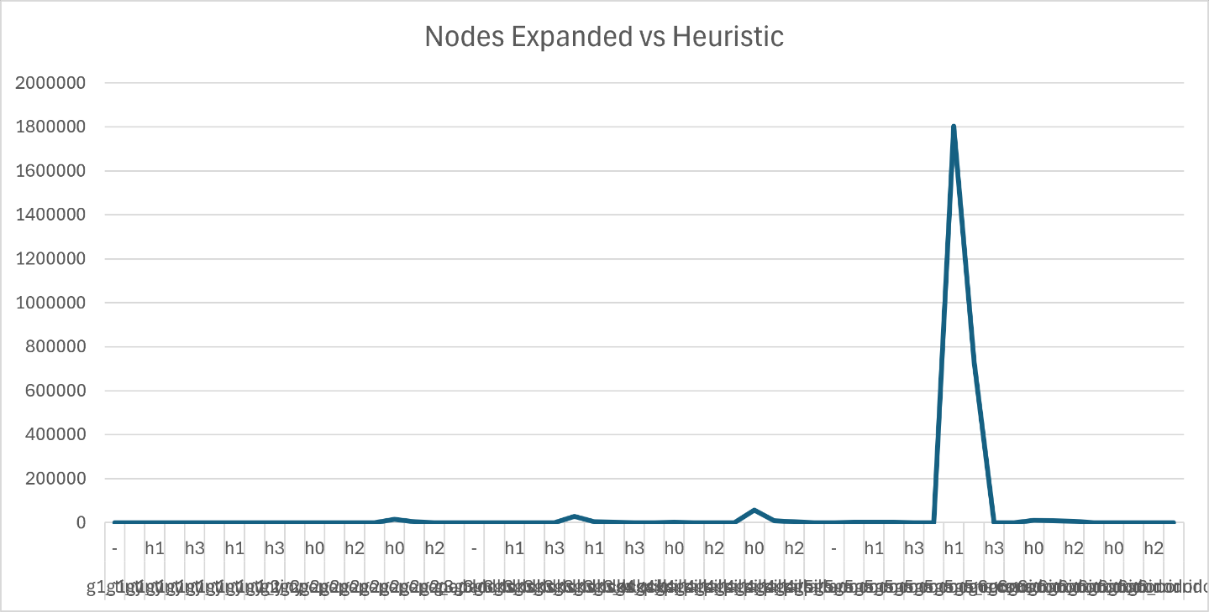
Nodes expanded for each heuristic across all grids.
Plot Two: Seconds Vs Heuristic (Runtime)
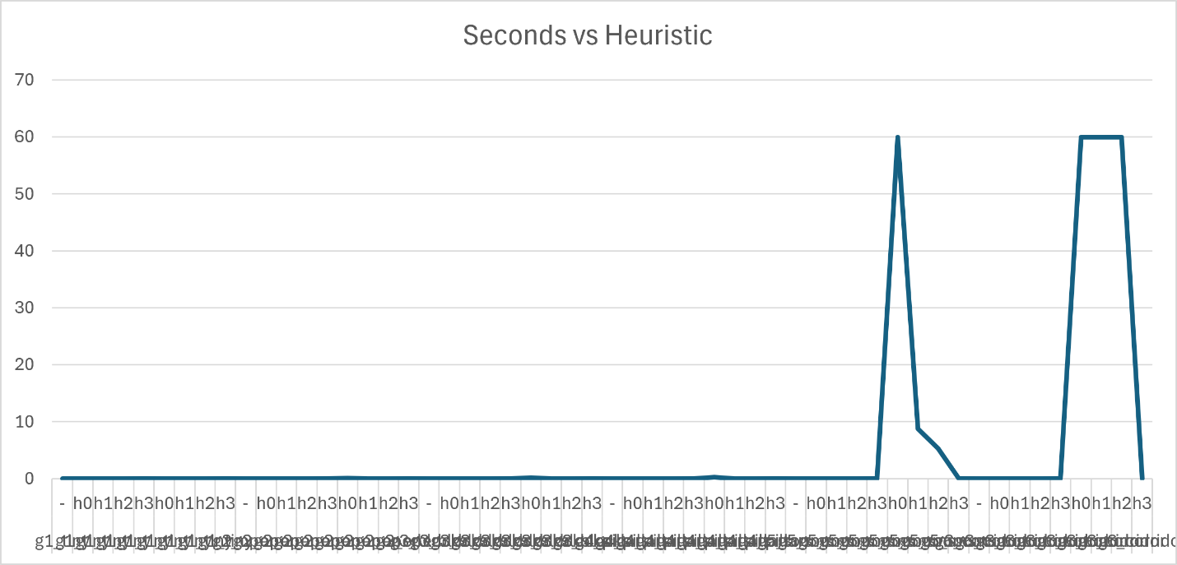
Runtime for each heuristic across all grids.
Analysis
DFS expands many nodes and is not optimal. A* performs significantly better when using h1 and h2 compared to h0, because the heuristics guide the search toward dirty cells. H2 consistently expands fewer nodes than h1, showing that adding the Manhattan distance improves search efficiency. IDA* is optimal but often slower than A, especially with h0, because it repeatedly performs depth-limited searches. With h2, IDA becomes much more efficient, reducing both nodes expanded and runtime. Overall, h2 provides the strongest performance improvements across algorithms.
Conclusion
The experiments demonstrate that heuristics dramatically affect search performance in Vacuum World. h0 provides no guidance, h1 offers a basic lower bound, and h2 significantly improves efficiency by incorporating movement cost. A* with h2 is the most effective combination, achieving optimal solutions with minimal node expansion. IDA* benefits from heuristics but remains slower due to repeated iterations. These results highlight the importance of admissible heuristics in informed search to be able to receive the strongest outputs.

‌

