Thesis Ch. 3 Code

Hannah Girgente

2024-03-31

setwd("E:/McIntyre_Lab/Thesis/Data/OdonateCommunity")

## Packages used:

library(BiodiversityR)

library(labdsv)

library(MASS)  
library(MVA)

library(vegan)  
library(plyr)  
library(betapart)  
library(ggplot2)

library(ggrepel)

library(grid)  
library(corrplot)

library(lattice)  
library(picante)

library(stats)  
library(sars)  
library(dplyr)

library(optpart)

library(cluster)

## Data used

#Data that includes adults seen at each site  
odes <- read.csv("odes-withadult.csv", row.names = 1, header = T)  
View(odes)   
  
#Data for only the nymphs sampled at each site  
odes.comm <- read.csv("nmds_odes.csv", row.names = 1, header = T)  
View(odes.comm)  
  
ode.matrix <- as.matrix(odes.comm) #convert the nymph dataset to a matrix  
  
#All site types (steephead or not)  
sites <- read.csv("oa_sites.csv", row.names = 1, header = T)  
  
#Sites types, exclusing sites that had no nymphs sampled at them  
sites.nmds <- read.csv("oa_sites-nmds.csv", row.names = 1, header = T)  
View(sites.nmds)  
  
#Environmental data for each site  
env <- read.csv("nmds_env.t.csv", row.names = 1, header = T)  
env_scale <- scale(env, center = F, scale = T) #scale the data, but not centered to avoid negatives  
env_matrix <- as.matrix(env_scale) #convert the data frame into a matrix  
View(env_matrix)  
  
#Environmental data (without the stream comp) for correlation analyses  
corr.env <- read.csv("corr_env.trans.csv", row.names = 1, header = T)  
corr.env.s <- scale(corr.env, center = F, scale = T) #scale the data  
View(corr.env.s)

# Species richness and diversity indicies

#Species richness per site  
ode.rich <- specnumber(odes)  
ode.rich

## RES01 RES03 RES04 RES05 WB01 CB01 TRSF01 LTSF01 LTSF02 BB01   
## 3 3 8 2 8 12 6 14 5 2   
## CCR01 EAFB01 EAFB02 EAFB03 BRSF01 BC01 ARBP01 TSP01 TSP02 LCWMA01   
## 2 13 4 3 7 8 22 8 2 9   
## LCWMA02 LCWMA03 JB01 PB01   
## 5 14 9 5

#Richness estimate  
sp_est <- specpool(odes)   
sp_est

## Species chao chao.se jack1 jack1.se jack2 boot boot.se n  
## All 47 71.71131 15.50821 65.20833 6.051142 76.48732 54.91349 3.246933 24

#Examine the richness across steephead and non-steephead sites  
ode.sp <- specpool(odes, pool = sites$type)  
ode.sp

## Species chao chao.se jack1 jack1.se jack2 boot  
## Non-Steephead 35 51.87912 11.34927 49.76923 6.428487 57.87821 41.66550  
## Steephead 31 40.16667 7.32986 41.00000 5.559594 45.58182 35.64675  
## boot.se n  
## Non-Steephead 3.614439 13  
## Steephead 3.450357 11

#Richness and estimates for steephead sites  
ode.sp["Steephead",]

## Species chao chao.se jack1 jack1.se jack2 boot boot.se n  
## Steephead 31 40.16667 7.32986 41 5.559594 45.58182 35.64675 3.450357 11

#Richness and estimates for non-steephead sites  
ode.sp["Non-Steephead",]

## Species chao chao.se jack1 jack1.se jack2 boot  
## Non-Steephead 35 51.87912 11.34927 49.76923 6.428487 57.87821 41.6655  
## boot.se n  
## Non-Steephead 3.614439 13

#If you want a particular richness metric for all stream types  
ode.sp[,c("boot", "boot.se")]

## boot boot.se  
## Non-Steephead 41.66550 3.614439  
## Steephead 35.64675 3.450357

#species accumulation curves for estimates of total species richness based on   
#iterative sampling with confidence intervals:  
(ode.sp = poolaccum(odes))

## N S Chao Jackknife 1 Jackknife 2 Bootstrap  
## 3 16.83 36.72105 24.99667 28.43333 20.60333  
## 4 19.89 36.93700 29.56500 34.32167 24.29547  
## 5 23.03 41.14426 34.16600 39.94400 28.06096  
## 6 25.25 44.16597 37.09167 43.39167 30.58451  
## 7 27.19 44.74907 39.48143 46.01595 32.73528  
## 8 29.18 48.79617 41.96375 48.83268 34.94433  
## 9 30.87 51.83979 44.10556 51.25625 36.83382  
## 10 32.59 52.36665 46.30600 53.83311 38.74927  
## 11 33.93 53.78104 47.91182 55.70173 40.19221  
## 12 35.45 57.26604 49.97917 58.36174 41.91178  
## 13 36.41 57.38650 50.99462 59.30667 42.91112  
## 14 37.64 60.45002 52.67357 61.43951 44.30745  
## 15 38.55 62.64866 53.88467 62.94938 45.32631  
## 16 39.67 63.91810 55.42938 64.94412 46.59917  
## 17 40.69 65.51823 56.78412 66.52033 47.75635  
## 18 41.68 67.00476 58.06611 68.08389 48.85599  
## 19 42.70 67.47292 59.46842 69.71117 50.02993  
## 20 43.62 69.06875 60.76750 71.29134 51.09995  
## 21 44.57 70.38964 62.07476 72.84233 52.19566  
## 22 45.28 70.13508 62.89136 73.70738 52.95232  
## 23 46.19 70.65415 64.09609 75.07004 53.98810  
## 24 47.00 71.71131 65.20833 76.48732 54.91349

plot(ode.sp)

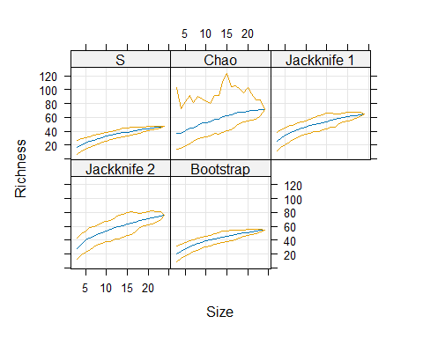

#To plot just one of these metrics on their own:  
ode.est <- poolaccum(odes)  
ode.est

## N S Chao Jackknife 1 Jackknife 2 Bootstrap  
## 3 17.69 38.89405 26.23667 29.81000 21.64407  
## 4 20.73 39.56719 30.62250 35.49417 25.23465  
## 5 22.85 40.14148 33.65000 39.18950 27.74464  
## 6 25.12 41.32984 36.46167 42.13767 30.29053  
## 7 27.15 42.96036 38.97857 44.92500 32.54470  
## 8 29.07 48.46818 41.62625 48.48661 34.72052  
## 9 30.94 51.39892 44.23778 51.83083 36.86964  
## 10 32.38 53.13243 46.19500 54.26522 38.50525  
## 11 33.96 55.59197 48.27818 56.73900 40.28573  
## 12 35.32 59.02730 50.18833 59.18985 41.85007  
## 13 36.58 59.82856 51.74615 60.83173 43.24919  
## 14 37.74 62.65811 53.41429 62.96945 44.60093  
## 15 38.85 65.04365 54.83800 64.72667 45.83176  
## 16 40.08 66.79618 56.42063 66.63304 47.20222  
## 17 40.98 66.89463 57.49765 67.66401 48.19537  
## 18 42.11 68.94635 59.08167 69.60873 49.50037  
## 19 43.03 69.35853 60.10158 70.58839 50.47601  
## 20 43.94 68.79715 61.15400 71.57884 51.46338  
## 21 44.71 69.71679 62.14810 72.86093 52.31074  
## 22 45.37 70.92454 63.01955 73.96716 53.04639  
## 23 46.21 71.25139 64.16391 75.26196 54.01725  
## 24 47.00 71.71131 65.20833 76.48732 54.91349

plot(ode.est, col="black",   
 strip=function(..., bg) strip.default(..., bg="gray90"),   
 display=c("boot", "S"))

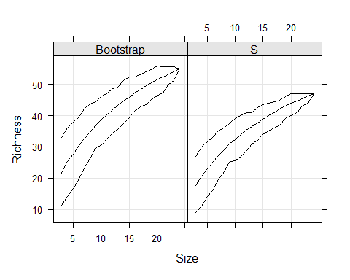

#Which stream type was the most diverse  
#Plot the average number of species at each steephead vs non-steephead site  
boxplot(specnumber(odes) ~ type, data = sites, xlab= "Stream type",   
 ylab = "# of species")

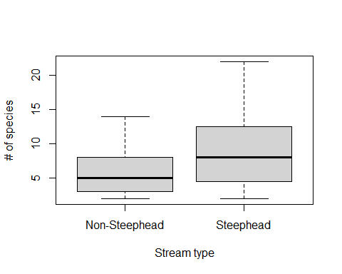

#Calculate the shannon's diversity index for each site  
diversity(odes[-1], index = "shannon")

## RES01 RES03 RES04 RES05 WB01 CB01 TRSF01 LTSF01   
## 1.0986123 1.0986123 2.0794415 0.6931472 1.9459101 2.3978953 1.6094379 2.5649494   
## LTSF02 BB01 CCR01 EAFB01 EAFB02 EAFB03 BRSF01 BC01   
## 1.3862944 0.6931472 0.0000000 2.4849066 1.3862944 1.0986123 1.9459101 1.9459101   
## ARBP01 TSP01 TSP02 LCWMA01 LCWMA02 LCWMA03 JB01 PB01   
## 3.0445224 1.9459101 0.6931472 2.0794415 1.3862944 2.5649494 2.0794415 1.6094379

sites.2 <- read.csv("oa_sites.csv", row.names = 1, stringsAsFactors = T)  
  
#Shannon's diversity index for each stream type  
diversitycomp(odes, y = sites.2, factor1 = "type", index ="Shannon",  
 method = "pooled")

##   
## type n Shannon  
## Non-Steephead 13 3.3692112  
## Steephead 11 3.1644258

#Which stream type had individuals the most evenly distributed over space  
diversitycomp(odes, y=sites.2, factor1="type", index="Jevenness",   
 method = "pooled")

##   
## type n Jevenness  
## Non-Steephead 13 0.94764596  
## Steephead 11 0.92150192

#Which stream type had the highest alpha diversity  
alpha <- tapply(specnumber(odes), sites, FUN= mean)  
alpha

## type  
## Non-Steephead Steephead   
## 5.8461538 8.9090909

#How similar were steephead sites to non-steephead sites (beta diversity)  
ode <- rowsum(odes, group= sites$type)  
betadiver(ode, method="w")

## Non-Steephead  
## Steephead 0.42424242

#Is beta diversity significantly different between steepheads and non-steepheads?  
ode.b <- betadiver(odes, method = "w")  
ode.ano <- anosim(ode.b, sites$type)  
ode.ano

##   
## Call:  
## anosim(x = ode.b, grouping = sites$type)   
## Dissimilarity: beta.w   
##   
## ANOSIM statistic R: 0.14875   
## Significance: 0.013   
##   
## Permutation: free  
## Number of permutations: 999

#Check if any sites are outliers with respect to ode richness  
occupancy <- read.csv("nmds_odes.csv", header=TRUE)  
boxplot(specnumber(occupancy), xlab = "Sites 1-23", ylab = "# of species")

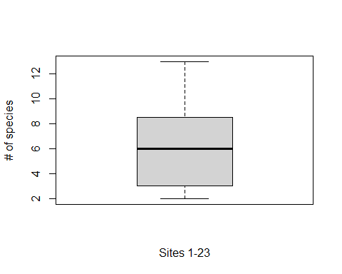

ano <- anosim(ode.matrix, sites.nmds$type, distance = "bray", permutations = 9999)  
ano

##   
## Call:  
## anosim(x = ode.matrix, grouping = sites.nmds$type, permutations = 9999, distance = "bray")   
## Dissimilarity: bray   
##   
## ANOSIM statistic R: 0.18258   
## Significance: 0.0099   
##   
## Permutation: free  
## Number of permutations: 9999

#species occurrence patterns  
abuocc(odes)

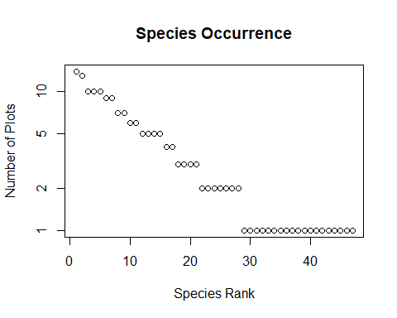

## Press return for next plot

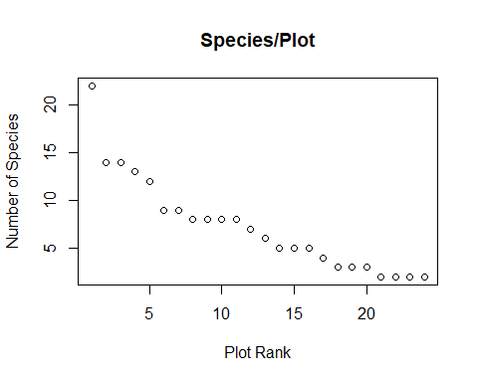

## Press return for next plot

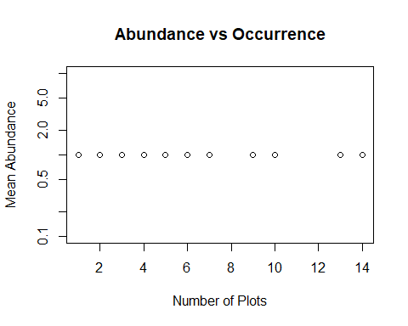

## Do you want to identify individual species? Y/N :   
## Press return for next plot

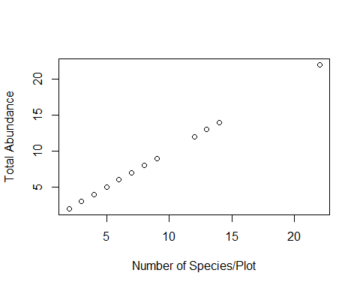

## Do you want to identify individual plots? Y/N :

# Mantel Tests

### (test to see if any environmental variables have a statistically significant impact on odonate assemblage structure)

### Canopy ###  
canopy <- env_matrix[,1]  
View(canopy)  
dist.ode <- vegdist(ode.matrix, method = "bray", binary = T)  
dist.can <- dist(canopy, method = "euclidean")  
ode.can <- mantel(dist.ode, dist.can, method = "spearman", permutations = 9999, na.rm = T)  
ode.can

##   
## Mantel statistic based on Spearman's rank correlation rho   
##   
## Call:  
## mantel(xdis = dist.ode, ydis = dist.can, method = "spearman", permutations = 9999, na.rm = T)   
##   
## Mantel statistic r: 0.2397   
## Significance: 0.058   
##   
## Upper quantiles of permutations (null model):  
## 90% 95% 97.5% 99%   
## 0.185 0.251 0.307 0.364   
## Permutation: free  
## Number of permutations: 9999

### p= 0.0561  
  
### Temperature ###  
temp <- env_matrix[,2]  
View(temp)  
dist.ode <- vegdist(ode.matrix, method = "bray", binary = T)  
dist.temp <- dist(temp, method = "euclidean")  
ode.temp <- mantel(dist.ode, dist.temp, method = "spearman", permutations = 9999, na.rm = T)  
ode.temp

##   
## Mantel statistic based on Spearman's rank correlation rho   
##   
## Call:  
## mantel(xdis = dist.ode, ydis = dist.temp, method = "spearman", permutations = 9999, na.rm = T)   
##   
## Mantel statistic r: -0.14396   
## Significance: 0.875   
##   
## Upper quantiles of permutations (null model):  
## 90% 95% 97.5% 99%   
## 0.173 0.225 0.268 0.314   
## Permutation: free  
## Number of permutations: 9999

### Velocity ###  
v <- env_matrix[,3]  
View(v)  
dist.ode <- vegdist(ode.matrix, method = "bray", binary = T)  
dist.v <- dist(v, method = "euclidean")  
ode.v <- mantel(dist.ode, dist.v, method = "spearman", permutations = 9999, na.rm = T)  
ode.v

##   
## Mantel statistic based on Spearman's rank correlation rho   
##   
## Call:  
## mantel(xdis = dist.ode, ydis = dist.v, method = "spearman", permutations = 9999, na.rm = T)   
##   
## Mantel statistic r: -0.12935   
## Significance: 0.7803   
##   
## Upper quantiles of permutations (null model):  
## 90% 95% 97.5% 99%   
## 0.219 0.286 0.345 0.408   
## Permutation: free  
## Number of permutations: 9999

### pH ###  
ph <- env_matrix[,4]  
View(ph)  
dist.ode <- vegdist(ode.matrix, method = "bray", binary = T)  
dist.ph <- dist(ph, method = "euclidean")  
ode.ph <- mantel(dist.ode, dist.ph, method = "spearman", permutations = 9999, na.rm = T)  
ode.ph

##   
## Mantel statistic based on Spearman's rank correlation rho   
##   
## Call:  
## mantel(xdis = dist.ode, ydis = dist.ph, method = "spearman", permutations = 9999, na.rm = T)   
##   
## Mantel statistic r: -0.20894   
## Significance: 0.969   
##   
## Upper quantiles of permutations (null model):  
## 90% 95% 97.5% 99%   
## 0.174 0.230 0.282 0.337   
## Permutation: free  
## Number of permutations: 9999

### DO ###  
do <- env_matrix[,5]  
View(do)  
dist.ode <- vegdist(ode.matrix, method = "bray", binary = T)  
dist.do <- dist(do, method = "euclidean")  
ode.do <- mantel(dist.ode, dist.do, method = "spearman", permutations = 9999, na.rm = T)  
ode.do

##   
## Mantel statistic based on Spearman's rank correlation rho   
##   
## Call:  
## mantel(xdis = dist.ode, ydis = dist.do, method = "spearman", permutations = 9999, na.rm = T)   
##   
## Mantel statistic r: -0.077149   
## Significance: 0.6835   
##   
## Upper quantiles of permutations (null model):  
## 90% 95% 97.5% 99%   
## 0.194 0.261 0.313 0.378   
## Permutation: free  
## Number of permutations: 9999

### TDS ###  
tds <- env_matrix[,6]  
View(tds)  
dist.ode <- vegdist(ode.matrix, method = "bray", binary = T)  
dist.tds <- dist(tds, method = "euclidean")  
ode.tds <- mantel(dist.ode, dist.tds, method = "spearman", permutations = 9999, na.rm = T)  
ode.tds

##   
## Mantel statistic based on Spearman's rank correlation rho   
##   
## Call:  
## mantel(xdis = dist.ode, ydis = dist.tds, method = "spearman", permutations = 9999, na.rm = T)   
##   
## Mantel statistic r: 0.085185   
## Significance: 0.1562   
##   
## Upper quantiles of permutations (null model):  
## 90% 95% 97.5% 99%   
## 0.109 0.147 0.179 0.223   
## Permutation: free  
## Number of permutations: 9999

### Width ###  
wid <- env_matrix[,7]  
View(wid)  
dist.ode <- vegdist(ode.matrix, method = "bray", binary = T)  
dist.wid <- dist(wid, method = "euclidean")  
ode.wid <- mantel(dist.ode, dist.wid, method = "spearman", permutations = 9999, na.rm = T)  
ode.wid

##   
## Mantel statistic based on Spearman's rank correlation rho   
##   
## Call:  
## mantel(xdis = dist.ode, ydis = dist.wid, method = "spearman", permutations = 9999, na.rm = T)   
##   
## Mantel statistic r: 0.17843   
## Significance: 0.0581   
##   
## Upper quantiles of permutations (null model):  
## 90% 95% 97.5% 99%   
## 0.143 0.187 0.228 0.273   
## Permutation: free  
## Number of permutations: 9999

# p=0.0566  
  
### Turbidity ###  
turb <- env_matrix[,8]  
View(turb)  
dist.ode <- vegdist(ode.matrix, method = "bray", binary = T)  
dist.turb <- dist(turb, method = "euclidean")  
ode.turb <- mantel(dist.ode, dist.turb, method = "spearman", permutations = 9999, na.rm = T)  
ode.turb

##   
## Mantel statistic based on Spearman's rank correlation rho   
##   
## Call:  
## mantel(xdis = dist.ode, ydis = dist.turb, method = "spearman", permutations = 9999, na.rm = T)   
##   
## Mantel statistic r: -0.019094   
## Significance: 0.523   
##   
## Upper quantiles of permutations (null model):  
## 90% 95% 97.5% 99%   
## 0.178 0.239 0.284 0.341   
## Permutation: free  
## Number of permutations: 9999

### Depth ###  
dep <- env_matrix[,9]  
View(dep)  
dist.ode <- vegdist(ode.matrix, method = "bray", binary = T)  
dist.dep <- dist(dep, method = "euclidean")  
ode.dep <- mantel(dist.ode, dist.dep, method = "spearman", permutations = 9999, na.rm = T)  
ode.dep

##   
## Mantel statistic based on Spearman's rank correlation rho   
##   
## Call:  
## mantel(xdis = dist.ode, ydis = dist.dep, method = "spearman", permutations = 9999, na.rm = T)   
##   
## Mantel statistic r: 0.19868   
## Significance: 0.0941   
##   
## Upper quantiles of permutations (null model):  
## 90% 95% 97.5% 99%   
## 0.193 0.252 0.304 0.365   
## Permutation: free  
## Number of permutations: 9999

### Sand ###  
sand <- env_matrix[,10]  
View(sand)  
dist.ode <- vegdist(ode.matrix, method = "bray", binary = T)  
dist.sand <- dist(sand, method = "euclidean")  
ode.sand <- mantel(dist.ode, dist.sand, method = "spearman", permutations = 9999, na.rm = T)  
ode.sand

##   
## Mantel statistic based on Spearman's rank correlation rho   
##   
## Call:  
## mantel(xdis = dist.ode, ydis = dist.sand, method = "spearman", permutations = 9999, na.rm = T)   
##   
## Mantel statistic r: 0.065289   
## Significance: 0.3269   
##   
## Upper quantiles of permutations (null model):  
## 90% 95% 97.5% 99%   
## 0.223 0.289 0.357 0.424   
## Permutation: free  
## Number of permutations: 9999

### Gravel ###  
grv <- env_matrix[,11]  
View(grv)  
dist.ode <- vegdist(ode.matrix, method = "bray", binary = T)  
dist.grv <- dist(grv, method = "euclidean")  
ode.grv <- mantel(dist.ode, dist.grv, method = "spearman", permutations = 9999, na.rm = T)  
ode.grv

##   
## Mantel statistic based on Spearman's rank correlation rho   
##   
## Call:  
## mantel(xdis = dist.ode, ydis = dist.grv, method = "spearman", permutations = 9999, na.rm = T)   
##   
## Mantel statistic r: 0.024979   
## Significance: 0.3783   
##   
## Upper quantiles of permutations (null model):  
## 90% 95% 97.5% 99%   
## 0.164 0.224 0.272 0.321   
## Permutation: free  
## Number of permutations: 9999

### Cobble ###  
cob <- env_matrix[,12]  
View(cob)  
dist.ode <- vegdist(ode.matrix, method = "bray", binary = T)  
dist.cob <- dist(cob, method = "euclidean")  
ode.cob <- mantel(dist.ode, dist.cob, method = "spearman", permutations = 9999, na.rm = T)  
ode.cob

##   
## Mantel statistic based on Spearman's rank correlation rho   
##   
## Call:  
## mantel(xdis = dist.ode, ydis = dist.cob, method = "spearman", permutations = 9999, na.rm = T)   
##   
## Mantel statistic r: -0.14788   
## Significance: 0.7436   
##   
## Upper quantiles of permutations (null model):  
## 90% 95% 97.5% 99%   
## 0.345 0.361 0.361 0.361   
## Permutation: free  
## Number of permutations: 9999

### Boulders ###  
bo <- env_matrix[,13]  
View(bo)  
dist.ode <- vegdist(ode.matrix, method = "bray", binary = T)  
dist.bo <- dist(bo, method = "euclidean")  
ode.bo <- mantel(dist.ode, dist.bo, method = "spearman", permutations = 9999, na.rm = T)  
ode.bo

##   
## Mantel statistic based on Spearman's rank correlation rho   
##   
## Call:  
## mantel(xdis = dist.ode, ydis = dist.bo, method = "spearman", permutations = 9999, na.rm = T)   
##   
## Mantel statistic r: -0.14788   
## Significance: 0.7311   
##   
## Upper quantiles of permutations (null model):  
## 90% 95% 97.5% 99%   
## 0.345 0.361 0.361 0.361   
## Permutation: free  
## Number of permutations: 9999

### fpom ###  
fpom <- env_matrix[,14]  
View(fpom)  
dist.ode <- vegdist(ode.matrix, method = "bray", binary = T)  
dist.fpom <- dist(fpom, method = "euclidean")  
ode.fpom <- mantel(dist.ode, dist.fpom, method = "spearman", permutations = 9999, na.rm = T)  
ode.fpom

##   
## Mantel statistic based on Spearman's rank correlation rho   
##   
## Call:  
## mantel(xdis = dist.ode, ydis = dist.fpom, method = "spearman", permutations = 9999, na.rm = T)   
##   
## Mantel statistic r: -0.10612   
## Significance: 0.8094   
##   
## Upper quantiles of permutations (null model):  
## 90% 95% 97.5% 99%   
## 0.154 0.208 0.261 0.313   
## Permutation: free  
## Number of permutations: 9999

### cpom ###  
cpom <- env_matrix[,15]  
View(cpom)  
dist.ode <- vegdist(ode.matrix, method = "bray", binary = T)  
dist.cpom <- dist(cpom, method = "euclidean")  
ode.cpom <- mantel(dist.ode, dist.cpom, method = "spearman", permutations = 9999, na.rm = T)  
ode.cpom

##   
## Mantel statistic based on Spearman's rank correlation rho   
##   
## Call:  
## mantel(xdis = dist.ode, ydis = dist.cpom, method = "spearman", permutations = 9999, na.rm = T)   
##   
## Mantel statistic r: -0.046225   
## Significance: 0.6256   
##   
## Upper quantiles of permutations (null model):  
## 90% 95% 97.5% 99%   
## 0.150 0.198 0.248 0.311   
## Permutation: free  
## Number of permutations: 9999

### Bryophytes ###  
bry <- env_matrix[,16]  
View(bry)  
dist.ode <- vegdist(ode.matrix, method = "bray", binary = T)  
dist.bry <- dist(bry, method = "euclidean")  
ode.bry <- mantel(dist.ode, dist.bry, method = "spearman", permutations = 9999, na.rm = T)  
ode.bry

##   
## Mantel statistic based on Spearman's rank correlation rho   
##   
## Call:  
## mantel(xdis = dist.ode, ydis = dist.bry, method = "spearman", permutations = 9999, na.rm = T)   
##   
## Mantel statistic r: -0.13029   
## Significance: 0.8542   
##   
## Upper quantiles of permutations (null model):  
## 90% 95% 97.5% 99%   
## 0.166 0.215 0.263 0.314   
## Permutation: free  
## Number of permutations: 9999

### Small wood ###  
sw <- env_matrix[,17]  
View(sw)  
dist.ode <- vegdist(ode.matrix, method = "bray", binary = T)  
dist.sw <- dist(sw, method = "euclidean")  
ode.sw <- mantel(dist.ode, dist.sw, method = "spearman", permutations = 9999, na.rm = T)  
ode.sw

##   
## Mantel statistic based on Spearman's rank correlation rho   
##   
## Call:  
## mantel(xdis = dist.ode, ydis = dist.sw, method = "spearman", permutations = 9999, na.rm = T)   
##   
## Mantel statistic r: 0.046965   
## Significance: 0.318   
##   
## Upper quantiles of permutations (null model):  
## 90% 95% 97.5% 99%   
## 0.158 0.212 0.261 0.317   
## Permutation: free  
## Number of permutations: 9999

### Large wood ###  
lw <- env_matrix[,18]  
View(lw)  
dist.ode <- vegdist(ode.matrix, method = "bray", binary = T)  
dist.lw <- dist(lw, method = "euclidean")  
ode.lw <- mantel(dist.ode, dist.lw, method = "spearman", permutations = 9999, na.rm = T)  
ode.lw

##   
## Mantel statistic based on Spearman's rank correlation rho   
##   
## Call:  
## mantel(xdis = dist.ode, ydis = dist.lw, method = "spearman", permutations = 9999, na.rm = T)   
##   
## Mantel statistic r: 0.065894   
## Significance: 0.301   
##   
## Upper quantiles of permutations (null model):  
## 90% 95% 97.5% 99%   
## 0.187 0.246 0.294 0.352   
## Permutation: free  
## Number of permutations: 9999

### Cumulative effect of all environmental variables ###  
dist.env <- dist(env_matrix, method = "euclidean")  
ode.env <- mantel(dist.ode, dist.env, method = "spearman", permutations = 9999, na.rm = T)  
ode.env

##   
## Mantel statistic based on Spearman's rank correlation rho   
##   
## Call:  
## mantel(xdis = dist.ode, ydis = dist.env, method = "spearman", permutations = 9999, na.rm = T)   
##   
## Mantel statistic r: 0.0088337   
## Significance: 0.4484   
##   
## Upper quantiles of permutations (null model):  
## 90% 95% 97.5% 99%   
## 0.204 0.268 0.327 0.390   
## Permutation: free  
## Number of permutations: 9999

# Non-metric Multidimensional Scaling (NMDS) ordination

set.seed(123) #make the result repeatable  
  
#run the NMDS ordination for binary data using the matrix you made in the matel test section  
meta.ode <- metaMDS(ode.matrix, distance = "bray", k= 3,   
 binary = T, weakties = F, autotransform = F)

## Run 0 stress 0.12569381   
## Run 1 stress 0.13207264   
## Run 2 stress 0.1255543   
## ... New best solution  
## ... Procrustes: rmse 0.015357493 max resid 0.049353741   
## Run 3 stress 0.13378539   
## Run 4 stress 0.12760246   
## Run 5 stress 0.13209831   
## Run 6 stress 0.12760246   
## Run 7 stress 0.13375227   
## Run 8 stress 0.13569847   
## Run 9 stress 0.12774168   
## Run 10 stress 0.1256937   
## ... Procrustes: rmse 0.015342387 max resid 0.049317482   
## Run 11 stress 0.13378603   
## Run 12 stress 0.12555411   
## ... New best solution  
## ... Procrustes: rmse 0.00016125404 max resid 0.00046114015   
## ... Similar to previous best  
## Run 13 stress 0.13149403   
## Run 14 stress 0.13378566   
## Run 15 stress 0.26484072   
## Run 16 stress 0.12774165   
## Run 17 stress 0.13378555   
## Run 18 stress 0.1337858   
## Run 19 stress 0.13157324   
## Run 20 stress 0.12774169   
## *** Best solution repeated 1 times

meta.ode

##   
## Call:  
## metaMDS(comm = ode.matrix, distance = "bray", k = 3, autotransform = F, binary = T, weakties = F)   
##   
## global Multidimensional Scaling using monoMDS  
##   
## Data: ode.matrix   
## Distance: binary bray   
##   
## Dimensions: 3   
## Stress: 0.12555411   
## Stress type 1, strong ties  
## Best solution was repeated 1 time in 20 tries  
## The best solution was from try 12 (random start)  
## Scaling: centring, PC rotation, halfchange scaling   
## Species: expanded scores based on 'ode.matrix'

plot(meta.ode)

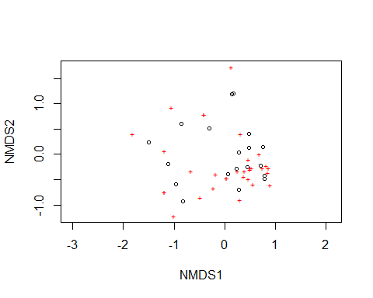

#extract the data scores into a data frame  
data.scores <- as.data.frame(scores(meta.ode)$sites)  
#add the stream type to the data frame for each site  
data.scores$type <- sites.nmds$type  
  
#see which # of dimensions results in the largest descrease in stress  
for(i in 2:5) print(metaMDS(ode.matrix, distance = "bray", k=i,  
 binary = T, weakties = F, autotransform = F, trace = F)$stress*100)

## [1] 19.73226  
## [1] 12.55539  
## [1] 8.4110362  
## [1] 5.9116537

#3 dimensions is best  
  
#Plot the stress values by # of dimensions  
stressplot(meta.ode)

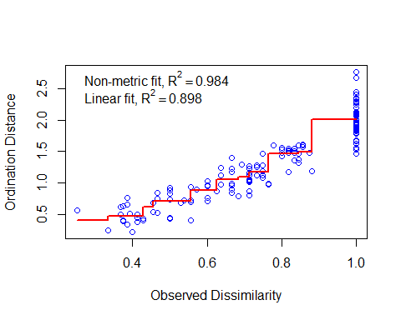

## Plot the site x species NMDS in ggplot ##  
nmds.plot <- ggplot(data.scores, aes(x = NMDS1, y = NMDS2)) +  
 geom_point(size = 4, aes(shape = type, color = type)) + # make point shape/color correlate to stream type  
 theme(axis.text.y = element_text(colour = "black", size = 12, face = "bold"),   
 axis.text.x = element_text(colour = "black", face = "bold", size = 12),   
 legend.text = element_text(size = 12, face ="bold", colour ="black"),   
 legend.position = "right", axis.title.y = element_text(face = "bold", size = 14),   
 axis.title.x = element_text(face = "bold", size = 14, colour = "black"),   
 legend.title = element_text(size = 14, colour = "black", face = "bold"),   
 panel.background = element_blank(), panel.border = element_rect(colour = "black", fill = NA, linewidth = 1.2),  
 legend.key=element_blank()) +   
 labs(x = "NMDS1", color = "Type", y = "NMDS2", shape = "Type") + #Add a legend   
 scale_colour_manual(values = c("#009E73", "#E69F00"))  
  
nmds.plot

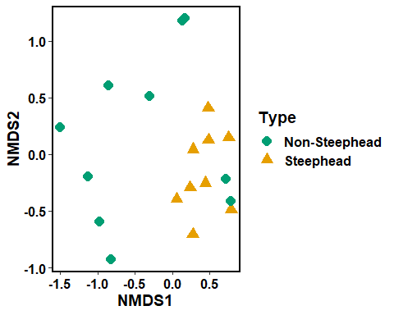

## envfit to add environmental data to the NMDS plot ##  
  
#Correlation analyses to decide if any metrics should be removed  
env_cor <- corr.env  
env_cor <- as.matrix(corr.env)  
env_cor <- na.omit(env_cor) #remove rows with empty values  
cor_mat <- cor(env_cor, method = 'pearson') #use pearson method to construct correlation matrix  
corrplot(cor_mat, method = "number", type = "lower", diag = F, tl.col = "black") #plot the lower half of the correlation matrix

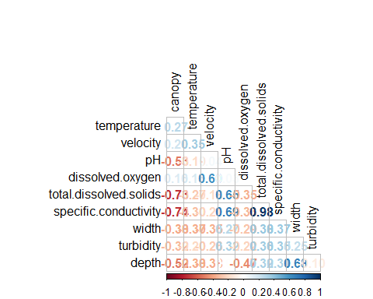

#remove spc due to high correlation with tds  
  
#create environmental vectors for each variable to fit onto NMDS plot  
en <- envfit(meta.ode, env_matrix, permutations = 999, na.rm = T) #use env_matrix object from the mantel tests earlier  
en

##   
## ***VECTORS  
##   
## NMDS1 NMDS2 r2 Pr(>r)  
## canopy -0.795844 0.605502 0.16559 0.223  
## temp -0.264503 -0.964385 0.20631 0.122  
## velocity 0.612280 -0.790641 0.00601 0.946  
## pH 0.974679 0.223608 0.09357 0.486  
## do -0.599471 0.800397 0.00725 0.948  
## tds 0.804172 0.594396 0.19115 0.192  
## width -0.428071 -0.903745 0.06554 0.597  
## turbidity 0.811618 0.584188 0.21410 0.155  
## depth -0.337145 -0.941453 0.09089 0.474  
## sand 0.211134 0.977457 0.11491 0.385  
## gravel -0.865424 0.501039 0.07906 0.544  
## cobble 0.960619 0.277868 0.06906 0.612  
## boulders 0.960619 0.277868 0.06906 0.612  
## fpom -0.582432 -0.812879 0.05158 0.629  
## cpom 0.540108 -0.841596 0.03318 0.750  
## bryophytes -0.994987 0.100009 0.00426 0.971  
## small_wood -0.335380 0.942083 0.17644 0.199  
## large_wood -0.724041 0.689757 0.06532 0.598  
## Permutation: free  
## Number of permutations: 999

#make the length of vector related to strength of correlation  
en_coord <- as.data.frame(scores(en, "vectors")) * ordiArrowMul(en)   
  
#Plot the nmds with the environmental data fitted to it  
nmds.env <- ggplot(data.scores, aes(x = NMDS1, y = NMDS2)) +  
 geom_point(data = data.scores, size = 4, aes(shape = type, color = type)) +  
 geom_segment(aes(x = 0, y = 0, xend = NMDS1, yend = NMDS2), # Add the environmental vectors as line segments  
 data = en_coord, linewidth =1, alpha = 0.5, color = "grey30") +  
 geom_text_repel(data = en_coord, aes(x = NMDS1, y = NMDS2), color = "grey30",   
 fontface = "bold", label = row.names(en_coord)) +  
 annotate(geom = "label", x = -1, y = 1.25, size = 5,  
 label = paste("Stress: ", round(meta.ode$stress, digits = 3))) + #Add the stress value to the plot  
 theme(axis.text.y = element_text(colour = "black", size = 12, face = "bold"),   
 axis.text.x = element_text(colour = "black", face = "bold", size = 12),   
 legend.text = element_text(size = 12, face ="bold", colour ="black"),   
 legend.position = "right", axis.title.y = element_text(face = "bold", size = 14),   
 axis.title.x = element_text(face = "bold", size = 14, colour = "black"),   
 legend.title = element_text(size = 14, colour = "black", face = "bold"),   
 panel.background = element_blank(), panel.border = element_rect(colour = "black", fill = NA, linewidth = 1.2),  
 legend.key=element_blank()) +   
 labs(x = "NMDS1", color = "Type", y = "NMDS2", shape = "Type") + #Legend  
 scale_colour_manual(values = c("#009E73", "#E69F00"))  
nmds.env

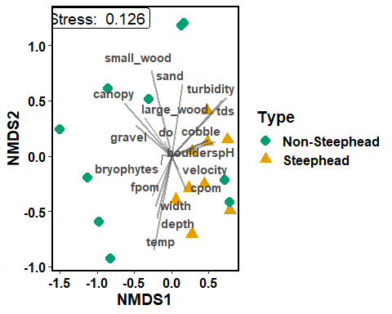

# Cluster analysis

### (see how sites group together by assemblage structure and by environmental data)

### Environmental data ###  
env_clust <- hclust(dist.env, method = "average")  
plot(env_clust, xlab = "Site by environment", ylab = "Euclidean dissimilarity", hang = -2)

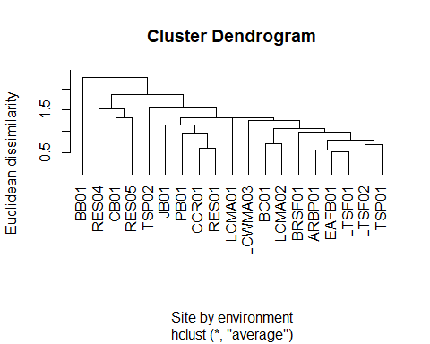

#See how correlated dissimilarity matrix is with the conphenetic dist.   
#(how well does our dendrogram fit our data)  
env.conph <- cophenetic(env_clust)  
cor(dist.env, env.conph)

## [1] 0.83362643

# Silhouette plot  
envpam <- pam(dist.env, k=2)  
attributes(envpam)

## $names  
## [1] "medoids" "id.med" "clustering" "objective" "isolation"   
## [6] "clusinfo" "silinfo" "diss" "call"   
##   
## $class  
## [1] "pam" "partition"

envpam$medoids

## [1] "ARBP01" "RES05"

envpam$clustering

## ARBP01 BB01 BC01 BRSF01 CB01 CCR01 EAFB01 JB01 LCMA01 LCMA02   
## 1 2 1 1 2 1 1 1 1 1   
## LCWMA03 LTSF01 LTSF02 PB01 RES01 RES04 RES05 TSP01 TSP02   
## 1 1 1 1 1 1 2 1 1

plot(envpam)

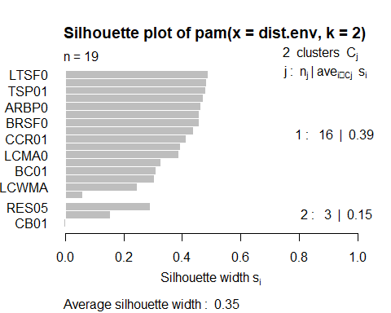

clusplot(envpam, labels = 2, cex = 0.65)

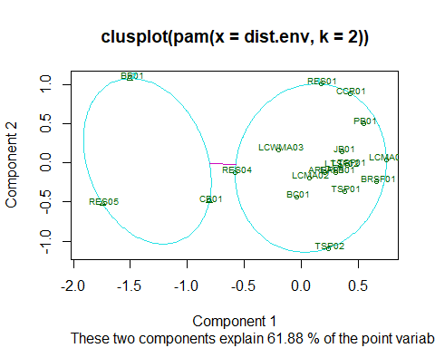

### Odonate data ###  
#Create a dissimilarity matrix for the odonate data at each site using bray-curtis  
clust.dist <- vegdist(odes, method = "bray", binary = T)  
  
#Make a hierarchical cluster dendrogram, using average linkage  
odes.clust <- hclust(clust.dist, method = "average")  
plot(odes.clust, xlab = "Site by species", ylab = "Bray-Curtis' dissimilarity", hang = -2) #use hang to bring the site names in line with each other

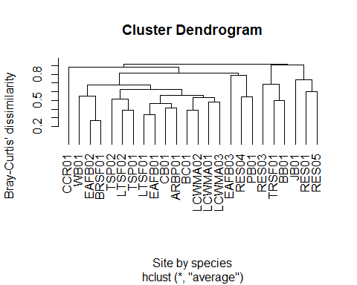

#Calculate the distance at which each each object merges with another on the dendrogram  
comm.coph <- cophenetic(odes.clust)  
  
#See how correlated dissimilarity matrix is with the conphenetic dist.   
#(how well does our dendrogram fit our data)  
cor(clust.dist, comm.coph) #pretty good fit

## [1] 0.80669279

odepam <- pam(clust.dist, k=3)  
attributes(odepam)

## $names  
## [1] "medoids" "id.med" "clustering" "objective" "isolation"   
## [6] "clusinfo" "silinfo" "diss" "call"   
##   
## $class  
## [1] "pam" "partition"

odepam$medoids

## [1] "RES01" "BC01" "TRSF01"

odepam$clustering

## RES01 RES03 RES04 RES05 WB01 CB01 TRSF01 LTSF01 LTSF02 BB01   
## 1 1 1 1 2 2 3 2 2 3   
## CCR01 EAFB01 EAFB02 EAFB03 BRSF01 BC01 ARBP01 TSP01 TSP02 LCWMA01   
## 3 2 2 2 2 2 2 2 2 2   
## LCWMA02 LCWMA03 JB01 PB01   
## 2 2 3 2

plot(odepam)

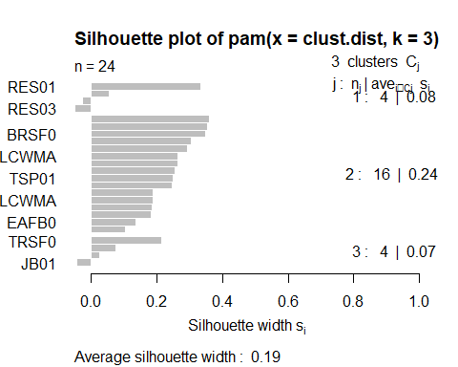

clusplot(odepam, labels = 3, cex = 0.65)

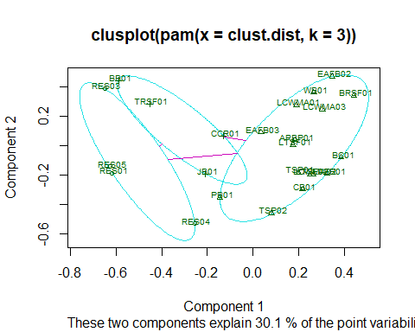

# Stacked species richness plot

### separated by life stage (adult and nymphs documented at each site)

#Create data frame for species richness separated by adult and nymph species at each site  
#Make an object containing all the sites sampled  
sites.graph <- c("RES01", "RES01", "RES03", "RES03", "RES04", "RES04","RES05",  
 "RES05", "WB01", "WB01", "TRSF01", "TRSF01", "BB01", "BB01",   
 "CCR01", "CCR01","LCWMA01", "LCWMA01", "LCWMA02","LCWMA02",   
 "LCWMA03","LCWMA03", "JB01", "JB01","PB01","PB01", "EAFB01",   
 "EAFB01", "EAFB02", "EAFB02", "EAFB03","EAFB03","BRSF01",   
 "BRSF01", "BC01", "BC01", "LTSF01","LTSF01", "LTSF02", "LTSF02",  
 "ARBP01", "ARBP01","TSP01", "TSP01", "TSP02", "TSP02","CB01", "CB01")  
# repeat each site twice, once for nymphal observations and another for adult  
sites.graph

## [1] "RES01" "RES01" "RES03" "RES03" "RES04" "RES04" "RES05"   
## [8] "RES05" "WB01" "WB01" "TRSF01" "TRSF01" "BB01" "BB01"   
## [15] "CCR01" "CCR01" "LCWMA01" "LCWMA01" "LCWMA02" "LCWMA02" "LCWMA03"  
## [22] "LCWMA03" "JB01" "JB01" "PB01" "PB01" "EAFB01" "EAFB01"   
## [29] "EAFB02" "EAFB02" "EAFB03" "EAFB03" "BRSF01" "BRSF01" "BC01"   
## [36] "BC01" "LTSF01" "LTSF01" "LTSF02" "LTSF02" "ARBP01" "ARBP01"   
## [43] "TSP01" "TSP01" "TSP02" "TSP02" "CB01" "CB01"

#Create a data frame with sites on x and its associated adult/nymphal species richness on y  
ode.comm <- data.frame(Site = sites.graph, sp.rich = c(3,0,3,0,5,3,2,0,8,0,5,1,2,  
 0,2,0,6,3,1,4,10,4,5,4,1,  
 4,8,5,4,0,0,3,7,0,6,1,12,  
 0,3,2,11,11,5,3,1,1,9,3))  
#Add a column to the data frame for life stage for each value of richness at a site  
ode.comm$stage <- c("Nymph", "Adult", "Nymph", "Adult", "Nymph", "Adult",   
 "Nymph", "Adult", "Nymph", "Adult", "Nymph", "Adult",   
 "Nymph", "Adult", "Nymph", "Adult", "Nymph", "Adult",   
 "Nymph", "Adult", "Nymph", "Adult", "Nymph", "Adult",   
 "Nymph", "Adult", "Nymph", "Adult", "Nymph", "Adult",  
 "Nymph", "Adult", "Nymph", "Adult","Nymph", "Adult",  
 "Nymph", "Adult","Nymph", "Adult","Nymph", "Adult",  
 "Nymph", "Adult","Nymph", "Adult","Nymph", "Adult")  
# alternate adult nymph so that each site has an adult and a nymph column  
ode.comm

## Site sp.rich stage  
## 1 RES01 3 Nymph  
## 2 RES01 0 Adult  
## 3 RES03 3 Nymph  
## 4 RES03 0 Adult  
## 5 RES04 5 Nymph  
## 6 RES04 3 Adult  
## 7 RES05 2 Nymph  
## 8 RES05 0 Adult  
## 9 WB01 8 Nymph  
## 10 WB01 0 Adult  
## 11 TRSF01 5 Nymph  
## 12 TRSF01 1 Adult  
## 13 BB01 2 Nymph  
## 14 BB01 0 Adult  
## 15 CCR01 2 Nymph  
## 16 CCR01 0 Adult  
## 17 LCWMA01 6 Nymph  
## 18 LCWMA01 3 Adult  
## 19 LCWMA02 1 Nymph  
## 20 LCWMA02 4 Adult  
## 21 LCWMA03 10 Nymph  
## 22 LCWMA03 4 Adult  
## 23 JB01 5 Nymph  
## 24 JB01 4 Adult  
## 25 PB01 1 Nymph  
## 26 PB01 4 Adult  
## 27 EAFB01 8 Nymph  
## 28 EAFB01 5 Adult  
## 29 EAFB02 4 Nymph  
## 30 EAFB02 0 Adult  
## 31 EAFB03 0 Nymph  
## 32 EAFB03 3 Adult  
## 33 BRSF01 7 Nymph  
## 34 BRSF01 0 Adult  
## 35 BC01 6 Nymph  
## 36 BC01 1 Adult  
## 37 LTSF01 12 Nymph  
## 38 LTSF01 0 Adult  
## 39 LTSF02 3 Nymph  
## 40 LTSF02 2 Adult  
## 41 ARBP01 11 Nymph  
## 42 ARBP01 11 Adult  
## 43 TSP01 5 Nymph  
## 44 TSP01 3 Adult  
## 45 TSP02 1 Nymph  
## 46 TSP02 1 Adult  
## 47 CB01 9 Nymph  
## 48 CB01 3 Adult

#Make Site a factor and arrange the sites so that all non-steepheads are together   
#on the left and all steepheads are together on the right  
ode.comm$Site <- factor(ode.comm$Site, levels = c("RES01", "RES03", "RES04",  
 "RES05","WB01", "TRSF01",   
 "BB01", "CCR01","LCWMA01",   
 "LCWMA02","LCWMA03","JB01",  
 "PB01","EAFB01", "EAFB02",   
 "EAFB03","BRSF01","BC01",   
 "LTSF01", "LTSF02","ARBP01",  
 "TSP01","TSP02","CB01"), ordered = T)  
  
# Sort by site and life stage (adult or nymph)  
odecomm_sort <- arrange(ode.comm, Site, stage)  
head(odecomm_sort)

## Site sp.rich stage  
## 1 RES01 0 Adult  
## 2 RES01 3 Nymph  
## 3 RES03 0 Adult  
## 4 RES03 3 Nymph  
## 5 RES04 3 Adult  
## 6 RES04 5 Nymph

# Calculate the cumulative sum of sp.rich for each site  
ode_cumsum <- ddply(odecomm_sort, "Site", transform, tot.rich=cumsum(sp.rich))  
  
# change the data source in ggplot to this new data frame  
  
#Stacked bar graph of species richness per site broken down to number of species  
#documented as nymphs and number of species documented as adults  
ode.plot <- ggplot(data = ode_cumsum, aes(x=Site, y=sp.rich, label=sp.rich, fill=stage)) + #color the two parts of the bar by life stage  
 geom_bar(stat = "identity") + #display the values in the data frame as is  
 geom_text(data=subset(ode.comm, sp.rich != 0), aes(y=sp.rich),   
 position = position_stack(vjust = 0.5), color="white", size=3.5) + #Add the sp. rich values to the bars  
 scale_fill_brewer(palette = "Paired") +  
 labs(x = "Site", y = "Species richness", fill = "Life stage") + #Axis and legend labels  
 theme_classic() +  
 theme(panel.grid= element_blank(),   
 axis.title = element_text(size = 16),   
 legend.text = element_text(size = 16),   
 legend.title = element_text(size = 16),  
 axis.text = element_text(angle = 90, vjust = 0.5, hjust = 1, size = 10,  
 color = "black")) + #Make the axis labels vertical rather than horizontal   
 scale_y_continuous(name = "Species richness", limits = c(0,25)) #Set the upper and lower bounds of the y axis  
ode.plot

