

School of InfoComm Technology

Data Science Capstone Project (DSCP)
Year 3 (2024/25), Semester 5

SCHOOL OF INFOCOMM TECHNOLOGY
Diploma in Data Science

ASSIGNMENT 3

Project Documentation

Tutorial Group: | DSCP Class 2 (Team C)

Student Number | Student Name | User Stories # & Short Description
S10243399K | Lim Jin Xin Hannah | 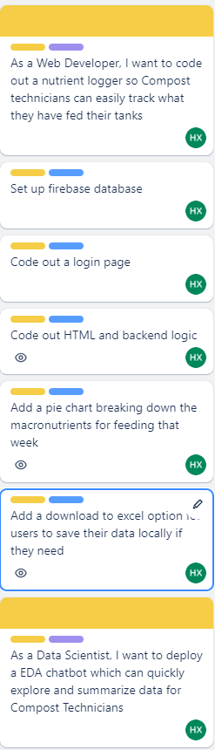  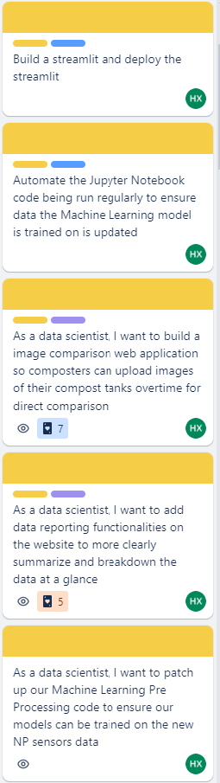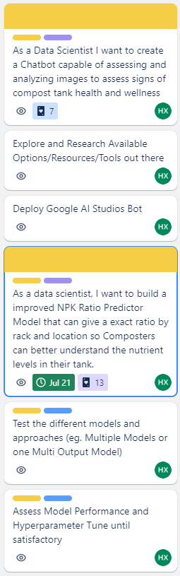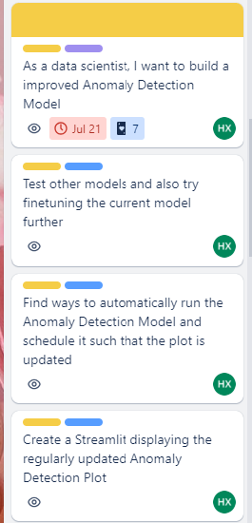  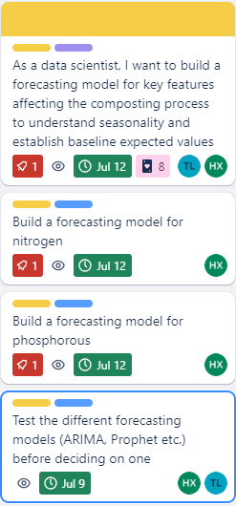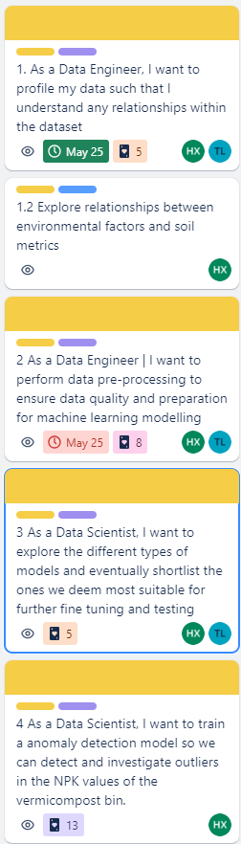  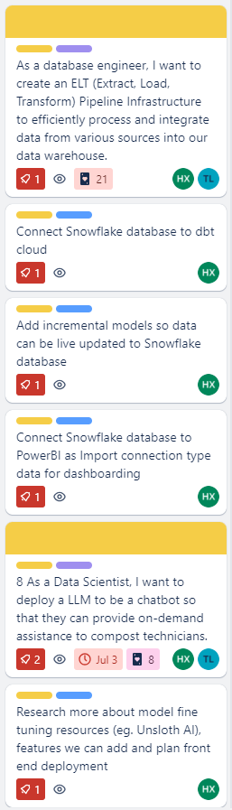

1. Introduction
In the contemporary landscape, sustainability has become a central focus for industries and governments alike, with a growing emphasis on harnessing data-driven solutions to address environmental challenges. This capstone project embodies this shift towards sustainable technology by integrating advanced data analytics, machine learning, and automation into real-world applications.
The project, titled "Sustainable Technology Integration and Automation," aimed to create a comprehensive suite of tools that optimize solar energy systems, manage composting operations, and provide intelligent insights into sustainability practices.
The primary objective of the project was to design and implement data-driven solutions that enhance the efficiency and effectiveness of sustainable technologies. This was achieved through a multi-faceted approach that involved the development of predictive models, automation pipelines, website development and further resources for users to aid both compost and solar panel technicians, and interactive dashboards.
Notably, specifically as myself and my teammate Trinity focused on Composting, my features focus on enhancing composting operations by providing advanced tools and automation for more accurate nutrient management, real-time anomaly detection, and predictive insights
Each component was meticulously crafted to address specific challenges within the broader context of sustainability, particularly in the areas of energy management and waste reduction.
The research questions that guided this project were as follows:
Solar Panels
- How can predictive analytics be leveraged to optimize the performance and reliability of solar energy systems?
- What role can machine learning and anomaly detection play in improving the operational efficiency of composting processes?
- How can automation and real-time data processing enhance the monitoring and decision-making capabilities in sustainable energy management?
Composting
- What are the key predictors of nutrient profiles in compost, and what can be used to customize these profiles for specific agricultural needs?
Hypothesis: Specific combinations of temperature, moisture, and biological composition are strong predictors of nutrient profiles in compost, and AI algorithms can effectively customize these profiles to meet different agricultural requirements.
- How can we monitor in real time and effectively display compost conditions such as temperature, moisture, and aeration, and predict the optimal composting interventions?
Hypothesis: A well-designed real-time dashboard that visualizes critical composting parameters and AI predictions can significantly improve the decision-making process for composters, leading to more efficient compost management.
- What are any other needs of Compost Technicians and what features can be integrated into our website that can aid them?
Hypothesis: Integrating a nutrient logger into the compost management system will enable more precise predictions of compost quality and more effective customization of nutrient profiles, tailored to specific agricultural needs.
These questions formed the foundation for the project’s development, driving the team to explore innovative solutions that not only addressed immediate challenges but also contributed to long-term sustainability goals.

Data Sources and Their Relevance
The success of this project hinged on the effective use of diverse data sources, each carefully selected to provide the necessary insights for the various applications developed. The primary data sources included:
- Estate Management Data: This dataset provided detailed information about the operations and maintenance of commercial estates, including energy usage, equipment performance, and maintenance schedules. This data was crucial for developing the energy forecasting models and optimizing the solar panel installations across different sites.
- Solar Operational Equipment (SOE) Data: SOE data included real-time metrics from solar panels, batteries, and inverters, such as energy output, battery state of charge (SOC), and equipment health indicators. This data was instrumental in building the anomaly detection systems and the dashboards that monitored solar energy performance.

- Weather Data: Weather data was sourced from multiple stations and included temperature, humidity, solar radiation, and wind speed. This data was essential for both the energy forecasting models and the anomaly detection systems, as weather conditions significantly influence solar energy production.

- Composting Data: Data related to composting processes, including nutrient levels (Nitrogen, Phosphorous, Potassium), temperature, and moisture content, were critical for developing the predictive models for compost efficiency and nutrient management.
This data was also used in the Compost Telebot to provide technicians with real-time insights and recommendations.
- Google Sheets and Postgres Databases: Data logged on these platforms came from Composting Locations live in Sengkang, Macpherson and later on towards the end of the semester, our own tanks in Ngee Ann Polytechnic.
Data from these platforms was used for various applications, including the Nutrient Logging Website and the automated pipelines that ensured data consistency and availability across different systems. These sources facilitated the seamless integration of data into the predictive models and dashboards.

Google Sheets and Snowflake Databases: Snowflake served as the central data warehouse for all Solar Panel related data. Snowflake’s capabilities were leveraged for real-time data processing and the automation of data updates, ensuring that the dashboards and models always operated with the most current information.
For Composting Data, since we already had a live data source in Google Sheets, we kept the data there and simply wrote python automation scripts whenever we needed to pull data from there into our relevant projects.
Each of these data sources played a pivotal role in the project. The integration of these diverse datasets allowed for a holistic approach to problem-solving, where insights from one area, such as solar energy management, could inform decisions in another area, such as composting operations.
This project represents a significant step towards integrating sustainable practices with advanced data science techniques. By addressing the research questions with targeted solutions, the project not only achieved its immediate objectives but also laid the groundwork for future innovations in sustainability. The use of robust data sources ensured that the solutions were grounded in real-world conditions, making them both practical and scalable. As the world continues to move towards sustainability, projects like this will be crucial in demonstrating the power of data-driven approaches to solving environmental challenges.

2. Methodology

Data Cleaning and Preprocessing Workflow:

The data preprocessing and cleaning pipeline for the Compost Fertilizer Optimization project is designed to effectively manage and prepare diverse datasets sourced from multiple composting centers. Our approach leverages both cloud-based and local database systems to streamline the ingestion, processing, and analysis of compost-related data. This section outlines the methodologies employed in the preprocessing and cleaning of data, which are crucial steps prior to any advanced analysis or machine learning modeling.
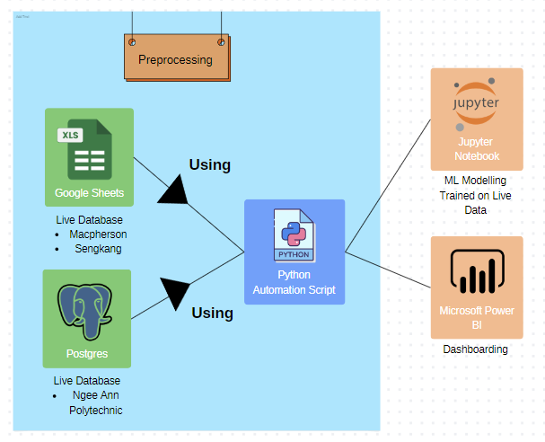

Data Collection and Integration
Data is collected in real-time from various sensors installed at multiple composting centers. These sensors record a wide array of parameters including temperature, moisture, pH levels, and nutrient content. The data is initially stored in Google Sheets and PostgreSQL databases, ensuring easy access and management. A hierarchical folder structure on Google Drive organizes the data by location and date, facilitating systematic access and retrieval.

Automation and Scripting
A Python automation script is the backbone of our preprocessing pipeline. We have 2 primary slightly different variations of the Script. Firstly, we have a script at the top of our Jupyter Notebook to ensure we are pulling in live data to train our models each time the file is ran. This script performs the following functions:
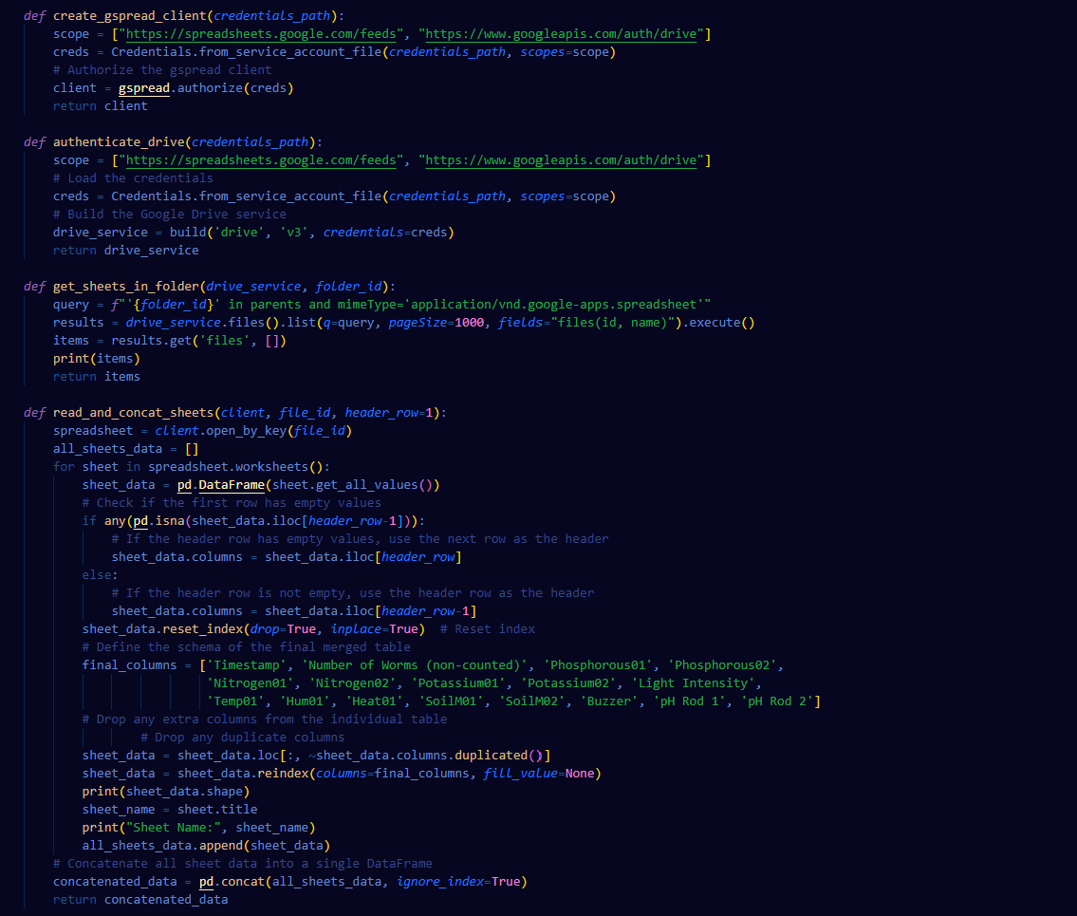
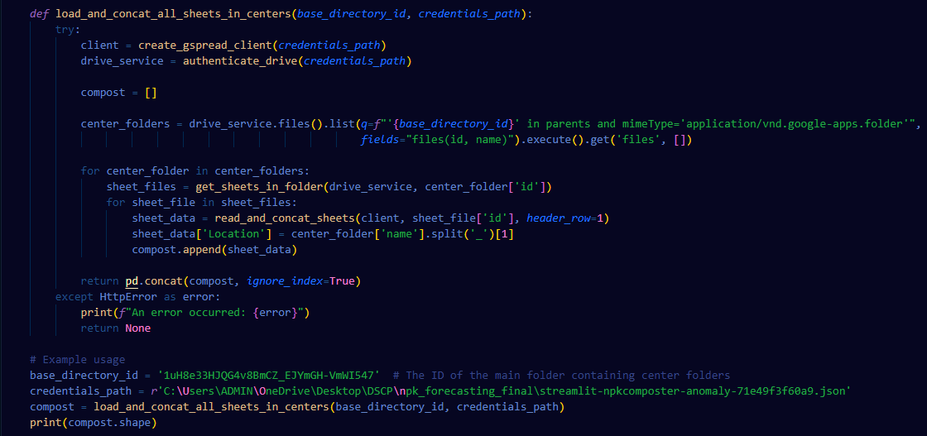
- Google Sheets and Drive API Integration: Using the gspread and googleapiclient.discovery libraries, the script authenticates and connects to Google Drive and Sheets. This allows for automated retrieval of spreadsheet data from specific folders.
- Data Aggregation: The script reads data from multiple sheets across different centers. Each sheet is processed to structure the data uniformly with predefined headers. This includes aligning columns like Timestamp, various nutrient measurements (Phosphorous01, Phosphorous02, etc.), and environmental factors (Temp01, Hum01).
- Concatenation: Data from all sheets are concatenated into a single DataFrame, providing a comprehensive dataset that includes a new column Location to indicate the source compost center.
Our second type of Python Automation Script is our ETL pipeline Data Cleaning Script:
The two pieces of code provided share a general purpose: they both use Google Sheets and Google Drive APIs to authenticate, fetch, and process data from spreadsheets stored in Google Drive. However, there are key differences in their functionality and specifics of implementation that affect how they handle and process the data:
- Authentication and Initialization: Both scripts use similar functions for creating a Google Sheets client and authenticating a Google Drive service. They both establish a scope for the Google API and use a service account file for authentication. The main difference here is purely stylistic, as both segments of code effectively perform the same tasks.
- Fetching Spreadsheet Data:
  - Both scripts include a function to retrieve spreadsheets from a specified folder in Google Drive. However, the first script goes further by listing all spreadsheets in all folders within a base directory, intended for broader data aggregation across multiple centers or categories.
- Data Processing and Concatenation:
  - The ETL pipeline Data Cleaning script's read_and_concat_sheets function not only reads data from each sheet but also performs a complex data cleaning and schema alignment process, ensuring all sheets adhere to a predefined set of columns (final_columns). This function also handles missing header rows by dynamically adjusting the header based on the presence of data.
  - The Jupyter Notebook script’s equivalent function includes location extraction based on the center folder's name, appending this as a new column in the dataset. This indicates that the second script is more tailored to a hierarchical data structure where the location or category of data (derived from folder names) is significant for analysis.
4. Usage of the Data:
- The ETL pipeline Data Cleaning Script is more set up for continual, scheduled operations, possibly for regular data updates and maintenance, which is indicated by its setup with a scheduler.
- The Jupyter Notebook Script, on the other hand, is a standalone operation that fetches all data once and processes it, suitable for one-time or ad-hoc data extraction and analysis.
5. Schema Definition and Handling:
- The ETL pipeline Data Cleaning Script defines a schema within the data processing function and enforces it across all data frames before concatenation. The Jupyter Notebook script assumes that the data schema is consistent or does not enforce a schema as rigorously beyond the data cleaning in individual sheets.

Data Cleaning
As mentioned, the consolidated DataFrame undergoes several cleaning steps to ensure data quality and readiness for analysis:

1. Handling Missing Values
- Action: Columns with more than 50% missing values were dropped. For the remaining columns, missing numeric values were filled with the median of the column.
- Rationale: Missing data can introduce bias and affect the performance of machine learning models. Removing columns with excessive missing data helps focus on more reliable features. Filling missing values with the median maintains the central tendency without being affected by outliers, which is crucial for maintaining a robust dataset for models like regression or classification.

2. Data Filtering
- Action: Rows with invalid timestamps or containing placeholders such as 'Unit' were removed.
- Rationale: Invalid or placeholder entries can skew the results of time-series analysis and other statistical models. Removing these ensures that only relevant and accurate temporal data is used, which is critical for models that depend on chronological sequences, like time-series forecasting or anomaly detection in temporal patterns.

3. Type Conversion
- Action: Attempted to convert certain columns like Phosphorous01, Phosphorous02, etc., to numeric types, replacing non-numeric values with NaN.
- Rationale: Machine learning algorithms require numerical input for computation. Converting these columns to numeric types ensures that the algorithms can process them. Moreover, replacing non-numeric entries with NaN before filling them helps in identifying and dealing with anomalies or misplaced data effectively.

4. Timestamp Normalization
- Action: The Timestamp column was converted to datetime format.
- Rationale: Normalizing timestamps to a uniform datetime format is crucial for time-series analysis, allowing for easier slicing of data based on time intervals and more accurate trend analysis. It also facilitates synchronization with other time-dependent data streams for integrated analyses.

5. Final Adjustments
- Action: Rows still containing placeholder timestamps or erroneous data were removed after the previous cleaning steps.
- Rationale: This step ensures the final cleanliness of the dataset, removing any residual data quality issues that could potentially mislead the learning algorithms or bias the analysis.
Notably, especially with live data, final adjustments is a key component as spreadsheets often contain complex formatting that can introduce inconsistencies when automating data extraction. This is especially problematic if the inconsistencies do not align with the data schema and cause codes to break.
Other examples of erroneous data we had to adapt and deal with as new data came along was the sudden addition of a second row of headers in some of the Macpherson and Sengkang datasets, crashing our codes initially. We had to adapt our pre processing steps accordingly.

6. Consolidation and Schema Adjustment
- Action: Data from multiple sources was consolidated into a single DataFrame with a predefined schema, standardizing column names and ensuring consistent data structure across the dataset.
- Rationale: A consistent schema is essential for automated data processing, reducing errors during data manipulation and making it easier to apply machine learning models that expect a certain structure of input data. It also facilitates scalability and repeatability of the preprocessing steps in a production environment.

Dashboard and Visualization Integration
The cleaned data is then made available for visualization and monitoring through a Microsoft Power BI dashboard. This dashboard connects directly to our Python environment via Jupyter notebooks, allowing stakeholders to view updated data and AI model predictions in real-time.

Statistical Methods or Machine Learning Techniques:

- NPK Ratio Predictor Model

Models Explored

1. Random Forest:
- Justification: Random Forest’s ensemble nature makes it particularly effective in handling the variability and non-linearity inherent in live compost data, where multiple factors interact. The model can manage noisy data and provide feature importance, which helps in understanding which factors most influence NPK ratios.

2. Decision Tree:
- Justification: Decision Trees are simple yet powerful models that provide clear, interpretable rules for prediction. For composting, where decision-making may involve complex, non-linear interactions between features (like moisture, temperature, and organic matter), Decision Trees can capture these relationships effectively. They are also easy to visualize and understand, which can be valuable for stakeholders who need transparency.

3. Ridge Regression:
- Justification: Ridge Regression is a linear model that includes a regularization term to prevent overfitting, making it well-suited for high-dimensional data with multicollinearity issues. In the context of composting, where the NPK ratios may be influenced by a combination of correlated factors, Ridge can provide stable and reliable predictions without overly complicating the model.

4. Lasso Regression:
- Justification: Lasso Regression, like Ridge, is a linear model with regularization, but it also performs feature selection by shrinking less important coefficients to zero. This is particularly useful in composting, where not all features may significantly impact the NPK ratios. Lasso helps in identifying and focusing on the most relevant factors, leading to a more parsimonious and interpretable model.

5. ElasticNet:
- Justification: ElasticNet combines the regularization principles of both Ridge and Lasso, making it ideal for situations where the data exhibits both multicollinearity and the need for feature selection. For NPK ratio prediction, ElasticNet offers a balanced approach, capturing the strengths of both models and potentially leading to better performance on live compost data.

6. XGBoost:
- Justification: XGBoost is a powerful gradient boosting algorithm that is highly effective for complex, non-linear prediction tasks. It handles large datasets with noisy data efficiently, making it suitable for real-time compost monitoring where the NPK ratios might be influenced by a wide range of dynamic factors. XGBoost’s ability to fine-tune predictions through boosting iterations can significantly enhance model accuracy.

7. AdaBoost:
- Justification: AdaBoost is another boosting algorithm that focuses on improving weak learners, typically simple models like Decision Trees, by emphasizing harder-to-predict samples. In composting, where certain conditions might lead to outliers or unusual NPK ratios, AdaBoost can help create a more resilient model by adapting to these challenging data points.

8. LightGBM:
- Justification: LightGBM is a gradient boosting framework designed for efficiency and scalability. It's particularly well-suited for large-scale datasets and scenarios where computational efficiency is crucial, such as continuous monitoring of compost tanks. LightGBM can quickly process large volumes of live data, offering rapid and accurate NPK predictions with minimal computational overhead.
Overall, using the metrics we found Random Forest Regressor performed the best and chose it as our final model.

Final Model Selection (Random Forest Regressor)
For predicting the nutrient ratios of Phosphorous, Nitrogen, and Potassium in compost, a MultiOutputRegressor framework encapsulating a RandomForestRegressor was chosen. This choice is driven by several factors inherent to the nature of compost data and the requirements of predictive accuracy and interpretability in an agricultural setting.
Random Forest Regressor:
- Robustness to Overfitting: Unlike decision trees, random forests mitigate overfitting risks by averaging multiple decision trees, each trained on different parts of the dataset.
- Handling Non-linear Relationships: Compost data often exhibit complex, non-linear relationships due to diverse biological and chemical interactions. Random forests can capture these complexities without the need for transformations.
- Feature Importance: This model provides insights into which variables most significantly impact nutrient levels, valuable for composters to prioritize factors in their processes.
MultiOutput Regression:
- Simultaneous Predictions: Instead of building separate models for each nutrient, this approach efficiently predicts all three nutrients (NPK) at once, maintaining consistency in predictions and reducing computational overhead.
- Correlation Between Outputs: It inherently considers the interdependencies between multiple target variables (NPK ratios), which are often correlated in biological systems.

Model Training
The model training involves several critical steps to ensure it learns effectively from the training data:
- Feature Engineering:
  - Scaling: Features like 'Number of Worms (non-counted)', 'Light Intensity', and environmental factors are scaled using StandardScaler. This standardization is crucial as it nullifies the bias due to different units of measurement, allowing the model to attribute importance based on the actual influence on the target variables.
  - Encoding Categorical Variables: Locations are transformed into numeric data through one-hot encoding, allowing the model to distinguish effects based on geographical data points.
- Data Splitting:
  - The data is split into training and testing sets, with 80% used for training and 20% for validation. This split ensures that the model can be validated on unseen data, mirroring real-world scenarios where predictions are made on new, incoming data.

Model Evaluation and Insights
Post-training, the model's performance is assessed using Mean Squared Error (MSE) and R-squared (R²) metrics:
- MSE: Measures the average squared difference between the estimated values and the actual value, providing a clear quantification of the model's prediction error.
- R²: Indicates the proportion of variance in the dependent variable that is predictable from the independent variables, offering insights into the overall effectiveness of the model.
High R² and low MSE values indicate a model that can reliably predict nutrient ratios, guiding composters in adjusting inputs and processes to achieve optimal compost quality.

Hyperparameter Tuning
To further enhance the model, hyperparameter tuning is employed using Grid Search:
- Grid Search Approach: Examines a range of predefined options for hyperparameters such as the number of estimators and the maximum depth of trees in the random forest. It automates the process of finding the most effective combination for minimizing prediction errors.
- Cross-Validation: Used during grid search to ensure that the tuning is robust against overfitting, using multiple subsets of the dataset to evaluate the model's performance.
The result of this comprehensive tuning is a model optimized for both accuracy and generalizability, equipped to handle the dynamic and varied conditions typical of compost environments.

Practical Implications for Composters
The insights derived from this model empower composters to:
- Predict NPK Ratios: Anticipate the nutrient content of their compost, enabling proactive adjustments in composting materials and methods.
- Understand Influence Factors: Identify which conditions and inputs most significantly affect nutrient levels, focusing efforts on high-impact factors to optimize compost quality.
- Enhance Compost Quality: Better nutrient balance in compost leads to more effective soil amendments, improving crop yields and sustainability of farming practices.
In summary, the chosen modeling approach not only facilitates accurate predictions but also delivers actionable insights that can significantly impact the efficiency and sustainability of composting operations.

- Forecasting Model

Notably, forecasting models need at least 1-2 years of data to be accurate. This is data we do not have but chose to build the model anyways under the assumption more live data would come in over time and the model will eventually improve in accuracy with more data to learn from.
Each model is chosen based on its ability to handle time-series data and predict future values, which is critical in applications like energy forecasting from environmental and weather data. Here’s a comprehensive breakdown of the models explored, their suitability for forecasting, the process of building and testing these models, hyperparameter tuning, and other considerations:

Models Explored
XGBoost (Extreme Gradient Boosting)
  - Suitability for Forecasting: XGBoost is well-suited for forecasting because of its robustness in handling various types of data, including non-linear relationships, and its ability to deal with missing data. It is particularly effective due to its ensemble learning technique, where it builds multiple models sequentially, each correcting errors made by the previous ones.
  - Model Building and Testing: The notebook initializes XGBoost with a set of basic parameters, then systematically explores different configurations through individual hyperparameter testing.
  - Hyperparameter Tuning: Individual hyperparameters like n_estimators, max_depth, min_child_weight, learning_rate, and others are tuned by testing a range of values and observing their impact on performance metrics like the R-squared score. This is done using loop-based testing rather than grid search, focusing on one parameter at a time to understand its direct effect.
Random Forest Regressor
  - Suitability for Forecasting: As an ensemble of decision trees, the Random Forest Regressor is excellent for forecasting due to its high accuracy and robustness against overfitting, which makes it capable of capturing complex patterns in data without being overly sensitive to noise.
  - Model Building and Testing: The model is fitted using training data with default parameters initially. Performance is assessed based on how well it predicts energy production, compared to actual data.
  - Hyperparameter Tuning: Similar to XGBoost, hyperparameters such as n_estimators, max_depth, and others are individually tested to evaluate their impact on the model's predictive accuracy.
Gradient Boosting Regressor
  - Suitability for Forecasting: This model is adept at handling various types of predictive modeling challenges, including forecasting, due to its ability to minimize errors via gradient descent. It builds upon the idea of correcting predecessor’s errors, gradually improving in accuracy.
  - Model Building and Testing: It starts with default settings and is systematically tested by altering its hyperparameters.
  - Hyperparameter Tuning: The notebook explores changes in parameters like learning_rate, n_estimators, and max_depth individually, assessing their effect on the model's performance.
Why ARIMA was chosen over these models:
I chose the ARIMA model over XGBoost, Random Forest, and Gradient Boosting Regressor due to its overall superior performance on our dataset, which consists of a single feature and one target variable, making it a univariate time series. ARIMA is specifically designed for this type of data, effectively modeling temporal dependencies, trends, and seasonality without the complexity of more generalized machine learning models.
Additionally, ARIMA’s simplicity and interpretability make it a more favorable choice, especially in an era where Explainable AI (XAI) is critical to stakeholder satisfaction. By applying Occam's Razor, which suggests that the simplest model that performs well should be preferred, ARIMA was the clear choice for ensuring robust generalization while maintaining transparency. Unlike machine learning models, which require extensive tuning and can behave as black boxes, ARIMA's parameters are straightforward, offering insights into the time series dynamics and aligning with our goal of clear and understandable forecasting.
ARIMA Approach
Before we delve into my findings for the ARIMA model, I will be describing my general approach as I tested different variations of ARIMA.
Version 1: Basic Time Series Forecasting
- Techniques Used: ARIMA and SARIMAX
- Operations: Filters data by location, optionally applies log transformation, performs exploratory data analysis (EDA) with plotting, checks for stationarity with the Augmented Dickey-Fuller (ADF) test, and if necessary, applies differencing to achieve stationarity.
- Visualization: Includes time series plots, seasonal decomposition, and autocorrelation analysis.
- Modeling: Depending on whether seasonal adjustments are specified, fits an ARIMA or SARIMAX model and prints model summaries.
- Scope: This version targets basic forecasting needs with optional seasonal adjustments, suitable for straightforward time series datasets.
Version 2: Advanced EDA and Automated Model Selection
- Enhanced Features: Adds checks for duplicate timestamps and missing values, uses interpolation for missing data, and includes automated model selection via auto_arima which helps in identifying the best model parameters.
- Visualization: Similar to Version 1 but includes visualizations for differenced series to handle non-stationarity more robustly.
- Modeling: Uses the auto_arima function to automatically determine the best ARIMA parameters and fits a SARIMA model based on these parameters. Additionally, forecasts and plots future values, evaluating model performance with metrics like RMSE.
- Scope: Suitable for more complex datasets that require a sophisticated approach to preprocessing and model parameter selection. It’s geared towards datasets with potential data quality issues (like duplicates or missing values) and where the optimal model parameters are not known in advance.
Version 3: Separated EDA and Modeling
- Structure: Splits EDA and modeling into separate functions, providing flexibility in processing and model fitting.
- Operations: Performs similar EDA checks as Version 2 but does not immediately proceed to modeling. Instead, it prepares the dataset thoroughly before handing it off to a separate modeling function.
- Modeling: Allows for either specified or automatically determined model orders. Provides a clear separation of data preparation and modeling, potentially useful in scenarios where different modeling strategies might be tested sequentially or in parallel.
- Scope: Best suited for scenarios where a staged approach to data analysis and modeling is necessary. Useful in research or complex projects where different modeling parameters need to be tested across different stages of data readiness.
Nitrogen01 Forecasting ARIMA Model
- Version 2
Model Specification
Sengkang: ARIMA(2,1,3)
MacPherson: ARIMA(4,0,20)
The model specification is derived using the auto_arima function, which automatically selects the best ARIMA parameters based on information criteria (AIC/BIC).
ARIMA(p,d,q) represents:
p: The number of autoregressive terms
d: The degree of differencing
q: The number of moving average terms
For Sengkang, ARIMA(2,1,2) means:
- 2 autoregressive terms
- 1st order differencing
- 3 moving average terms
For MacPherson, ARIMA(4,0,20) means:
- 4 autoregressive terms
- No differencing
- 20 moving average terms
Finding: The MacPherson model is significantly more complex, suggesting more intricate patterns in its nitrogen levels compared to Sengkang.
- Data Characteristics
Sengkang:
- Observations: 238
- Mean: 137.45
- Standard deviation: 35.67
- Range: 59.00 to 180.00
MacPherson:
- Observations: 2367
- Mean: 161.20
- Standard deviation: 23.58
- Range: 81.00 to 201.00
Finding: MacPherson has about 10 times more observations than Sengkang, allowing for a more detailed analysis. MacPherson also shows higher average nitrogen levels but less variability compared to Sengkang.
- Stationarity
Sengkang:
- Original series: Non-stationary (ADF p-value: 0.1789)
- After differencing: Stationary (ADF p-value: 1.11e-28)
MacPherson:
- Series is stationary (ADF p-value: 0.0001817)
- No differencing required
Finding: The Sengkang data exhibits a trend or seasonal component that requires differencing to achieve stationarity, while MacPherson data is inherently stationary, suggesting more stable nitrogen levels over time.
- Model Performance
Sengkang:
- Log Likelihood: -826.189
- AIC: 1669.876
- BIC: 1680.755
MacPherson:
- Log Likelihood: -9889.264
- AIC: 19707.424
- BIC: 19857.218
Finding: The much higher AIC and BIC values for MacPherson reflect its larger sample size and more complex model. However, these values aren't directly comparable between the two locations due to the difference in sample sizes.
- Model Coefficients
Sengkang: All AR and MA terms were not statistically significant (p > 0.05)
MacPherson:
- Constant term (161.2106) highly significant
- Most AR and MA terms not statistically significant
Finding: The lack of significant coefficients in both models, especially Sengkang, suggests that the models may not be capturing the underlying patterns effectively. This could indicate that alternative modeling approaches might be more suitable.
- Residual Diagnostics
Sengkang:
- No significant autocorrelation (Ljung-Box p-value: 0.96)
- Heteroskedasticity present (p-value: 0.00)
- Non-normal residuals (Jarque-Bera p-value: 0.00)
MacPherson:
- Some remaining autocorrelation (Ljung-Box p-value: 0.01)
- No heteroskedasticity (p-value: 0.84)
- Non-normal residuals (Jarque-Bera p-value: 0.00)
Finding: Both models show issues with residual diagnostics. Sengkang's model exhibits heteroskedasticity, indicating changing variance over time, while MacPherson's model shows some remaining autocorrelation. Both have non-normal residuals, which could affect the reliability of confidence intervals and forecasts.
- Time Series Characteristics
Sengkang:
- Significant fluctuations over time
- Notable drops and spikes, particularly around early May 2024
- General upward trend from mid-May 2024 onwards
MacPherson:
- Significant fluctuations over time
- Noticeable downward trend from April to June 2024
- High volatility with rapid short-term changes
Finding: The two locations show different temporal patterns. Sengkang exhibits more dramatic changes with a recent upward trend, while MacPherson shows a gradual decline with high short-term volatility. This suggests that local factors significantly influence nitrogen levels, and a one-size-fits-all modeling approach may not be optimal.
Overall Conclusions:
- Model Adequacy: The ARIMA models for both locations show signs of inadequacy, with non-significant coefficients and issues in residual diagnostics. This suggests that more advanced or alternative modeling techniques might be necessary.
- Temporal Patterns: The two locations exhibit distinct temporal patterns in nitrogen levels, highlighting the importance of location-specific analysis and modeling.
- Data Quality: The large difference in the number of observations between the two locations raises questions about data collection consistency or potential issues with the Sengkang data collection process.
- Stationarity: The difference in stationarity between the two locations indicates different underlying processes affecting nitrogen levels, which could be due to local environmental factors or human activities.
- Volatility: Both locations show high volatility in nitrogen levels, but with different patterns, suggesting the need for models that can handle rapid short-term changes.
These findings indicate that while the ARIMA models provide some insights, there's significant room for improvement in modeling nitrogen levels at these locations. Considering alternative models, incorporating external variables, and investigating the causes of the observed patterns could lead to more accurate and reliable forecasts.
Comparison with Version 1 ARIMA Model
The Version 1 ARIMA model was chosen over the Version 2 model for several reasons:
Simplicity and Interpretability: Version 1 used simpler ARIMA models (e.g., ARIMA(2,1,2) for Sengkang) compared to the more complex models in Version 2 (e.g., ARIMA(4,0,20) for MacPherson). Simpler models are often preferred as they are easier to interpret and less prone to overfitting.
Furthermore, applying occams razor’s principal, we should always choose the simpler model for generalization.
Computational Efficiency: The simpler models in Version 1 are computationally less intensive, allowing for faster model fitting and forecasting, which can be crucial in real-time or large-scale applications.
Robustness to Overfitting: The complex model in Version 2, especially for MacPherson (ARIMA(4,0,20)), shows signs of overfitting with many insignificant terms. Version 1's simpler models may be more robust to changes in the data.
Forecast Stability: Simpler models often produce more stable forecasts over longer horizons, which might be preferable depending on the specific requirements of the nitrogen level monitoring system.
While Version 2 provides a more detailed analysis and potentially captures more complex patterns in the data, the choice of Version 1 reflects a balance between model complexity, interpretability, and practical considerations in the context of the overall nitrogen monitoring system. However, the insights gained from Version 2 could be valuable for future model refinements and for understanding the limitations of the simpler models used in Version 1.
- Version 3
Model Specification
Sengkang: SARIMAX(4, 0, 3)
MacPherson: SARIMAX(3, 0, 4)
These models were derived using a combination of domain knowledge and data-driven approaches. The SARIMAX(p,d,q) notation represents: p: Number of autoregressive terms d: Degree of differencing q: Number of moving average terms
For Sengkang, SARIMAX(4,0,3) means:
- 4 autoregressive terms
- No differencing
- 3 moving average terms
For MacPherson, SARIMAX(3,0,4) means:
- 3 autoregressive terms
- No differencing
- 4 moving average terms
Finding: The model specifications indicate complex temporal dependencies in both locations, with slightly different patterns between them.
- Data Characteristics
Sengkang:
- Observations: 297
- Nitrogen range: Approximately 150 to 171
MacPherson:
- Observations: 2945
- Nitrogen range: Approximately 130 to 145
Finding: MacPherson has significantly more data points, potentially allowing for more robust model estimation. Both locations show considerable nitrogen value variations.
- Stationarity
Sengkang:
- ADF Statistic: -1.9367842128718517
- p-value: 0.31499608932473383
MacPherson:
- ADF Statistic: -5.147225664391284
- p-value: 1.1256655529163162e-05
Finding: MacPherson's data is stationary, while Sengkang's is not. This suggests that the no-differencing assumption in the Sengkang model might need reconsideration.
- Model Performance
Sengkang:
- Log Likelihood: -268.923
- AIC: 553.846, BIC: 583.396
- RMSE: 2.048455631636844
MacPherson:
- Log Likelihood: -2507.936
- AIC: 5031.871, BIC: 5079.774
- RMSE: 2.684003163218812
Finding: Both models show reasonable performance. The higher AIC/BIC for MacPherson is expected due to the larger dataset. The RMSE values suggest good predictive power for both models.
- Model Coefficients
Sengkang: All AR and MA terms are statistically significant (p < 0.05), indicating that each term contributes meaningfully to the model.
MacPherson: Most AR and MA terms are highly significant (p < 0.001), except for ar.L1 which is marginally significant (p = 0.150).
Finding: The significance of most coefficients in both models suggests that they are capturing important temporal patterns in the data.
- Residual Diagnostics
Sengkang:
- Ljung-Box test: No significant autocorrelation (p-value: 0.71)
- Heteroskedasticity present (p-value: 0.00)
- Non-normal residuals (Jarque-Bera p-value: 0.00)
MacPherson:
- Ljung-Box test: No significant autocorrelation (p-value: 0.99)
- Some heteroskedasticity (p-value: 0.00)
- Non-normal residuals (Jarque-Bera p-value: 0.00)
Finding: Both models successfully address autocorrelation but show issues with heteroskedasticity and non-normality in residuals. This suggests that while the models capture the main patterns, there might be some unmodeled complexities in the data.
- Time Series Characteristics
Finding: Ultimately this model was not used due to a lack of seasonality captured by the model compared to Version 1.
Conclusion: Version 3 was where I tested the SARIMAX Model, which ultimately was not used because there was much lesser seasonality present.
Furthermore, Version 1 strikes a better balance between model complexity and performance, ensuring reliable, interpretable, and efficient temperature forecasting across different locations.
The choice of Version 1 reflects a pragmatic approach that prioritizes stability, generalizability, and ease of implementation and maintenance. These factors are crucial for a operational forecasting system that needs to perform consistently across various locations and over extended periods.
Final Model (Nitrogen01)
ARIMA
- ARIMA Model Selection and Building
ARIMA models were chosen for this analysis due to their ability to capture complex temporal patterns in univariate time series data. The model selection process differed for MacPherson and Sengkang, reflecting the unique characteristics of each location's nitrogen data.
4.1 MacPherson: ARIMA(4,0,20)
The MacPherson model was selected based on:
a) Stationarity: ADF test results (test statistic: -4.5189, p-value: 0.00018) indicated stationarity.
b) ACF and PACF plots: Suggested complex MA and AR components.
c) Model order selection: A grid search determined the optimal combination of p=4 and q=20.
4.2 Sengkang: ARIMA(2,1,2)
For Sengkang, a different model structure was chosen:
a) Non-stationarity: ADF test results (test statistic: -2.3064, p-value: 0.1699) indicated non-stationarity.
b) Differencing: First-order differencing was applied, making the series stationary (differenced ADF p-value: 1.11e-28).
c) ACF and PACF plots: Showed significant autocorrelations at multiple lags, suggesting both AR and MA components.
d) Model Order Selection: The ARIMA(2,1,2) model was chosen, balancing complexity and fit.
- Model Fitting and Evaluation
5.1 MacPherson: ARIMA(4,0,20)
a) Model fit: Log-likelihood of -9827.712, AIC of 19707.424.
b) Residual diagnostics: Some remaining autocorrelation (Ljung-Box p-value: 0.01), homoscedastic residuals, non-normal distribution.
c) Parameter significance: Many AR and MA terms not statistically significant.
5.2 Sengkang: ARIMA(2,1,2)
a) Model fit: Log-likelihood of -826.172, AIC of 1662.345.
b) Residual diagnostics: No significant autocorrelation (Ljung-Box p-value: 0.96), heteroscedastic residuals (p-value: 0.00), extremely non-normal distribution (Jarque-Bera p-value: 0.00).
c) Parameter significance: None of the AR or MA terms are statistically significant, suggesting potential overfitting or the need for a different model structure.
- Insights and Trends
6.1 MacPherson
a) Baseline nitrogen level: About 161 units.
b) Short-term dependencies: Strong positive autocorrelation at lag 2.
c) Complex seasonality: Captured by high-order MA terms.
d) Trend: Slight downward trend over time.
e) Volatility: High variability (std: 23.57), range: 81 to 201 units.
6.2 Sengkang
a) Baseline nitrogen level: Not directly interpretable due to differencing.
b) Volatility: Lower variability compared to MacPherson (std: 34.04), range: 56 to 180 units.
c) Trend: The time series plot shows fluctuating patterns with sudden drops and rises.
d) Seasonality: The seasonal decomposition plot suggests a complex seasonal pattern.
e) Non-stationarity: The original series required differencing, indicating the presence of a stochastic trend.

Phosphorous01 Version 2 ARIMA Model
During the implementation of the SARIMA forecasting model using the statsmodels library, we encountered an anomaly where the forecast predictions were displayed extending backward in time rather than projecting forward. Despite confirming that the DataFrame's datetime index was correctly formatted and chronologically ordered, the issue persisted.
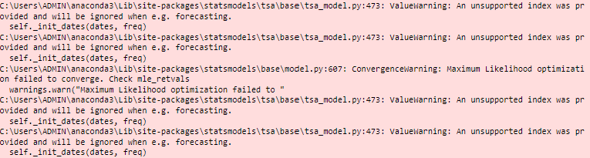
This warning indicates that the datetime index used in the model might not be recognized appropriately by the statsmodels library, despite being correctly formatted according to typical pandas DataFrame specifications. This suggests a potential compatibility or handling issue within the library itself.

Implications
The improper recognition of the datetime index is critical as it directly impacts the model’s ability to correctly align and forecast future data points. This misalignment results in forecasts that incorrectly map to past dates rather than future intervals, undermining the utility and accuracy of the model’s predictive capabilities.
Hence, despite attempts to test, I will not be analyzing the model due to potential inaccuracies in the forecasted results.
Phosphorous01 Version 3 ARIMA Model
The code is organized into three main functions:
2.1. perform_advanced_eda()
2.2. perform_modeling()
2.3. process_all_locations()
- Detailed Analysis of Functions
3.1. perform_advanced_eda()
This function conducts comprehensive EDA for each location:
a) Data Preparation:
- Checks for and handles duplicate timestamps
- Interpolates missing values
b) Visualization:
- Plots original time series
- Performs and visualizes seasonal decomposition
c) Stationarity Analysis:
- Conducts Augmented Dickey-Fuller (ADF) test
- If non-stationary, differences the series and plots the result
d) Correlation Analysis:
- Plots Autocorrelation Function (ACF) and Partial Autocorrelation Function (PACF)
3.2. perform_modeling()
This function handles the modeling process:
a) Model Selection:
- Uses specified SARIMA orders if provided
- Otherwise, employs auto_arima to find optimal parameters
b) Model Fitting:
- Fits SARIMAX model with chosen parameters
c) Forecast Accuracy:
- Performs train-test split (80-20)
- Computes Root Mean Square Error (RMSE) on test set
3.3. process_all_locations()
This function orchestrates the entire process:
a) Iterates through unique locations b) Calls perform_advanced_eda() for each location c) Specifies SARIMA orders for SengKang and MacPherson d) Calls perform_modeling() for each location e) Stores fitted models in a dictionary
- Key Features and Improvements
- Robust handling of data irregularities (duplicates, missing values)
- Advanced seasonal decomposition analysis
- Automatic model parameter selection with auto_arima
- Flexibility to use pre-specified model orders
- Quantitative assessment of model performance using RMSE

- Model Outputs
The code generates several outputs for each location:
- Time series plots (original and differenced if necessary)
- Seasonal decomposition plots
- ACF and PACF plots
- SARIMA model summary
- RMSE for forecast accuracy

- Interpretation and Findings
- The model adapts to each location's unique characteristics by either using pre-specified orders or finding optimal parameters.
- Seasonal decomposition helps in understanding underlying patterns in the data.
- RMSE provides a quantitative measure of forecast accuracy, allowing for comparison between locations.
Based on the model outputs provided for Version 3, I'll discuss the findings, interpret the quality of the output, and explain what these findings mean. Then, I'll compare Version 1 and Version 3, justifying why Version 1 is the better model.

Findings and Interpretation for Version 3:
1. MacPherson:
a) ACF and PACF:
- The ACF shows strong autocorrelation at multiple lags, gradually decreasing.
- The PACF shows significant spikes at lags 1 and 2, with smaller spikes after.
This suggests an AR(2) or higher order process.

b) Time Series Characteristics:
- The original time series shows high variability and some sudden drops in temperature.
- There's a clear upward trend in the middle of the series.
- The seasonal decomposition reveals a complex seasonal pattern.
c) Model Output:
- The SARIMAX(3, 0, 4) model was used.
- The AIC is 28003.631, which is relatively high.
- Several AR and MA terms are statistically significant (p < 0.05).

2. SengKang:
a) Stationarity:
- The ADF test p-value (0.0864) > 0.05, indicating non-stationarity.
- The differenced series appears more stationary.
b) ACF and PACF of Differenced Series:
- The ACF shows a gradual decline, suggesting potential overdifferencing.
- The PACF has a significant spike at lag 1, then cuts off.
This suggests an AR(1) process on the differenced series.
c) Time Series Characteristics:
- The original series shows clear level shifts and some cyclical patterns.
- The seasonal component in the decomposition is less pronounced than for MacPherson.
d) Model Output:
- The SARIMAX(4, 0, 3) model was used.
- The AIC is 2006.444, much lower than MacPherson's.
- Several AR and MA terms are statistically significant.
Quality of Output and Meaning:
1. The models capture some of the time series characteristics, but there are concerns:
- High AIC for MacPherson suggests potential overfitting.
- Non-stationarity in SengKang's original series may affect model reliability.
2. The seasonal components differ between locations, indicating location-specific patterns.
3. Both models show some significant AR and MA terms, suggesting they capture some underlying patterns in the data.
4. The differencing applied to SengKang's data improved stationarity but may have led to some information loss.
Comparison of Version 1 and Version 3:
Version 1:
- Used ARIMA(4, 0, 20) for MacPherson and ARIMA(2, 1, 2) for SengKang.
- Performed basic EDA and stationarity tests.
- Used a simpler modeling approach.
Version 3:
- Used SARIMAX(3, 0, 4) for MacPherson and SARIMAX(4, 0, 3) for SengKang.
- Conducted more advanced EDA, including seasonal decomposition.
- Attempted to account for seasonality in the models.
Why Version 1 is Better:
1. Simplicity: Version 1 uses simpler ARIMA models, which are often more interpretable and less prone to overfitting.
2. Consistency: Version 1 applies differencing to SengKang's data, addressing non-stationarity more directly.
3. Model Fit: Version 1's ARIMA(2, 1, 2) for SengKang has a lower AIC (1991.451) compared to Version 3's SARIMAX(4, 0, 3) (AIC 2006.444), indicating a better fit.

4. Avoiding Overcomplication: Version 3's attempt to model seasonality may have introduced unnecessary complexity, especially given the unclear seasonal patterns in the data.
5. Robustness: The simpler models in Version 1 are likely to be more robust to changes in the data and less sensitive to potential outliers or anomalies.
In conclusion, while Version 3 provides more detailed EDA, the added complexity in modeling doesn't seem to significantly improve the results. Version 1's simpler approach appears to capture the essential patterns in the data without overcomplicating the model structure, making it the better choice for this particular dataset.
Phosphorous01 Final Model
The code is structured around two primary functions:
a) perform_eda_and_modeling(): This function conducts Exploratory Data Analysis (EDA) and modeling for a specific location.
b) process_all_locations(): This function applies the EDA and modeling process to all unique locations in the dataset.
2.2 Data Preparation and EDA
For each location, the model performs the following steps:
- Data Filtering: Isolates data for the specified location.
- Optional Log Transformation: Applies logarithmic transformation if specified.
- Time Series Plotting: Visualizes the temperature data over time.
- Descriptive Statistics: Provides summary statistics of the temperature data.
- Stationarity Testing: Conducts Augmented Dickey-Fuller (ADF) test to check for stationarity.
- Differencing: Applies differencing if the series is non-stationary.
- Seasonality Analysis: Performs seasonal decomposition of the time series.
- ACF and PACF Analysis: Plots autocorrelation and partial autocorrelation functions.
2.3 Model Fitting
The function attempts to fit either an ARIMA or SARIMAX model based on the provided parameters:
- ARIMA is used when no seasonal_order is provided.
- SARIMAX is used when a seasonal_order is specified.
The model parameters (p, d, q) can be customized for each location or a default order can be used.
2.4 Forecasting and Visualization
After fitting the models, the code includes a forecast_and_plot() function that:
- Generates forecasts for the next 25 weeks.
- Plots actual vs. forecasted values.
- Saves the plot as an image file.
- Model Outputs
The model produces several outputs:
- Descriptive statistics for each location's temperature data.
- Stationarity test results and interpretation.
- Seasonal decomposition plots.
- ACF and PACF plots.
- Model summary statistics (AIC, coefficients, etc.).
- Forecasted temperature values for the next 25 weeks.
- Plots comparing actual and forecasted values.
- Key Features
- Flexibility: Allows for different ARIMA orders for specific locations.
- Comprehensive Analysis: Combines EDA, statistical tests, and forecasting.
- Visualization: Provides multiple plots for data interpretation.
- Automated Processing: Handles multiple locations without manual intervention.
Findings:
- Model Summary:
  - The model used for MacPherson is ARIMA(4, 0, 20), indicating 4 autoregressive terms, no differencing, and 20 moving average terms.
  - The AIC (Akaike Information Criterion) is 27995.879, which is relatively high, suggesting the model might be overfitting.
- Time Series Characteristics:
  - The time series plot shows high variability and some sudden drops in temperature.
  - The ADF test statistic (-3.684) and p-value (0.004) indicate that the series is stationary, meaning differencing is not required.
- ACF and PACF:
  - The ACF plot shows significant autocorrelation at multiple lags, declining slowly.
  - The PACF plot shows significant partial autocorrelation at lag 1, with smaller spikes at other lags.
- Seasonal Decomposition:
  - The seasonal component shows a clear pattern, indicating the presence of seasonality in the data.
SengKang:
- Model Summary:
  - The model used for SengKang is ARIMA(2, 1, 2), indicating 2 autoregressive terms, first-order differencing, and 2 moving average terms.
  - The AIC is 1991.451, which is much lower than MacPherson's, suggesting a potentially better fit.
- Time Series Characteristics:
  - The time series plot shows less variability compared to MacPherson, with some clear trends and patterns.
  - The original series was non-stationary, requiring differencing. After differencing, the series became stationary.
- ACF and PACF:
  - Both ACF and PACF plots show significant spikes at the first lag, with smaller spikes at other lags, supporting the chosen ARIMA order.
- Seasonal Decomposition:
  - The seasonal component shows a clear and consistent pattern, indicating strong seasonality in the data.
Interpretation and Findings:
- Stationarity:
  - MacPherson's data was initially stationary, while SengKang's required differencing to achieve stationarity. This suggests that SengKang's temperature data has a stronger underlying trend.
- Seasonality:
  - Both locations show clear seasonal patterns, but SengKang's seasonality appears more consistent and pronounced.
- Variability:
  - MacPherson's temperature data shows higher variability and more extreme fluctuations compared to SengKang. SengKang's temperature seems to follow a more predictable pattern, while MacPherson's temperatures are more erratic and might be influenced by local factors not captured in the model.
- Forecast Reliability:
  - Given the model characteristics, forecasts for SengKang are likely to be more reliable than those for MacPherson due the erraticness of Macpherson’s model combined with us having minimal data to work with (Forecasting usually needs at least 1-2 years of data). However, both models display clear seasonality overall.

- Anomaly Detection Model

Model Selection and Implementation (Prophet)
The core of the anomaly detection system is built using the Prophet model, known for its robustness in handling time series data with strong seasonal effects.
- Prophet Model: Chosen for its ability to manage data with irregular trends and seasonal fluctuations typical in agricultural datasets. It accommodates yearly, weekly, and daily seasonality, making it ideal for this application where environmental conditions affecting compost quality can vary significantly throughout the year.
- Model Training
Data Preparation: The data used to train the Prophet model should ideally be in a DataFrame with two columns: ds and y. The ds (datestamp) column should contain the dates, and the y column should contain the values we want to forecast, in this case, the NPK ratios.
Model Initialization and Fitting:
  - Initialization: A Prophet model instance is created. This can include setting the seasonality, changepoint detection, and other configurable parameters that Prophet allows to tailor the model to specific time series characteristics.
  - Fitting: The model is then fitted to the data. This involves learning the underlying patterns in the seasonal variations and trends in the historical data of NPK ratios.
Forecasting: Once trained, the model can make forecasts for future dates. It computes the forecasted values (yhat) and the uncertainty intervals (yhat_lower and yhat_upper) for these predictions.

Creation of the NPK Ratio Column
The NPK ratio column is an engineered feature that represents the balance of nutrients. Here’s how it's typically computed:
- Calculation Method:
  - An instance of a custom NPKRatio class is created for each row, taking the values of phosphorous, nitrogen, and potassium as inputs.
  - The calculate_ratio method of this class computes the ratio according to a predefined formula, which might be aimed at achieving a particular balance, such as the 4:2:1 ratio often sought in fertilizers.
  - This method ensures that the ratio calculation handles zeros and other potential anomalies in nutrient levels gracefully.
- Applying the Calculation:
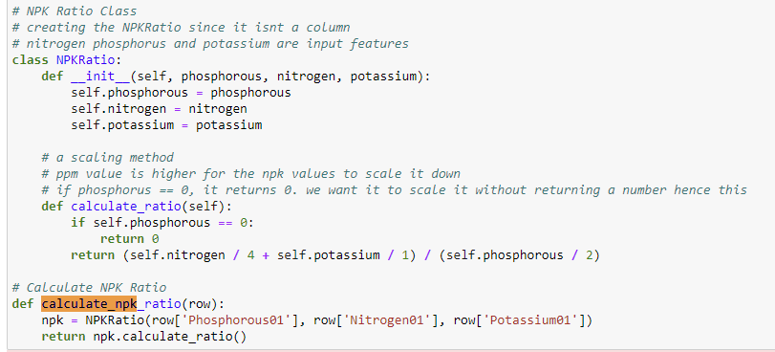
  - The calculate_npk_ratio function is applied across the DataFrame using the apply method, which assigns the computed ratio to a new column called NPK_Ratio.
Notable ML Considerations
Rationale for Scaling and Not Transforming the Data (aside from creating NPK Ratio Target Column)
- Prophet Model Characteristics:
Robustness to Scale: The Prophet model is designed to be robust to the absolute scale of the data. It focuses on identifying trends, seasonality, and holiday effects (if specified) in the time series data. The internal workings of Prophet handle these aspects without requiring normalized or standardized input features.
Time Series Data: Prophet operates on time series data directly. The primary transformation it handles is decomposing the data into its components (trend, seasonality, and residuals), rather than scaling the magnitude of the input values.
Hence, in theory there is no need to scale the data which is effectively what my calculate_npk_ratio function is doing.
However, the NPK ratio is computed to establish a standardized measure of nutrient balance. The calculation aims to balance the nutrients in relation to a known beneficial ratio for plant growth (for example, a 4:2:1 ratio for nitrogen to phosphorus to potassium). Hence, scaling is unintentionally done as a byproduct to create the Target Variable for the column to predict, not because it is needed for Prophet.
- Choosing Not to Transform the Data
Robust to Non-Normalized Data: Prophet is designed to handle time series data as it is encountered in real-world scenarios, which often includes non-normalized and non-standardized values. The model includes components that automatically adjust for trends and seasonality, which can effectively manage even raw data scales.
Direct Interpretability: Using raw values allows for results that are immediately interpretable in the context they are used. For compost management, seeing actual ratios or values can be more meaningful than normalized scores, especially when making real-time decisions or adjustments. In time series analysis, especially with environmental or agricultural data, the absolute values (like temperature, pH, and nutrient levels) can be crucial for understanding underlying patterns and predicting future conditions. Normalizing or transforming these values could obscure these patterns.

Anomaly Detection
Using the trained Prophet model, the system forecasts future NPK ratios and determines confidence intervals for these predictions.
- Forecasting and Anomaly Identification: Future data points falling outside the predicted confidence intervals are flagged as anomalies. This approach helps in identifying significant deviations from expected nutrient balances, which could indicate issues in the composting process or data recording errors.

Insights and Impact
The anomaly detection model provides several critical insights:
- Real-Time Monitoring: Allows compost managers to monitor nutrient levels continuously, ensuring that the composting process remains within the desired nutrient specifications.
- Early Warning System: By identifying anomalies, the system serves as an early warning mechanism, prompting further investigation and remedial actions to avoid potential negative impacts on compost quality.
- Trend Analysis: The seasonal decomposition of NPK ratios helps understand long-term trends and seasonal variations, which are vital for strategic planning in agricultural practices.

Model Evaluation
The model's effectiveness is evaluated using:
- Mean Absolute Error (MAE) and Mean Squared Error (MSE): These metrics assess the average magnitude of the errors in predictions, providing a clear picture of model accuracy.
- R-squared (R²): Measures the proportion of variance in the dependent variable that is predictable from the independent variables, offering insights into the overall effectiveness of the model.

Conclusion
The anomaly detection model for NPK ratio prediction in compost using Prophet provides a sophisticated tool for managing compost quality through precise monitoring and early detection of nutrient imbalances. Its implementation can lead to more sustainable and efficient agricultural practices by ensuring optimal compost conditions conducive to healthy crop growth.

Assumptions and Limitations:
Assumption:
- The data collected is representative of typical conditions in community composting facilities, and is accurate.
- Live data will continue being updated to the google sheets so we can train the model on more data.

3. Results

3.1 NPK Ratio Predictor Model:

Overview
The NPK Ratio Predictor Model is designed to optimize the composting process by accurately predicting the essential nutrient ratios—Nitrogen (N), Phosphorus (P), and Potassium (K)—using a set of environmental variables within the compost tank.
By integrating this model into a user-friendly Streamlit application, we ensure it is accessible and actionable for community composters.

Value to Composters
1. Enhanced Nutrient Management:
- The model provides precise predictions of NPK ratios, which are critical for assessing the nutrient content of compost. This accuracy enables composters to fine-tune the addition of materials to maintain or adjust the nutrient balance, ensuring the compost produced meets the specific requirements for different types of soil and crops.
2. Real-Time Decision Making:
- With real-time data processing capabilities, the model empowers composters to make immediate decisions based on the current nutrient status of the compost. This dynamic approach helps in adapting quickly to any changes in the composting environment, such as sudden shifts in temperature or moisture levels, which could affect the decomposition process and, subsequently, the nutrient content.
3. Cost Efficiency and Waste Reduction:
- By optimizing the input of materials based on the predicted nutrient output, the model aids in reducing waste and lowering costs associated with compost production. Composters can avoid the overuse of materials that do not contribute to the desired nutrient balance, thus promoting more sustainable composting practices.
4. Quality Assurance and Compliance:
- For composters who need to meet certain regulatory standards regarding nutrient levels in compost, this model provides a reliable tool for ensuring compliance. Regular monitoring and adjusting based on model predictions can help maintain the quality and consistency of the compost produced.
Statistical and Machine Learning Analysis:
- The application of scaling techniques ensures that all environmental variables influence the model equitably, enhancing the accuracy of nutrient predictions. The performance metrics like MSE and R^2 provide a quantifiable measure of the model’s accuracy, allowing for continual improvement through techniques such as hyperparameter tuning.

Impact and Future Directions
Predictive Power and Environmental Sustainability:
- The predictive capabilities of the model not only enhance operational efficiency but also contribute to environmental sustainability. By optimizing compost nutrient content, the model helps in producing higher quality compost, which can improve soil health and reduce dependency on chemical fertilizers.
Streamlit UI:
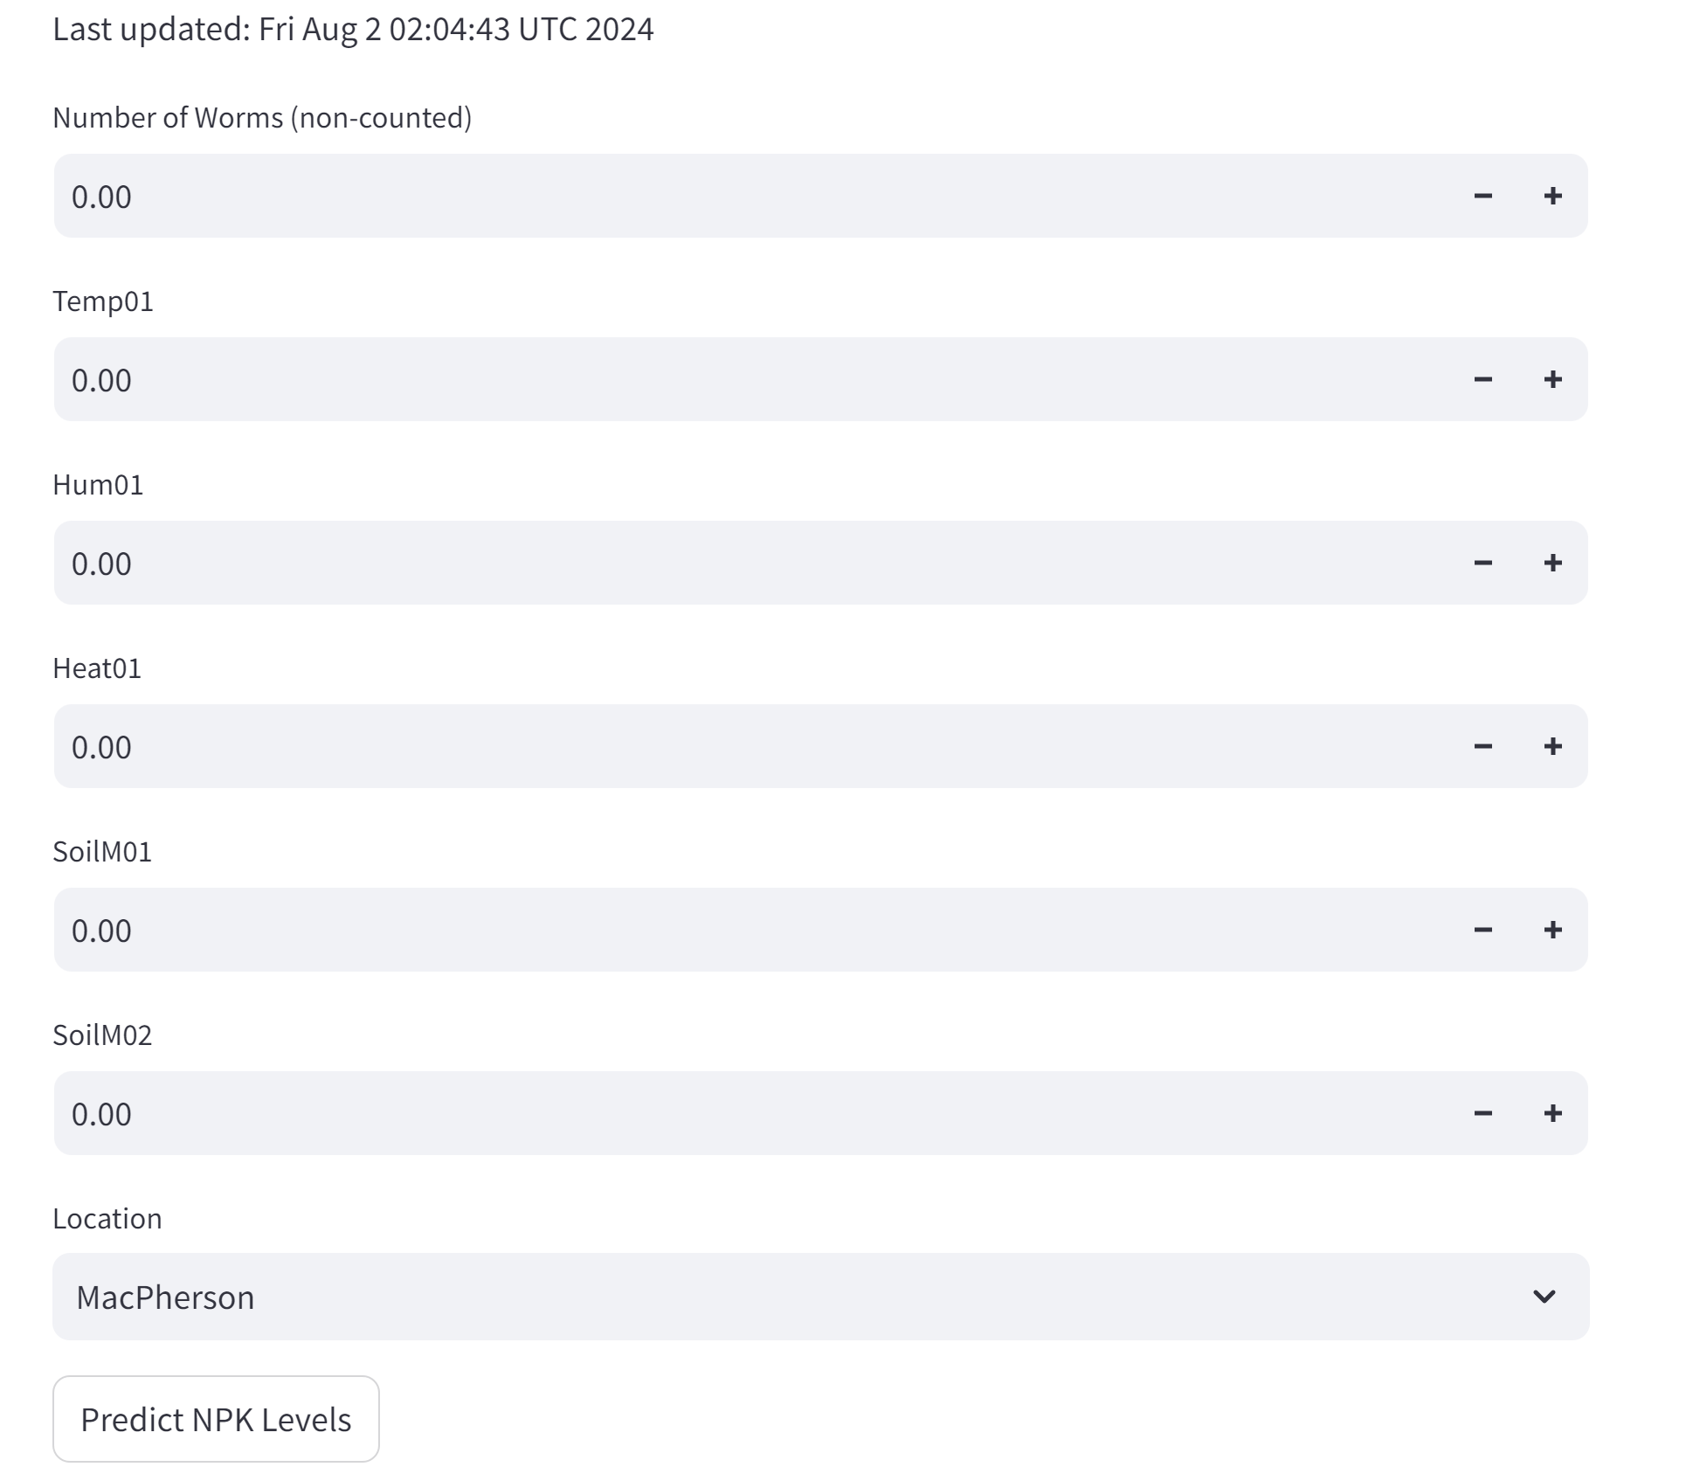
As mentioned earlier users simply begin by inputting the relevant fields and information about their tanks since we are trying to predict the NPK ratio based on environmental data in the tank.
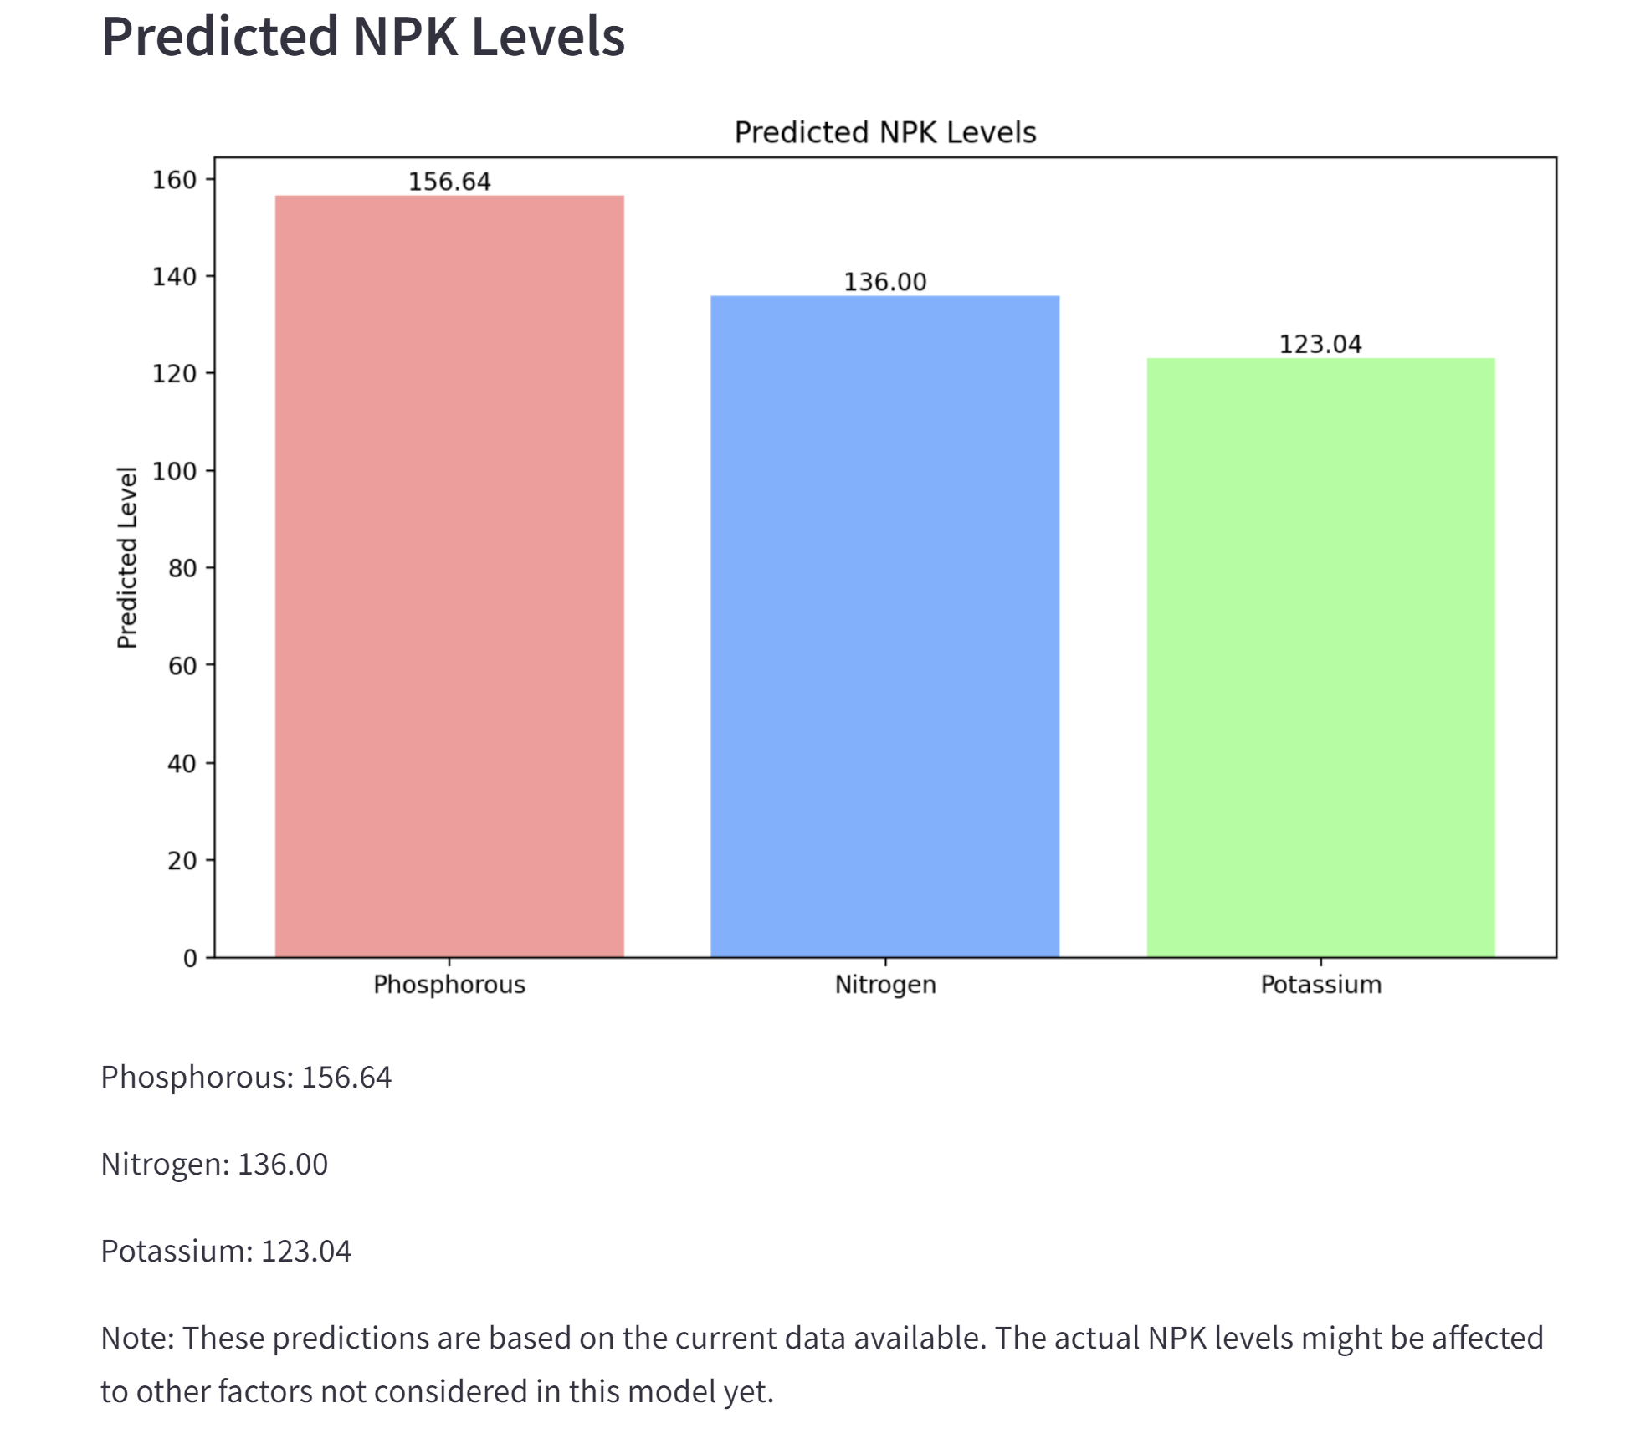
Subsequently, this NPK output is generated complete with a visualisation for easier comprehension.
Streamlit Automation
Our system consists of a GitHub repository that hosts the Python scripts and a directory for the pickled models. The system is designed to update the model predictions daily using automated scripts and to reflect these updates in a Streamlit application.
Workflow Description:
- Python Script Development:
  - A Jupyter Notebook was developed to build the machine learning model for predicting NPK ratios.
  - The notebook was converted into a Python (.py) script to facilitate automation. This script includes code for training the model and saving it as a pickled file (.pkl).
- Model Storage:
  - The Python script stores the serialized version of the machine learning model in a /model directory within the GitHub repository.
  - Each execution of the script overwrites the existing pickled model file, ensuring that the most recent version of the model is always available.
- Automation via GitHub:
  - A script is set up in GitHub to trigger the execution of the Python script stored in the repository. This is scheduled to run daily.
  - This automated script ensures that the model is retrained (if necessary) and the pickled file is updated daily with the latest data and model adjustments.
- Streamlit Integration:
  - The Streamlit application is configured to use the model stored in the /model directory.
  - Streamlit does not natively support scheduled redeployments; however, by overwriting the pickled model file, a change is detected, which triggers a re-run of the Streamlit application.
  - This setup effectively schedules the Streamlit application to update daily, reflecting the latest predictions from the updated model.
Conclusion:
The integration of GitHub for script execution, Python for modeling, and Streamlit for deployment provides a robust system for managing and updating our NPK ratio prediction model. This setup allows for the daily automation of model updates without manual intervention, ensuring that the latest data is always used for predictions and that these updates are immediately available to end-users through the Streamlit application. The system not only enhances the accuracy and reliability of the predictions but also increases the operational efficiency by automating routine tasks.
Streamlit Error Handling
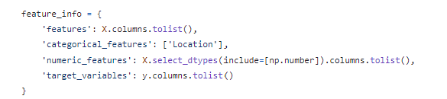
In response to concerns about potential disruptions in the Streamlit application due to unexpected data changes, a safeguard was implemented within the Python script. This safeguard involves documenting essential feature information to ensure consistency in data handling and model input requirements. The code snippet provided creates a dictionary, `feature_info`, which catalogs the columns in the dataset that are used in the model, distinguishing between categorical and numerical features, and identifying the target variables. This dictionary is then saved as a JSON file (`feature_info.json`) in the `models` directory. By doing so, even if future data updates lead to the exclusion of certain features due to a high proportion of missing values (over 60%), the application can refer to this JSON file to verify the integrity and structure of the expected input features. This proactive approach prevents the application from breaking due to missing data columns, ensuring the Streamlit app remains robust and functional regardless of changes in the underlying data.
Nitrogen01 and Phosphorous01 Forecasting Model
A Nitrogen and Potassium ARIMA forecasting model can aid composters especially in terms of understanding seasonal patterns, managing tank variability, and aligning with expected averages. Below are examples of insights compost technicians can derive from the model:

Strategic Forecasting and Seasonal Awareness
1. Understanding Seasonal Variations:
- Seasonal Forecasting: Nitrogen and Potassium levels in compost can vary significantly with changes in season due to temperature fluctuations, varying moisture levels, and changes in microbial activity. An ARIMA model, known for its ability to model and predict time series data with seasonal patterns, can forecast these nutrient levels, helping composters anticipate and prepare for seasonal changes.
- Seasonal Optimization: With knowledge of seasonal trends, composters can adjust their composting inputs and processes to optimize nutrient levels throughout the year. This proactive approach ensures that the compost maintains its quality and effectiveness, irrespective of seasonal variations.

Benchmarking and Performance Evaluation
2. Comparing Against Average Values:
- Benchmarking: By comparing current tank nutrient levels with historical averages predicted by the ARIMA model, this benchmarking helps in identifying whether the compost is nutrient-deficient or nutrient-rich compared to typical levels.
- Quality Control: Regular comparison against average values ensures that any deviations from expected nutrient levels are quickly identified and corrected, maintaining the overall quality and consistency of the compost.

Enhanced Decision-Making and Operational Efficiency
3. Predictive Insights for Better Resource Management:
- Resource Allocation: Predictive insights from the ARIMA model enable better planning and allocation of resources. For instance, knowing in advance that Nitrogen levels are likely to drop can prompt composters to integrate more nitrogen-rich materials in the upcoming batches.

Risk Management and Mitigation
4. Risk Reduction through Predictive Forecasts:
- Mitigating Nutrient Imbalances: Predictive models help in identifying potential nutrient imbalances before they become problematic. This early warning system allows for timely interventions that can prevent crop failures or poor soil health resulting from imbalanced compost.
- Adapting to Environmental Changes: ARIMA models can also factor in unexpected environmental impacts, such as an unusually rainy season or drought conditions, allowing composters to adjust their practices accordingly.
Final Streamlit:

Time Series Plot for Nitrogen Levels
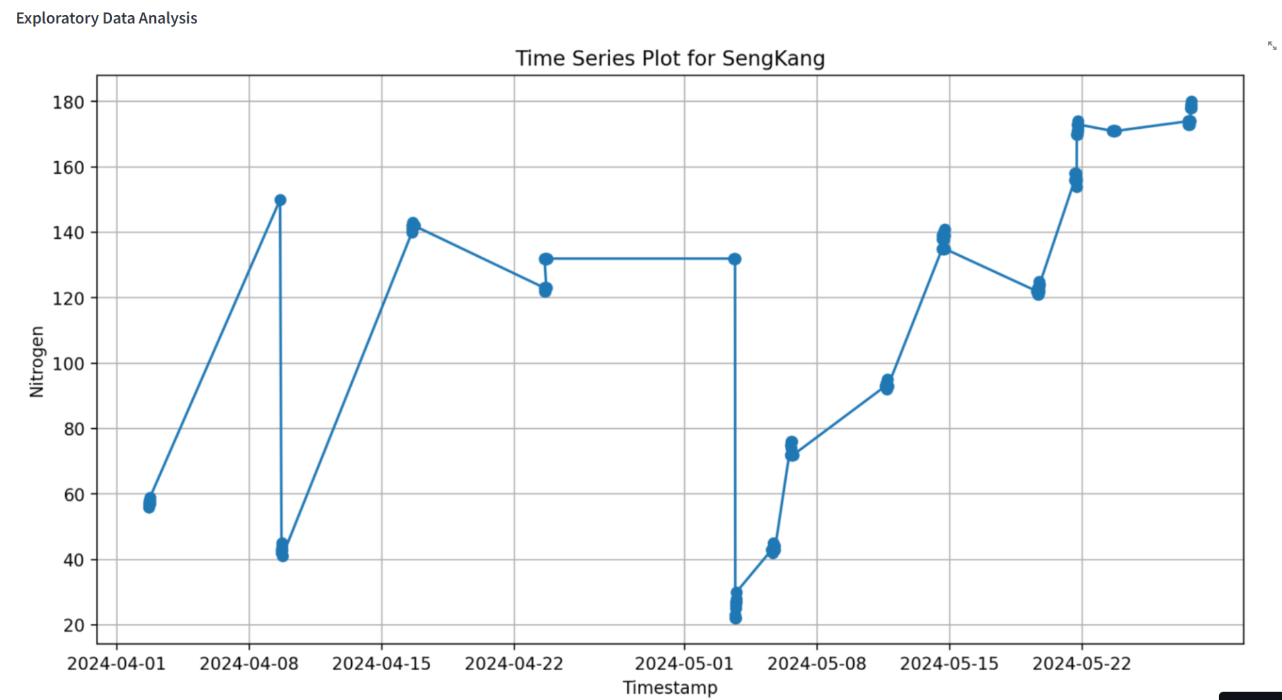
- What It Shows: This plot displays both the historical and forecasted nitrogen levels in the compost tank. The blue points represent actual measured values, and the red line shows the forecasted levels based on the ARIMA model.
- Interpretation: Compost technicians can observe the nitrogen levels over time, noticing any significant trends, seasonal patterns, or anomalies. For instance, if nitrogen levels rise during certain periods, it might correlate with specific compost inputs or environmental conditions.
- Value: Understanding these patterns helps in anticipating changes and making informed decisions about when to add or adjust compost materials to maintain optimal nitrogen levels.

Residuals Over Time and Histogram of Residuals
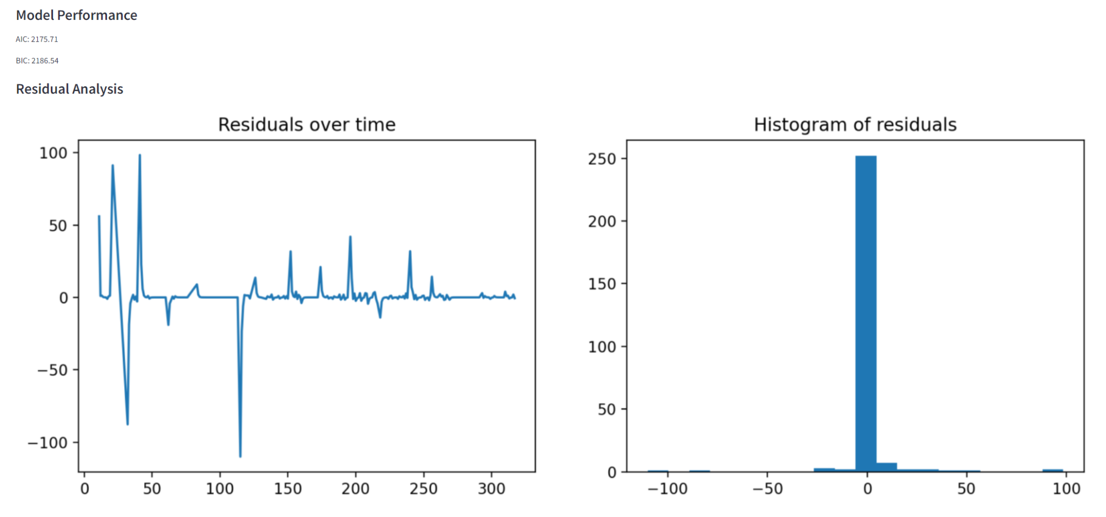
- What It Shows: The residuals plot displays the differences between the observed and predicted nitrogen values over time, showing how well the model fits the data. The histogram provides a distribution view of these residuals.
- Interpretation: Ideally, residuals should be randomly distributed around zero, indicating that the model is a good fit for the data. Any patterns in the residuals plot or significant deviations from zero in the histogram suggest model inadequacies or potential outliers in the data.
- Value: Technicians can use this information to assess the accuracy of the model. If the residuals indicate a poor fit, adjustments may be needed either in the model or in operational practices.

Seasonal Decomposition
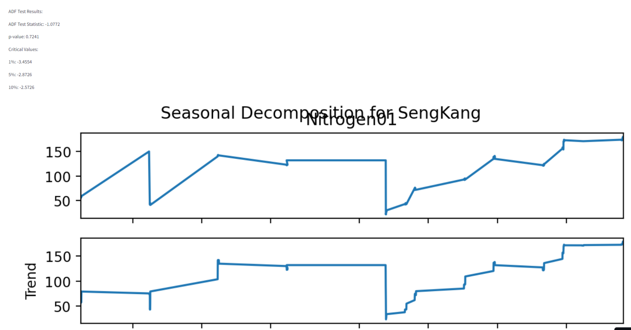
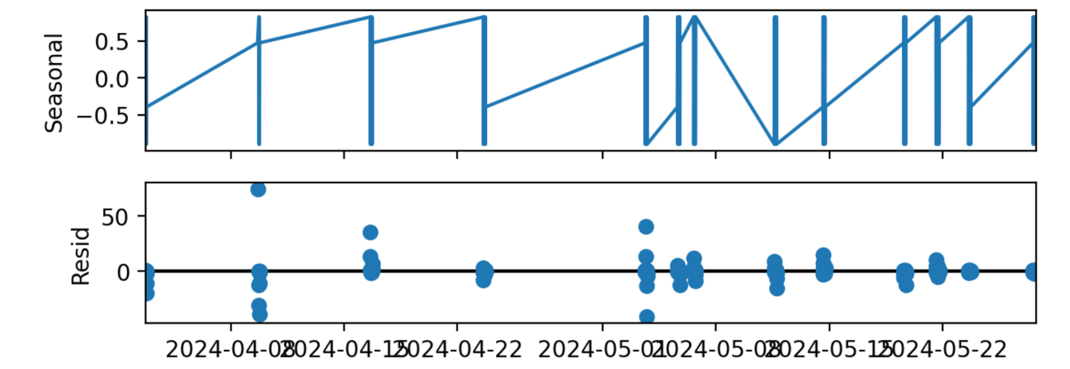

- What It Shows: This analysis breaks down the time series into trend, seasonal, and residual components.
- Interpretation: The trend component shows whether nitrogen levels are increasing, decreasing, or stable over time. The seasonal plot highlights recurring patterns or cycles in the nitrogen levels.
- Value: Identifying the trend helps in long-term planning for resource allocation and compost management. Recognizing seasonal patterns enables technicians to predict and prepare for periodic changes in nitrogen levels.

Forecasted Values Table
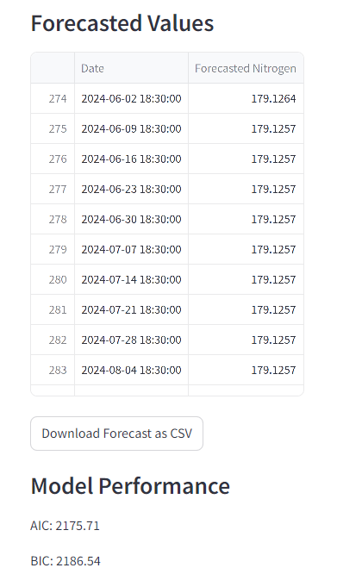
- What It Shows: This table lists specific forecasted values of nitrogen for future dates.
- Interpretation: Each entry provides a predicted nitrogen level for a given date, allowing technicians to see expected conditions in advance.
- Value: This precise data supports short-term operational decisions, such as adjusting the compost mix or scheduling interventions to correct or maintain desired nitrogen levels.
Streamlit Automation
Our system utilizes a GitHub repository to manage the deployment and updating of forecasting models. These models are crucial for providing timely predictions, which are displayed in a Streamlit application. The repository includes a special file, last_update.txt, which plays a critical role in the updating process.
Workflow Description:
- Python Script Execution:
  - A Python script, responsible for running the forecasting models, is executed via an automated script set up within the GitHub repository. This script is part of a scheduled job that runs daily to ensure the models are using the most recent data.
- Updating the Last Updated Timestamp:
  - Each time the Python script runs, it updates the last_update.txt file with the current date and time. This file acts as a log to track when the forecasting models were last executed, providing transparency and up-to-date information to the users of the Streamlit application.
- Streamlit Application Deployment:
  - The Streamlit application is designed to read from the last_update.txt file. Each modification to this file triggers a redeployment of the Streamlit application. This mechanism ensures that the application always displays the latest model outputs and forecasts to the end-users. The displayed date and time from the last_update.txt file inform users about the recency of the data and predictions they are viewing.
- Automation and Reliability:
  - This setup not only automates the process of updating and deploying the forecasting models but also enhances the reliability of the application. Users receive updated information daily, which is crucial for decision-making processes based on the model’s forecasts. The automated update of the last_update.txt file serves as a simple yet effective solution to trigger Streamlit redeployments, ensuring the application remains current without requiring manual intervention.
This innovative approach leverages basic file manipulation to overcome limitations in the Streamlit platform regarding scheduled updates, demonstrating a practical application of automation in maintaining and deploying predictive models.
Streamlit Error Handling
Similar error handling approaches from the NPK multitarget predictor was carried over here.

Practical Recommendations for Compost Technicians:
- Monitor Trends and Patterns: Regularly review the time series and seasonal decomposition plots to understand how nitrogen levels respond to different composting activities and external conditions.
- Utilize Forecasts: Use the forecasted nitrogen values to proactively manage the compost environment, ensuring that nitrogen levels remain within optimal ranges for effective composting.
- Evaluate Model Performance: Keep an eye on the residuals to evaluate the model's performance. Significant residuals can indicate a need for model recalibration or may suggest unforeseen changes in the composting process.
Anomaly Detection Model

1. Early Detection of Nutrient Imbalances
- Prompt Intervention: Anomaly detection models are designed to identify deviations from expected NPK levels early on. This early detection allows compost technicians to promptly address any imbalances before they adversely affect the compost's overall quality. For example, if Nitrogen levels are detected to be abnormally low, technicians can quickly add nitrogen-rich materials to rebalance the nutrient levels.

2. Maintaining Compost Quality
- Consistency in Product Quality: Consistent nutrient levels are crucial for high-quality compost that meets both regulatory standards and customer expectations. Anomaly detection helps ensure that each batch of compost maintains a consistent quality by alerting technicians to any irregularities in NPK ratios, which could indicate issues in the composting process or the materials used.

3. Optimization of Composting Processes
- Process Adjustments: By continuously monitoring NPK ratios and identifying anomalies, technicians can better understand how various inputs, like different types of organic waste, affect the nutrient balance. This knowledge allows them to fine-tune the composting process, optimizing the mix of materials to achieve the desired nutrient profile efficiently.

4. Cost Efficiency
- Reduction in Waste and Resource Use: Detecting anomalies in NPK ratios helps prevent the overuse of materials and reduces waste. For instance, identifying an excess of Potassium early on prevents the unnecessary addition of Potash-rich materials, thereby saving costs and minimizing waste. This efficient use of resources directly translates to cost savings and more sustainable composting practices.
Final Streamlit
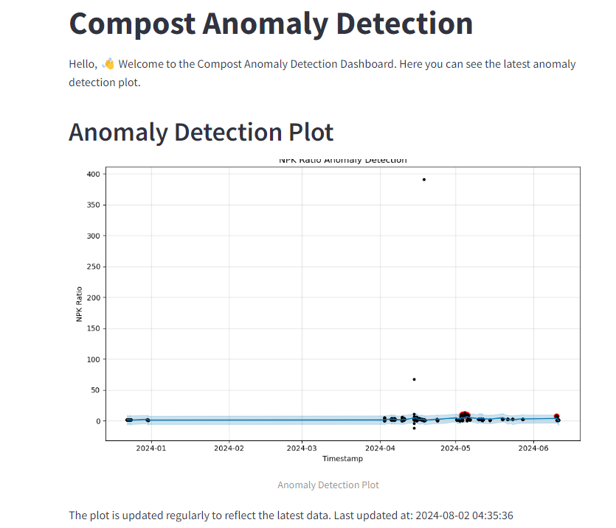

Understanding the Plot
- What It Shows: This plot visualizes NPK ratio readings over several months, from January to June 2024. The blue dots represent normal daily NPK ratio levels, while the red and black dots indicate identified anomalies where the NPK ratios were significantly higher or lower than typical levels.
- Anomalies: Points that deviate substantially from the cluster of blue dots are marked distinctly, drawing attention to unusual readings. These anomalies could indicate errors in measurement, unexpected changes in compost composition, or environmental factors affecting the compost.

Interpretation and Value
- Immediate Anomaly Recognition: Technicians can quickly spot dates on which the NPK ratio deviated from normal ranges. This immediate visual cue allows for rapid response to potential issues.
- Historical Data Comparison: By observing the historical pattern of the NPK ratios, technicians can identify if these anomalies represent one-time occurrences or part of a recurring pattern.
- Targeted Investigation: Each anomaly can trigger a targeted investigation by Compost Technicians to determine the cause—whether it’s a result of input errors, compost mix changes, environmental influences, or equipment malfunctions.
- Adjustment and Optimization: Understanding when and why anomalies occur helps in adjusting the composting process to maintain optimal nutrient balances, crucial for effective compost production.

Practical Recommendations for Compost Technicians:
- Regular Monitoring: Check the anomaly detection plot regularly to stay updated on any unusual NPK ratio readings. Early detection of anomalies allows for quicker corrective actions. Do note, as mentioned earlier the plot will update estimatedly every 1-2 months. The cause for this huge gap is the SL2 dataset provided thus far often updates barely once or twice a week, sometimes only once in a whole month. For that reason, we cannot schedule this too often as Anomaly Detection models need lots of data to be accurate and not mislead Compost Technicians.
- Record Keeping and Analysis: Maintain detailed records of activities and environmental conditions on days leading up to an anomaly. This can help in pinpointing potential causes and preventing future occurrences.
- Calibration and Maintenance: Anomalies might also indicate issues with the sensors or measurement devices used. Regular calibration and maintenance of equipment are advised to ensure accurate readings.
- Feedback Loop: Use insights gained from investigating anomalies to refine compost input proportions and processing techniques, enhancing overall compost quality and consistency.
This anomaly detection tool is invaluable for maintaining the health and efficiency of the composting process, ensuring that the resulting compost meets desired quality standards. It not only aids in operational management but also supports the long-term sustainability and effectiveness of composting practices.

Generative AI Chatbot
Integrating a generative AI chatbot that supports a variety of AI models and multimodal inputs offers significant advantages for compost technicians. Such a chatbot can revolutionize the way they interact with data, analyze compost conditions, and make informed decisions.
1. Versatile Querying Options
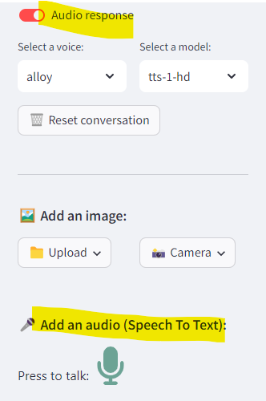
- Accessibility in Field Conditions: Compost technicians often work in environments where traditional computing devices may be impractical. A chatbot that can process text, voice, images, and videos allows technicians to interact with the AI system directly from the field. For example, a technician could verbally describe a problem or take a photo of the compost and receive immediate feedback.
- Speech-to-Text Functionality: This feature is particularly beneficial for hands-free operation, allowing technicians to make queries or receive guidance without having to stop their work. It enhances safety and efficiency, as technicians can stay engaged with their tasks while interacting with the chatbot.

2. Multiple AI Model Support

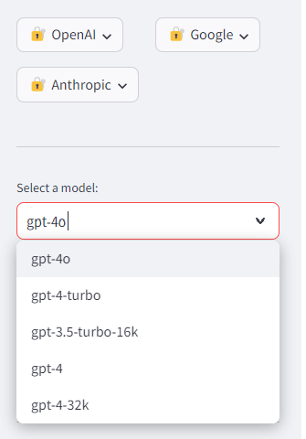
- Comprehensive Insights: Different AI models like OpenAI's, Google's Gemini, and Anthropic's Claude have varied strengths and specializations. Access to multiple models through a single interface allows compost technicians to pull a broader range of insights and suggestions, ensuring that the guidance they receive is as accurate and comprehensive as possible.
- Choice of Expertise: Depending on the query's nature and complexity, technicians can choose which model to consult. For example, one model might be better at image analysis, while another might excel in predictive analytics or natural language understanding.

3. Multi-Modal Input Capability
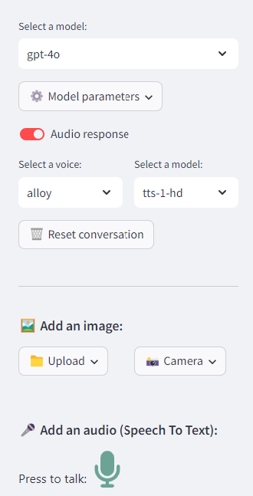
- Enhanced Diagnostic Capability: The ability to analyze images or videos directly can revolutionize how compost conditions are monitored. For instance, a technician can take a photo of a compost pile exhibiting signs of imbalance, and the AI can analyze the image to suggest possible issues and remedies based on visual cues.
- Immediate Problem-Solving: If a technician observes an unusual pattern in the compost, they can immediately capture an image or video and receive analysis, significantly speeding up the troubleshooting process.

4. Customizable Parameters
- Tailored Responses: Adjusting the model temperature for response variability allows technicians to control how conservative or adventurous the AI's responses are. This is particularly useful in scenarios where creativity or out-of-the-box thinking might be beneficial.
- Audio Responses: For environments where reading text might be inconvenient or unsafe, audio responses enable technicians to receive spoken feedback, making the interaction more natural and accessible while on the move.

5. Telegram Bot as a Communication Medium
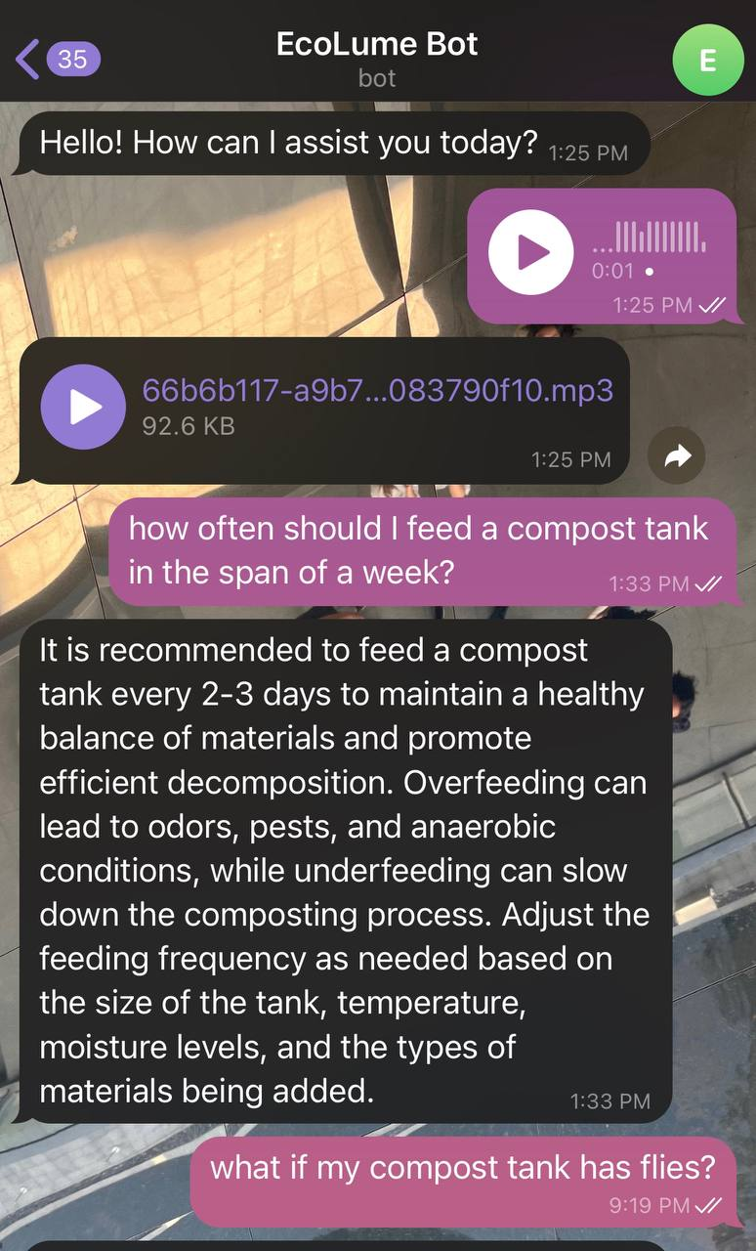
- Ease of Use: Leveraging a Telegram bot for this AI chatbot interface makes it accessible on any device that supports Telegram, from smartphones to tablets. This universality ensures that all technicians can access the AI tools without needing specialized equipment.
- Continuous Access: The portability of Telegram allows technicians to have constant access to the chatbot, ensuring that they can consult the AI at any time, whether they are on-site or reviewing data remotely.

EDA Chatbot
Compost management involves monitoring various environmental and material metrics to ensure optimal decomposition and nutrient balance. The Ecolume chatbot facilitates this by enabling technicians to upload their data and receive comprehensive analyses directly through a conversational interface. This approach not only democratizes data analytics but also enhances decision-making efficiency.

Key Features of Ecolume
- Multi-Modal Data Input: Users can upload data in CSV format directly to the chatbot, which is particularly useful for handling various types of environmental data records.
- Interactive Analysis Tools: The chatbot utilizes natural language processing to interact with users, offering custom analyses based on user queries. This includes data cleaning, summarization, and advanced statistical analysis.
- Real-Time Data Processing: Integration with OpenAI's powerful language models allows Ecolume to process and analyze data in real-time, providing immediate insights.

Detailed Functionalities
- Data Overview: Upon uploading their data, users are presented with a snapshot of their dataset, helping them to quickly grasp the fundamental aspects of their data.
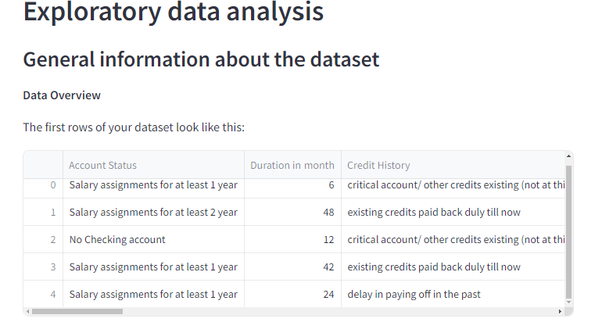
- Data Cleaning Insights: Ecolume identifies and reports missing values, duplicate data, and potential errors, prompting users for corrective actions.

- Advanced Analytical Capabilities: The chatbot performs correlation analysis, detects outliers, and suggests new feature creation, enhancing the depth of analysis available to compost technicians.An example can be seen in Data Summarization below, where the Chatbot is prompting us to investigate specific features and finding which may be of value/interest/concern.
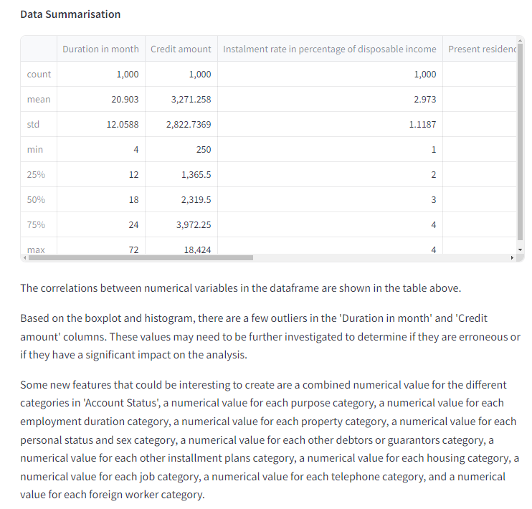
- Customizable Queries: Users can specify variables of interest for detailed analysis, including statistical summaries, normality checks, and trend analysis, making the tool adaptable to specific informational needs.
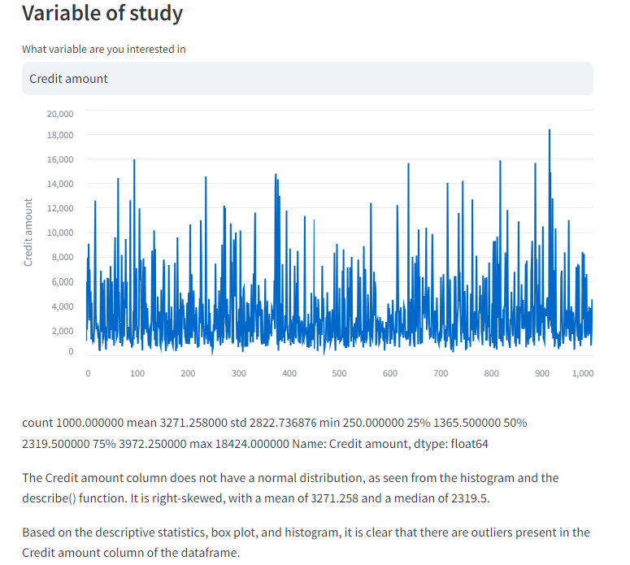


Notably, all plots can be interacted with (eg.expanded, made full screen for clearer viewing etc) as shown below:
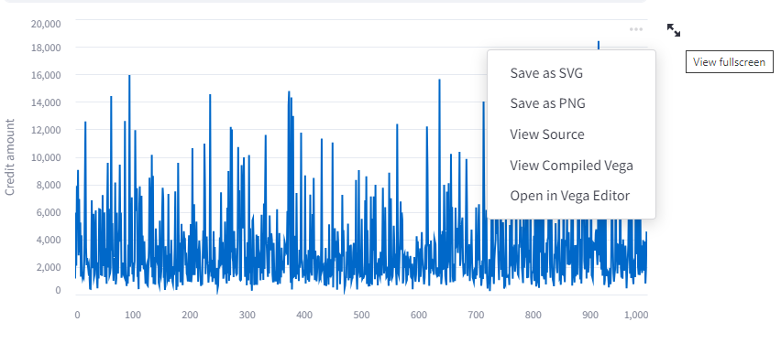

Benefits for Compost Technicians
- Enhanced Understanding of Compost Data: Technicians can gain deeper insights into the factors affecting compost quality, such as moisture content, temperature fluctuations, and nutrient levels.
- Improved Operational Efficiency: Quick access to data analysis allows for faster decision-making, reducing downtime and enhancing overall compost production efficiency.
- Data-Driven Decision Making: With accurate and timely data insights, technicians can make informed decisions that align with best practices and operational goals, ultimately improving the quality of compost produced.
Pygwalker Visualisations

1. Interactive Data Exploration:
- Pygwalker is an integration of the Streamlit library with a visualization tool inspired by Voyager, allowing users to interactively explore their data. Composters can upload their data (e.g., from sensors, logs, or manual records) and use Pygwalker to visually explore different aspects of the data.
- Dynamic Filtering: Users can dynamically filter data, drill down into specific aspects (like temperature or humidity over time), and instantly see how changes in parameters affect the composting process.

2. Visual Insights:
- Visual Dashboards: Composters can create custom dashboards that display critical metrics like temperature, moisture levels, pH, and decomposition rates. These dashboards can be updated in real-time, providing composters with an immediate visual representation of their compost’s status.
- Trend Analysis: Pygwalker allows for the easy creation of trend lines, histograms, and heatmaps, which can help composters identify patterns in the composting process, such as when temperature or moisture levels are consistently off-target.

3. Customization and Flexibility:
- Custom Visuals: Pygwalker supports a wide range of chart types, allowing composters to create visuals that best represent their specific data. Whether it's line charts for tracking temperature over time or bar charts comparing nutrient levels across different compost batches, Pygwalker provides the tools needed.
- Data Exploration Without Coding: Composters can interact with their data and create visualizations without needing to write code. Pygwalker’s user-friendly interface allows for the exploration of data by simply dragging and dropping fields, making it accessible to those without a technical background.

5. Enhanced Decision-Making:
- Informed Decisions: By visualizing data trends and patterns, composters can make more informed decisions about when to turn compost, add materials, or adjust moisture levels. This can lead to more efficient composting processes and higher-quality compost.
- Scenario Analysis: Composters can simulate different scenarios by adjusting data inputs and visualizing the potential outcomes. For example, they could explore what happens to the composting process if moisture levels are adjusted by a certain percentage.

6. Collaboration and Sharing:
- Shared Dashboards: Composters can share their visualizations and dashboards with team members or collaborators, facilitating better communication and collaborative decision-making. Stakeholders can view the same data insights without needing to be in the same physical location.
- Reporting: Visualizations created with Pygwalker can be exported or embedded in reports, making it easier to communicate findings and progress to other stakeholders or regulatory bodies.

Summary:
Deploying the Streamlit library Pygwalker on a website enables composters to interactively explore, visualize, and monitor their data. It empowers them to gain real-time insights, detect trends, and make informed decisions, ultimately leading to a more efficient and effective composting process. The ability to create custom dashboards, visualize data without coding, and share insights with others makes it a versatile tool for composters looking to optimize their operations.
Image Comparison Website

The Image Comparison feature offers practical benefits in monitoring and managing compost quality and consistency over time. Particularly in terms of visual monitoring.

1. Visual Monitoring of Compost Quality
- Direct Comparison: Compost technicians can upload images of different compost tanks or different stages of compost decomposition side by side. This direct visual comparison allows technicians to quickly assess and compare the physical state of the compost, such as color, texture, and moisture level, which are indicative of the compost’s health and quality.
- Historical Analysis: By comparing current compost conditions with historical images, technicians can track changes over time, identify patterns, and detect deviations from expected compost progressions. This historical analysis is crucial for ensuring that the composting process is consistent and effective.

2. Enhanced Diagnostic Capabilities
- Problem Identification: If a compost batch exhibits unexpected characteristics, technicians can use the image comparison tool to juxtapose it against a standard or expected condition. This can help in diagnosing issues like inadequate aeration, excessive moisture, or contamination.
- Progress Tracking: For ongoing experiments or adjustments in composting techniques, being able to visually document and compare changes over time helps in quantifying the impact of new methods or treatments.
Nutrient Logger Website


A nutrient logging feature is immensely beneficial to composters as it enables the systematic tracking and analysis of nutrient levels within compost batches over time. This functionality not only aids in maintaining the desired balance of nutrients essential for effective composting but also provides critical data that can be used to optimize compost recipes and processes.

By having a historical record of nutrient levels, composters can identify trends, diagnose issues related to nutrient imbalances, and tailor their composting practices to specific needs, such as enhancing soil health or catering to particular types of crops. In turn this can lead to improved outcomes, more consistent product quality, and better resource management, ultimately enhancing the overall efficiency and sustainability of composting operations.

1. Automated Nutrient Analysis
- Real-Time Macronutrient Pie Chart Generation and Visual Breakdown of Nutrient Ratios: This feature allows composters to instantly visualize the nutrient composition of their compost. By having a clear, real-time graphical representation of macronutrient ratios (such as Nitrogen, Phosphorus, and Potassium), composters can quickly assess whether the current balance aligns with optimal conditions for compost quality. This immediate feedback enables timely adjustments, such as adding more green or brown materials to balance the carbon-to-nitrogen ratio, enhancing the overall quality and effectiveness of the compost.
- Balance Nutrient Profiles for Improved Compost Quality: Maintaining balanced nutrient profiles is crucial for producing high-quality compost that effectively supports plant growth. Automated nutrient analysis ensures that the compost consistently meets the desired nutrient specifications, reducing guesswork and reliance on less frequent laboratory nutrient analysis.

2. Tank-Specific Management
- Filter and Sort Data by Individual Tanks: This functionality allows composters to manage multiple compost tanks efficiently. By filtering and sorting data according to specific tanks, technicians can easily compare different batches, monitor the progress of each tank individually, and apply customized management strategies based on the unique conditions or requirements of each tank. This targeted approach helps in identifying underperforming tanks and making data-driven decisions to optimize each composting process.

3. Environmental Impact Tracking
- Monitor and Manage CO2 Emissions: An essential aspect of sustainable composting practices is the monitoring and management of carbon emissions. This feature supports composters in tracking their CO2 footprint, helping them to implement strategies that reduce greenhouse gas emissions, such as adjusting aeration practices or the carbon-to-nitrogen ratio. By actively managing their environmental impact, compost facilities can not only comply with environmental regulations but also contribute positively to climate change mitigation efforts.
- Support Sustainable Composting Practices: Tracking environmental impact goes hand in hand with promoting sustainability. This tool empowers composters to continuously improve their practices in ways that are environmentally friendly and sustainable, enhancing their reputation and potentially qualifying them for certifications in organic and sustainable composting.

4. Historical Data Access
- Review Past Feeding Sessions and Outcomes: Access to historical data allows composters to learn from past experiences, identify patterns, and understand the long-term effects of their composting methods. This retrospective analysis is invaluable for troubleshooting problems, refining processes, and training new staff. By building a comprehensive historical dataset, composters can use advanced analytics to predict future outcomes and further refine their composting techniques.

5. Operational Efficiency
- Streamline Record-Keeping Processes: Automating data entry and record-keeping not only saves time but also reduces the likelihood of errors associated with manual data management. This streamlined process enhances the efficiency of operations, allowing staff to focus more on critical tasks such as monitoring compost quality and optimizing processes.
- Reduce Manual Calculations and Analysis Time: Automated systems for nutrient analysis and environmental impact assessment significantly reduce the time and effort required for manual calculations and data analysis. This efficiency gain translates into faster decision-making and increased capacity to manage larger volumes of compost or more complex composting systems.

Website Summarizer

Time Efficiency
- Rapid Information Processing: Technicians often face time constraints and may need to digest large volumes of information quickly. A summarizer chatbot can process and condense lengthy research papers, articles, or reports into concise summaries, highlighting key points and findings. This saves time that would otherwise be spent reading through entire documents.

Improved Knowledge Management
- Enhanced Learning: By quickly accessing the core insights from extensive documents, technicians can more efficiently learn and apply new techniques or understand complex systems relevant to their fields.
- Regular Updates: Keeping up with the latest advancements, safety protocols, or regulatory changes is crucial. A summarizer chatbot can provide digestible updates from newly published materials, helping technicians stay informed without overwhelming them with information.

Decision Support
- Supporting Evidence-Based Decisions: With quicker access to research summaries, technicians can make informed decisions based on the latest data and studies. This is especially critical when considering the fast-paced evolution of technology and methods in both the composting and solar panel industries.

Enhanced Accessibility
- Breaking Down Complex Information: Technical documents can be dense and packed with jargon. A summarizer chatbot can break down this complexity into easier-to-understand summaries, making technical content more accessible to technicians without advanced specializations.

Competitive Advantage
- Staying Ahead: In industries like composting and solar energy, where technological and methodological innovations can create significant competitive advantages, having rapid access to summarized key insights can help a company or technician stay ahead of the curve.

Dashboards
This dashboard integrates various data points into a comprehensive monitoring interface, allowing technicians to observe and manage nutrient levels, environmental conditions, and their effects on compost quality over time.
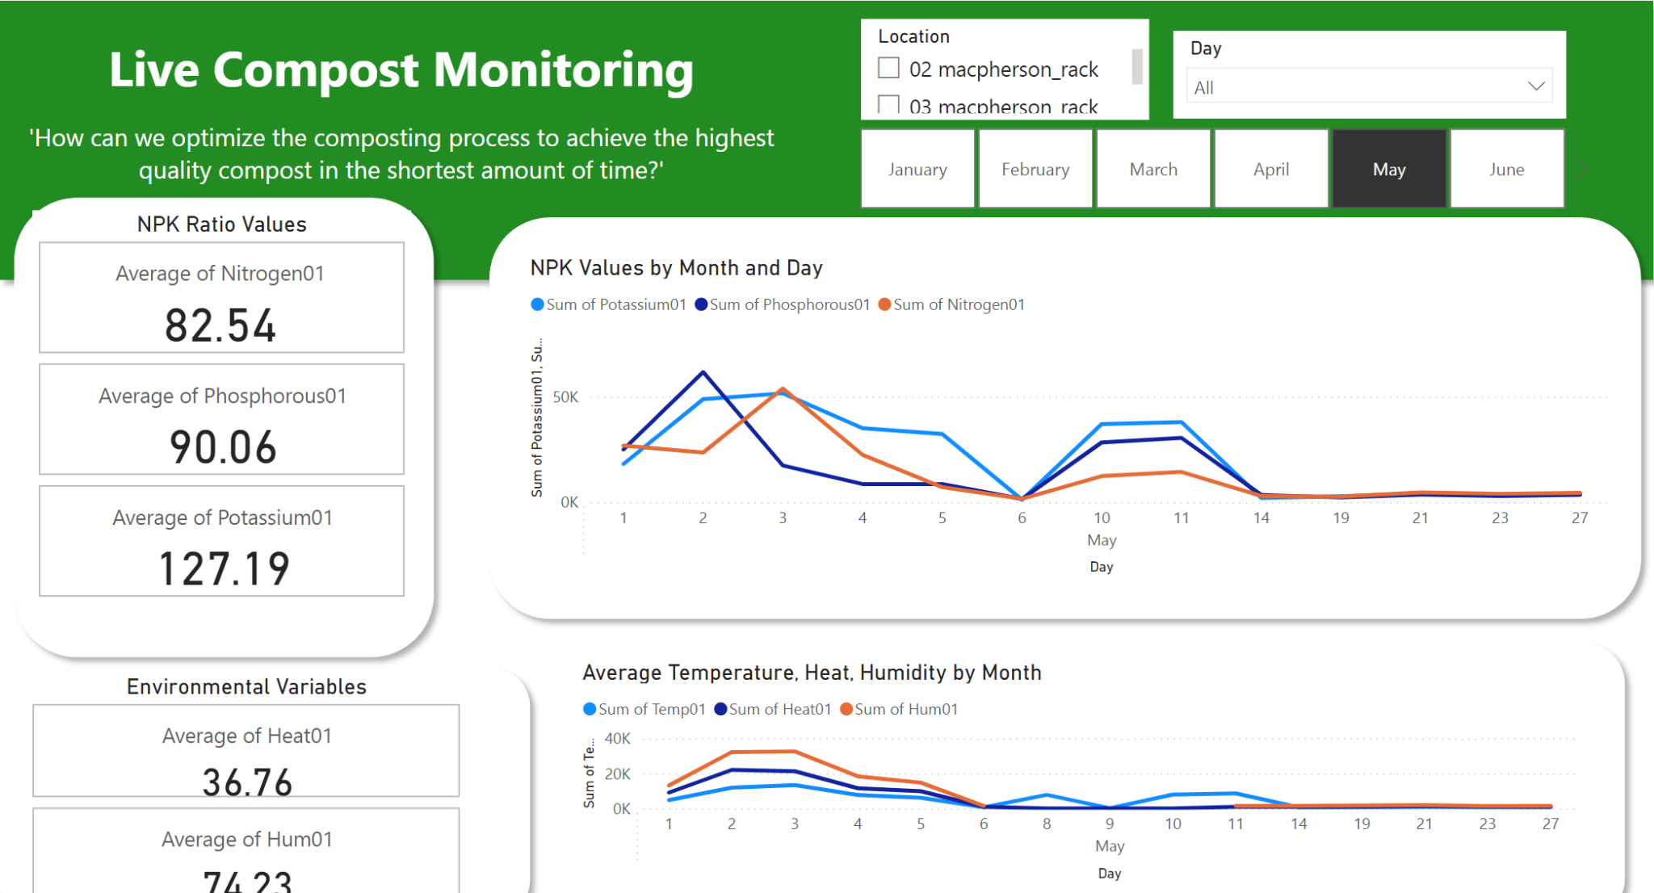

Key Components and Their Interpretations

1. NPK Ratio Values
- Visual Representation: Displays average values of Nitrogen, Phosphorous, and Potassium (NPK) as static numbers.
- Purpose: Provides a quick snapshot of the current average nutrient levels in the compost, which are critical for assessing the nutrient balance.
- Interpretation:
  - Nitrogen (82.54): Essential for plant growth and composting processes.
  - Phosphorous (90.06): Important for the development of roots and flowers.
  - Potassium (127.19): Helps in disease resistance and water uptake regulation.
- Insights: The relatively high average of Potassium suggests good disease resistance potential in the compost. However, balancing all three nutrients is crucial for optimal compost quality.

2. NPK Values by Month and Day
- Visual Representation: A line graph tracking the sum of NPK values over the days of May.
- Purpose: Monitors daily fluctuations in nutrient levels, providing insights into their dynamic changes over time.
- Interpretation: The graph shows significant variability in nutrient levels, with noticeable peaks and troughs indicating input changes or decomposition stages affecting nutrient availability.
- Insights: Monitoring these fluctuations helps in identifying specific days or conditions under which nutrient spikes or drops occur, enabling targeted interventions.

3. Environmental Variables
- Visual Representation: Displays average values for environmental factors like heat and humidity.
- Purpose: Provides context for environmental conditions that affect composting efficacy.
- Interpretation:
  - Average Heat (36.76): High temperatures can accelerate decomposition but also lead to nutrient loss if not managed.
  - Average Humidity (74.23): Optimal humidity is necessary to support microbial activity without causing anaerobic conditions.
- Insights: Maintaining a balance in heat and humidity is essential for efficient composting. Extreme values could be detrimental to compost health.

4. Average Temperature, Heat, Humidity by Month
- Visual Representation: A line graph showing the sum of temperature, heat, and humidity levels through May.
- Purpose: Tracks broader environmental trends that influence composting processes.
- Interpretation: Similar trends in temperature and heat suggest a correlation that might affect microbial activity and decomposition rates.
- Insights: Identifying patterns in environmental conditions allows technicians to predict and adjust composting strategies to maintain optimal decomposition conditions.

Key Findings and Trends
Nutrient Management: The daily monitoring of NPK values indicates that nutrient levels can vary widely, possibly due to input changes or natural decomposition processes. This highlights the need for regular adjustments and monitoring to maintain a balanced nutrient profile.
However, we did not monitor by hour as when we did that the line chart was consistently flat. So as long as Compost Technicians monitor their NPK values daily, that should suffice.
Environmental Impact: The close tracking of temperature, heat, and humidity was due to their significant impact on compost quality in general. For example;
- Temperature and Heat Correlation:
  - Both temperature and heat metrics show closely related trends over the days of May.
  - Peaks in temperature are often matched by peaks in heat levels, suggesting that as ambient temperatures rise, the heat within the compost also increases.
- Humidity Trends:
  - Humidity levels display less variability compared to temperature and heat, maintaining a relatively stable line across the month.
  - There are minor fluctuations in humidity, but these do not show a direct or inverse correlation with the temperature or heat peaks.

Linking Environmental Trends to NPK Values:
- Response of NPK Values to Rising Temperature and Heat:
  - During periods where both temperature and heat spike, there is a noticeable trend where the different NPK values also rise and fall in a somewhat similar trend. This could indicate that increased temperatures enhance the release or availability of Potassium in the compost.
  - Their fluctuations appear to have some degree of synchronization with the thermal metrics, suggesting factors like temperature play a significant role in their variability.
Research has also shown the combination of temperature and moisture has a synergistic effect Cornell University (n.d.) Cornell University (n.d.) on the composting process hence our findings are backed up by research which Compost Technicians should have the knowledge of, showing how our dashboard can be of use to them.
Temperature is a vital component in the composting process. It affects the rate at which organic materials decompose, with higher temperatures generally accelerating microbial activity and the breakdown of organic matter.
Moisture content is equally crucial. It provides the necessary environment for microbial life to thrive and helps in the movement of substances like oxygen and nutrients within the compost. Adequate moisture levels enable effective microbial activity, leading to efficient breakdown and a potentially higher availability of nutrients, including NPK components.

Recommendations for Compost Technicians:
- Monitor and Regulate Temperature: Implement measures to control extreme temperature fluctuations within the compost pile, particularly during hotter months, to optimize nutrient retention, especially for Potassium.
- Detailed Analysis of Other Factors: Since Nitrogen and Phosphorous levels show less responsiveness to temperature and heat, a deeper analysis of compost composition and other environmental factors should be conducted to determine how best to manage these nutrients.
- Leverage Data for Predictive Adjustments: Use historical data trends observed in the dashboard to predict potential changes in nutrient levels based on forecasted weather conditions, allowing preemptive adjustments to composting practices.
By leveraging these insights, compost technicians can not only improve the nutrient profile of their compost but also enhance the overall efficiency and effectiveness of their composting operations.
Forum

Link: https://hannahjxlim.wixsite.com/ecolume-community

Knowledge Sharing
- Exchange Best Practices and Innovative Techniques: This feature enables composters to share successful strategies and innovative composting techniques with each other. By exchanging knowledge about what works and what doesn’t, composters can enhance their own practices, avoid common pitfalls, and innovate more effectively. This can be especially beneficial for tackling complex composting challenges that require tried and tested solutions.
- Troubleshoot Common Composting Challenges Collectively: Collaborative problem-solving can significantly accelerate the identification of effective solutions. When composters come together to discuss challenges, they can pool their experiences and expertise to find solutions more quickly and efficiently than they might on their own.

Peer Support & Community Building
- Connect with Experienced Composters for Advice: This feature allows less experienced composters to benefit from the wisdom and experiences of veterans in the field. For new entrants, having access to a mentor or an experienced advisor can make the difference between a successful composting operation and a failed one.
- Mentor Newcomers to the Field: For experienced composters, this platform provides an opportunity to give back to the community by mentoring newcomers. This not only helps in raising the overall standard of composting practices but also fosters a sense of community and continuity within the composting industry.

Industry Trends
- Stay Updated on Latest Composting Technologies and Methods: The composting industry is continually evolving with new technologies and methods that can make composting more effective, environmentally friendly, and cost-efficient. This feature helps composters stay informed about the latest developments, ensuring they are not left behind as new trends and technologies emerge.

Resource Sharing
- Post and Access Valuable Resources (Guides, Research Papers): Access to a centralized repository of resources like how-to guides, research papers, case studies, and whitepapers can significantly enhance a composter’s knowledge and operational efficiency. This feature empowers composters to learn continuously and apply the latest scientific research and practical insights to their operations.
- Share Information on Equipment: By sharing reviews, recommendations, and sources for composting equipment, composters can help each other make informed purchasing decisions. This can be particularly valuable for those looking to optimize their expenditure on equipment and supplies.

4. Discussion

Interpreting results in light of the Research Questions or Hypotheses

1. Key Predictors of Nutrient Profiles
- Hypothesis Assessment: The models effectively utilize temperature, moisture, and the available data on biological composition to predict and customize nutrient profiles, confirming my hypothesis about these factors being strong predictors.
- Addressing the Research Question: The detailed analysis and visualizations produced by my models such as the NPK Ratio Predictor Model allow composters to understand how environmental conditions impact nutrient levels, helping them customize the composting process for specific agricultural needs.

2. Monitoring and Displaying Compost Conditions
- Hypothesis Assessment: The implementation of a real-time dashboard visualizing critical composting parameters, as seen in the Streamlit UI and Pygwalker visualizations, supports my hypothesis that such tools can significantly improve decision-making processes.
- Addressing the Research Question: My dashboard and interactive tools effectively display real-time data on critical compost conditions, providing a practical and immediate resource for monitoring and predicting necessary composting interventions.

3. Needs of Compost Technicians
- Hypothesis Assessment: The integration of nutrient loggers and anomaly detection models into the system supports the hypothesis that these features can lead to more precise predictions of compost quality and nutrient management tailored to specific needs.
- Addressing the Research Question: By providing tools that enhance nutrient management, real-time decision-making, and quality assurance, I addressed the practical needs of compost technicians, ensuring that the compost management system is both effective and user-friendly.

Results and Implications for Future Directions
- Impact of Models: My models not only provide operational efficiency and cost reduction but also enhance environmental sustainability by allowing composters to produce higher quality compost. This contributes to soil health and reduces dependency on chemical fertilizers.
- Future Research Directions: While my current models are effective, exploring the incorporation of more detailed data on biological compositions and expanding the depth of mechanism-driven models could further improve accuracy and adaptability.
Overall, my work provides substantial advancements in using AI for compost management, demonstrating the effectiveness of data-driven models and real-time monitoring in improving composting practices. Future efforts could focus on enhancing these models with more granular data and expanding their capabilities to include more predictive factors, potentially increasing the scope and accuracy of predictions.
Limitations
In my analysis, several limitations have been identified that potentially affect the scope and effectiveness of the research. These limitations include both inherent restrictions in the methodologies applied and external constraints related to the quality and availability of data.

1. Absence of Mechanism-Driven Modeling
One significant limitation in my approach is the reliance primarily on data-driven models, which predict based on observed correlations in the dataset. This method, while efficient for large datasets, lacks the ability to uncover the causal relationships governing the physical, chemical, and biological processes of composting. This absence limits our understanding of how changes in environmental conditions and input materials directly influence compost quality and decomposition rates.

2. Data Quality and Completeness
The quality and completeness of the data significantly influence the accuracy and reliability of our models. Issues such as biased data collection, incomplete datasets, or inaccuracies in measurements due to sensor errors are potential pitfalls that could skew model outputs. These inaccuracies may lead to suboptimal decision-making, based on misleading model predictions.

3. Generalization of Models
Another concern is the generalization of the models across different composting setups and environmental conditions. The models were developed using a specific set of data, and there is a risk that they may not perform as well under varying conditions. This limitation restricts the applicability of the models to other geographic locations or composting systems that differ significantly from the training dataset.

4. Complexity of Composting Processes
The composting process is influenced by a complex interplay of factors, and the current models may not fully capture all the critical interactions or feedback loops. This simplification can overlook essential dynamics of the composting process, potentially leading to predictions that do not accurately reflect the system’s behavior under different conditions.

5. Real-Time Data Processing Challenges
The effectiveness of real-time monitoring and predictive analytics is contingent upon the capability to process and analyze data promptly. Delays in data processing could lead to outdated information being displayed on the dashboard, slowing the response to changes in compost conditions and potentially affecting the timely management of the composting process.
Addressing these limitations in future work will be crucial for enhancing the robustness, accuracy, and practicality of the models. Efforts will include integrating mechanism-driven modeling, improving data collection and processing methodologies, testing the models under diverse conditions, and continuously refining the user interface based on feedback from end-users. By overcoming these challenges, I aim to develop a more effective and widely applicable system that can significantly impact sustainable compost management.

Comparison to Existing Research:
The ability to identify various food items and composting processes within the tank marks an innovative application in the field of smart composting systems researched by Suchisrit Gangopadhyay and Anthony Zhai in their Research Paper, ‘CGBNet: A Deep Learning Framework for Compost Classification’ (Gangopadhyay & Zhai, 2022).
This approach aims to enhance the functionality of compost classification systems like TrashNet, GarbageNet, and CompostNet. Although these technologies are breaking new ground in classifying compost using computer vision (CV), they are not yet fully adept at distinguishing between different types of compostable materials with high accuracy (Gangopadhyay & Zhai, 2022). The existing literature indicates potential but also highlights the need for further enhancements to accurately integrate CV within compost management systems. In the research paper, it was achieved using CGBNet, transfer learning and subclass classification to achieve a accuracy of 95% (Gangopadhyay & Zhai, 2022).
For our group submission we merely uploaded images to a LLM which could process the image and give generic responses but it was not specifically trained to analyze and classify Compost Images. Comparing my results to this research paper showed me it is possible to accurately classify Compost using Deep Learning and how my group could have improved our LLM.
We could have created a Deep Learning Model as described in the research paper, and built a pipeline collecting the output and informing our LLM of it. This way, the LLM could have given a more accurate response since it would be better able to understand the tank’s state based on insights derived by the CGBNet model.
Additionally, our model adopts a data-driven approach, similar to existing models in the market. However, unlike mechanism-driven models that incorporate underlying physical, chemical, and biological processes (Lauwers, Appels, Thompson, Degrève, Van Impe, & Dewil, 2013), our model does not yet capture these dimensions due to data limitations. Mechanism-driven models are critical in representing the fundamental mechanisms that govern the decomposition of organic matter and transformation of nutrients during composting processes.
Hence, mechanism-driven models was something that intrigued me as combined with our data driven models, I believe it can produce very powerful results.
Areas for Further Research:
Given the existing gap in effectively modeling the mechanistic aspects of composting, further research should focus on exploring substrates that can facilitate mechanism-driven modeling as suggested by the research paper “ AReviewofComposting Process Models of Organic Solid Waste with a Focus on the Fates of C, N, P, and K” that substrates could contribute to reducing the complexity (Yang, Muhayodin, Larsen, Miao, Xue, & Rotter, 2021). This exploration could pave the way for more accurate and scientifically grounded models that reflect the complex dynamics of composting processes. Future research should aim to:
- Investigate suitable substrates that enhance the feasibility of mechanism-driven modeling, overcoming current challenges associated with such approaches.
- Determine the specific equipment and coding requirements necessary for setting up and implementing mechanism-driven models in composting.
- Compare the benefits of mechanism-driven models against data-driven models to ascertain their respective advantages and limitations in practical composting applications.
Through these research initiatives, we can advance our understanding of composting processes and develop more sophisticated models that not only improve the efficiency of composting operations but also contribute to environmental sustainability.

5. Reflection

1. Experience and Challenges
Working on this capstone project has been a challenging yet immensely enlightening journey for me. Initially, the steep learning curve presented a significant challenge. We were required to quickly grasp a variety of new concepts and technologies, which was daunting, especially as it seemed my groupmates experienced a mixture of burnout and/or complacency by the time we reached our third assignment.
In the first two assignments, I had a slight advantage due to my prior experience in app development, which aided me in managing the UI/UX aspects of our project—developing a genuine website. However, our project also heavily involved generative AI, a field none of my teammates and I had direct experience with before. This lack of familiarity with deep learning concepts, crucial for understanding and implementing Large Language Models (LLMs), put us at a distinct disadvantage. Despite this, we persevered, dedicating ourselves to learning and applying these new technologies as best we could.
This project taught me invaluable lessons in teamwork and the importance of recognizing and valuing the diverse strengths within a team. Initially, I found it frustrating when some teammates were unable to contribute to coding or more technical tasks. Over time, I observed their efforts in taking on different responsibilities such as handling reports and presentations, which allowed me to focus on the programming aspects. This division of labor helped me appreciate the different types of contributions that are essential for the success of a project.
The real-world nature of this project was particularly striking. We were not handed all the solutions but were expected to explore and learn independently. This aspect of the project is very much reflective of the IT industry, where technologies evolve rapidly, and continuous learning is a necessity. Through this project, I have also developed a better understanding of how to navigate human dynamics in a team setting. Dealing with issues such as uneven work distribution, dependency, and conflicts over credit and responsibilities was challenging. However, these experiences taught me how to manage team dynamics more effectively, seek advice when needed, and accept that such challenges are part of working in a team.
In retrospect, this project not only enhanced my technical skills in areas such as generative AI, web development, Python scripting, and automation but also refined my soft skills, including communication and teamwork. Despite the hurdles, the project was a rewarding experience that provided me with a realistic glimpse into the industry and an opportunity to grow both professionally and personally.

2. Personal Growth and Development
Through the extensive suite of tools and models I've implemented, I've significantly enhanced my skills as a data scientist, particularly in the realms of data analytics and visualization. Here’s how each component contributed to my growth:
- Improved NPK Ratio Predictor & Anomaly Detection Model: Developing these models not only honed my predictive modeling skills but also improved my understanding of machine learning algorithms. This experience is crucial for performing accurate predictions and identifying outliers in data, fundamental skills in data science.
To be more specific, I learnt how to predict multiple target variables (Using the MultiRegressorOutput wrapper) and how to pickle files as well as load them into streamlit for deployment.
Previously, the Machine Learning module exposed us to streamlit briefly but this Capstone project really pushed me to use it for deployment to our website. It is also where I learnt how to “reschedule” and automatically update streamlit files, not a functionality streamlit offers, but with some creativity and tinkering, is possible as discussed prior in the report.
- Nitrogen and Phosphorous Forecasting Model: Building forecasting models like these are essential for predictive analytics. It helped me better understand time series data and modeling techniques, directly enhancing my ability to provide actionable insights from historical data trends.
Specifically, I learnt about ARIMA, SARIMAX, LSTM, and even explored statistical methods like z-score and Dixon’s q-test. I explored the different parameters and learnt in detail how they work and influenced the model’s output especially when creating the streamlit interface and deciding which parameters may be useful if we let the user toggle them (eg. PDQ Values)
- Data Preprocessing (Macpherson and Sengkang Data): Handling and cleaning specific location-based data taught me to manage real-world data efficiently, understanding its unique challenges, and preparing it for effective analysis, a core skill in data analytics.
Furthermore, over the last 2 years we rarely had experiences and opportunities to work with live data. Hence, this felt like a rare treasured opportunity and was good exposure.
I learnt how to train machine learning models on live data, schedule the models to be retrained on the live data, clean and preprocess the live data while ensuring our model’s deployment remains unaffected with error handling measures in place to ensure any changes in the retrained live data will not break the model, as well as create a ELT pipeline for the live data.
Previously in ADO, we learnt how to create a ELT pipeline using snowflake and dbt cloud. For this assignment, Trinity and I took into consideration factors like cost and long term deployment, hence we explored other options such as running a python script daily on our device using the task scheduler which would update a csv locally with the new data, connect that csv to power bi where we plotted our dashboard and trigger automatic updates using incremental refresh. The changes will then be published to PowerBI services where we can embed our dashboard in our website with the link from the published PowerBI dashboard.
- Streamlit Applications for NPK Prediction, Anomaly Detection, and Forecasting Models: Developing these interactive, user-friendly data visualization tools made complex data more accessible and understandable, improving my skills in creating practical visualization interfaces.

- Automated Retraining and Error Handling: By automating the retraining of machine learning models and handling errors in real-time, I learned to maintain the efficiency and accuracy of analytical models under dynamic conditions, which is an advanced skill in operationalizing AI.
As mentioned earlier, since Streamlit did not allow us to schedule regular updating and rerunning of the deployed Streamlit, we had to explore ways to do so.
One example would be our team’s forecasting model. Essentially I created a last_update.txt file in our github repository as well as a .yml file. The .yml file updates the last_update.txt file with the time and date whenever the workflow is run (which also triggers the running and retraining of our model and generates the new respective outputs). The .txt file is referenced in the streamlit to display when the Streamlit was last updated as a feature but more importantly, since it is read in the Streamlit, Streamlit detects a change in the source file and redeploys it, now displaying the new updated ML model output and the last_updated time.
As for error handling, one example of a concern I had and implemented error handling for was since in my pre processing code, I determined to drop a column if the null rate was more than 60%. But what if a input feature for the streamlit is dropped by the preprocessing code because out of the blue the null rate for that day is more than 60%? Our streamlit would break and crash and would not be accessible to Composters. With considerations like these, I added error handling methods to deal with this.
- ETL Pipeline and Live Monitoring Dashboard: Constructing an ETL pipeline and a live monitoring dashboard improved my ability to efficiently process and visualize live data streams. This experience is invaluable for any data-intensive real-time monitoring or reporting task.
The Python script I'm working with is designed to automate the fetching, cleaning, and updating of sensor data from a PostgreSQL database, saving it into a local CSV file. It leverages libraries such as `pandas` for data manipulation, `numpy` for handling numerical operations, `sqlalchemy` for database interactions, and `schedule` for managing task scheduling. The script contains a data cleaning function that converts timestamps to datetime, standardizes, and cleans both categorical and numerical fields. There's also a data fetching and processing function that pulls data from the database, processes it using the cleaning function, and merges it with existing data in a CSV file, creating the file if it doesn't already exist. If I enable the scheduling part of the script, which is currently commented out but assumed to be active, it would automate the script to run daily at midnight. This automation ensures that the data is regularly updated without my manual intervention. Such automation not only keeps the data up-to-date but also enhances efficiency, reduces potential for errors, and supports continuous monitoring—key factors in environments where the integrity and timeliness of data are critical.
- Nutrient Logging Website and Related Infrastructure: Building a full-stack application with login, landing pages, and database management expanded my understanding of how data flows through applications and how to manage it securely and efficiently.
- Integration and Deployment Skills: By integrating various tools into a unified platform and deploying them using Vercel and Docker, I gained valuable experience in DevOps practices for data science, ensuring my projects are scalable and maintainable.
- GenAI Chatbot, Telegram LLM Bot, EDA Chatbot: Implementing AI-driven chatbots enhanced my skills in natural language processing and conversational AI, useful for deriving insights from textual data and improving user engagement.
- Image Comparison Website and Community Forum: These platforms allowed me to explore different aspects of data visualization and community engagement, crucial for projects that require comparative analysis and collaborative efforts.
Overall, these implementations have not only broadened my technical toolkit but also deepened my understanding of how data analytics and machine learning can be applied to real-world problems, making me a well-rounded data scientist proficient in both the theoretical and practical aspects of data analytics and visualization.

3. Areas for Improvement
As I reflect on my journey and the projects I've tackled so far, I've identified several key areas where I could enhance my capabilities as a data scientist:

1. ELT Pipelining:
Improving my skills in ELT (Extract, Load, Transform) pipelining is crucial for managing data workflows more efficiently. This involves gaining a deeper understanding of data extraction techniques, optimizing data loading processes, and refining data transformation strategies. Mastering ELT would allow me to handle larger datasets more effectively and ensure that data remains consistent and accessible throughout different stages of a project.

2. Deep Learning:
Although I have a foundational understanding of machine learning, my knowledge of deep learning is relatively limited. This area is particularly important for tasks involving image recognition, natural language processing, and predictive modeling with complex datasets. Enhancing my deep learning skills would involve learning more about neural networks, understanding different architectures like CNNs (Convolutional Neural Networks) and RNNs (Recurrent Neural Networks), and applying these concepts to real-world problems. Engaging with platforms such as TensorFlow or PyTorch could provide practical experience and deepen my understanding.
Furthermore with LLMs taking the world by storm and their technology being heavily dependent on Deep Learning, it made me quickly realise how far I was falling behind without any Deep learning knowledge.

3. Model Deployment:
While I am comfortable developing backend models, deploying these models in a production environment is an area where I need improvement. Model deployment involves not just making a model operational but ensuring it can handle real-time data, scale according to demand, and integrate seamlessly with existing IT infrastructure. Learning more about cloud services, containerization with Docker, and orchestration with Kubernetes would be beneficial for deploying models more effectively and securely.

4. UI/UX for Website Generation:
My experience in integrating backend models with the frontend is limited, which hampers my ability to create holistic applications that are user-friendly and visually appealing. Improving in UI/UX design would entail learning web development languages such as HTML, CSS, and JavaScript more thoroughly, as well as frameworks like React or Angular. This would enable me to design more intuitive interfaces that can effectively display data and interact with users.
Focusing on these areas will not only round out my skill set but also enhance my ability to contribute to more complex projects and collaborate effectively with multidisciplinary teams. Investing time in online courses, engaging in hands-on projects, and participating in workshops or bootcamps can accelerate my learning and application of these skills.

4. Impact on Understanding and Relevance
Working on this sustainability project has profoundly expanded my understanding of environmental impacts and the practical measures we can take to mitigate them. Focusing on composting, I learned about its simplicity and efficacy in managing food waste. The process not only disposes of organic waste but also transforms it into valuable fertilizer through the activity of worms, which can be used to enrich soil naturally. This insight revealed to me the tangible benefits of small-scale, daily actions towards sustainability—how each meal's leftovers can contribute to a cycle that significantly cuts down on landfill waste and reduces methane emissions, a potent greenhouse gas.

Moreover, the segment of the project involving solar panels opened my eyes to the vast energy demands of institutional settings like schools. Discovering that the numerous solar panels installed at our school could only offset 6% of the electricity usage during a typical semester was startling. This highlighted the excessive amount of energy consumed by such facilities and the broader societal implications. It underscored the urgent need for more efficient energy use and a greater adoption of renewable energy sources. Reflecting on these aspects has not only deepened my appreciation for sustainable technologies but also solidified my understanding of their critical role in combating environmental degradation. The project connected theoretical knowledge to real-world applications, reinforcing the importance of sustainability in everyday life and its potential to drive significant environmental improvements.

5. Utilization of GenAI Tools Based on PAIR Framework
Using the PAIR framework developed by Professor Oguz A. Acar from King's College London, I focused on implementing generative AI tools to specifically address the challenges of compost management within the broader context of sustainability, as per the agreed work distribution in my group. Here’s how I applied the four steps of the PAIR framework to my segment of the project:

1. Problem Formulation:
The primary challenge I aimed to address was enhancing the efficiency and accessibility of compost management practices. The goal was to make the process of composting more user-friendly and to facilitate better decision-making through accessible data insights, thereby promoting sustainable waste management practices.

2. AI Tool Selection:
I selected a suite of generative AI tools designed to cater to the specific needs of compost management:
- GenAI Chatbot: This chatbot integrates multiple AI models from OpenAI, Google, and Anthropic and supports multimodal inputs including text, images, video, and audio, making it versatile for diverse user interactions. This flexibility allowed users from various backgrounds to interact with the tool seamlessly.
- Telegram Bot LLM: This tool provides composters in the field with the ability to query using text or voice straight from the popular messaging platform for convenience, offering real-time insights and visual analysis of compost conditions.
- EDA Chatbot: Focused on making data analysis approachable, this chatbot allows composters to upload and interactively explore their data, enhancing their understanding and management capabilities.
- Document Querier: This tool aids users in quickly accessing and understanding content related to composting by allowing users to query anything related to a website link they provide the Streamlit which sends it to the LLM which does web scraping. Some examples include clarifying with the document specific things mentioned in the document or asking it to summarize the document etc.

3. Interaction:
Each tool was deployed to optimize the interaction with users:
- The GenAI Chatbot was particularly useful in providing instant responses to queries about composting techniques and troubleshooting issues, adapting its responses based on user feedback.
- The Telegram Bot LLM proved essential for field workers who needed quick, reliable analyses of compost conditions based on textual/audio inputs and outputs.
- The EDA Chatbot transformed how composters interacted with their data, facilitating a deeper understanding through a user-friendly interface.
- The Document Summarizer enabled users to quickly grasp the essence of extensive resources, saving time and enhancing learning.

4. Reflection:
Reflecting on the use of these GenAI tools, I found that they significantly improved the management and understanding of composting processes. They not only made the data more accessible but also enhanced user engagement and operational efficiency. Furthermore, they served as 24/7 on site and mobile Assistants to Compost Technicians for no to minimal costs. This project underscored the practical applications of AI in environmental sustainability, demonstrating how tailored AI solutions can lead to real-world improvements in compost management. The experience reinforced the value of integrating AI to address specific challenges in sustainability, offering a promising pathway for future initiatives.

6. Conclusion
In conclusion, several key findings and practical implications have emerged from the integration of machine learning models and data visualization techniques. These outcomes not only enhance operational efficiency in compost management but also embody the broader applications of data analytics and visualization in environmental sustainability practices.

Key Findings and Conclusions
- Effective Nutrient Management: The NPK Ratio Predictor Model proved instrumental in accurately predicting essential nutrient ratios within the compost. By analyzing environmental variables such as temperature, moisture, and aeration, the model ensures that the nutrient content of the compost aligns with the requirements for various soil types and crop needs.
This showed ways Composters can better manage tank nutrient levels, if sensor data driven models can quite accurately predict future NPK ratios based on tank environmental data, what more can more advanced mechanism driven models predict since they also account for microbial, biological and chemical activities in the tank data driven models cannot detect.
Notably, from our earlier research (Cornell University, n.d.), research papers have suggested such models can be difficult to implement. However, I believe together with data driven models, together the 2 model types can bring much deeper insights. Thus, it is worth the effort.
Overall, this precision supports composters in adjusting material inputs to maintain or alter nutrient balances effectively, and has huge potential to go further.
- Interdependence and Correlations between tank variables and NPK values: With the strong correlation between tank environmental variables and NPK values as seen in our NPK Ratio Predictor, it suggests with more data and sensors, even more insightful data driven models can be derived with the right research done and models used.
For example, if more sensors detecting the air/gas concentrations in the tank were added, could it indicate anything about the decomposition process of the food items? Can this help to predict optimal times to turn the compost pile?
Proof of such findings came from our dashboard, suggesting temperature, heat and moisture played a huge role in microbial activity levels and in turn NPK ratio.
- Importance of Real-Time Data Monitoring:
Our Dashboards has revolutionized the way compost technicians monitor and manage nutrient levels within compost batches. With real-time tracking of key nutrients—Nitrogen (N), Phosphorous (P), and Potassium (K)—technicians are now able to make informed decisions on adjusting compost inputs to maintain optimal nutrient balances. This real-time data access helps in promptly addressing any nutrient imbalances, significantly enhancing the quality and efficacy of the compost produced.
- Sustainability Impact: By optimizing material inputs based on predicted nutrient outputs, the model significantly reduces waste and lowers the costs associated with compost production. This not only promotes sustainable composting practices but also enhances the economic feasibility of compost operations.
From a sustainability viewpoint, the project underscored the potential of data science to aid environmental management practices. By optimizing the composting process, the project contributes to reducing the carbon footprint of agricultural practices and promoting sustainable farming methods.
The predictive models can even serve as a reliable tool for ensuring that the compost meets specific regulatory standards concerning nutrient levels. This aspect is crucial for commercial composters who must adhere to stringent environmental regulations.

Practical Implications and Significance
- Precision in Nutrient Management:
  - The development of the NPK Ratio Predictor Model marked a significant achievement in our project. By accurately predicting essential nutrient ratios based on environmental variables, the model empowered composters to adjust inputs dynamically, ensuring optimal nutrient balance for various soil and crop requirements. This precision in managing nutrient levels is crucial for sustainable agricultural practices and can lead to enhanced soil health and crop yields.
- Enhancement of Real-Time Decision-Making:
  - Integrating predictive models into a user-friendly Streamlit applicationand dashboards (both of which automatically refresh regularly on live data) allowed for real-time data processing and decision-making. Composters could immediately respond to changes in nutrient levels, adjusting their composting strategies promptly to maintain the desired nutrient balance. This capability not only improved the compost quality but also minimized resource wastage, aligning with sustainable composting objectives.
- Generative AI
  - Deploying Generative AI into the field of Composting and Solar Panels felt like two very different worlds coming together but it worked out well and truly shows the versatility of Generative AI. Hopefully this can spark further exploration into where and what else Generative AI can do in both Sustainability and far reaching areas/concerns of society.
- Operational Efficiency and Cost Reduction:
  - By enabling composters to optimize the input of materials based on predicted nutrient outputs, the project significantly reduced the costs associated with compost production. This was particularly beneficial in minimizing the overuse of materials that do not contribute effectively to the nutrient balance, thereby promoting more efficient and cost-effective composting practices.
- Quality Assurance and Regulatory Compliance:
  - For composters facing stringent regulatory standards concerning nutrient levels, the predictive model provided a reliable means of ensuring compliance. Regular monitoring and adjustments, guided by accurate model predictions, helped maintain the quality and consistency of the compost, meeting both regulatory and market standards.
- Future Directions and Scalability:
  - The predictive capabilities of the NPK model have not only proven beneficial for current composting operations but also offer scalability and adaptability for other environmental management applications. The model’s framework can be tailored to various composting environments and conditions, potentially benefiting a broader spectrum of the agricultural sector.
- Educational Impact and Knowledge Dissemination:
  - This project also served as a valuable educational tool, enhancing understanding among compost technicians and other stakeholders about the importance of data-driven decision-making in environmental sustainability. Workshops and training sessions based on our findings have fostered a deeper appreciation and skill set for employing data science in everyday composting practices.
- Challenges and Continuous Improvement:
  - Throughout the project, we encountered challenges such as data variability and model sensitivity to environmental changes. These challenges highlighted the need for ongoing model refinement and adaptation, ensuring the predictive tools remain robust and effective under varying operational conditions.
In conclusion, the successful implementation of data science techniques in this composting project has set a precedent for the application of similar methodologies in other environmental and agricultural domains. As a data scientist, the insights gained from this project underscore the transformative potential of machine learning and predictive analytics in making substantial environmental impacts. The project not only advanced my technical and analytical skills but also enriched my understanding of the practical challenges and opportunities in environmental data science.
Website Appendix Explanation

- CSS Components

<link href="https://cdn.jsdelivr.net/npm/bootstrap@5.1.3/dist/css/bootstrap.min.css" rel="stylesheet">
<link href="https://cdnjs.cloudflare.com/ajax/libs/font-awesome/5.15.3/css/all.min.css" rel="stylesheet">

Above code is used to reference external CSS stylesheets:

Bootstrap: A popular CSS framework that provides pre-designed components and responsive grid layouts.
FontAwesome: A library that provides scalable vector icons, often used for UI elements like buttons and menus.

The <style> block contains internal CSS that defines the styling for various elements on the webpage. It includes:
- Body Styles: Setting background color and text color.
- Navbar Styles: Customizing the background color of the navigation bar.
- Button Styles: Defining the appearance of primary buttons, including hover effects.
- Card Styles: Applying rounded corners, shadows, and hover effects to card elements.
- Filter Section: Styling the filter section with padding, borders, and shadows.
- Image Container: Styling for images, including positioning and hover effects.
- Responsive Design: Media queries adjust the layout for smaller screens, ensuring a mobile-friendly design.
- Table Styling: Customizing the appearance of tables, including spacing and background colors.
- Dark Mode Styles: Defining styles for dark mode, changing colors to darker shades for better visibility in low-light environments.
- Additional Elements: Customizing other elements like loading overlays, toasts (notifications), charts, and navbar logos.
This next sections of the code begins with the closing of the <head> tag and continues into the body of the HTML document, where the visible content and the structure of the webpage are defined. For example, here is the body of our HTML Login Page:
- Body Code (Login Page)
- homeContainer Container

In HTML, a "container" typically refers to an element (often a <div>, <section>, or another block-level element) that is used to group and organize content within a webpage. Containers are fundamental to structuring the layout of a webpage, and they are especially useful when combined with CSS for styling and responsive design.

In this case, the homeContainer serves as a structured, styled, and functional grouping of elements that make up the login page of the web application.

It is designed to display the login and registration forms, accompanied by a visual element, when the user is not authenticated. This container is crucial for managing the initial user interaction and ensuring a smooth transition to other parts of the application.



HTML Strucuture:

As mentioned earlier, the login screen is encapsulated within a primary HTML container called homeContainer, which is responsible for holding all the elements related to the login page.

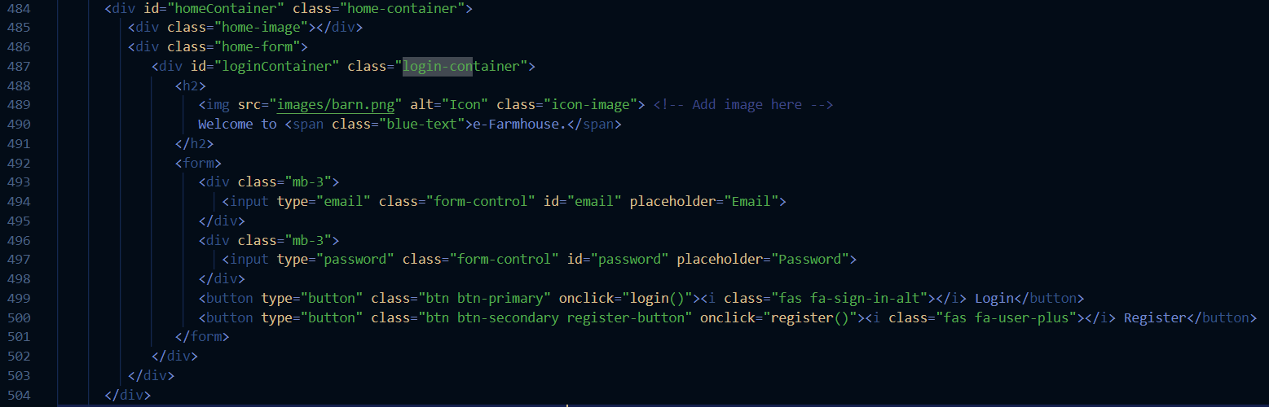

It is the main container for the login screen, defined by the following HTML:
<div id="homeContainer" class="home-container">

It serves as the overarching container that groups all elements of the login page, including images, forms, and other visual components. This is the layout and overall appearance of this section

The HTML structure within this container is organized into several key components:

- home-image

Inside the homeContainer, there is a section for displaying an image, defined as:
<div class="home-image"></div>

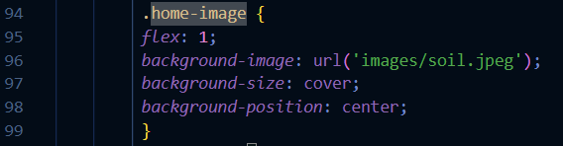

This home-image component is used to display a background image that enhances the aesthetic appeal of the login screen. The image and its properties, such as size and position, are controlled by the corresponding CSS class home-image.

- home-form


Home Form (home-form): This section contains the login and registration form. The loginContainer inside it specifically handles user authentication inputs.
The .home-form class is used to style the <div class="home-form"> element, which contains the login and registration form on the homepage. Here's how the CSS definition of .home-form works and how it affects the layout and appearance of the form:
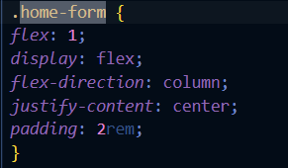

CSS Properties of .home-form
- flex: 1;
  - This property is part of the Flexbox layout model. The flex shorthand property combines flex-grow, flex-shrink, and flex-basis into a single property.
  - flex: 1; means that this element will grow to fill the available space within its parent container (homeContainer) while maintaining its proportions relative to any other flex items.
  - In this case, it ensures that the .home-form element takes up one unit of space, making it stretch to fill the space alongside the .home-image element display: flex;
  - display: flex; makes the .home-form a flex container, enabling the use of Flexbox layout properties on its child elements (in this case, the form and its components like the input fields and buttons).
  - This property allows for easy alignment and distribution of space among the child elements.
- flex-direction: column;
  - This property sets the main axis of the flex container to run vertically (from top to bottom).
  - As a result, the child elements (such as the form inputs and buttons) are stacked in a vertical column.
  - Without this property, the default flex-direction is row, which would align the elements horizontally.
- justify-content: center;
  - justify-content aligns the child elements along the main axis (which is vertical due to flex-direction: column;).
  - justify-content: center; centers the form vertically within the .home-form container, ensuring that it appears in the middle of the available space, which improves the visual balance and user experience.
- padding: 2rem;
  - The padding property adds space inside the .home-form element, between the content and the border of the container.
  - 2rem is a relative unit of measurement (based on the root font size) that provides consistent spacing regardless of screen size or zoom level.
  - This padding ensures that the form elements do not touch the edges of the container, giving them some breathing room and making the layout look clean and organized.

login-container
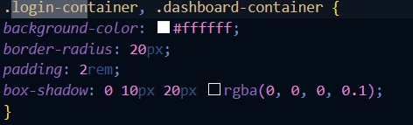
The loginContainer is the specific area within the home-form where users interact with the login form. It includes input fields for email and password, as well as buttons for logging in and registering. This component is styled to look like a "white container," with its layout and appearance controlled by the login-container CSS class.
- home-image

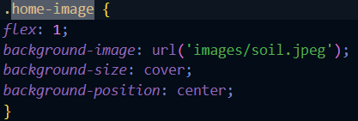

- login-container
The loginContainer is the specific area within the home-form where users interact with the login form. It includes input fields for email and password, as well as buttons for logging in and registering. This component is styled to look like a "white container," with its layout and appearance controlled by the login-container CSS class.
- Body Code (Website Landing Page)


Let's break down what each part of this code is doing:

- Body Start and Header Section


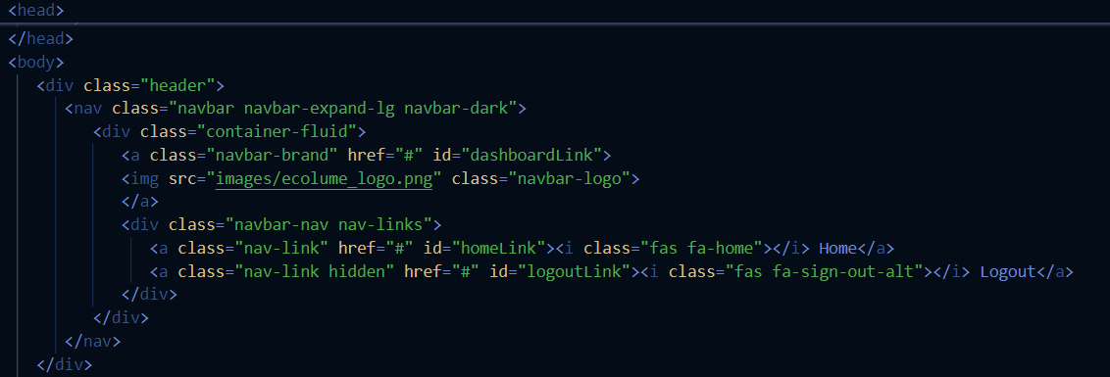

Header: The <div> with class header contains a navigation bar (<nav>) using Bootstrap's navbar classes. This navigation bar includes:
- Brand Link: A logo that links to the dashboard, represented by an image (<img src="images/ecolume_logo.png">).
- Navigation Links: Two links within nav-links:
  - Home Link: A link to the home page with a house icon.
  - Logout Link: A link to log out, which is initially hidden (class="hidden") and will be shown when the user is logged in.

- Home Container
Home Container: This is the main landing section of the website, divided into two parts:
- Home Image: A full-page image (home-image), possibly a background image.
- Home Form: A form (home-form) that contains:
  - A welcome message and a small icon (barn.png).
  - Login Form: Fields for email and password input with Bootstrap styling (form-control), and two buttons for logging in and registering. The buttons trigger JavaScript functions login() and register().

- Dashboard Container
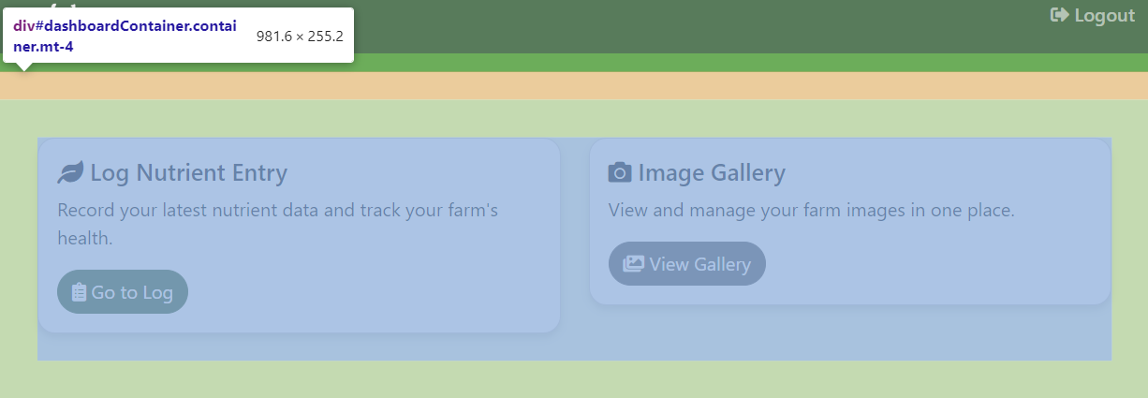
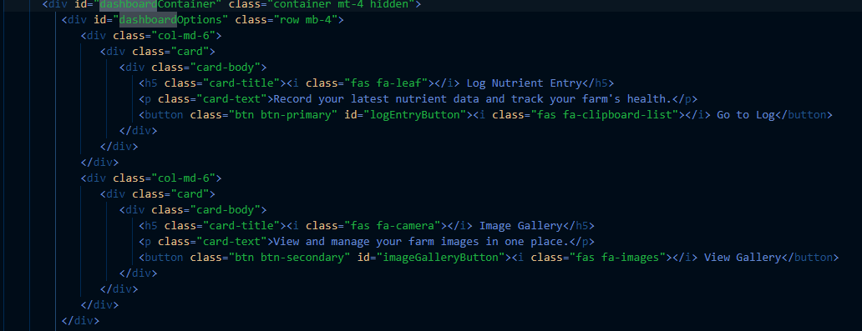
<div id="dashboardContainer" class="container mt-4 hidden">
- id="dashboardContainer": This is an identifier used to uniquely define this HTML element, allowing for specific CSS styling or manipulation via JavaScript.
- class="container mt-4 hidden":
  - container: A Bootstrap class that sets a fixed width at each responsive breakpoint to align content neatly.
  - mt-4: Bootstrap class for adding a margin-top space equivalent to the value of 1.5rem or 24px.
  - hidden: Initially hides the dashboard container from view. This is controlled via JavaScript to show or hide the container based on user interactions or authentication status.
<div id="dashboardOptions" class="row mb-4">
- id="dashboardOptions": Identifies this division for styling or scripting.
- class="row mb-4":
  - row: A Bootstrap grid system class that ensures horizontal alignment of child elements, known as columns.
  - mb-4: Adds a bottom margin.
First Column (Nutrient Log Entry):
- col-md-6: Ensures that the column takes up half the width of its parent container on medium-sized devices and larger. On smaller screens, it would take up the full width by default, making it responsive.
- card: Bootstrap component used for content organization. It provides a boxed area with some padding and margin.
- card-body: The content holder inside the card, including text and interactive elements.
- card-title and card-text: Semantically mark the title and the descriptive text of the card.
- The button (btn btn-primary) labeled "Go to Log" is styled with Bootstrap classes for aesthetic consistency and is likely wired through JavaScript (id="logEntryButton") to handle user clicks, navigating to the nutrient logger.
Second Column (Image Gallery):
- Similar to the first column, but dedicated to managing the image gallery.
- btn btn-secondary: A secondary style for the button, differentiating it visually from the primary action in the first column.
- id="imageGalleryButton": This button is set up for interaction to trigger a display of the image gallery or to navigate to a dedicated gallery management page.

- Nutrient Logger
The Nutrient Logger feature as mentioned earlier in the report, allows users to log various environmental and nutritional data points associated with specific tanks or batches, enhancing the ability to manage and optimize agricultural processes. Below, I'll break down how each part of this feature works, from the front-end interactions to the back-end processes.

HTML and CSS Structure
- User Interface:
  - HTML: The feature is housed within a section of the HTML document identified by the logEntrySection. This section includes a form (logEntryForm) where users input data such as date, tank name, food item, and quantities of nitrogen, phosphorus, potassium, and emissions. Each input field is marked as required, ensuring that users provide all necessary information before submission.
  - CSS: Styling is provided through Bootstrap for responsive layout and custom CSS rules that enhance visual presentation and interactivity (e.g., hover effects on buttons and cards).

JavaScript and Backend Interaction
- JavaScript Functionality:
  - Data Submission: The submitLogEntry() function captures the form data when a user submits a new entry. It packages the data and pushes it to a Firebase database under a new log entry. Each entry is tied to the user's ID, ensuring data segmentation and security.
  - Data Retrieval and Display: The loadLogEntries() function fetches existing log entries from Firebase, filters them based on user inputs (date, tank, and sorting preferences), and displays them in a dynamically created HTML table within the logTable section.
  - Data Manipulation: Users can apply filters, reset filters, and delete specific log entries using respective functions (applyFilters(), resetFilters(), and deleteLogEntry()). These interactions are handled asynchronously to ensure a responsive user experience.
  - Chart Visualization: The updateMacronutrientChart() function uses Chart.js to visually represent the total recorded amounts of nitrogen, phosphorus, and potassium as a pie chart, aiding in quick assessment of nutrient balances.

Firebase Integration
- Firebase Services:
  - Authentication: Manages user sessions and access rights, ensuring that data access and operations are securely managed.
  - Realtime Database: Stores and retrieves user data in real time, which includes log entries and user-specific settings.
  - Storage: While primarily used for handling image uploads in other sections of the application, it demonstrates the capability to handle large data sets and files securely.

Responsive Design and Accessibility
- Responsive Web Design:
  - The application is designed to be fully responsive, utilizing Bootstrap's grid system to adjust the layout for different screen sizes. This ensures that the nutrient logging feature is accessible and usable across all devices.
- Dark Mode Toggle:
  - A toggle switch is provided to switch between light and dark modes, enhancing visual comfort for users under different lighting conditions.

User Interaction and Experience Enhancements
- Dynamic UI Updates:
  - Dynamic elements like modal dialogs for tank addition, toast notifications for user feedback, and real-time updates to the UI reflect changes immediately, providing a fluid and interactive user experience.
- Error Handling and Feedback:
  - Extensive error handling and user feedback mechanisms are in place to guide the user through the application's use and troubleshoot issues (e.g., logging errors, data submission confirmations).

Conclusion
The Nutrient Logger feature is a robust component of a larger agricultural or compost management system, designed with user-friendliness, data integrity, and real-time operations in mind. By integrating advanced web technologies and Firebase services, it offers a secure and efficient way for users to monitor and manage agricultural inputs and environmental conditions effectively.

Alteryx Professional Certification Proof
Alteryx Designer Core Micro-Credential: General Knowledge



Alteryx Designer Core Micro-Credential: Data Preparation

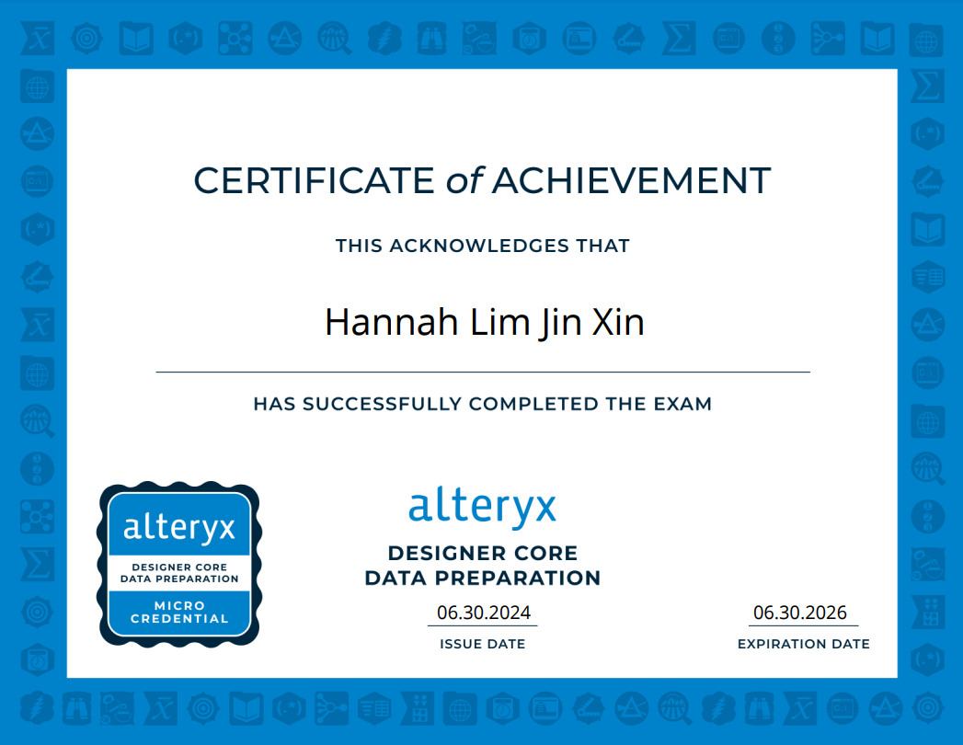

Alteryx Designer Core Micro-Credential: Data Manipulation

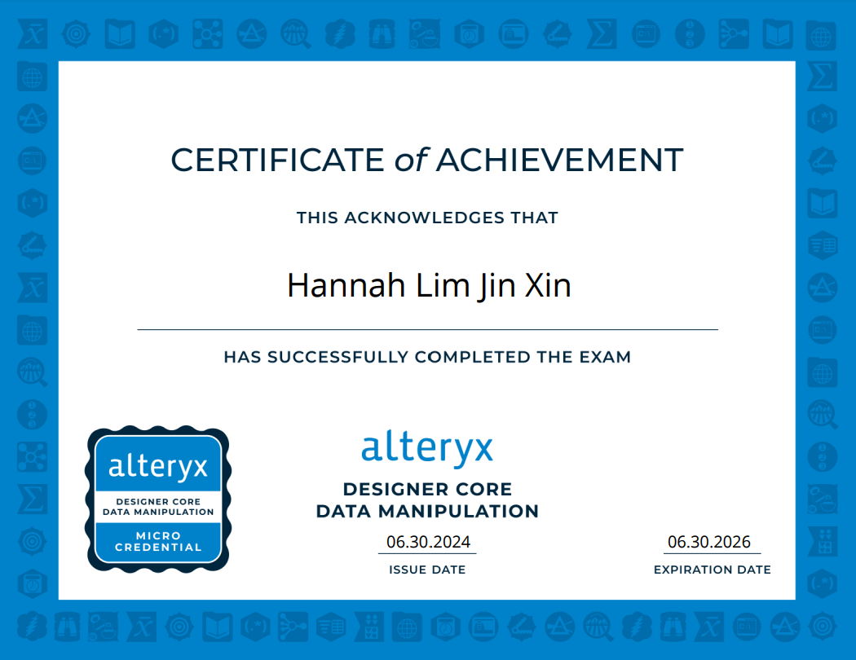

Alteryx Designer Core Micro-Credential: Data Transformation



Alteryx Core Designer Certification



References

Cornell University. (n.d.). Temperature, microbes, and composting. Retrieved from https://compost.css.cornell.edu/Factsheets/FS5.html
Cornell University. (n.d.). Monitoring moisture for optimal composting conditions. Retrieved from https://compost.css.cornell.edu/monitor/monitormoisture.html

Gangopadhyay, S., & Zhai, A. (2022). CGBNet: A deep learning framework for compost classification. IEEE Systems, Man, and Cybernetics Society Section. https://doi.org/10.1109/ACCESS.2022.3201099
Lauwers, J., Appels, L., Thompson, I. P., Degrève, J., Van Impe, J. F., & Dewil, R. (2013). Mathematical modelling of anaerobic digestion of biomass and waste: Power and limitations. Progress in Energy and Combustion Science, 39(4), 383-402.
Yang, Z., Muhayodin, F., Larsen, O. C., Miao, H., Xue, B., & Rotter, V. S. (2021). A review of composting process models of organic solid waste with a focus on the fates of C, N, P, and K. Processes, 9(3), 473. https://doi.org/10.3390/pr9030473

