Introduction
Gene expression is often dynamically altered by various epigenetic, transcription factors. Physical binding of such promoters, enhancers or introns to specific DNA regions heavily influence downstream gene behaviours and phenotypic responses. Thus, comprehensive genetic analysis of mutations is extremely helpful in predicting and explaining physiological response in disease states. In this study, gene X is hypothesized to be an epigenomic factor regulating gene expression which could be altered by mutations. To characterise the mutated version of this gene and determine the molecular mechanism behind this mutant phenotype, a multi-omics approach was utilised. Genomic mutations were located and identified using variant calling, transcriptomic dysregulation was quantified using RNA-seq and physical binding loci was identified using CUT&RUN data. It is hypothesized that mutations in gene X disrupt its physical DNA-binding capacity, leading to downstream target gene regulation failure.
Methods
To characterise the mutation in gene X, variant calling is performed to identify differences by mapping the haploid DNA sequences of mutant individuals against the reference sequence. BWA (ver. 0.7.19) was first used to create an index for the reference sequence (GeneX_reference.fa). In the following pipeline, the paired-end reads for the mutant sample were then aligned to the indexed reference genome for finding maximal exact matches using BWA-MEM, designed for reading Illumina data efficiently. Assignment of read group identifiers to distinguish sample types was performed during alignment. Resulting SAM alignments were converted to BAM format, sorted by coordinates, and indexed using SAMtools (ver. 1.23) for down-stream analysis. The sorted BAM file, along with the reference sequence and their corresponding index files were uploaded to the IGV web app for visualisation of variants. FreeBayes (ver. 1.3.10) was configured for a haploid organism and quality thresholds including minimum alignment mapping quality of 30 and minimum bases quality score of 25 were set to identify point mutations specific to the mutant strain. Resulting VCF files were then filtered using BCFtools (ver. 1.23) to only retain variants with non-zero alternate allele frequency as well as Phred-scaled quality scores and read depths larger than or equal to 10. To ensure that the identified mutations were not due to background genetic drifts or referencing errors, this mapping and variant calling pipeline was repeated for the normal control reads to verify mutant phenotype differences.

Transcriptomics analysis on the effects of the identified mutation on gene X expression was analysed using RStudio (ver. 2026.04.0-526; R version 4.5.1). RNA sequence data of 1000 genes from 5 normal and 5 mutant individuals were filtered to ensure each sample had an adequate number of reads. To assess data quality and replicate consistency prior to analysis, raw read counts were normalised using a regularised log transformation. Global sample similarities are evaluated via the production of histogram to investigate the data distribution. DESeq2 package is used to normalize the data and compute gene expression changes. The distribution of the resulting statistics was investigated using the EnhancedVolcano package. Only gene results with an adjusted p-value of less than 0.05 were retained for downstream analysis with a log. The top 5 upregulated and downregulated genes were identified according to the magnitude of log₂ fold change. A PCA analysis was performed to visualise unsupervised sample grouping and an heatmap was constructed to ensure correct clustering of data.

To further investigate the gene X binding sites on the genome and differentiate between genes affected by direct regulations and those affected by secondary downstream pathways, physical binding proof was integrated from the previous transcriptomic data results. The genomic binding coordinates from the wild-type CUT&RUN assay (gene_x_binding_sites.bed) was mapped against the genome annotation (genes.gff3) using bedtools intersect. The -wa and -wb flag were used to retain the metadata and full genomic coordinate for every identified overlap. Cross-referencing between these functionally bound loci and the differentially expressed gene lists confirmed whether the mutation in transcription factors cause direct failure of binding at the promoter sites of the most severely dysregulated gene targets.

Results
Upon filtering for high-quality variants in the mutant sequences against the reference, three point mutations were identified. This includes the alteration of base A to T at position 82 (QUAL = 6180, DP = 189), T to C at position 309 (QUAL = 18935, DP = 530) and C to G at position 620 (QUAL = 8639, DP = 260) as visualised in the IGV platform (Figure 1). These single-nucleotide substitutions may cause missense or nonsense mutation, potentially causing functional structural impacts on the resulting protein.
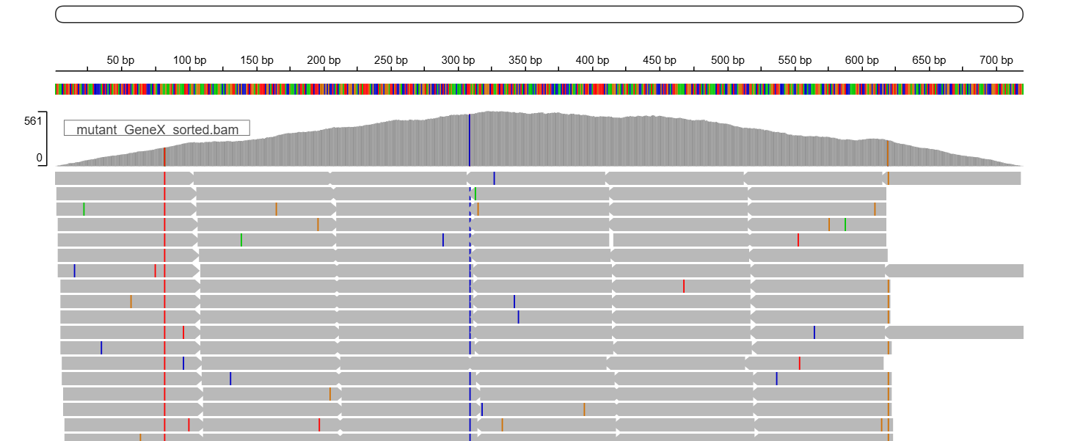
Figure 1: Genomic visualisation (via IGV) of the genome with identified mutation sites overlayed (highlighted in red, blue and yellow).

Initial exploratory data analysis of the regularized log-transformed counts confirmed high quality and reproducibility of the data. Robust clustering of samples is seen in both PCA and sample distance heatmaps (Appendix), confirming the primary variance source in the dataset is driven by biological condition (normal vs mutant). To quantify the downstream impact of these mutations, gene expression analysis revealed that upon comparison between mutant and normal individuals, 42 genes were up-regulated while 50 were down-regulated under the threshold of FDR <0.01 and absolute log₂(Fold Change) > 1. The distribution of transcriptomic shifts among the top targeted genes is visualised in the volcano plot (Figure 2). The top up-regulated gene is GENE_0046 (log₂FC = 2.33, P_{adj} = 2.36 x 10⁻²⁵), effectively demonstrating severe over-activation. This is followed by GENE_0913, GENE_0975, GENE_0400 and GENE_0492 (Table 1). GENE_0325 (log₂FC = -2.33, P_{adj} = 1.47 x 10⁻¹⁸) was the most down-regulated gene, followed by GENE_0022, GENE_0231, GENE_0127 and GENE_0773 (Table 2).
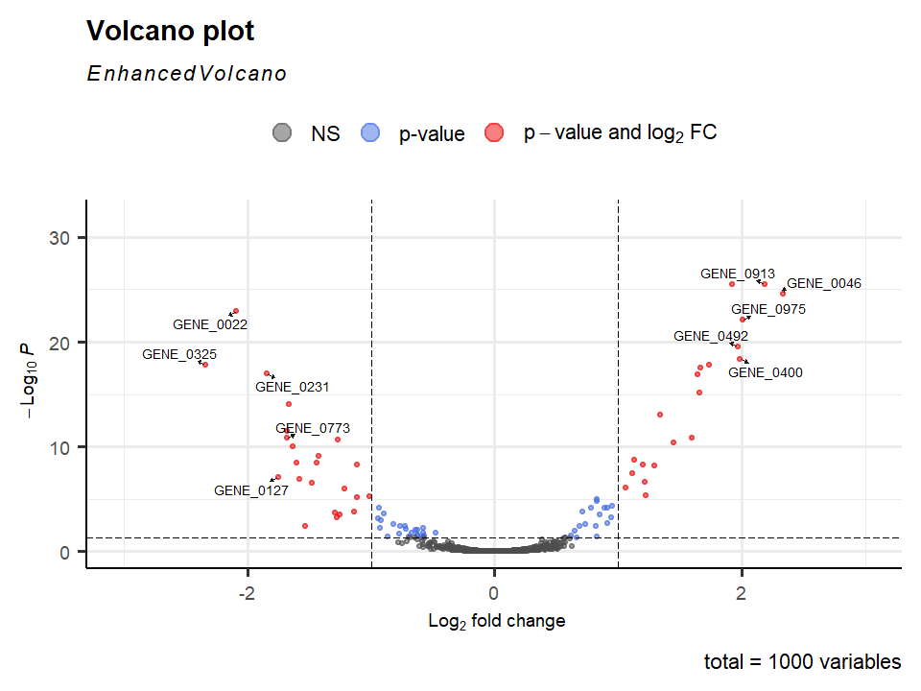
Figure 2: Volcano Plot showing the distribution of gene’s statistical significance (p-value, y-axis) against magnitude of change (log2fold change, x-axis). Genes with a statistical significance of Padj<0.05 and an absolute log2(Fold Change) >1 are highlighted in red. Top 10 genes with the most significant changes are labelled.

Gene ID | Base Mean | Log₂ Fold Change | Adjusted P-value
GENE_0046 | 689.58 | 2.34 | 2.36E-25
GENE_0913 | 668.57 | 2.19 | 2.88E-26
GENE_0975 | 405.86 | 2.00 | 8.21E-23
GENE_0400 | 102.55 | 1.99 | 4.16E-19
GENE_0492 | 309.46 | 1.97 | 2.64E-20
Table 1: Statistical metrics of the top 5 most upregulated genes.

Gene ID | Base Mean | Log₂ Fold Change | Adjusted P-value
GENE_0325 | 44.67 | -2.34 | 1.47E-18
GENE_0022 | 186.34 | -2.09 | 1.25E-23
GENE_0231 | 162.80 | -1.84 | 1.10E-17
GENE_0127 | 48.39 | -1.75 | 8.08E-08
GENE_0773 | 169.97 | -1.68 | 1.60E-11
Table 2: Statistical metrics of the top 5 most downregulated genes.
The transcriptomic shifts observed in the mutant strain resulted from a disruption of both direct and indirect regulation by Gene X, as shown by the intersection of CUT&RUN binding data with the genome annotation using bedtools. 40% of the top 10 differentially expressed genes (including upregulated GENE_0975, GENE_0400; downregulated GENE_0127, GENE_0773) possessed physical wild-type gene X binding peaks at their loci as these regions were identified as overlaps in the bedtools results file. This confirms that gene X binds directly to these severely dysregulated targets and the primary, direct nature of this regulation. The identified point mutations likely disrupt the protein’s DNA-binding capacity at these regions, leading to a direct failure in the transcriptional regulation for these target genes. Conversely, the remaining highly dysregulated targets (including upregulated GENE_0046, GENE_0913 and GENE_492; downregulated GENE_0325, GENE_0022 and GENE_0231) lacked physical binding evidence. This absence of overlap suggests that these loci are secondary, indirect targets that are not bound by Gene X nor directly influenced by the identified mutations. Instead, the downstream transcriptomic changes result from the loss of the primary regulatory pathway initiated by gene X. The mechanism of the regulatory binding is further revealed by the IGV visualisations. GENE_0773 (Figure 3) demonstrated classic promoter binding as the binding site peak matches with the starting exon of the gene while GENE_0127 (Figure 4) has a downstream exonic binding as the peak corresponds to the second exonic coding region of the reverse gene strand. Intronic binding is demonstrated by both GENE_0400 (Figure 5) and GENE_0975 (Figure 6) as both peaks is situated in the intron region of their respective gene strands. The structural diversity highlights gene X as a complex global regulator and that identified point mutations affect binding capacities across multiple distinct regulatory element types.

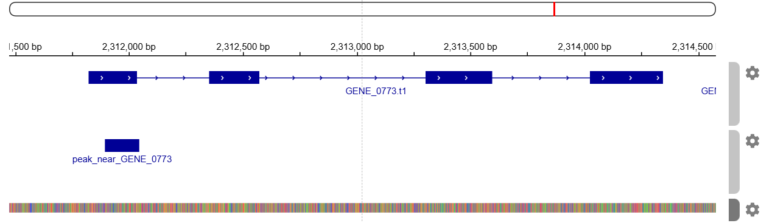
Figure 3: Genomic visualisation of Gene X binding at GENE_0773 locus. Structural annotation (top track) indicates transcription on the forward strand. CUT&RUN binding peak (bottom track) aligns near the start site.

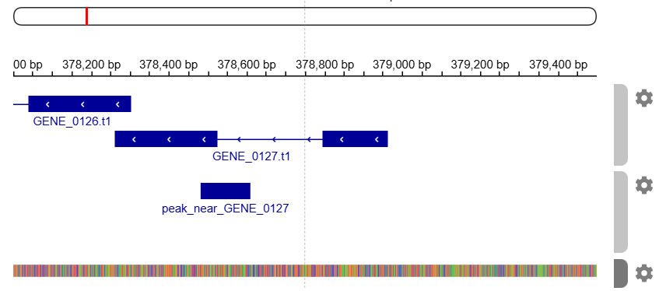
Figure 4: Genomic visulisation of Gene X binding at GENE_0127 locus. Structural annotation (top track) indicates transcription on the reverse strand. CUT&RUN binding peak (bottom track) downstream of the transcription start site, overlapping at the second exonic region.

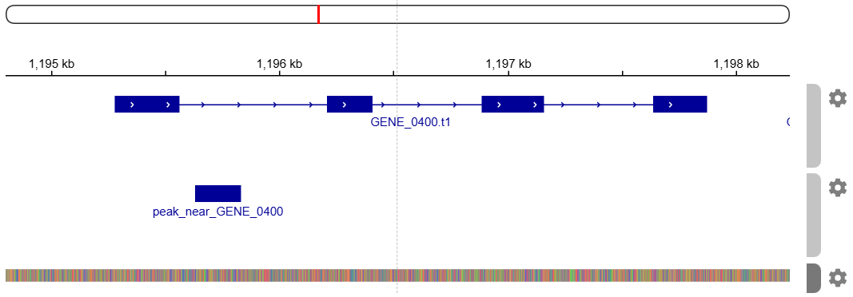
Figure 5: Genomic visulisation of Gene X binding at GENE_0400 locus. Structural annotation (top track) indicates transcription on the forward strand. CUT&RUN binding peak (bottom track) downstream of the transcription start site and at the first intronic region.
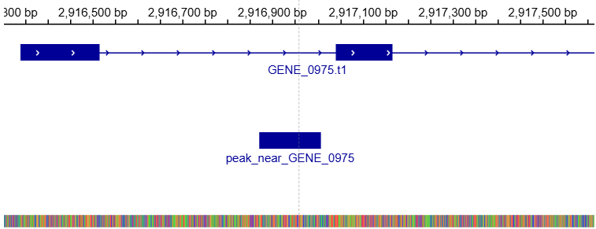
Figure 6: Genomic visulisation of Gene X binding at GENE_0975 locus. Structural annotation (top track) indicates transcription on the forward strand. CUT&RUN binding peak (bottom track) downstream of the transcription start site and at the first intronic region.

Conclusion
The mutated phenotype is found to be caused by three specific point mutations in gene X. This led to a physical loss-of-function response with failed DNA binding ability, causing significant transcriptomic shifts with various upregulated and downregulated genes. Gene X was identified as a master regulator with various direct intronic and exonic binding targets, leading to secondary cascading effects on multiple other genes.
Although this study successfully mapped the transcriptomic changes of gene X mutations, exact regulatory mechanisms could be further explored with additional transcriptomic techniques. Future studies can benefit from Nascent RNA-seq to verify whether transcriptomic shifts are driven by failed transcription initiation or altered mRNA decay rates. Transcriptomic enrichment assays such as NET-seq can also be used to investigate elongation or polymerase activity during transcription.

Appendix
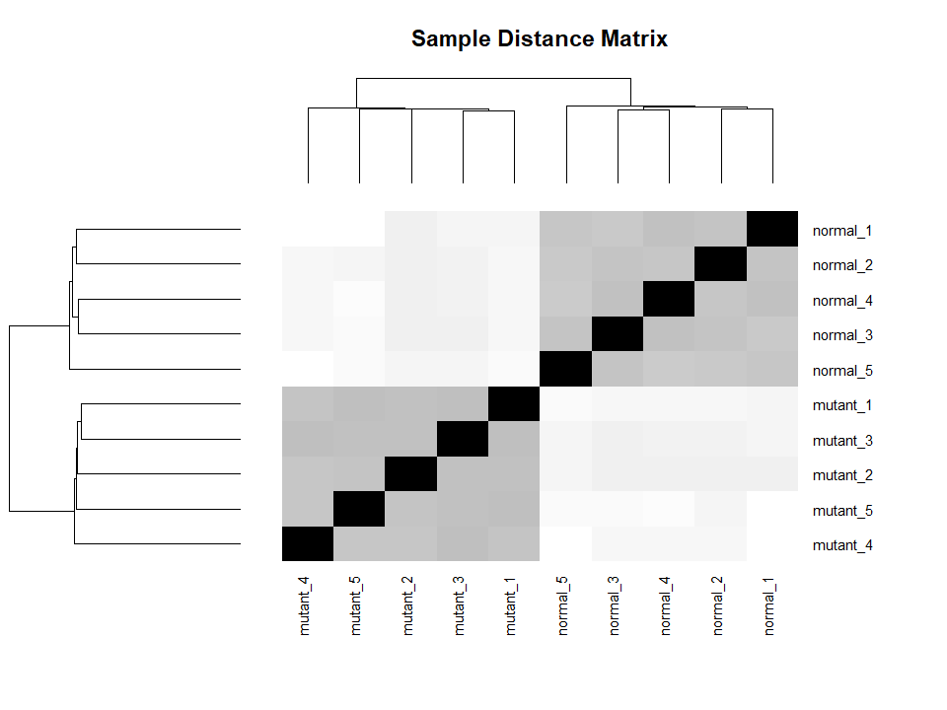
Figure 7: Sample distance matrix and hierarchical clustering of RNA-seq replicates. Heatmap shows Euclidean distances between read counts of all samples, with darker shades indicating higher similarity between sample pairs. Dendrograms demonstrate perfect clustering by experimental groups, confirming reproducibility and distinct global expression profile between normal and mutant strains.

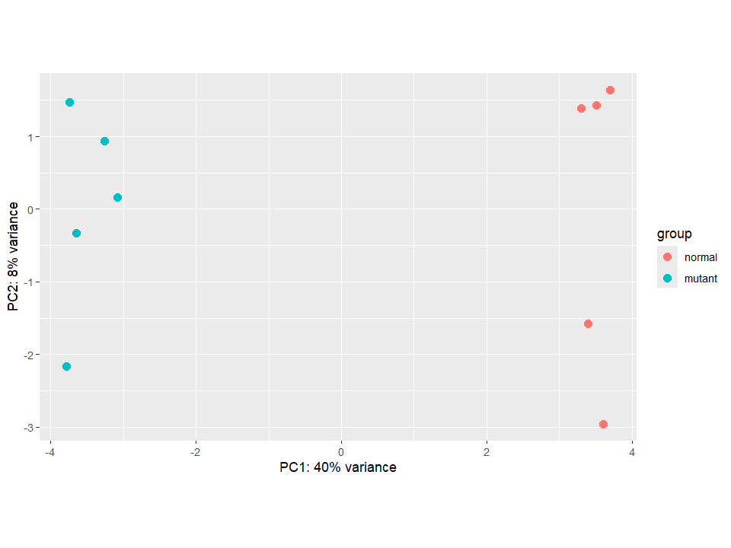
Figure 8: Principal Component Analysis of global gene expression. PC1 (x-axis) accounts for 40% of the total variance with clear separation of samples by biological conditions, confirming gene mutations as the primary drivers of the observed transcriptomic shifts.
References
Blighe K, Rana S, Lewis M (2026). EnhancedVolcano: Publication-ready volcano plots with enhanced colouring and labeling. R package version 1.31.0, https://bioconductor.org/packages/EnhancedVolcano.
Danecek, P., Bonfield, J.K., Liddle, J., Marshall, J., Ohan, V., Pollard, M.O., Whitwham, A., Keane, T., McCarthy, S.A., Davies, R.M. and Li, H. (2021). Twelve years of SAMtools and BCFtools. GigaScience, 10(2). doi:https://doi.org/10.1093/gigascience/giab008.
Garrison, E. and Marth, G. (2012). Haplotype-based variant detection from short-read sequencing. arXiv:1207.3907 [q-bio]. [online] Available at: https://arxiv.org/abs/1207.3907.
Li, H. and Durbin, R. (2009). Fast and accurate short read alignment with Burrows-Wheeler transform. Bioinformatics (Oxford, England), [online] 25(14), pp.1754–60. doi:https://doi.org/10.1093/bioinformatics/btp324.
Li, H., Handsaker, B., Wysoker, A., Fennell, T., Ruan, J., Homer, N., Marth, G., Abecasis, G. and Durbin, R. (2009). The Sequence Alignment/Map format and SAMtools. Bioinformatics, 25(16), pp.2078–2079.
Love, M.I., Huber, W. and Anders, S. (2014). Moderated estimation of fold change and dispersion for RNA-seq data with DESeq2. Genome Biology, 15(12), p.550. doi:https://doi.org/10.1186/s13059-014-0550-8.
Quinlan, A.R. and Hall, I.M. (2010). BEDTools: a flexible suite of utilities for comparing genomic features. Bioinformatics, 26(6), pp.841–842.
Wickham et al., (2019), "Welcome to the tidyverse," Journal of Open Source Software, 4(43), 1686, 10.21105/joss.01686
Wickham H, François R, Henry L, Müller K, Vaughan D (2026). dplyr: A Grammar of Data Manipulation. R package version 1.2.1, https://dplyr.tidyverse.org.

GAI declaration
General Statement | I used GenAI tools in the preparation of this work.
In the rows below, provide the required information about any GenAI tools and how they were used.
Gemini 3.1 Pro | Google DeepMind, Gemini 3.1 Pro; link with chat history: https://gemini.google.com/share/8b41ae8412d6  This was used to assist R code writing for Volcano Plot visualisation, the usage of bedtools to identify genome binding sites and interpretation of IGV platform visualisation for regulatory binding mechanisms.
Grammarly | Grammarly Inc (web version); https://www.grammarly.com  This was used for spell and grammar checks on the final version of this assignment.

