**Albedo Estimation Project**

GOAL: calculate albedo of three, 1-acre plots of land in CA.

PROCESS:

1. **Data sources and collection**

I decided to use satellite images as my main data source. Landsat 8 data products provided by the USGS EROS Center consist of quantized and calibrated scaled Digital Numbers (DN) representing multispectral image data acquired by both the Operational Land Imager (OLI) and Thermal Infrared Sensor (TIRS). I choose Landsat 8 for the following factors:

* spatial resolution of 30 meters provides approximately 4 measurements per 1-acre cell.
* The satellite circumvents the globe every 16 days, affording seasonal coverage.
* Multispectral images contain information on the electromagnetic spectrum relevant to shortwave reflection.
* The Landsat 8 satellite is currently in orbit, transmitting data in real-time allowing essentially real-time estimates of albedo.
* The data has been made accessible at no cost to the public via command-line utilities and Nasa’s open API.

1. **Data Processing**

Refer to the commented code at the top of calc_abedo_main.py for description of the method used to calculate albedo. Citations and references are included.

Below is a chart showing the wavelength range for the bands used (1,3,4,5,7). These bands were chosen in accordance with the method from the paper: Smith, R.B. 2010. “The heat budget of the earth’s surface deduced from space.”

|  |  |  |  |
| --- | --- | --- | --- |
| **Spectral Band** | **Wavelength** | **Resolution** | **Solar Irradiance** |
| Band 1 - Coastal / Aerosol | 0.433 – 0.453 µm | 30 m | 2031 W/(m²µm) |
| Band 2 - Blue | 0.450 – 0.515 µm | 30 m | 1925 W/(m²µm) |
| Band 3 - Green | 0.525 – 0.600 µm | 30 m | 1826 W/(m²µm) |
| Band 4 - Red | 0.630 – 0.680 µm | 30 m | 1574 W/(m²µm) |
| Band 5 - Near Infrared | 0.845 – 0.885 µm | 30 m | 955 W/(m²µm) |
| Band 6 - Short Wavelength Infrared | 1.560 – 1.660 µm | 30 m | 242 W/(m²µm) |
| Band 7 - Short Wavelength Infrared | 2.100 – 2.300 µm | 30 m | 82.5 W/(m²µm) |
| Band 8 - Panchromatic | 0.500 – 0.680 µm | 15 m | 1739 W/(m²µm) |
| Band 9 - Cirrus | 1.360 – 1.390 µm | 30 m | 361 W/(m²µm) |

**Fig. 1 OLI Spectral Bands:** Landsat scenes are made of several files or layers (bands) of data. Each band represents a section of the electromagnetic spectrum that has been selected because it is useful for distinguishing kinds of land cover and land use from one another, and measuring ways they change over time. Source: <https://en.wikipedia.org/wiki/Landsat_8#Operational_Land_Imager>

1. **Verification of output**

I did not have much time to implement a thorough test for accuracy. However, I have many ideas on exactly how I would do this. For starters, each image has a cloud cover value recorded in the metadata file. Simply go to the xxxx _MTL.txt file and look for the line “cloud_cover =”. For instance, the cloud cover for Tahoe forest on 8/8/2016 is 11%. I would probably set a threshold (perhaps 20%) in order to include data. Furthermore, I would flag outliers for further inspection. I would also employ a statistical prediction, based on historical variability of albedo by season and check the data against those predictions. I may also consider a machine learning approach. In terms of low hanging fruit, I would check the cloud cover value. If the cloud cover data is not high enough resolution, I may pull cloud cover data from the weather service or other source.

If available, I would use higher resolution image data to obtain a more robust average over an area. Landsat 8 was the highest resolution, real-time data I found during my search. I would also check the standard deviation and skewness of the pixel values over the 1-acre cell. We expect the standard deviation to be small since the land cover is homogenous (on most farms). If the standard deviation passes a threshold, I’d flag it for further analysis.

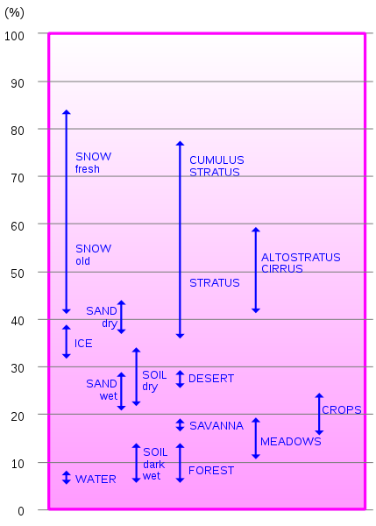

Fig. 2. Percentage of diffusely reflected sunlight in relation to various surface conditions

To test my method initially, I would calculate the albedo of known types of land. For example, the forest in Tahoe should have an albedo around .08 - 0.15 (see figure on right). In fact, I calculated an albedo of 0.215 on one acre of ostensibly forest land in Tahoe. This difference could be due to land change-- the image on google maps may not be recent and may no longer be forested. Alternatively, there could be a seasonal effect or this forest simply has an above average albedo. I would choose several types of land (desert, forest, water, etc.) that I am certain are still that type and test them on my program. Unfortunately, I ran out of time to do this. I would research other useful test to check my output if I had more time.

**Information on running my program:**

You must first download the command line utility: landsat-util (a command line utility that makes it easy to search, download, and process Landsat imagery).

* Github: https://github.com/developmentseed/landsat-util
* Full documentation: https://pythonhosted.org/landsat-util/
* Installation: <https://pythonhosted.org/landsat-util/installation.html>

To run the program.

First, open calc_albedo_main.py. Scroll to the line “ACTION REQUIRED.” Select the location of interest to calculate the albedo of interest. Currently there are three options. Of course, in the future, I would automate it to take in any lon, lat.

1. Anderson Almond Orchard in Hilmar, CA
2. Spottswoode Winery in St. Helena, CA
3. Forest in Tahoe

Simply run in your terminal:

$ python calc_albedo_main.py

This will download image files into ‘~/landsat’, which you can browse to view images of certain bands and the metadata. The calculated albedo will appear in the terminal output.

**Results**

I ran my program on three 1-acre land areas. Please refer to calc_albedo_main.py for information on location, data of the three land areas.

Command-line output:

$ albedo of Anderson Almond Orchard in Hilmar, CA is 0.119326151633

$ albedo of Spottswoode Winery in St. Helena, CA is 0.0456889953098 (seems a bit low for crops)

$ albedo of Forest in Tahoe is 0.214935211868