Hannah Machado

Feb. 2nd, 2017

CSC 210

**Computing for scientists homework 1:**

1. **Raphson's Cubic:** Try to read the original paper of Raphson above. Notice that he is trying to solve the cubic equation 3r^2 x - x^3 = c r^2 for the parameter values c = r = 10.0, with the initial guess of x = 3.0. Reproduce his answer for the root in Phaser using Newton-Raphson method.
   1. To solve the problem, I have to find F so I can plug it into phaser. We know that the general formula for F is F= xn - f(xn)/f’(xn) so:
      1. First plug in the value 10 into c and r in the original given equation to find f(xn):

3*(10^2)x-x^3= 10*10^2

300*x-x^3=1000

300*x-x^3-1000=0

* + 1. Now derive Raphson’s equation with the number plugged in to find f’(xn):

300-3*x^2=0

* + 1. Find F:

F= xn-(300*xn-xn^3-1000)/(300-3*xn^2)

* 1. In Phaser, select equation, add custom equation and enter the equation found. Set the initial condition to 3 and apply. The numbers obtained were:

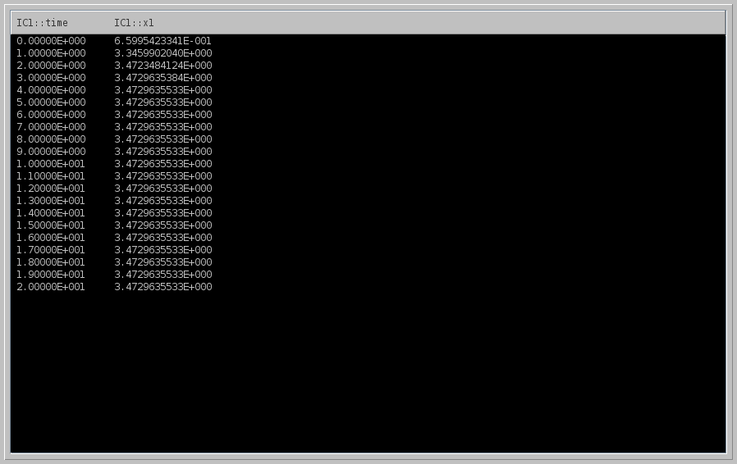

When the number 3 is plugged into the equation F= xn-(300*xn-xn^3-1000)/(300-3*xn^2), the obtained result is approximately 3.4652, which is very similar to the result 3.4729 obtained in Phaser.

1. **sqrt(2) by Sumerians:** On the Sumerian tablet (see the link above), four digits (1)(24)(51)(10) of an approximation to sqrt(2) are given in base 60. Compute 12 binary digits of this approximation. Please show the steps of your computations.
   1. First, convert (1)(24)(51)(10) from base 60 to decimals:
      1. 1 24 51 10= 1+24/60+51/60^2+10/60^3= 1.41421296
   2. Now I have to transform that to binary.
      1. First, let’s transform the binary value on the left side.

½= 0R1

1 we are done.

* + 1. Now, find the value of the fraction 0.41421296:
       1. First, we multiply 0.41421296 by 2 to find the most significant digit (the rightmost digit). Since our result is less than 1, the most significant digit in our answer is 0.
       2. Next, we take the fractional part of our previous result and multiply by 2 again. If the result is greater than 1, the next digit of our answer is 1, otherwise it is zero.
       3. Again take the fractional part of our previous result and multiply by 2 until you reach a fractional part of 0.
       4. To solve for 0.41421296:

0.41421296*2= 0.828425 Answer: 0.0

0.828425*2= 1.65685 Answer: 0.01

0.65685*2= 1.3137 Answer: 0.011

0.3137*2=0.62764 Answer: 0.0110

0.62764*2= 1.2548 Answer: 0.01101

0.2548*2= 0.5096 Answer: 0.011010

0.5096*2=1.0192 Answer: 0.0110101

0.0192*2= 0.0384 Answer: 0.01101010

0.0384*2= 0.0768 Answer: 0.011010100

0.0768*2= 0.1536 Answer: 0.0110101000

0.1536*2=0.3072 Answer: 0.01101010000

0.3072*2= 0.6144 Answer:0.011010100000

* 1. Now summing both parts:
     1. 1+0.011010100000= 1.011010100000

Answer: The approximation with 12 binary digits is 1.01101010000

1. **Is faster better?:** Consider the map x1 -> 0.375*x1 + 1.5/x1 - 0.5/(x1*x1*x1). Iterate this map (derived by Alkalsadi around 1450AD) with the starting value 2.0 until 15 digits settle down. How many iterations are required? Now, count the number of all the additions, subtractions, multiplications and divisions you have made to obtain your approximation to sqrt(2).

Next do the same with Newton's method using x1 ->0.5*(x1 + 2.0/x1).

Which method requires fewer number of iterations?

Which method requires fewer number of arithmetical operations to compute sqrt(2) to the same precision?

1. After plugging in the equation into Phaser and running it, I observed that 4 iterations are required. After the fourth iteration the numbers are the same, meaning I have found my fixed point at the value of approximately 1.4142

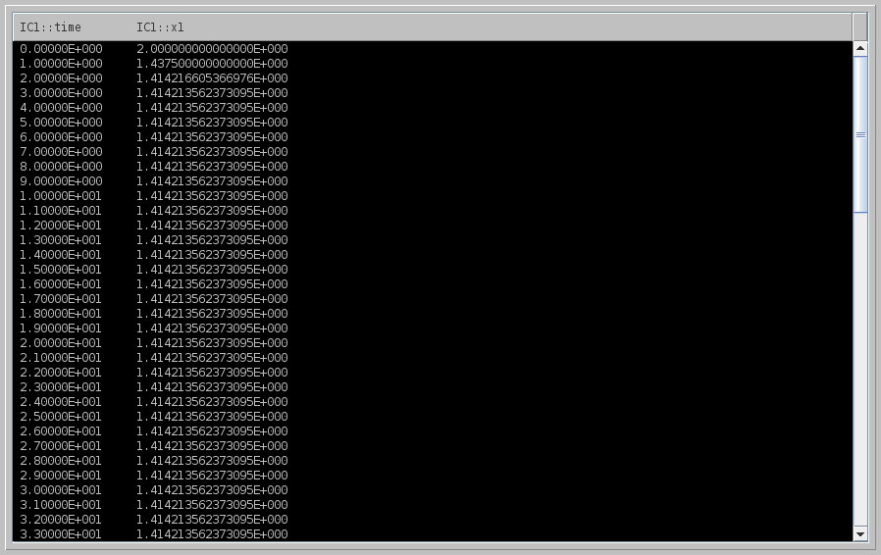 b. The number of all the additions, subtractions, multiplications and divisions you have made to obtain your approximation to sqrt(2) is 7

c. Newton's method using x1 ->0.5*(x1 + 2.0/x1) requires only 3

d. The method that requires fewer number of iterations is Alkasadi’s

e. The method that requires fewer number of arithmetical operations to compute sqrt(2) to the same precision is Newton’s

1. **Small angle approximation:** In physics, it is often convenient to use the 'small angle approximation' by replacing sin(x) with x when x is small. Use Newton-Raphson method to find a value of x which satisfies the equation sin(x) - x = 0.017.

remember to use radians!

* 1. To solve the problem, I have to find F so I can plug it into phaser. We know that the general formula for F is F= xn - f(xn)/f’(xn) so: ***from Hannah to Isa: he said this formula in class!! It’s the Newton-Rapha on method formula***
     1. Our f(x) is: sin(x)-x= 0.017

sin(x)-x-0.017=0

* + 1. The derivative is: f’(x)= cos(x)-1
    2. Therefore, our F function is

F= xn -(sin(xn)-xn-0.017)/(cos(xn)-1) ***here Im just substituting f(x) for our formula and f’(x) for the derivative!!***

* 1. In Phaser, select equation, add custom equation and enter the equation found. Set the initial condition to 3 and apply. The numbers obtained were:

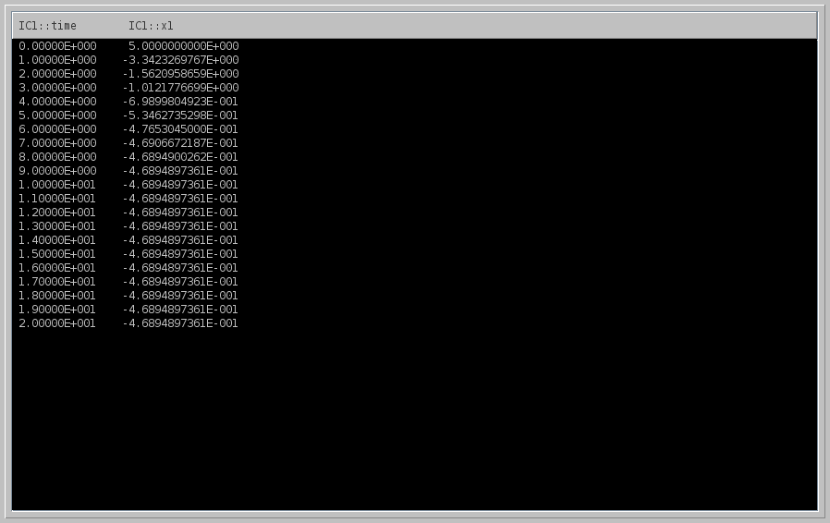

-4.6894897361E-001, giving us the answer that the solution to the equation is approximately x= -0.469

1. **Your favorite computer trouble:** Write a short report (half a page?) about your favorite, or scariest, hardware, software, security, etc. problem. Please indicate your sources. -->

One of the security problems that call my attention nowadays is the issue of surveillance, which can lead to spying. Using technology for security purposes is a relatively new idea that is not fully open to the public due to confidential information and a high level of education that is needed to ensure understanding. Because of that, many people are not aware of what happens, but the government can easily interfere any phone call, email, text and go into any computer if the hacking level is high enough. Edward Snowden, for example, was one of the persons to break this taboo. He leaked information about US spying agencies and made everyone question whether or not law enforcement should use surveillance features like breaking into cellphones and computers. It is claimed that such tools are used to stop terrorism, but it can also be considered a breach in privacy. So much as a web camera or any other device that has been connected can be accessed anytime. It is claimed that “activities of millions (if not billions) of citizens have been caught up in a dragnet style surveillance problem called PRISM, even when the communication has nothing to do with terrorism. (Shah)” So the real question is, should we enforce boundaries to the surveillance features allowed? Or even further, how to ensure the government is complying, since the programs are claimed to be top secret? This issue can lead to the constant feeling of insecurity and being watched and it is not comfortable to live knowing that there are people watching you all the time. Hopefully some standard and limitations are going to be established in the near future, so that people can be assured that their privacy is secure.

Sources:

Reel, Monte. "Secret Cameras Record Baltimore's Every Move From Above."*Bloomberg.com*. Bloomberg, 23 Aug. 2016. Web. 02 Feb. 2017.

Shah, Anup. "Surveillance State: NSA Spying and More." *Surveillance State: NSA Spying and More - Global Issues*. N.p., n.d. Web. 02 Feb. 2017.