Isabel Wyss

CSC 210

September 25, 2018

Homework: Week 4

**1. Linear maps in the plane:** Consider the linear map in two variables depending on a parameter a:

x1 -> 0.75*x1 + a*x2

x2 -> -a*x1 + 0.75*x2

Notice that the origin is a fixed point for all values of a. Determine the parameter values for which the origin is unstable, stable, or asymptotically stable. Draw phase portraits to support your findings. Note: You can use the Linear 2D MAP in the MAP library of Phaser.

Hint: There are two values of the parameter a for which the origin is stable.

*Optional:* Can you answer the same questions for the linear map:

x1 -> -0.75*x1 + a*x2

x2 -> -a*x1 - 0.75*x2

Stable: a = 0, a = 0.6615 → stable because the graph is spiraling in toward the fixed point

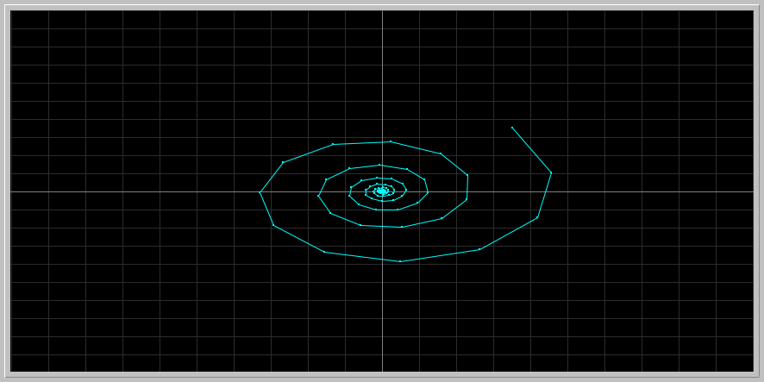

Asymptotically stable: a < 0.6615 → converging toward fixed point (0)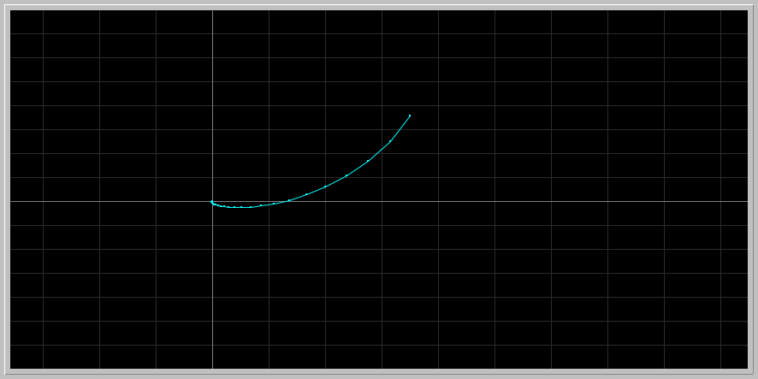

Unstable: a > 0.6615

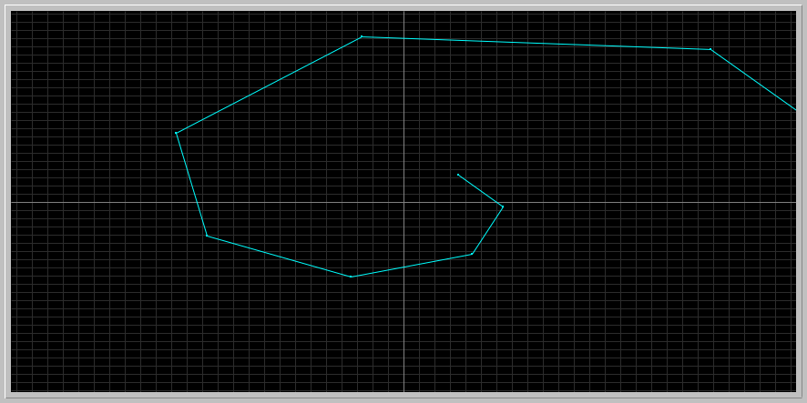

**2. Nicholson-Bailey model:** The following pair of difference equations is a famous model that describes the interaction of host-parasitoid populations (one insect feeds on another):

Hn+1 = k Hn e( -a Pn )

Pn+1 = c Hn [1 - e( -a Pn ) ]

Variables

Hn : Density of host at generation n

Hn+1 : Density of host at generation n+1

Pn : Density of parasitoid at generation n

Pn+1 : Density of parasitoid at generation n+1

Parameters

k : Reproductive rate of host

a : Searching efficiency constant of parasitoid

c : Average number of viable eggs deposited by parasitoid on a single host

You can read more about this model at [Phaser Web site .](http://www.phaser.com/modules/ecology/nicholson/index.html)

In 1941, Debach and Smith in their laboratory experiment started with 36 housefly, [Musca domestica,](http://en.wikipedia.org/wiki/Housefly) and 18 of its pupal parasite [Nasonia vitripennis](http://www.rochester.edu/College/BIO/labs/WerrenLab/nasonia/) and followed the populations for seven generations. They arranged the fecundity rate of the host to be 2 (k = 2, c = 1), and determined the searching efficiency constant to be a = 0.045. Please read their original paper at the link below:

DE BACH, P. and SMITH, H.S. [1941]. "Are Population Oscillations Inherent in the Host-Parasite Relation?" Ecology, 22, 363-369. [JSTOR URL](http://links.jstor.org/sici?sici=0012-9658%28194110%2922%3A4%3C363%3AAPOIIT%3E2.0.CO%3B2-X)

In particular examine their data on Table I on page 367 and Figure 1 on page 368 of their article. Their Figure 1 looks like the following Phaser view: Download the following phaser Project file [debach_smith.ppf](http://www.math.miami.edu/~hk/csc210/week4/debach_smith.ppf) by just clicking on it ( or by right-click and save it to our computer. Now load this file into Phaser).

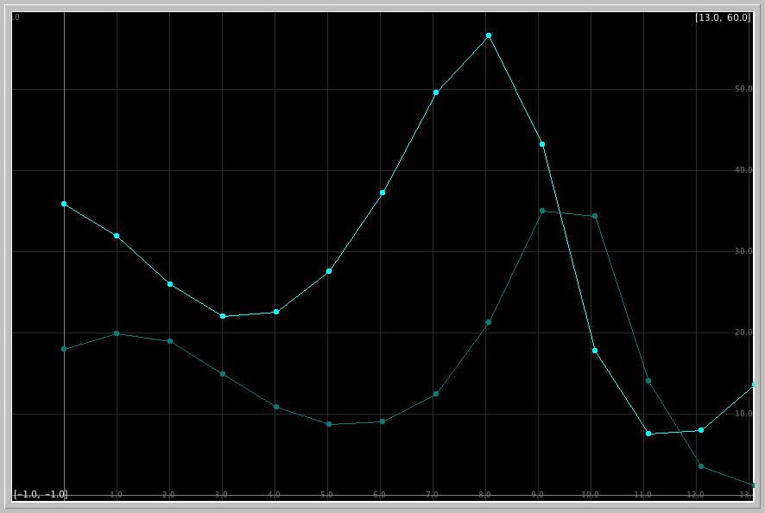

What is the experimental count of the host and parasitoid in the second and fifth generations in the paper of DeBach and Smith?

The experimental count of the host and parasitoid:

Second Generation:

* Host: 26
* Parasite: 18

Fifth Generation

* Host: 29
* Parasite: 9

What does the Phaser simulation of the Nicholson-Bailey model predict for these counts?

Phaser simulation prediction:

Second Generation:

* Host: 26.0787
* Parasite: 18.9451

Fifth Generation:

* Host: 28.1169
* Parasite: 8.7541

What are the relative errors in the model predictions?

Relative errors in model predictions:

Second Generation:

Host : 26 - 26.0787 = -0.0787 → |-0.0787| / 26 = 0.003027 → 0.003027 * 100 = 0.30269 → = **0.30% relative error in model predictions for host in the second generation**

Parasite**:** 18 - 18.9451 = -0.9451 → |-0.9451| / 18 = 0.05250 → 0.05250 * 100 = 5.25 → = **5.25% relative error in model predictions for parasite in the second generation**

Fifth Generation

Host**:** 29 - 28.1169 = 0.8831 → |0.8831| / 29 = 0.03045 → 0.8831 * 100 = 3.045 **→**

**= 3.045% relative error in model predictions for host in the fifth generation**

Parasite: 9 - 8.7541 = 0.2459 → |0.2459| / 9 = 0.02732 → 0.02732 * 100 = 2.7322 →

**= 2.73% relative error in the model predictions for parasite in the fifth generation**

* The experimental count and Phaser’s simulation of the model had very similar values
* The number of parasites decreases from the second generation to the fifth generation, this is because the number of hosts were decreasing in the first generations and therefore the parasites did not have enough hosts
* As the number of parasites decreased over time, the number of hosts slowly increased over time
* The intersection point of the two models signify the an equal ratio of 1:1, meaning there’s equilibrium.
* The relative errors in the model predictions are that a and k are approximations
* The relative population densities are periodical

**3. Radioisotopes used in nuclear medicine:** Investigate which radioisotopes are used in nuclear medicine. Select one used in Positron Emission Tomography (PET) imaging, and another one in radiotherapy for cancer treatment. Look up their half-lives. Use Phaser and the ODE x1' = k*x1, determine the decay constants k of the two radioisotopes you have selected. Use at least two initial conditions for each to make sure that k does not depend on the initial amount. Here is a link to get you started on [radioisotopes in nuclear medicine.](https://www.radiochemistry.org/nuclearmedicine/radioisotopes/01_isotopes.shtml)

Radioisotope used in PET: Fluorine-18

Half life: 109.8 minutes

k = 0.693 / 109.8 = **0.00631**

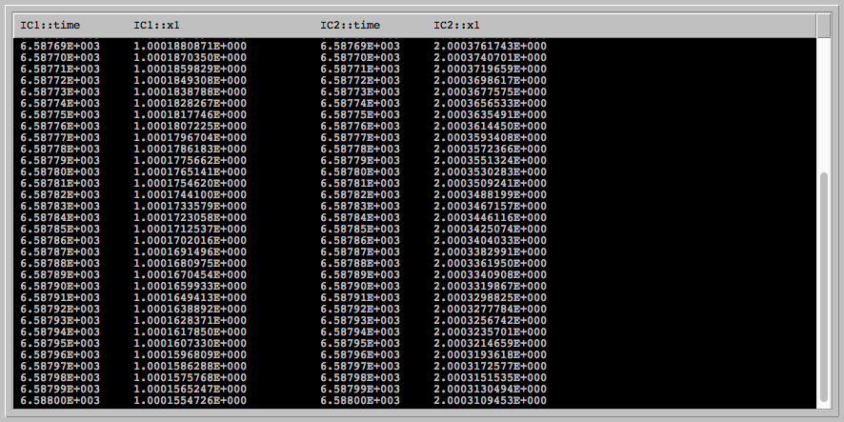

Radioisotope used in radiotherapy: Strontium-89

Half life: 50.5 days

k = 0.693 / 50.5 = **0.0137**

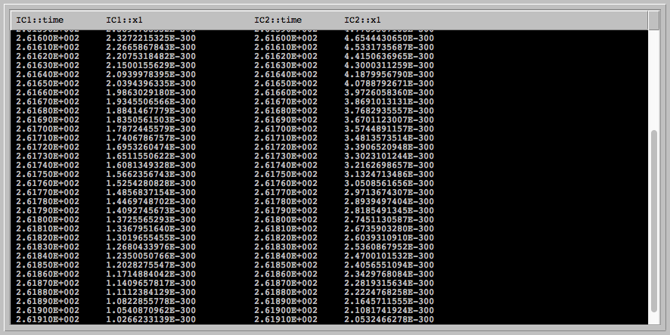

**4. C-14 dating:** The half life of radioactive carbon C-14 is known to be approximately 5730 years. Using Phaser, determine the decay constant k of C-14.

* The decay constant (k) = approximately -0.00012
* Two different initial conditions were used: IC1 = 100 and IC2 = 200 → Decay constant (k) does not depend on initial condition, since it’s half life will occur anyway.
* The half lives are shown below:
* IC of x = 100 → half life of 50, IC of x = 200 → half life of 100

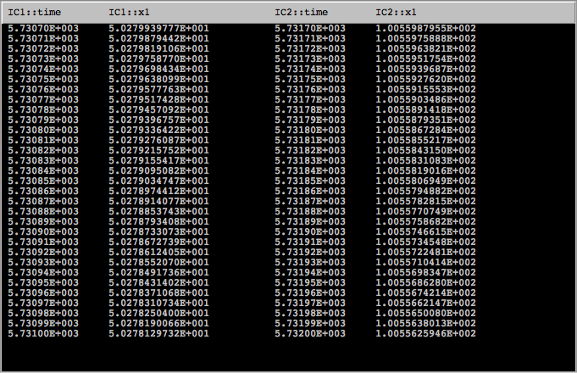

In 1989, fibres from the Shroud of Turin were found to contain about 92% of the level of C-14 in living matter. Determine the age of the shroud using PHASER. Suppose that there was 0.2% error in the determination of the percentage of C-14 in the sample of the shroud. What is the range of possible dates for the sample?

* Age of Shroud where it contains about 92% of the level of C14 in living matter = 690 years
* This can be seen from the Xi values iterated, where after 690 years, there is a 92% level

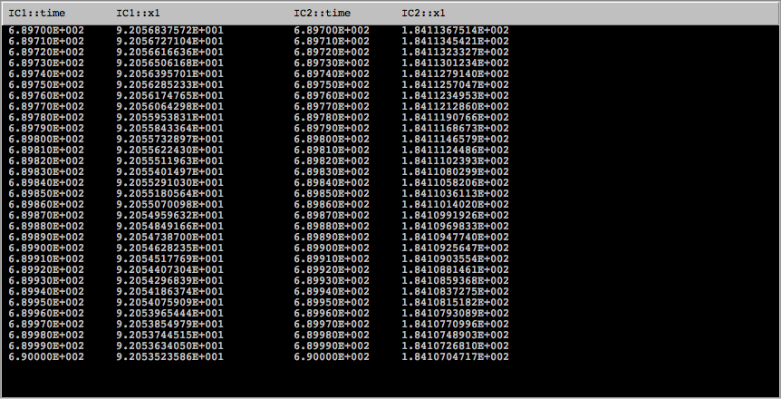

* If there was a -0.2% error in the determination of percentage of C14 in the sample, there would be a 91.8% level contained, and the age would be about 712 years. This is seen in the Xi values, which show that after 712 years , the C14 level was at about 91.8.

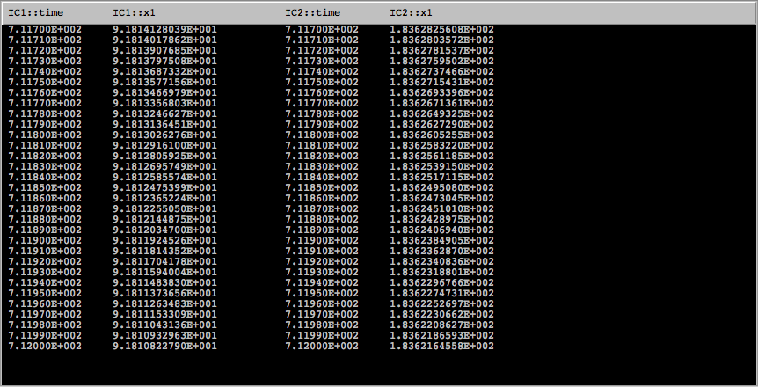

* If there was a +0.2% error in the determination of percentage of C14 in the sample, there would be a 92.2% level contained, and the age would be about 676 years. This is seen in the Xi values, which show that after 676 years , the C14 level was at about 92.1.

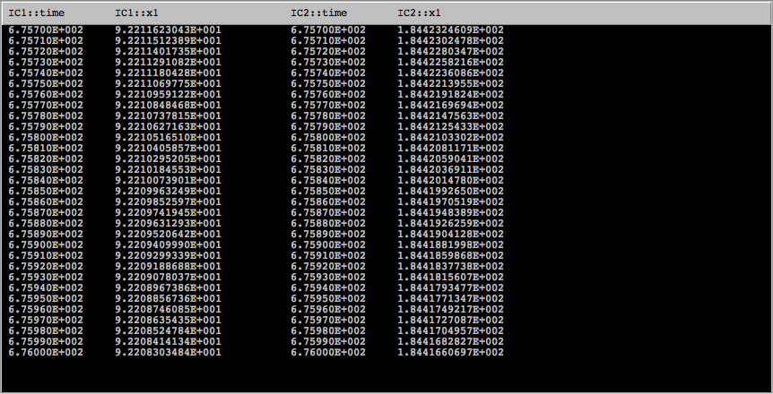

Some people do not agree with the results of the C-14 dating of the Shroud. Do some research on the Web (see the links above, for example) and identify an objection or raise one of your own. Argue for or against the objection.

Many people believe in the religiously symbolic meaning of the shroud. These people believe that the shroud was wrapped around the body of Jesus, especially since the shroud can be dated back to the correct time through scientific evidence. I agree with the objection that there is no clear evidence that the shroud was wrapped the body of Jesus, despite it’s similar timing, as more evidence needs to support this theory.